System Requirements

* Microsoft SQL Server Express 2008 R2, with the following features installed:
  + Database Engine
  + Reporting Services in Native Mode
  + Microsoft SQL Server Management Studio
  + Microsoft SQL Server Business Intelligence Development Studio

|  |
| --- |
|  |
|  |

Configuring the Report Server

1. Open **Reporting Services Configuration Manager** from

Start 🡪 All Programs 🡪 Microsoft SQL Server 2008 R2 🡪Configuration Tools 🡪 **Reporting Services Configuration Manager**

|  |
| --- |
|  |
| NOTE: The Reporting Services Configuration tool is used to configure a Reporting Services installation. You can configure a local or remote report server instance as long as you are a member of the local administrator group on the report server computer. |

1. In the “Connect to a report server instance” dialog box, make sure that your local report server instance (for example: **MSSQLSERVER**) is selected and click **Connect**.

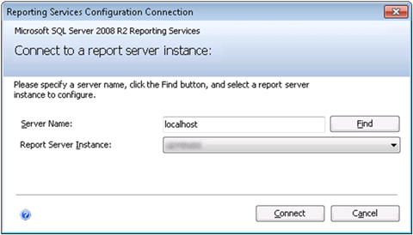

**Figure 1** ***Reporting Services Configuration Manager connection***

1. On the Service Account page, use as shown below:

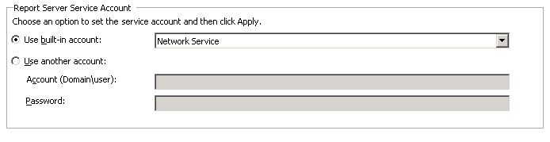

1. On the “Web Service URL**”**  page, make sure that the Virtual Directory is set to **ReportServer_*%YourSqlServerInstanceName%***

For example **ReportServer** for the SQL Server default instance and that the **TCP Port** is set to **80**.

|  |
| --- |
| **http://ecn.channel9.msdn.com/o9/learn/SQL2008R2TrainingKit/Demos/ReportingServices/Demo.html/local/note.gifNote:** |
| The virtual directory name identifies which application receives the request. Because an IP address and port can be shared by multiple applications, the virtual directory name specifies which application receives the request. |

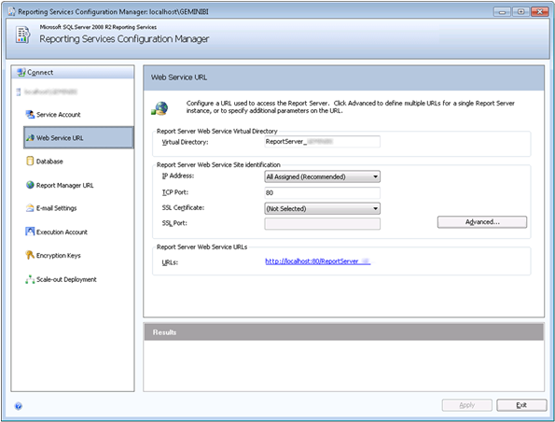

**Figure 2 *Web Service Configuration***

1. On the **Database** page, make sure that:
   1. **SQL Server Name** points to your local SQL Server instance (for example **localhost\.)**.
   2. **Report Server Mode** is set to **Native**.

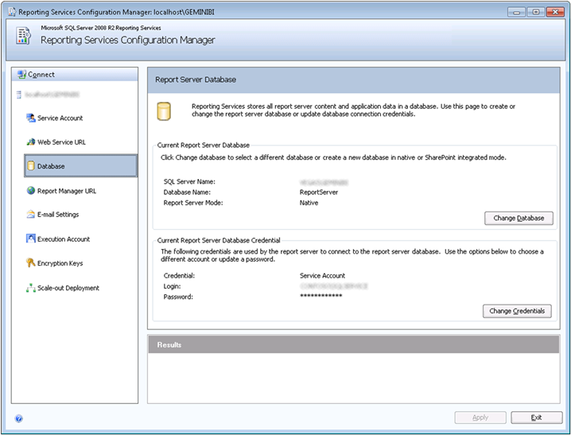

**Figure 3** ***Database Configuration***

1. If the Database Configuration values are not set as above, follow these steps:
   1. Click **Change Database** to open the Report Server Database Configuration Wizard.
   2. Click **Create a new report server database** and then **Next.**
   3. In the **Database Server** page, set the **Server Name** to point the local SQL Server instance and select **Current User -Integrated Security** for the **Authentication Type.**

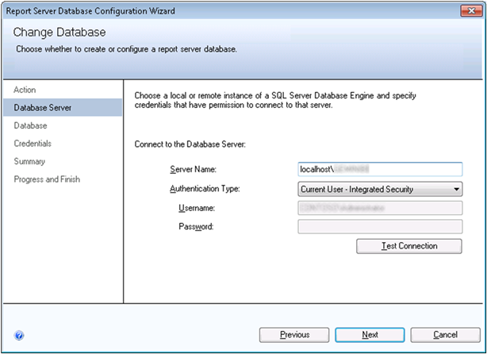

**Figure 4 *Change Database Server Configuration***

* 1. Click **Next**.
  2. In the **Database** page, type **ReportServer** as the **Database Name** and click **Native Mode** for the **Report Server Mode.**

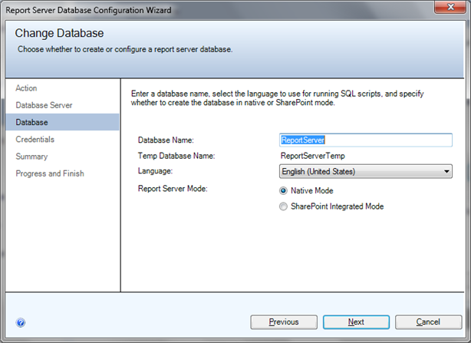

**Figure 5 *Change Database Configuration***

* 1. Click **Next** to continue.
  2. In the **Credentials** page, select **Service Credentials** for the **Authentication Type**.

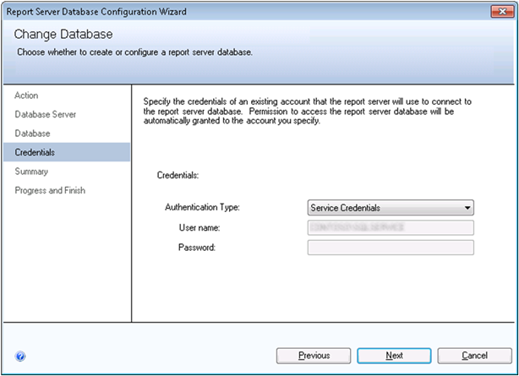

**Figure 6** ***Change Database Configuration***

* 1. Click **Next,** and finally **Finish** to complete the wizard.

1. On the **Report Manager URL** page, make sure that the **Virtual Directory** is set to **Reports_*%YourSqlServerInstanceName%*** (for example **Reports** for the SQL Server default instance)**.**

|  |
| --- |
| **http://ecn.channel9.msdn.com/o9/learn/SQL2008R2TrainingKit/Demos/ReportingServices/Demo.html/local/note.gifNote:** |
| Use the Report Manager URL page to configure or modify the URL used to access Report Manager. By default, the Report Manager URL inherits the prefix, IP address, and port of the Report Server Web service URL. This is because Report Manager provides front-end access to the Web service that runs within the same Report Server service. |

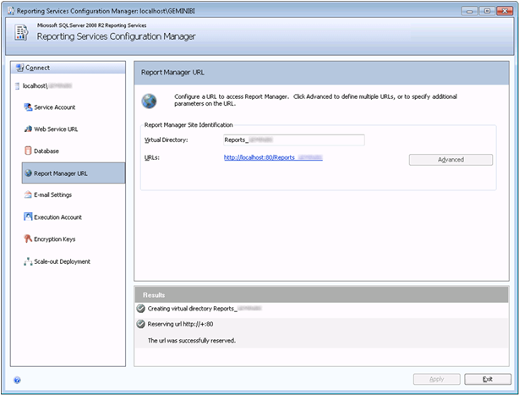

**Figure 7** ***Report Manager URL***

|  |
| --- |
|  |
| NOTE: If you see a warning message saying: *The Report Manager virtual directory is not configured*, click **Apply** to create it and configure it. |

1. Click **Exit** to close the Configuration Manager.

Deploying the Sample Reports

1. Open Business Intelligence Development Studio from

Start 🡪 All Programs 🡪 Microsoft SQL Server 2008 R2 with administrative privileges.

1. Click the File menu, point to Open and then click Project/Solution.

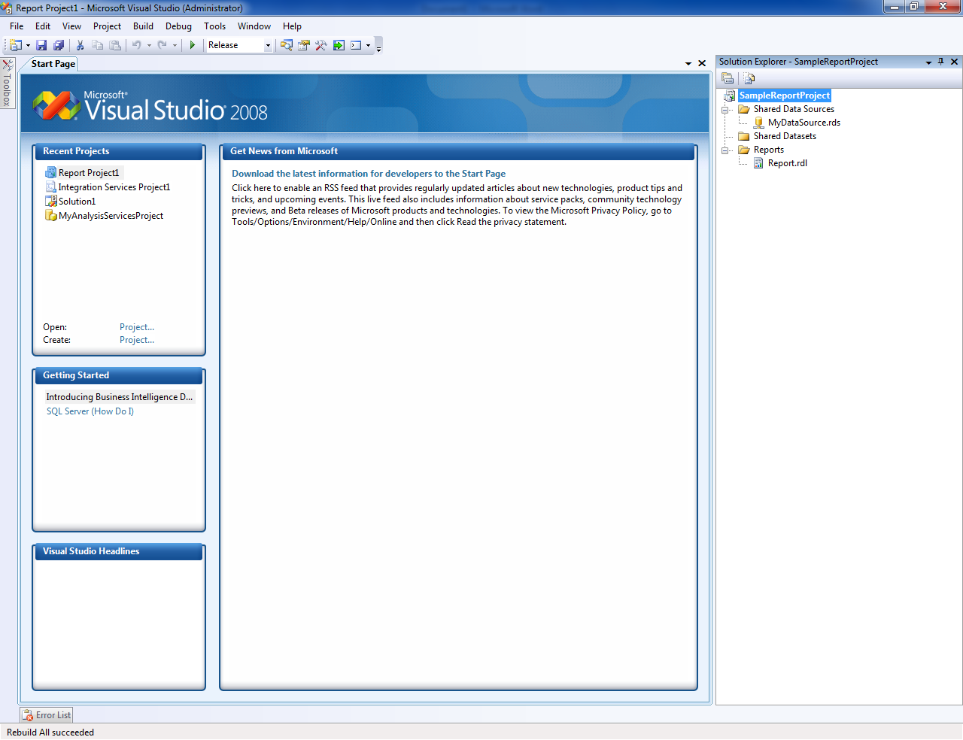

Figure 8 “*SampleReportProject” in Business intelligence Development Studio*

1. On the Visual Studio toolbar, select **Release** in the **Solution Configurations** (the default configuration is **Debug**).

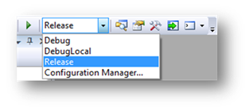

Figure 9 Release *Configuration*

1. Right-click the Solution,”SampleReportProject”project and select Properties.
2. On the **General** tab, configure the **General** properties as follows:
   1. Set **OverwriteDataSources** to **True**
   2. Set **TargetReportFolder** to **AW2008SampleReports**
   3. Set **TargetServerURL** to **http://<servername>/reportserver**

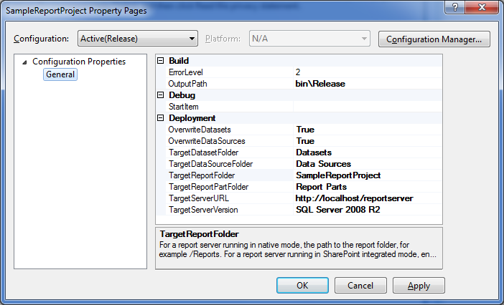

Figure 10 *Project Configuration*

1. Click **OK**.
2. On the **Build** menu, click **Deploy “**SampleReportProject**”**

|  |
| --- |
|  |
| NOTE: When you deploy the solution, the reports are published to the report server. |

Browsing the Reports in the Report Manager

1. Open **Internet Explorer** with administrator privileges.

|  |
| --- |
|  |
| NOTE: It is important to run the Web browser as administrator otherwise; you will not be able to browse the reports. |

1. Browse the **Report Manager** at **http://localhost/reports**.
2. In the **Home** page, click the **SampleReportProject** folder. You should see all Reports.

|  |
| --- |
| **http://ecn.channel9.msdn.com/o9/learn/SQL2008R2TrainingKit/Demos/ReportingServices/Demo.html/local/note.gifNote:** |
| Report Manager is a Web-based tool that includes features for viewing and managing reports. It is part of a report server installation. To open Report Manager, type the Report Manager URL in a browser window. You can use any supported Web browser to view a report through a direct connection to a report server. Every report has a URL address on a report server. You can use that address to open it in a new browser window independently. |

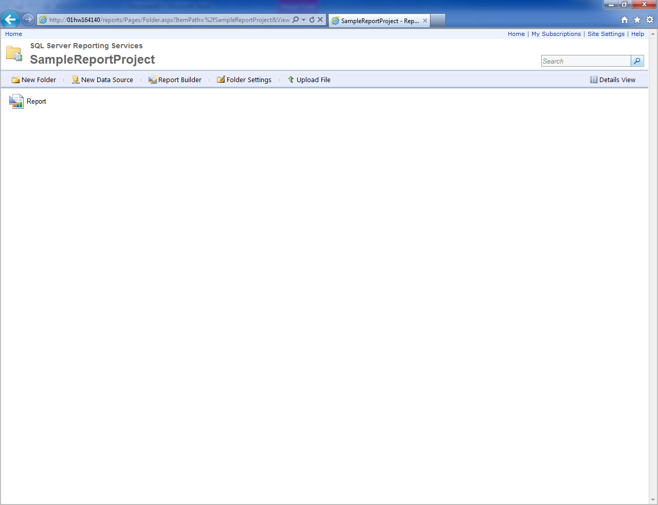

Figure 11 *SampleReportProject in Report Manager*

**Lesson Contents**

* [Overview](http://channel9.msdn.com/Learn/Courses/SQL2008R2TrainingKit/ReportingServices2008/ReportingServicesDemo/Overview)
* [**Setup and ​Configurati​on**](http://channel9.msdn.com/Learn/Courses/SQL2008R2TrainingKit/ReportingServices2008/ReportingServicesDemo/Setup-and-Configuration)
  + [Task 1 – Running the ​Configurati​on Wizard](http://channel9.msdn.com/Learn/Courses/SQL2008R2TrainingKit/ReportingServices2008/ReportingServicesDemo/Setup-and-Configuration#_Toc263257477)
  + [Task 2 – Configuring the Report Server](http://channel9.msdn.com/Learn/Courses/SQL2008R2TrainingKit/ReportingServices2008/ReportingServicesDemo/Setup-and-Configuration#_Toc263257478)
  + [Task 3 – Deploying the ​Adventure​Works Sample Reports](http://channel9.msdn.com/Learn/Courses/SQL2008R2TrainingKit/ReportingServices2008/ReportingServicesDemo/Setup-and-Configuration#_Toc263257479)
  + [Task 4 – Browsing the Reports in the Report Manager](http://channel9.msdn.com/Learn/Courses/SQL2008R2TrainingKit/ReportingServices2008/ReportingServicesDemo/Setup-and-Configuration#_Toc263257480)
* [Demo Flow](http://channel9.msdn.com/Learn/Courses/SQL2008R2TrainingKit/ReportingServices2008/ReportingServicesDemo/Demo-Flow)
* [Opening Statement](http://channel9.msdn.com/Learn/Courses/SQL2008R2TrainingKit/ReportingServices2008/ReportingServicesDemo/Opening-Statement)
* [Step-by-Step Walkthrough](http://channel9.msdn.com/Learn/Courses/SQL2008R2TrainingKit/ReportingServices2008/ReportingServicesDemo/Step-by-Step-Walkthrough)
* [Summary](http://channel9.msdn.com/Learn/Courses/SQL2008R2TrainingKit/ReportingServices2008/ReportingServicesDemo/Summary)