##### GIT INIT TO GITHUB #####

CREATING EMPTY REPOSITOY( GIT INIT) AND CREATE FILES PUSHING REPOSITORY TO GITHUB

step:1 create a new empty repository in your local machine

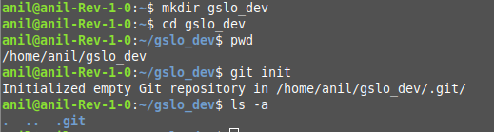

step:2 create new files inside your project workspace

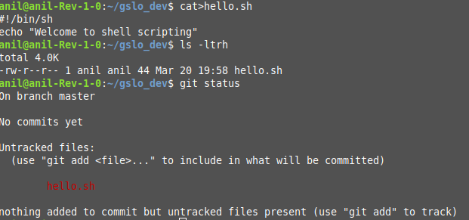

step:3 move hello.sh from project workspace to stage (or) index area

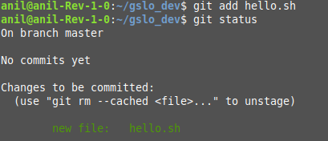

step:4 move hello.sh from stage (or) index area to local repository

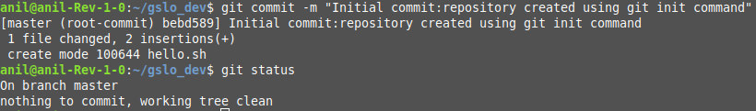

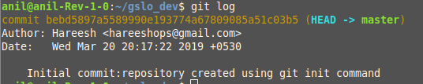

step:5 create empty repository in github.com

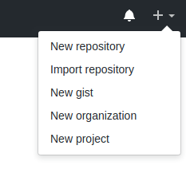

create repository without readme.md file

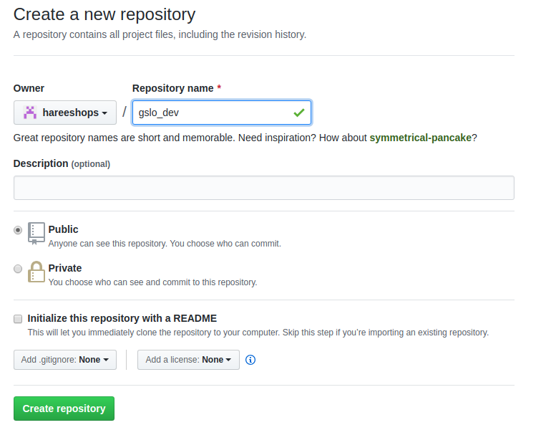

step:6 Move files from local repository to remote github server.

before moving files to github, add remote URL to your local machine and verify whether remote URL added to machine or not.



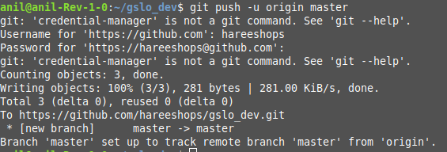

Verify whether files moved or not Github server

