##### CLONE TO GITHUB #####

Clone remote repository to local machine and make changes and push changes to Github

step:1 copy repository URL from project page as shown below and aslo notice repository have hello.sh file.

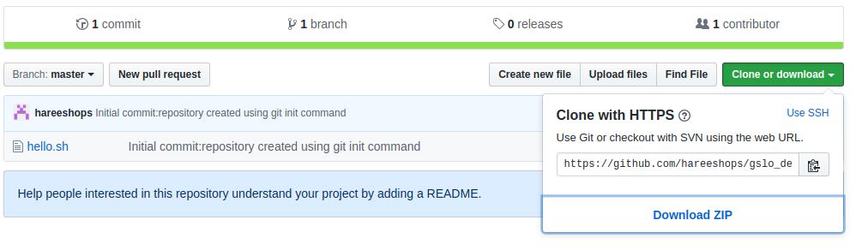

step:2 clone remote repository to local machine

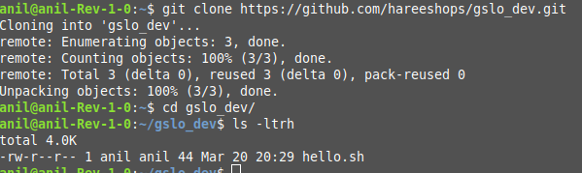

step:3 create new file in workspace

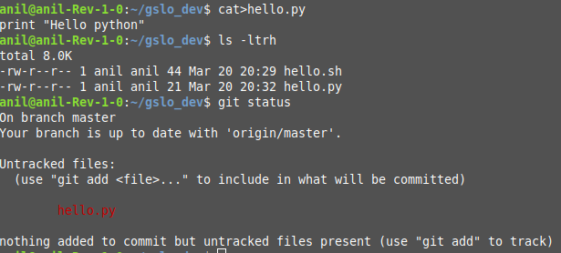

step:4 move file from workspace to stag area

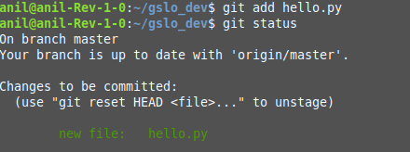

step:5 move file from stage area to localrepository



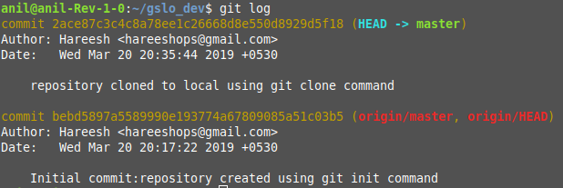

step:6 move file from localrepository to remote repository(github)

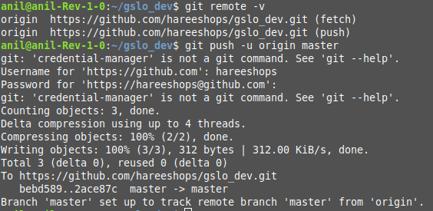

check remote github status:

