###########STEPS TO IMPLEMENT GIT PULL AND GIT FETCH###########

1. create new repository in github

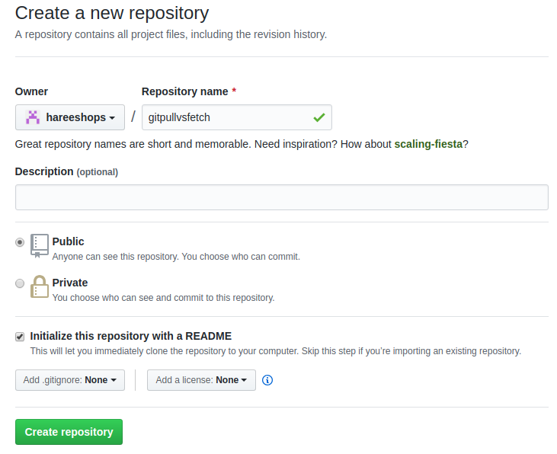

2. create two folders in your local machine like below **dev1 and dev2**

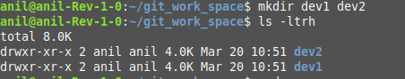

3. clone github repo to dev1 and dev2 folder

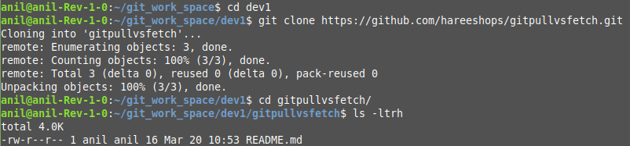

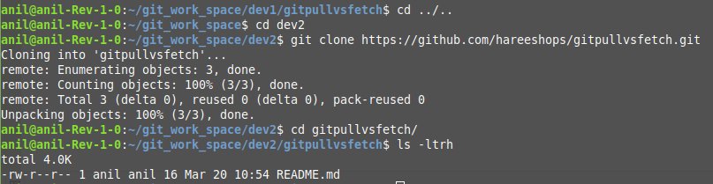

4. create Hello.sh new file in dev2 workspace , commit file to local repo and push to remote

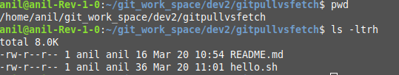

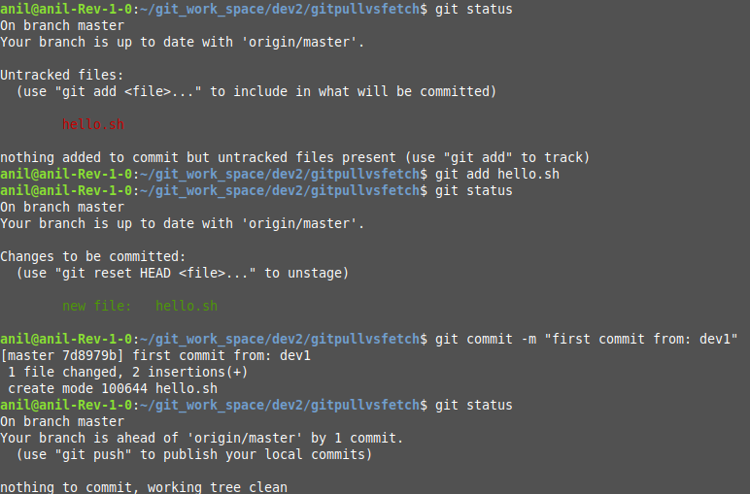

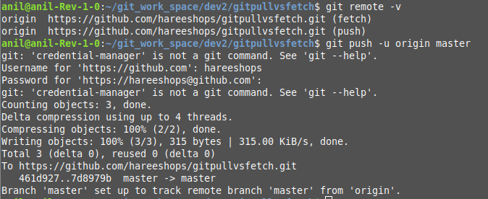

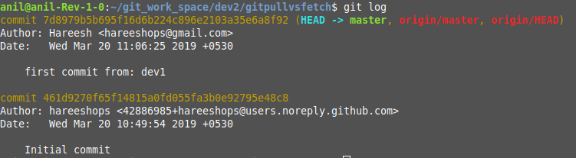

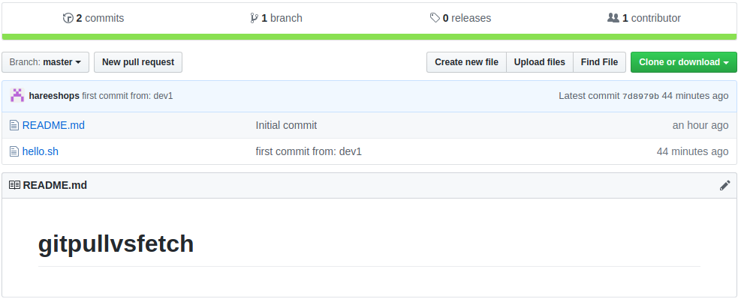

5. create Hello.java new file in dev1 workspace , commit file to local repo and push to remote

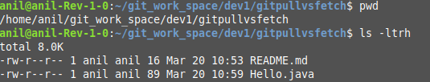

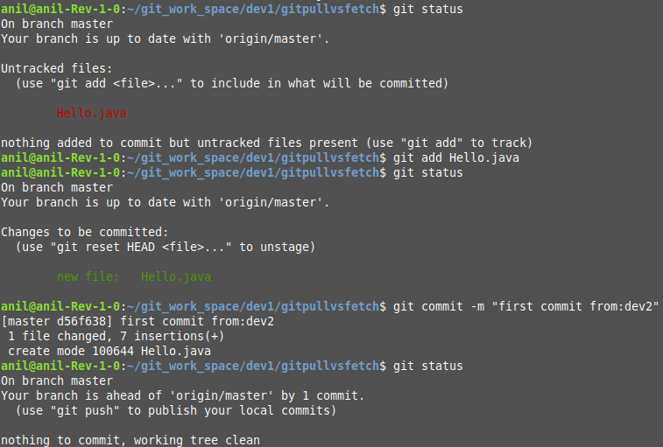

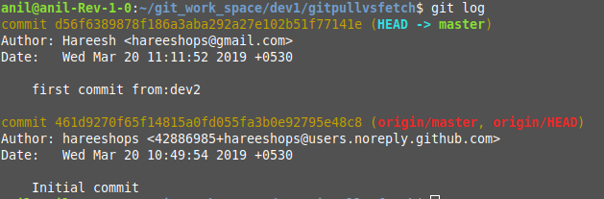

Notice we got error while pushing code to github

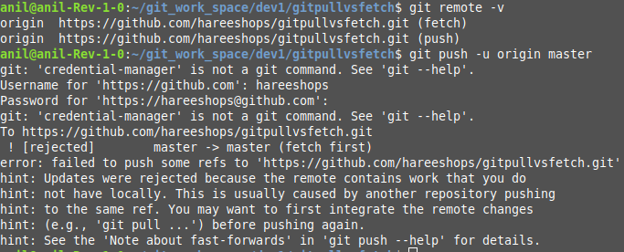

Now here comes concept git pull and fetch

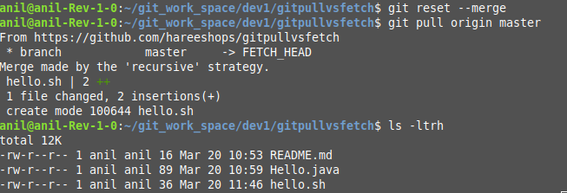

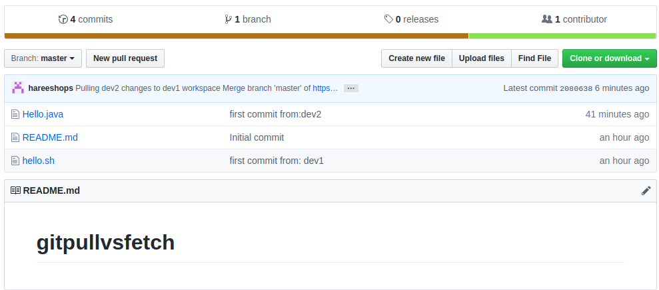

fetch:

