########## git rm, git reset, git checkout##########

git rm : git rm is used to unstage files (staging to workspace)

git reset: git checkout is used to unstage files (staging to workspace)

git checkout : to discard changes in working directory

step:1 create two files inside repository as shown below.

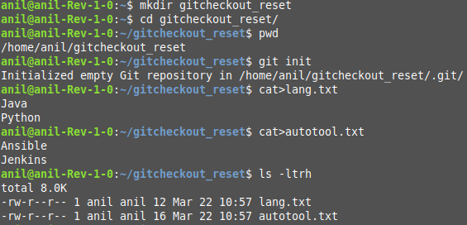

Step:2 check git status before staging files and after staging files.

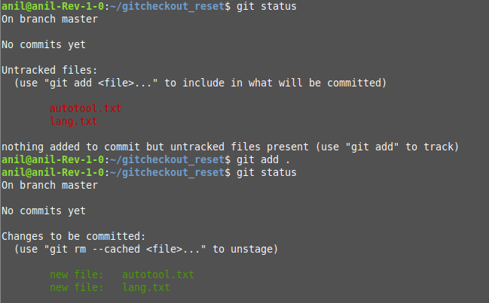

Step:3 By using git rm command to unstage files(stage to workspace)

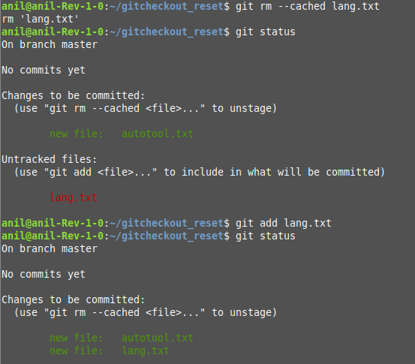

Step:4 commit and check status

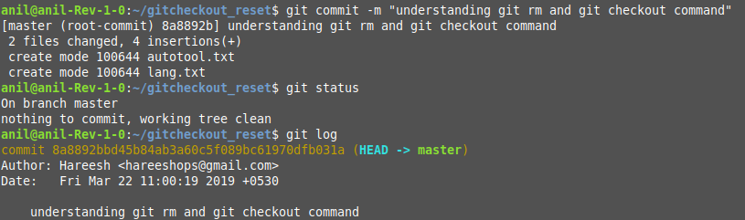

Step:5 To understand git checkout command i am adding content inside our two files.

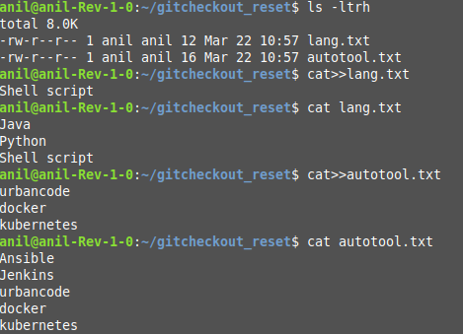

Step:6 to discard changes in working directory

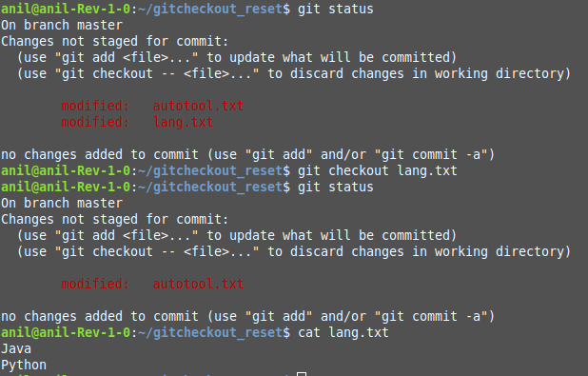

Step: 7 Unstage files using git reset command

file content and status:

