########## FEW IMPORTANT LINUX COMMANDS ##########

pwd: print working directory

$ pwd

ls: list files

$ ls

ls with options:

syntax: ls [options] [arguments]

$ ls -a (list files along with hidden files)

$ ls -l (long listing files)

$ ls -ltrh (listing files in human readable format)

mkdir: make directory or folder

syntax: mkdir [directory_name]

$ mkdir git_work

cd: change directory or navigating to directory

syntax: cd [directory_name]

$ cd git_work

clear: to clear screen

$ clear

########## GIT TERMINOLOGY ##########

repository

centralized version control system (svn)

distributed version control system(git)

workspace

staging area

local repository

remote repository

########## TO INSTALL GIT ##########

Download git from below official link based on your operaating system and architecture

https://git-scm.com/downloads

########## TO CHECK GIT VERSION ##########

$ git –-version

########## TO GET HELP ##########

$ git –help

########## TO CREATE EMPTY REPOSITORY ##########

git init:

git init command creates empty repository. Inside repository folder (or) project folder, inside project it creates .git folder.

* The .git is a hidden folder.
* The .git folder contains all the information that is necessary for your project in version control and all the information about commits, remote repository address etc. All are present in this folder. It also contains a log which stores your commit history so that you can roll back to history.

practical steps to create empty git repository:

step:1 create project folder using **mkdir** command

$ mkdir git_work

step:2 navigate to git_work folder using **cd** command

$ cd git_work

step:3 verify present working directory using **pwd** command

$ pwd

step:4 issue git init command

$ git init

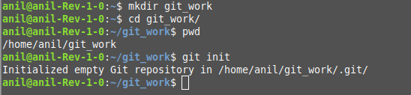

########## TO ADD CONFIGURATIONS ##########

git config: git config command helps you to setup various configuration options for your git repository.

$ git config –global user.email “[youremail@github.com](mailto:youremail@github.com)”

$ git config –global user.name “yourname”

to check what configurations added to git

$ git config --list

########## TO CHECK REPOSITORY STATUS ##########

git status: The git status command displays the state of the working directory and the staging area

before checking git status create file with some content

$ cat>hello.html

hi everyone

ctrl+d --> to save

$ git status

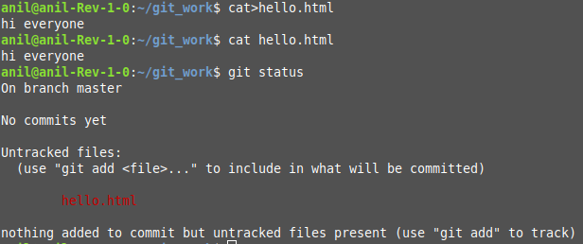

########## TO ADD FILES ##########

git add: git add command add files from workspace to staging area.

syntax: git add [filename]

$ git add hello.html # to add single file

$ git add . # to add all files in your repository

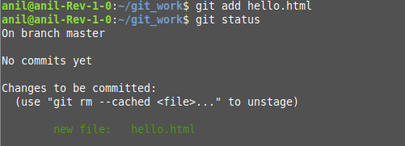

########## TO COMMIT FILES ##########

git commit:

The below command is used to commit files to repository.

$ git commit -m “my first file to repository”

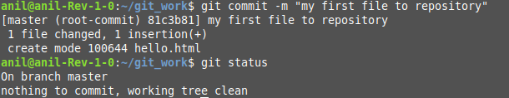

########## TO CHECK COMMIT LOGS ##########

git log:

The git log command shows you the commit history.

$ git log

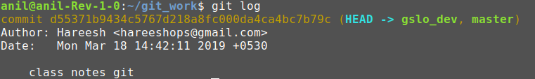

########## TO PUSH REPOSITORY FROM LOCAL to GITHUB SERVER ##########

Before pushing repository we need to add git remote path to your local repository

Add git remote:

$ git remote add origin [https://github.com/hareeshops/git_work.git](https://github.com/hareeshops/test1.git)

$ git remote -v

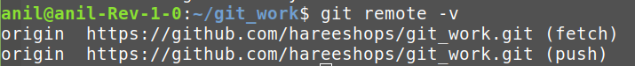

To push repository from local to remote:

$ git push -u origin master

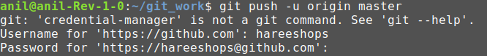

########## TO CREATE NEW BRANCH ##########

To create new branch:

$ git branch gslo_dev



To view exist branches:

$ git branch



* master is default branch for git repositories. In above screenshot our repository is pointing to master branch.

To switch different branch:

syntax: git checkout [branch-name]

$ git checkout gslo_dev

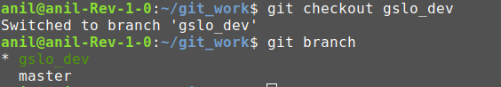

* After checkout from **master** to **gslo_dev** branch, notice screenshot repository is pointing **gslo_dev** branch

########## PULL FROM REPOSITORY ##########

git pull: fetch + merge

########## FETCH FROM REPOSITORY ##########

git fetch:

########## GIT STASH ##########

########## GIT CHERRY PICK ##########