**Software Design Document**

*Game Based Learning*

Project-4

April 2, 2017

**Group 8**

150101027- I.N.Dilip Kumar

150101051-Hareesh Reddi

150101032-L.Sai Shobith

**Contents:**

**1 Introduction**

1.1 Purpose…………………………………………………………………………...3

1.2 Scope of the Project……………………………………………………………..3

1.3 Overview of the Document………………………………………………….......3

1.4 References………………………………………………………………………..3

**2 Data Flow Diagram**

2.1 Level 0 Diagram…………………………………………………………………4

2.2 Level 1 Diagram…………………………………………………………………5

2.3 Level 2 Diagrams………………………………………………………………..6

2.3.1 Level 2 Diagram for Interaction and Instructions Module………….6

2.3.2 Level 2 Diagram for Game Module…………………………………..7

2.3.3 Level 2 Diagram for High Score Module…………………………….8

**3 Process Decomposition Diagram……………………………………………………….**9

**4 Entity Relationship Diagram…………………………………………………………….**10

**5 Data Dictionary…………………………………………………………………………….**10

**1 Introduction**:

**1.1 Purpose:**

The purpose of the Software Design Document is to provide a description of the design of a system fully enough to allow software development to proceed with an understanding of what is to be built and how it is expected to build. The Software Design Document provides information necessary to provide description of the details for the software and system to be built.

**1.2 Scope:**

This Software Design Document is for a base level system, which will work as a proof of concept for the use of building a system the provides a base level of functionality to show feasibility for large-scale production use. This Software Design is focused on the base level system and critical parts of the system. For this particular Software Design Document, the focus is placed on generation of the documents and modification of the documents. The system will be used in conjunction with other pre-existing systems and will consist largely of a document interaction facade that abstracts document interactions and handling of the document objects.

**1.3 Overview of the Document:**

The first chapter contains the Introduction part, which gives a basic idea about the project. The second chapter gives information about the Data Flow Diagrams. The third chapter gives information about the Process Decomposition Diagram. The fourth chapter gives information about the Entity-Relationship Diagrams. The fifth chapter gives information about the Data Dictionary

**1.4 References:**

1. <http://nptel.ac.in/courses/Webcourse-contents/IIT%20Kharagpur/Soft%20Engg/pdf/m05L12.pdf>
2. Software Engineering: A Practitioner's Approach, Roger S Pressman – Sixth Edition
3. <http://nptel.ac.in/courses/Webcourse-contents/IIT%20Kharagpur/Soft%20Engg/left_mod6.html>

**2. Data Flow Diagrams:**

**2.1 Level 0 Diagram:**

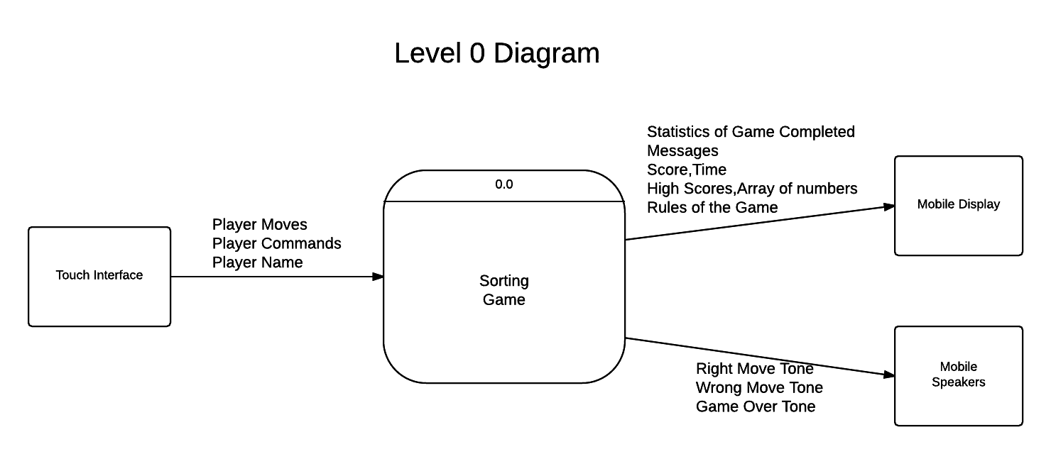

**Sorting Game**: Implements the sorting game by taking the command from the player through touch interface and communicates with the player through mobile display and mobile speakers.

**2.2 Level 1 Diagram:**

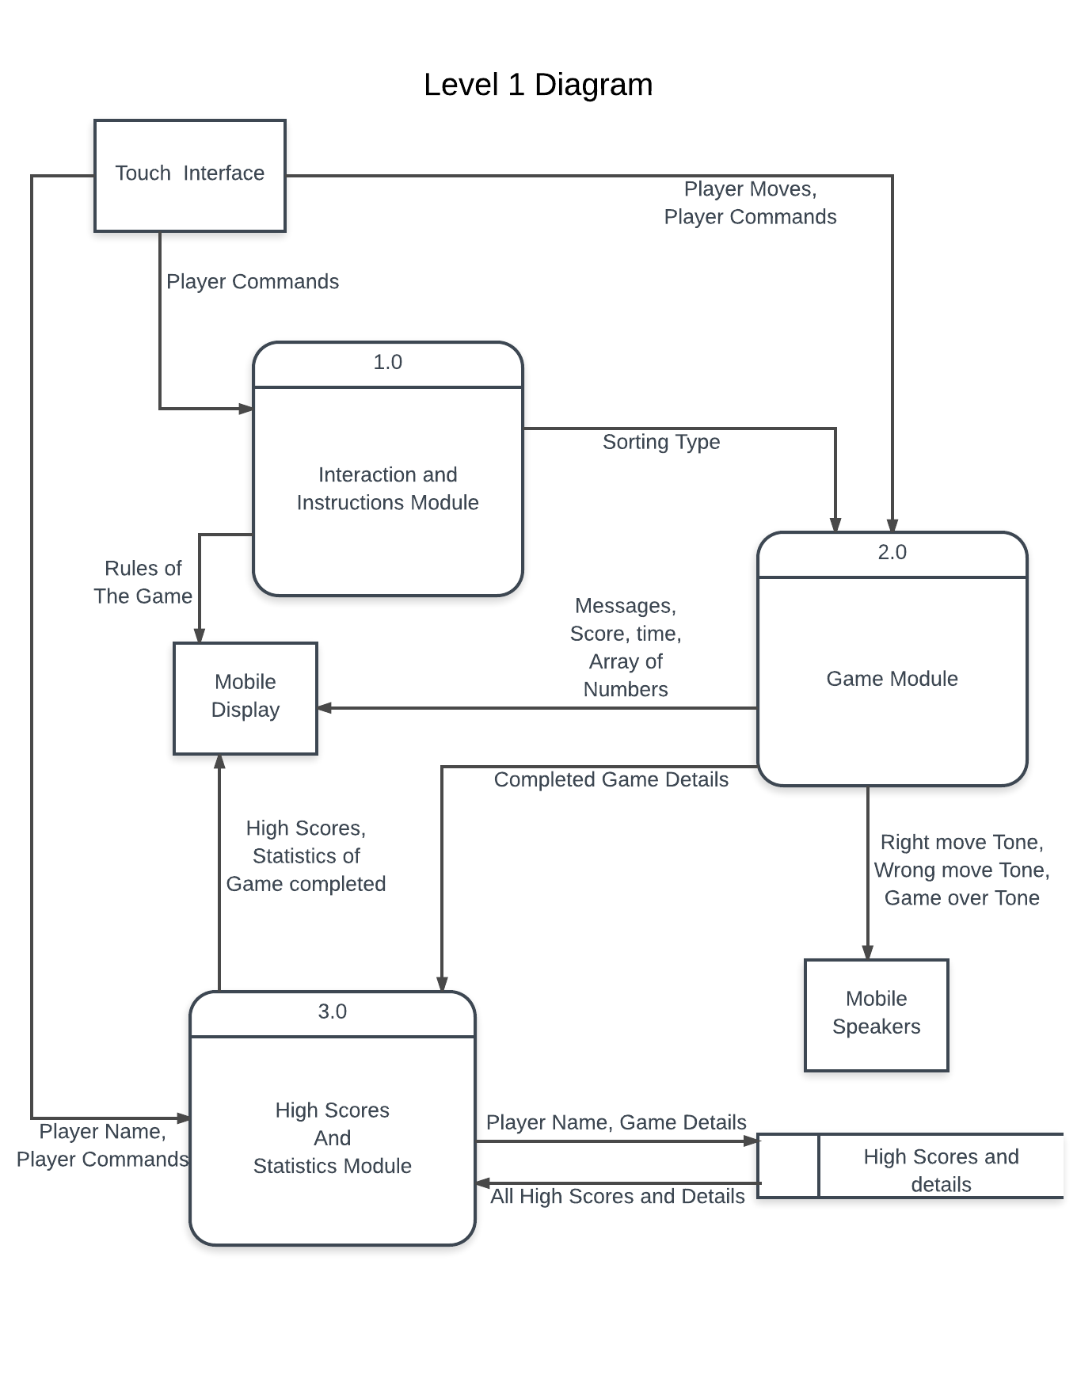

1. **Interaction and Instruction module**: It will display the different sorting algorithms for the player to select and after selecting, it will show the rules for that particular game.

**2.0 Game module**: Implements the game according to the selected sorting algorithm. After each move, it will tell whether the player move is correct or wrong. It also plays different sounds after each move to tell whether it is correct or wrong and also a different sound at the end of the game.

**3.0 High Scores and Statistics module**: It will display all the high scores when requested by the player. It will calculate and update the high scores upon completion of each game.

**2.3 Level 2 Diagrams:**

**2.3.1 Level 2 Diagram for Interaction and Instructions Module:**

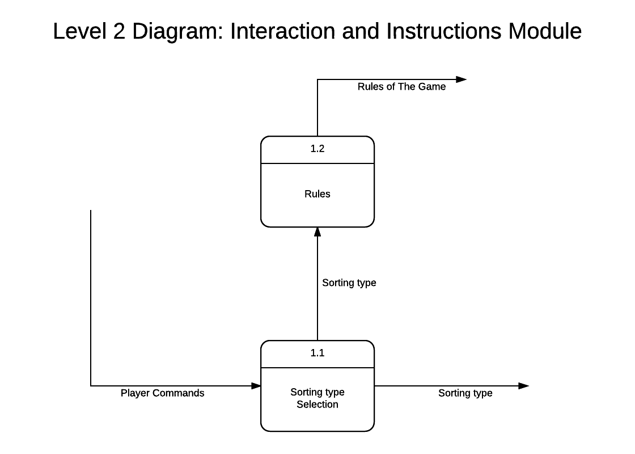

**1.1 Sorting type selection**: Receive the command from the player and selects the sorting type.

**1.2 Rules**: Displays the rules of a particular sorting type.

**2.3.2 Level 2 Diagram for Game Module:**

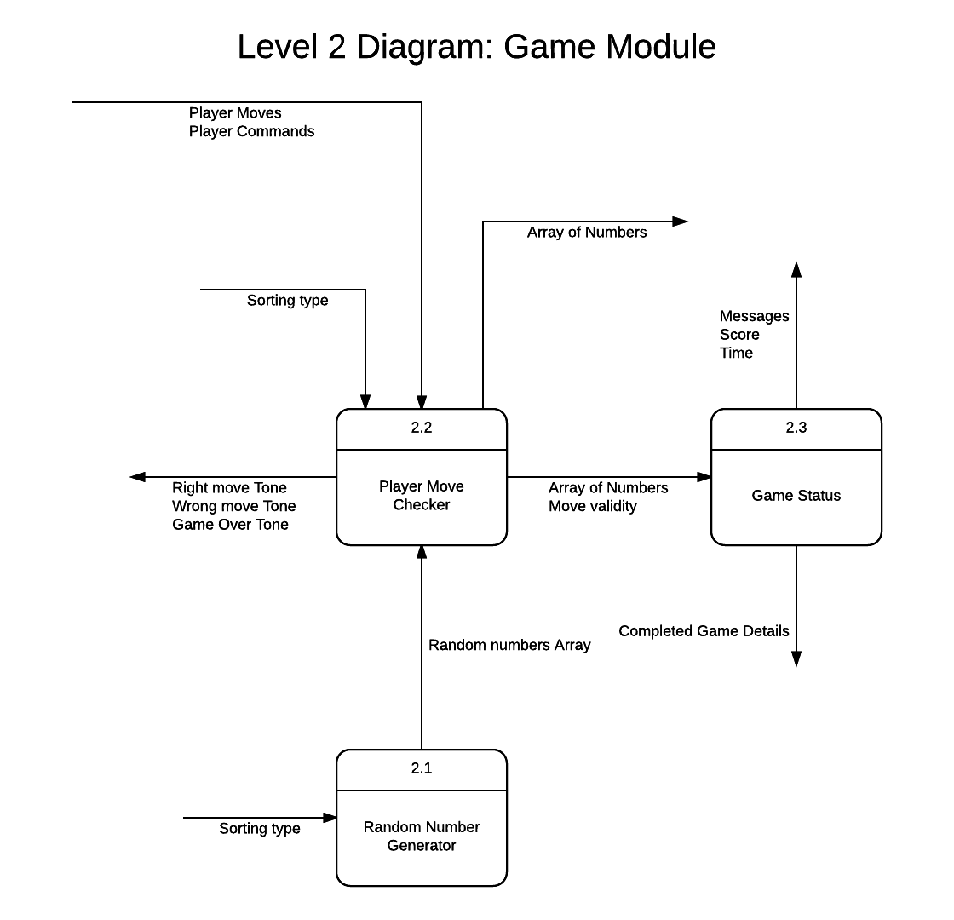

**2.1 Random number generator**: Generates array of random numbers for the game according to the sorting algorithm selected.

**2.2 Player move checker**: Checks whether the move made by the player is correct or wrong and plays sounds accordingly.

**2.3 Game Status**: Check whether the game is completed or not by checking the order of numbers and if the game is completed then it will send the game details.

**2.3.3 Level 2 Diagram for High Scores and Statistics Module:**

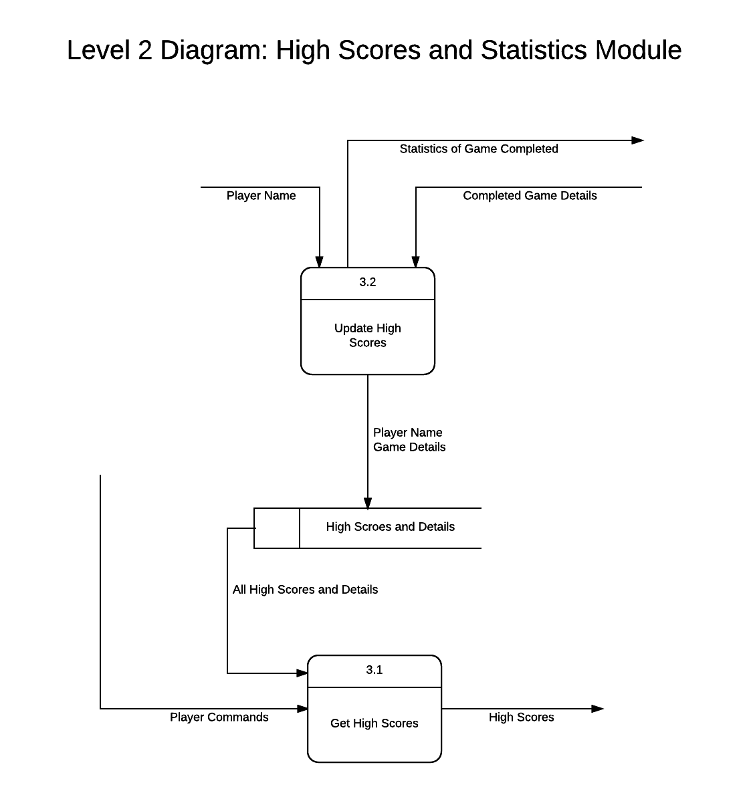

**3.1 Get high scores**: It will display high scores when requested by the player.

**3.2 Update high scores**: It will update the high score database and displays the statistics at the end of the each game.

**3 Process Decomposition Diagram:**

**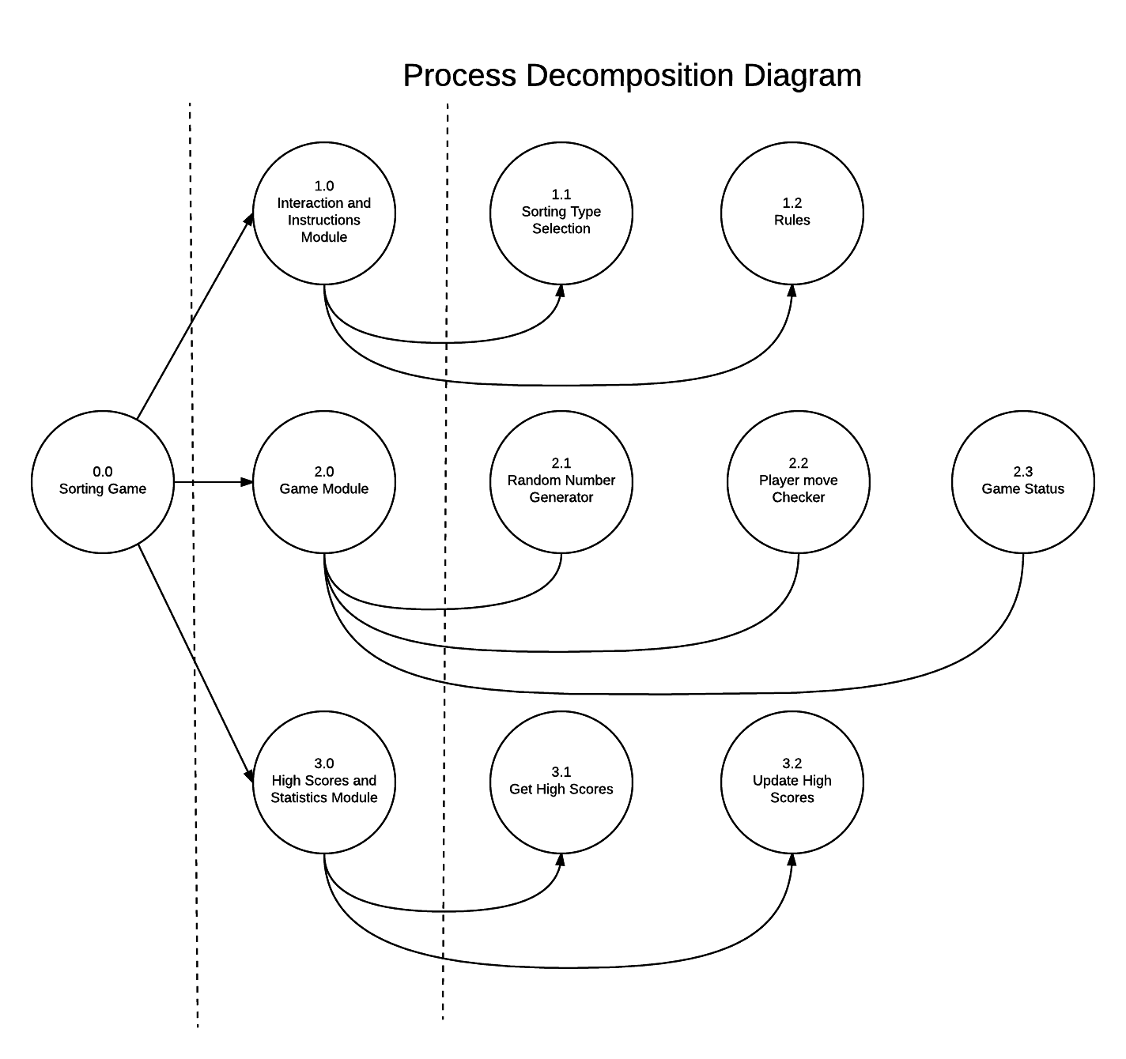  
Level-0 Level-1 Level-2**

**4 Entity Relationship Diagram:**

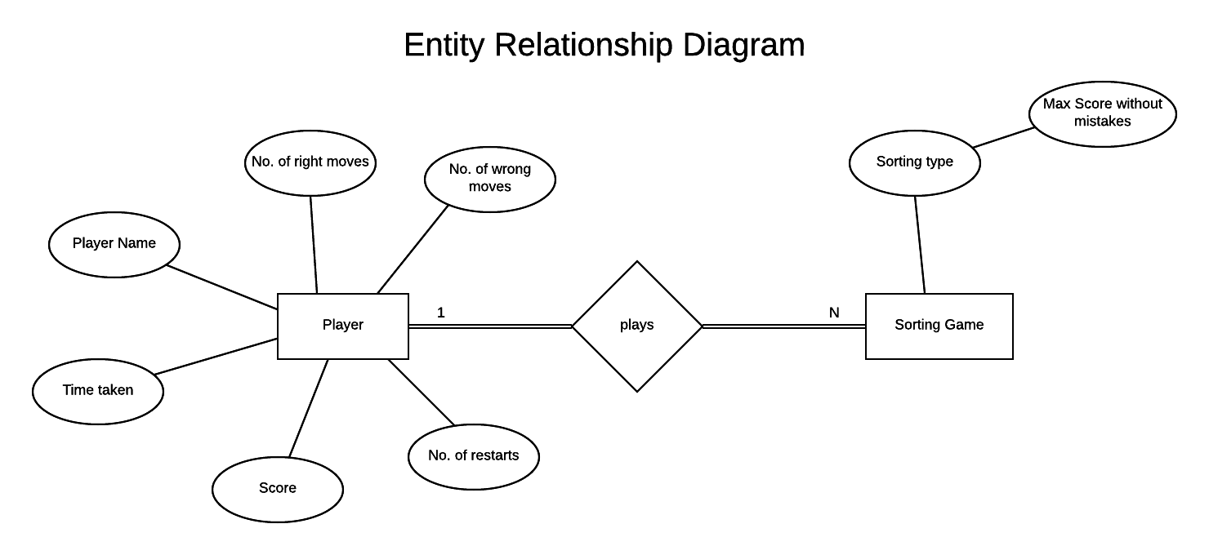

**5 Data Dictionary:**

|  |  |  |
| --- | --- | --- |
| **Data object/**  **External entity** | **Type** | **Description** |
|  |  |  |
| **Touch Interface** | Mobile Screen | The mobile screen on which the player will play the game |
| **Player Moves** | Hand Gestures | The gestures that are made by the player to make a move in the game |
| **Player Name** | String | The name of the player |
| **Messages** | String | Notifications when the player is playing the game |
| **Score** | Integer | The score of the player so far while playing the game |
| **Time** | Integer | The time so far the game is being played in seconds |
| **High Scores** | Table | The table, which contains the names of the player and the high scores, time. |
| **Array of Numbers** | Integers | The list of numbers on the screen after every move made by the player |
| **Rules of the game** | Text | The rules for playing the game for the selected sorting algorithm |
| **Right move tone** | Sound | This tone will be heard when the move made by the player is correct |
| **Wrong move tone** | Sound | This tone will be heard when the move made by the player is Wrong |
| **Game over tone** | Sound | This tone will be heard when the game is completed |
| **Mobile Display** | Mobile GUI | The display screen of the mobile |
| **Mobile Speakers** | Mobile hardware | The speakers of the mobile phone |
| **Sorting type** | String | The type of sorting that is selected by the player |
| **Completed Game details** | List | The time, number of restarts, score, number of wrong moves, number of right moves |
| **Game details** | List | The time, number of restarts, score, number of wrong moves, number of right moves |
| **All high scores and details** | Table | The table which contains the names of the player and the high scores they have got with time |
| **Random numbers array** | Integers | The list of numbers generated by the random number generator |
| **Move validity** | Boolean | A variable used to check whether the move is correct or wrong |