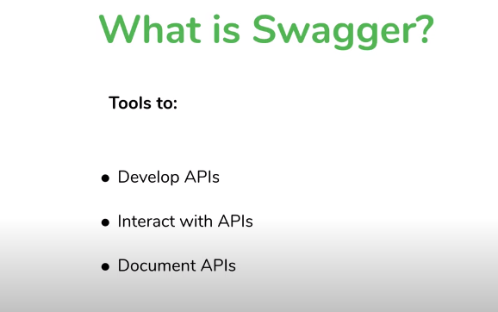

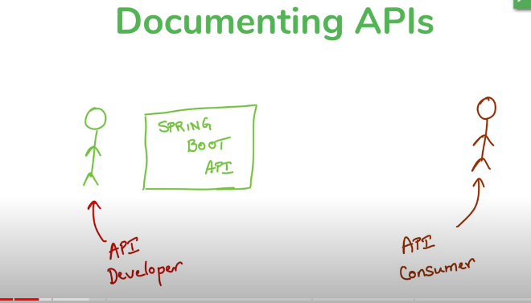

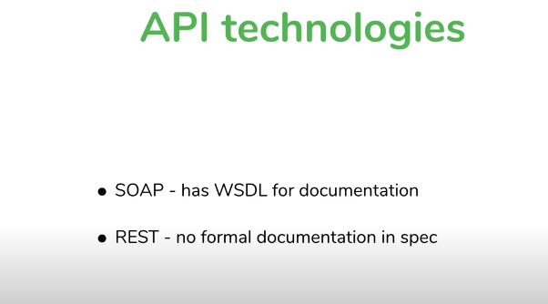

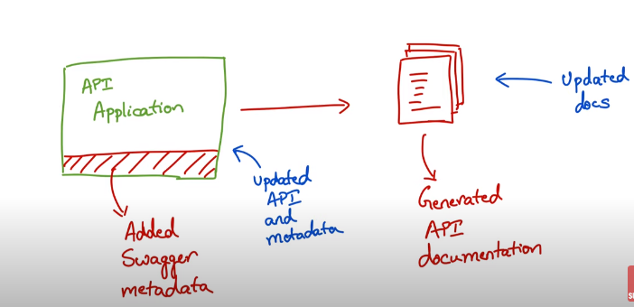

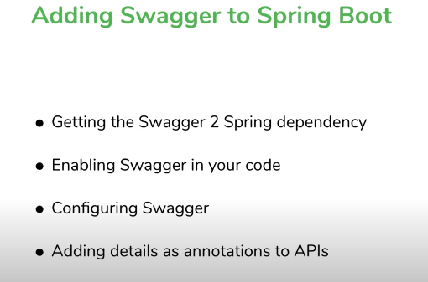

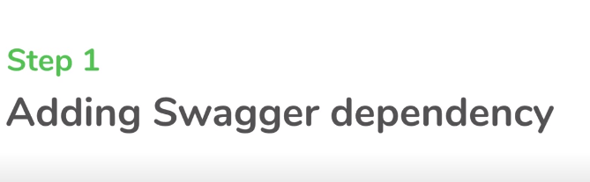

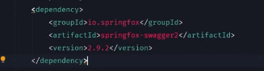

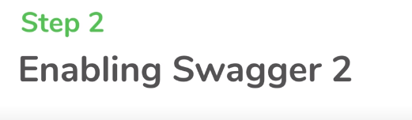

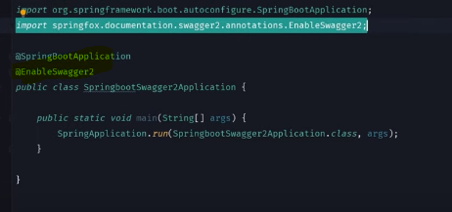

Swagger will provide one extra api for us if we configure swagger in our springboot appln.

Ie; [**http://localhost:8080/v2/api-docs**](http://localhost:8080/v2/api-docs) **->this generates JSON documentation**

For getting HTML documentation use below dependency

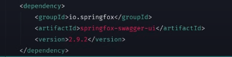

So now our root URL is having the HTML Documentation.

Ie; [**http://localhost:8080/swagger-ui.html**](http://localhost:8080/swagger-ui.html)

* For Customizing swagger we need to create a spring bean of type Docket and then set the properties on it.

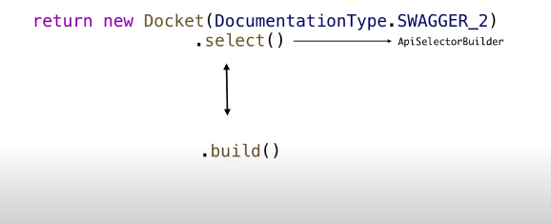

The below code is for customizing.It will help swagger to customize api’s which are under the path /api

And also it will consider only specific packages for documentation.So MVC structure will be excluded.

