**SYSTEM ARCHITECTURE**

Social Network built on Elgg

Process (Using neo4j

Graph DB

IDE

import api

users = api.get_users(id)

Elgg Database (MYSQL)

**Sample Graph Database**

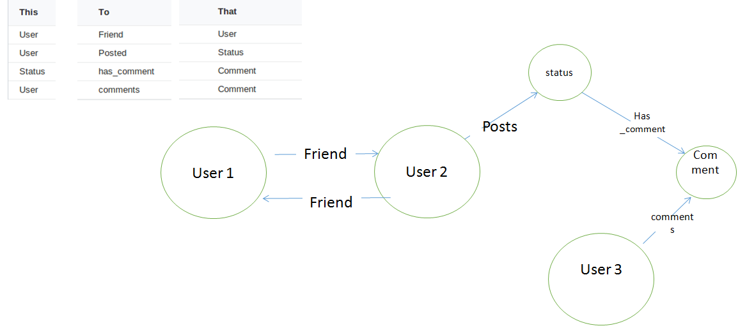

**Elgg Mysql DB Model**

