**Introduction**

# significance of interpersonal variation in gut microbiome: highly personalized characteristic of the gut microbiome has been proposed as the main reason for its variable response to dietary fiber interventions;

# benefit of dietary fiber administration, favor growth of benefit bacteria and metabolites (SCFA)

# among current cross-sectional studies, inconsistent signature of baseline microbiome and mechanism that responsible for individualized responses have been concluded. Reasons: analyze the bacterial taxa individually; response may be time-dependent; confounding factors in human studies

# the gut microbiome is a complex and dynamically changing ecosystem;

the advantage of viewing the microbiota from an ecological perspective;

successful story of the application of ecological framework to gut microbiome

# how to view the individualized response to dietary fiber intervention from the ecological perspective; propose the ecological mechanism model(fig 1)

# the advantage of mouse model to study the proposed ecological model (easily controlled confounding factors);

the model is robust enough to free from confounding factors: meta-analysis of human data show consistent responders;

significance of the inferred microbial responders by our ecological framework

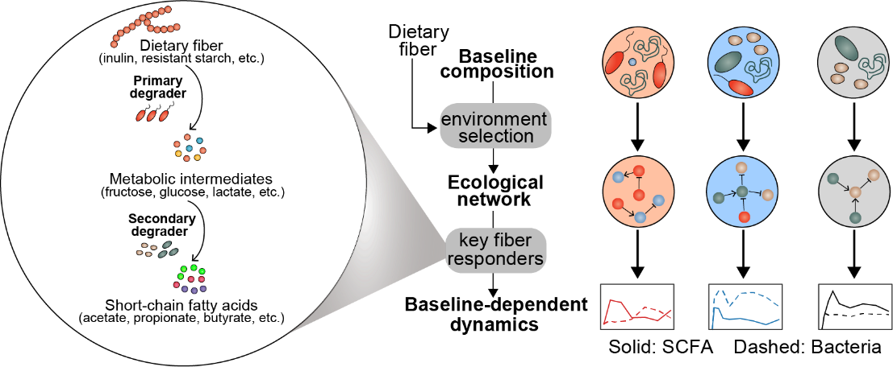

**Figure 1. Proposed model of baseline-dependent dynamical responses of gut microbiota and SCFA metabolites to dietary fiber intervention from the perspective of microbial ecology.** Within the individualized ecological network produced by specific gut microbial configuration, some microbes may play irreplaceable roles during the metabolic process of dietary fiber and consequently drive the dynamic response of gut microbiota to dietary fiber intervention.

**Results**

**# Employing isogenic mouse lines with distinct gut microbiome to study various responses of gut microbiome to dietary fiber intervention**

1. age- and gender-matched C57BL6/N mice purchasing from four different vendors feature distinct gut microbiota: absence of Un Muri in Shanghai when compared to the other three vendors
2. more similar composition & bacterial presence within each vendor than between vendors
3. experimental design

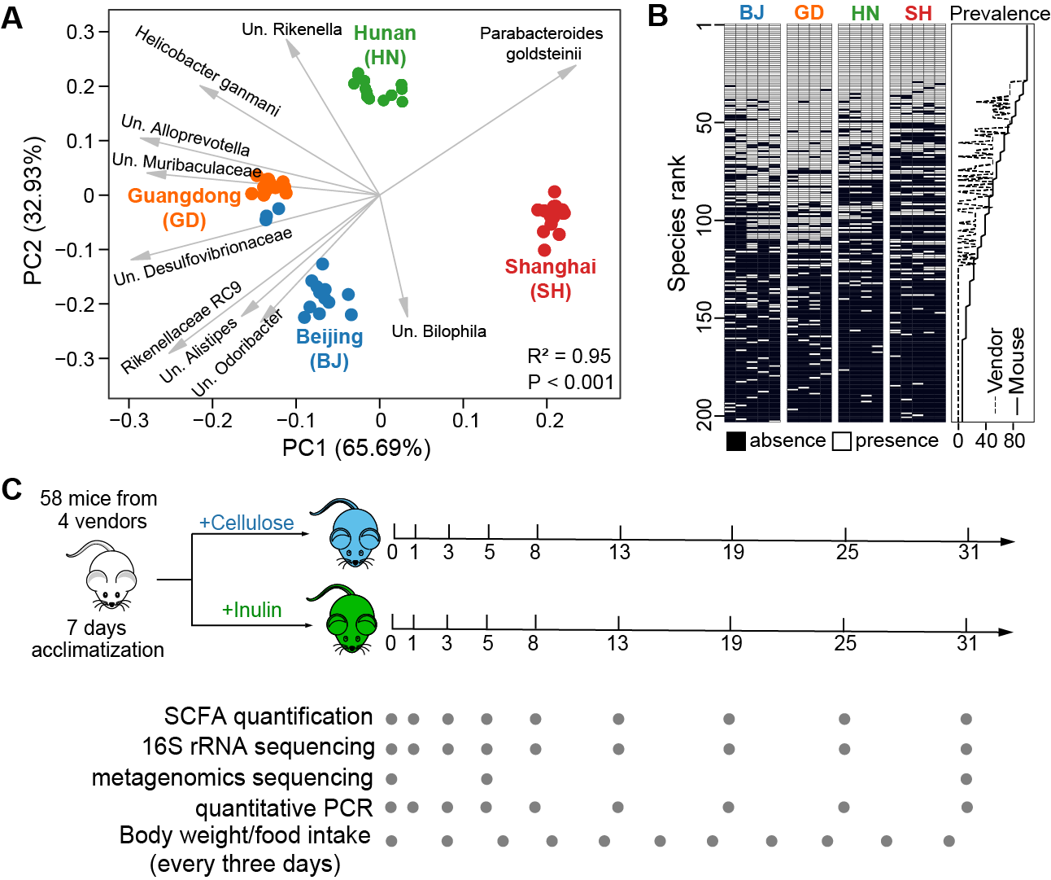

**Figure 2. Isogenic mouse lines featuring distinct microbiome were employed to study various responses of gut microbiome to dietary fiber intervention. (A).** Fecal bacterial microbiota composition of age- and gender-matched C57BL6/N mice purchasing from four different vendors (Beijing, Guangdong, Hunan, Shanghai) were evaluated using 16S rRNA gene sequencing. Biplot generated using DEICODE (robust Aitchison PCA, RPCA). Gray arrows represent the dominant bacterial taxa in these samples. Adonis analysis was performed to test for differences in baseline gut microbiota composition across four vendors (*P* < 0.001). “Un.” Labels indicate bacteria taxa that are unclassified at the lower taxonomic level (Methods). **(B).** Presence (threshold: 0.001%) and prevalence of bacterial taxa across individual mice and four vendors. In the right panel, the prevalence score of a taxon across mice (solid line) was defined as the fraction of mice that contains this taxon in their baseline microbiota and that across vendors (dashed line) was defined as the fraction of vendors whose mice all contain this taxon. **(C).** Mice with different microbiota settings (BJ, GD, HN, and SH) were fed with either cellulose- or inulin-supplemented diet after acclimatizing for 1 week. Gray dots indicate the days on which data were collected from fecal samples.

**# Longitudinal multi-omics monitoring reveals baseline- and time-dependent response of gut microbiome to dietary fiber intervention**

1. response is time-dependent (short- vs long-term response)
2. response is baseline-dependent (move the baseline-dependent p-value plot here?)

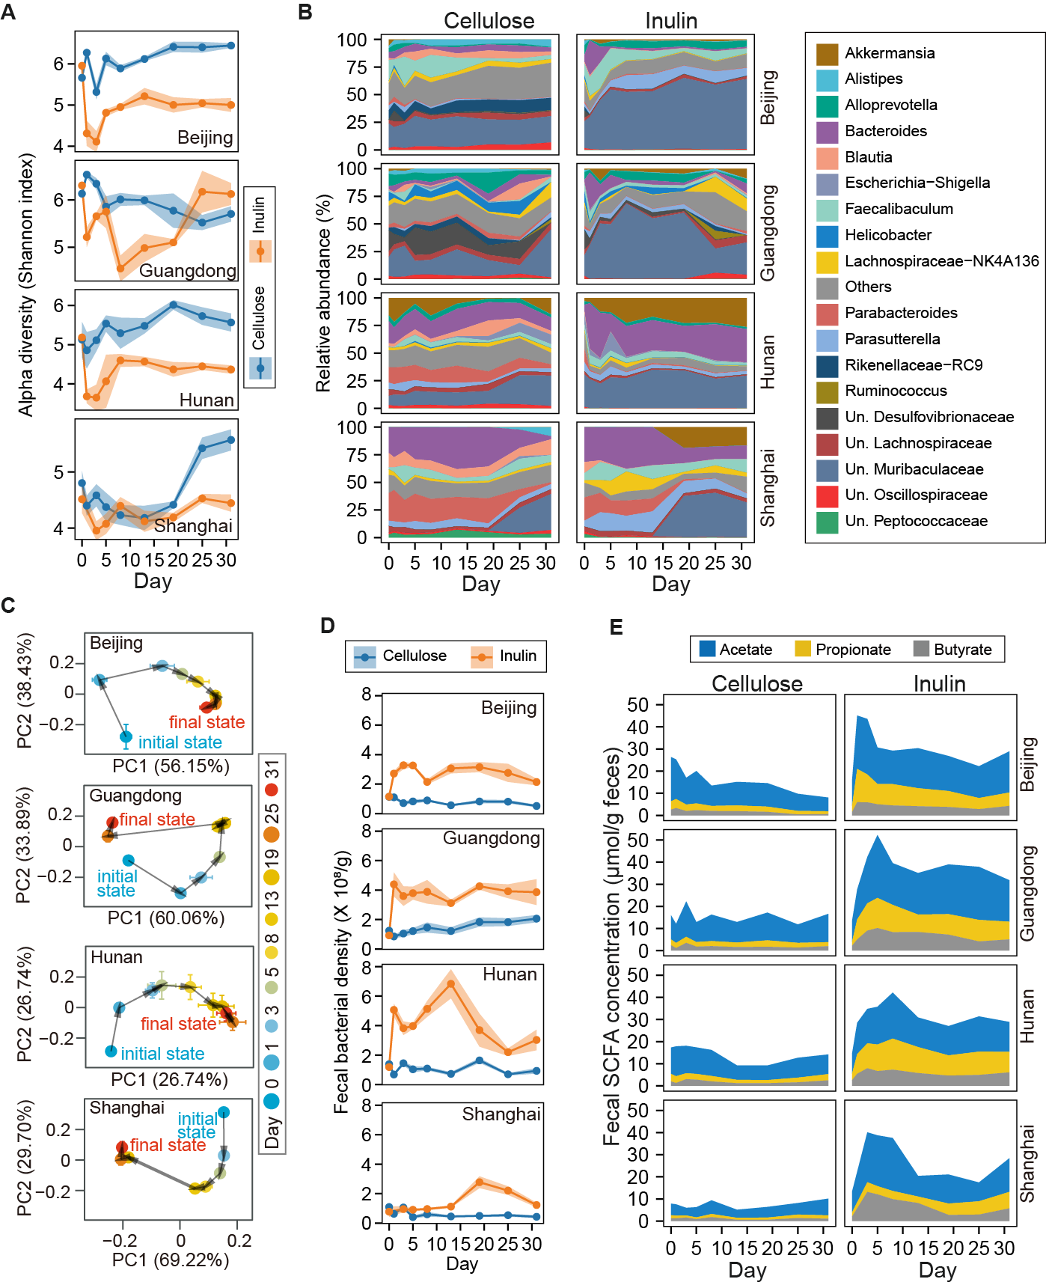

**Figure 3. Longitudinal multi-omics monitoring reveals baseline- and time-dependent response of gut microbiome to dietary fiber intervention. (A).** The effect of inulin supplementation on alpha diversity (Shannon index) of mice gut microbiota from different vendors. The shadow around the line shows standard error of the mean. **(B)**. The effect of inulin supplementation on the composition of mice gut microbiota from different vendors at the genus level. **(C).** Robust Aitchison principal-component analysis (RPCA) of temporal trajectories of gut microbiota composition following the inulin intervention in each vendor. Each point represents the mean principal-component (PC) score of all mice in a group at one time point, and the error bar represents the SEM. **(D).** The effect of inulin supplementation on fecal bacterial density of mice gut microbiota from different vendors. The shadow around the line shows standard error of the mean. **(E).** The effect of inulin supplementation on fecal SCFA production of mice gut microbiota from different vendors.

**# Modeling longitudinal microbiome data reveals key taxa driving baseline-dependent dynamic response of gut microbiota to dietary fiber intervention**

1. brief introduction of two complementary approaches to identify inulin responder, the difference
2. why glv-inferred responder recognized as primary degrader(ref, draft genome contain inulin PULs)
3. responders contribute most of the gut microbial dynamic response (qPCR)
4. distinct abundance of responders in baseline microbiome lead to different dynamic response
5. competition relationship between responders revealed by gLV model

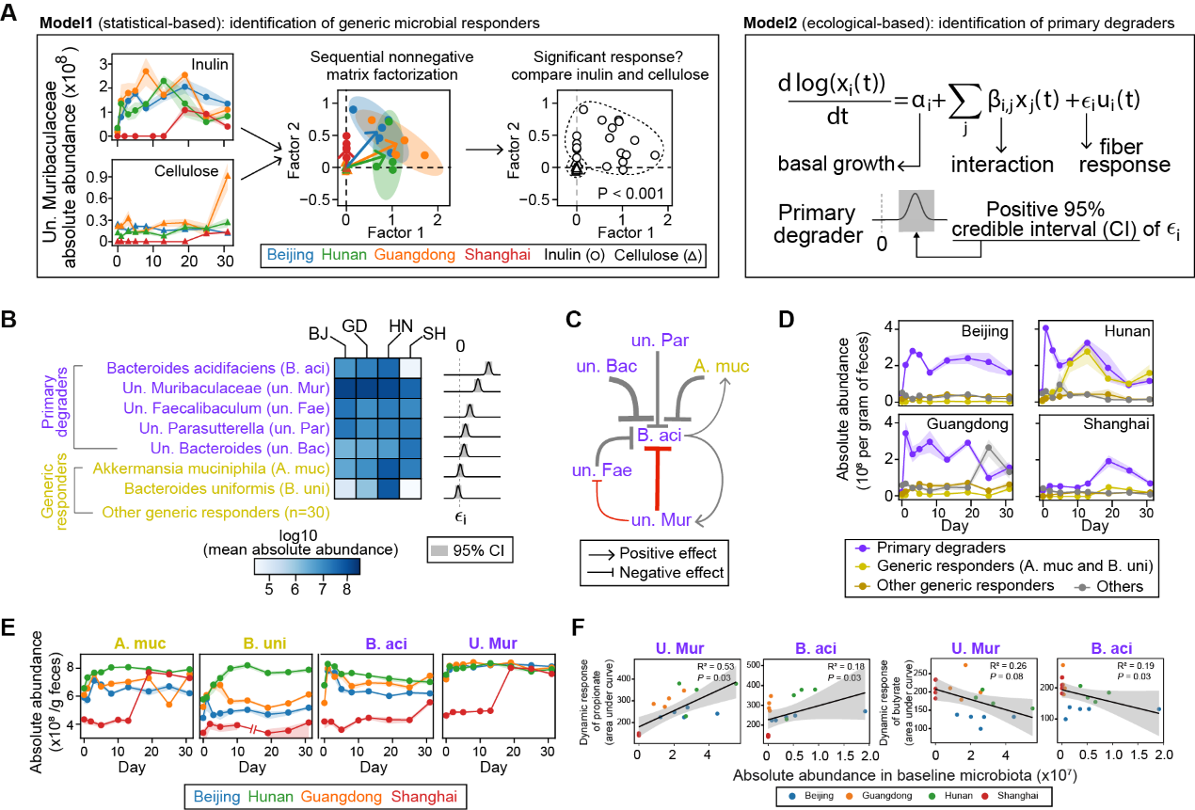

**Figure 4. Modeling longitudinal microbiome data reveals key taxa driving baseline-dependent dynamic response of gut microbiota to inulin intervention. (A).** Two complementary models were used to infer the microbial responders to inulin intervention.The statistical-based model used to infer the generic microbial responders to inulin intervention. The ecological-based model (generalized Lotka–Volterra equation, gLV) used to infer the microbial responders to inulin intervention (Method). **(B).** Inulin responders (increased abundance compared with cellulose group) identified by two complementary models. Among 37 generic responders identified with model1, 5 bacterial taxa were further identified by the gLV model as primary degrader of inulin. The top two abundant generic responders were shown together. In the right panel, posterior distribution of the model parameter indicating growth response to inulin of the seven bacterial taxa was shown. **(C).** Ecological interaction network inferred by the gLV model. Inulin degraders (purple font) and key inhibitions (red arrows) are highlighted. Point and blunt arrows represent positive and negative interactions respectively. The arrow thickness is proportional to the posterior mean of the corresponding interaction coefficient; only interaction coefficients significantly different from 0 (95% credible interval) are shown. **(D).** Dynamics in the absolute abundance of the gut bacterial taxa when decomposed according to the analysis results in **(B)**. **(E).** Dynamics in the absolute abundance of the top two inulin degraders and generic responders over time. **(F)**. Scatter plots with correlation coefficients show the significant correlations between the initial abundance of key inulin degraders and responses of SCFA metabolites to inulin intervention. For panels **D**, **E**, the shadow around the line shows standard error of the mean.

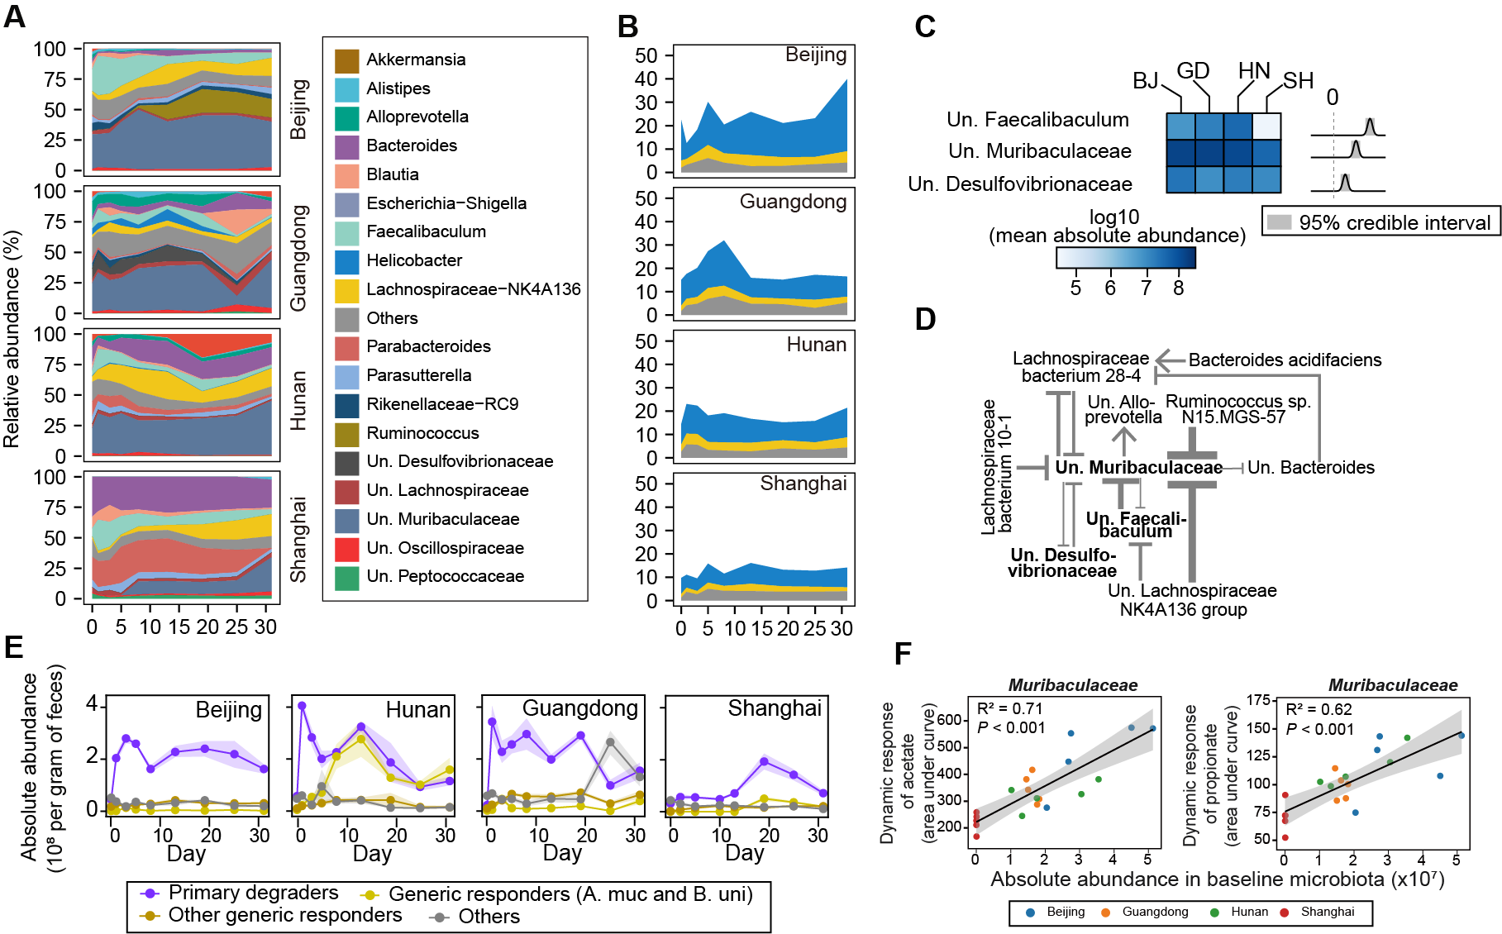

**Figure 5. Application of the ecological model to other dietary fiber (resistant starch) successfully reveals corresponding key taxa driving baseline-dependent dynamic response of gut microbiota.**

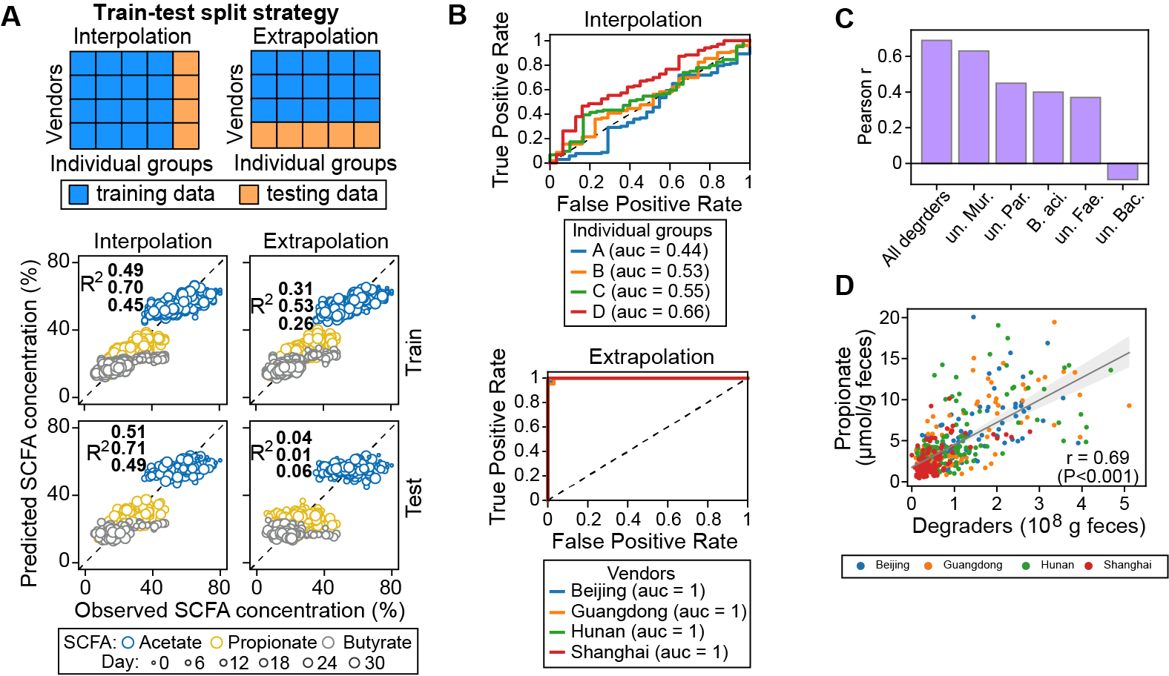

**Figure 6. Integrated analysis of microbiome and metabolome further strengthen the critical role of model-identified degraders during the metabolic process of dietary fiber by gut microbiome.**