REQUIREMENTS SPECIFICATION
AuthNorm Migration
Cloudera Java Streaming → Databricks Lakehouse
Re-platforming a plain-Java Kafka-to-Kafka normalization pipeline onto Databricks using Spark Structured Streaming, Auto Loader, and Delta Lake.

FIELD | VALUE
Document Type | Requirements Specification (SRS)
System / Project | AuthNorm — Real-Time Event Normalization
Source Platform | Cloudera Hadoop (CDH/CDP), plain-Java streaming app
Target Platform | Databricks on Azure, Delta Lake on ADLS Gen2
Migration Approach | Two-phase: Phase 1 minimal-change JAR reuse, Phase 2 Spark-native
Document Version | 1.0
Status | Draft for Review
Audience | Data Architects, Platform Engineering, Application Engineering

Table of Contents
Table of Contents 1
1. Executive Summary 1
Migration Goal 1
2. Current State (As-Is) 1
2.1 Existing System Overview 1
2.1.1 AuthNorm Application (in scope for migration) 1
2.1.2 Real-Time Ingestion Application (out of scope, used as data source) 1
2.2 Current Architecture (As-Is) 1
2.3 Known Pain Points 1
3. Target State — Phase 1 (Minimal-Change Re-host) 1
3.1 Design Intent 1
3.2 Target Architecture — Phase 1 1
3.3 Component Responsibilities — Phase 1 1
3.4 Data Flow — Phase 1, Step by Step 1
3.5 Reference Code Skeleton — Phase 1 1
3.6 Phase 1 Pros & Cons 1
4. Target State — Phase 2 (Spark-Native Long-Term) 1
4.1 Design Intent 1
4.2 Target Architecture — Phase 2 1
4.3 Medallion Layers 1
Bronze Layer — bronze.raw_events 1
Silver Layer — silver.authnorm_events 1
Gold Layer — gold.* (business marts) 1
4.4 What Changes Between Phase 1 and Phase 2 1
5. Functional Requirements 1
5.1 Source / Ingestion 1
5.2 Processing 1
5.3 Sink / Output 1
5.4 Configuration & Catalog 1
6. Non-Functional Requirements 1
6.1 Performance & Scalability 1
6.2 Reliability & Recovery 1
6.3 Observability 1
6.4 Security & Compliance 1
7. Integration Points & Dependencies 1
8. Data Model 1
8.1 Source — bronze.raw_events (Parquet, surfaced as Delta) 1
8.2 Target — silver.authnorm_events (Delta) 1
8.3 Dead-Letter — silver.authnorm_events_dlq 1
9. Security & Governance 1
9.1 Identity & Access 1
9.2 Data Classification 1
9.3 Network 1
10. Migration Plan 1
10.1 Phased Approach 1
10.2 Parallel-Run Strategy (Reconciliation) 1
10.3 Roll-back 1
11. Risks & Mitigations 1
12. Success Criteria & Acceptance 1
13. Appendices 1
13.1 Glossary 1
13.2 Open Questions 1
13.3 References 1

1. Executive Summary
This document specifies the requirements, target architecture, and migration plan for moving the AuthNorm application from a Cloudera Hadoop cluster to the Databricks Lakehouse Platform on Azure.
AuthNorm is a real-time event-normalization application written in plain Java (no Spark, no Flink). It currently runs on Cloudera as a long-lived JVM process. It consumes events from a raw Kafka topic, applies a set of normalization, enrichment, and validation transformations, and produces normalized events back to a second Kafka topic for downstream consumers.
In parallel, a separate Real-Time Ingestion application consumes the same raw Kafka topic and lands the events as Parquet files in Azure Data Lake Storage Gen2 (ADLS Gen2). The Parquet dataset is functionally a faithful, time-ordered replay of the raw Kafka topic.

Migration Goal
Re-host AuthNorm on Databricks with two design intents:
- Phase 1 — Minimal-Change Re-host: Replace the Kafka consumer with a Parquet/Delta-based source. Reuse the existing Java AuthNorm logic, packaged as a JAR, by invoking it from a thin Spark Structured Streaming wrapper. Output to a Delta table. Preserve business semantics 1:1.
- Phase 2 — Spark-Native Long-Term Solution: Re-implement the normalization logic in idiomatic Spark (DataFrame/SQL with selective UDFs), adopt the Medallion architecture (Bronze/Silver/Gold), introduce Delta Live Tables (DLT) for declarative orchestration, and unlock horizontal scalability, declarative data-quality expectations, and built-in lineage.
Key Insight: Because an upstream system already lands the raw Kafka topic to Parquet in ADLS, AuthNorm does not need to consume Kafka directly from Databricks. Reading the Parquet/Delta landing zone is functionally equivalent and removes the cross-cluster Kafka dependency entirely.

2. Current State (As-Is)

2.1 Existing System Overview
Two independent applications consume the same upstream raw Kafka topic in the Cloudera environment:

2.1.1 AuthNorm Application (in scope for migration)
ATTRIBUTE | VALUE
Runtime | Plain Java (JVM-based long-running process)
Framework | Apache Kafka Java client (consumer + producer); no Spark, no Flink
Deployment | Cloudera cluster (YARN application or stand-alone JVM)
Input | Raw Kafka topic (let us call it raw_events)
Processing | Per-record normalization, enrichment, validation, and reference-data lookups
Output | Normalized Kafka topic (let us call it authnorm_events)
State | Mostly stateless; minor in-memory caches for reference data
Delivery Semantics | At-least-once (Kafka offset commit after successful publish)
Throughput | [To be confirmed: events/sec, peak/avg]
Latency SLA | [To be confirmed: end-to-end ms]

2.1.2 Real-Time Ingestion Application (out of scope, used as data source)
ATTRIBUTE | VALUE
Runtime | Separate streaming application (existing, will remain operational)
Input | Same raw Kafka topic (raw_events)
Output | Parquet files in ADLS Gen2 — partitioned (commonly by ingest date/hour)
Cataloged As | External table on top of Parquet (Hive Metastore / Unity Catalog)
Data Fidelity | 1:1 with raw Kafka topic — every Kafka event is written as a Parquet row
Latency to Landing | Near-real-time (seconds-to-minutes, depending on commit policy)

2.2 Current Architecture (As-Is)
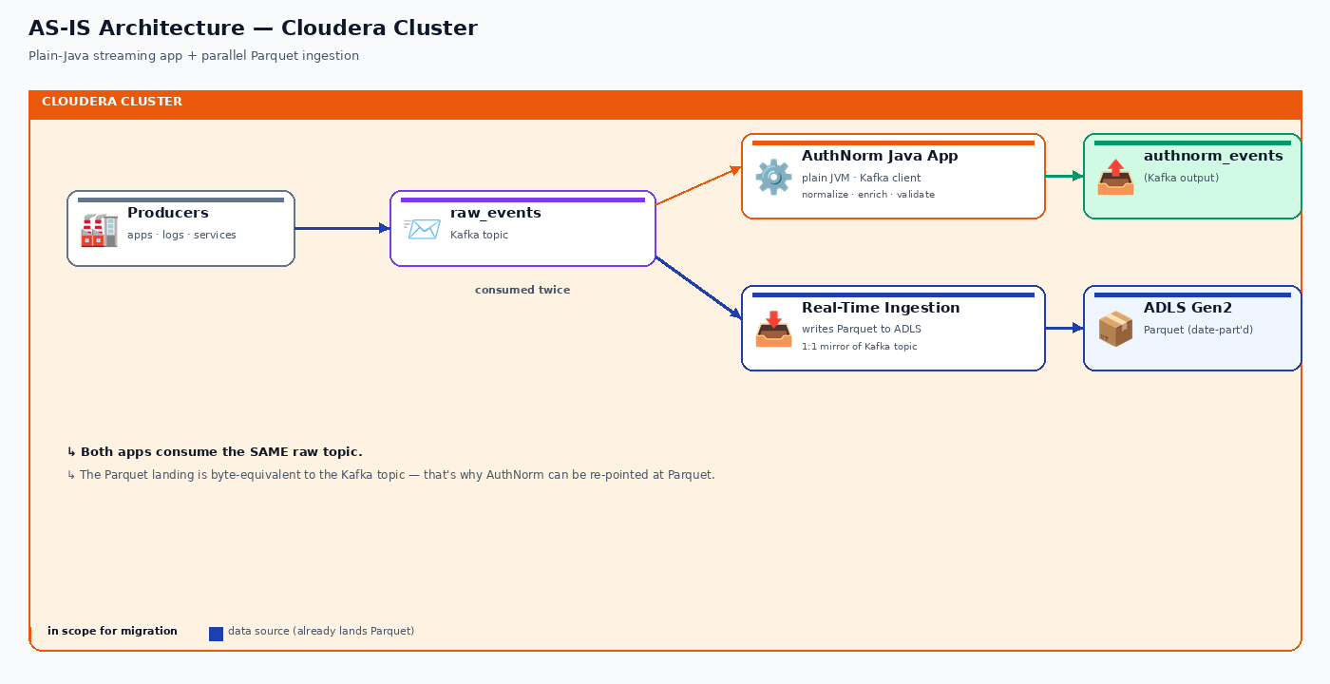
Figure 1 — As-Is architecture on Cloudera: both AuthNorm and the Real-Time Ingestion app consume the same raw Kafka topic.

2.3 Known Pain Points
- Tight coupling to Cloudera; the JVM app shares cluster resources with other workloads and competes for capacity.
- Operational toil: manual scaling, restarts, offset management, alerting must be hand-built.
- No native CDC, no schema enforcement on Kafka — schema drift surfaces only at consumer time.
- Limited observability: no lineage, no native data-quality metrics, custom JMX-based monitoring.
- Cloudera platform lifecycle / licensing pressures motivate migration to a managed cloud platform.

3. Target State — Phase 1 (Minimal-Change Re-host)

3.1 Design Intent
Phase 1 is a re-host migration: the same AuthNorm business logic, the same per-event contract, the same output schema — only the source changes from Kafka to the existing Parquet landing zone in ADLS, and the sink changes from Kafka to a Delta table on Databricks.
Minimal-Change Principle: The existing Java AuthNorm transformation classes are reused as-is, packaged into a JAR and invoked from a thin Spark Structured Streaming driver. No business logic is rewritten in Phase 1.

3.2 Target Architecture — Phase 1
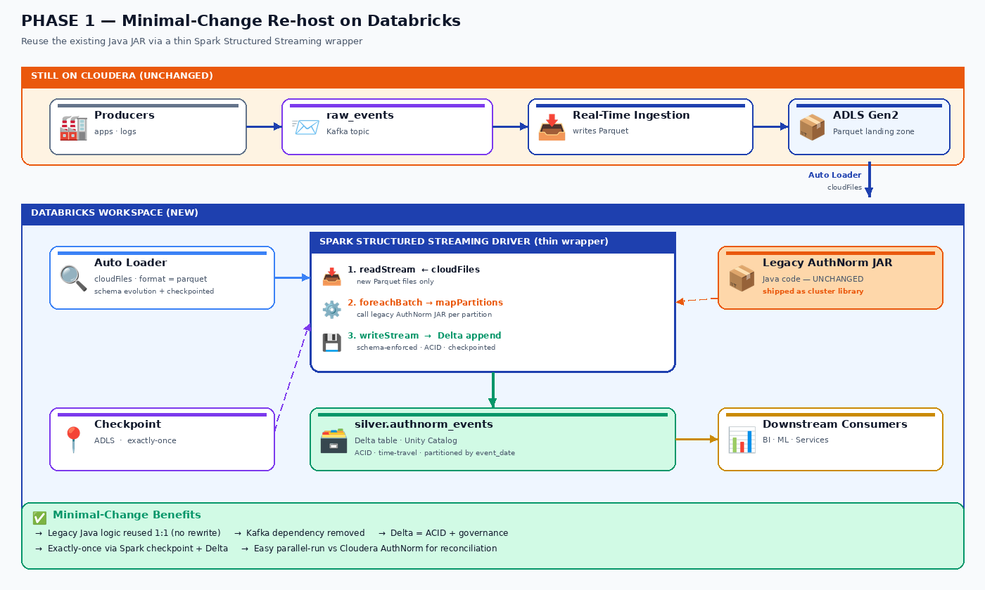
Figure 2 — Phase 1 architecture: Auto Loader streams Parquet from ADLS into a thin Spark wrapper that invokes the legacy AuthNorm JAR (unchanged) and writes to a Delta sink.

3.3 Component Responsibilities — Phase 1
COMPONENT | RESPONSIBILITY | TECH
Source | Parquet landing zone for raw events (continues to be written by the existing ingestion app) | ADLS Gen2 + Parquet
Stream Reader | Discover new Parquet files incrementally; emit a streaming DataFrame | Auto Loader (cloudFiles)
AuthNorm JAR | The existing Java normalization logic, packaged as an uber-JAR; no code changes | Java 11/17 JAR on cluster libraries
Streaming Driver | Per micro-batch: deserialize, invoke AuthNorm Java for each row, materialize result, write to Delta | Scala or PySpark + foreachBatch
Sink | Delta table that holds the normalized output; ACID + schema-enforced | Delta Lake on ADLS Gen2
Checkpoint | Tracks processed files and offsets for exactly-once semantics on retries | Spark checkpoint location on ADLS
Schema Registry | (Optional) JSON / Avro schema validation if upstream serializes with Avro | Confluent Schema Registry or schema file in ADLS
Orchestration | Job runs continuously; restart on failure; alerting on SLA breach | Databricks Workflows (Jobs UI / API)
Catalog | Tables registered for discoverability and access control | Unity Catalog
Secrets | Storage account keys, service principals | Databricks Secret Scopes (Azure Key Vault backed)

3.4 Data Flow — Phase 1, Step by Step
- The existing Real-Time Ingestion App continues to consume raw_events from Kafka and writes Parquet files to a known ADLS path (for example abfss://landing@.../raw_events/date=YYYY-MM-DD/hour=HH/).
- On Databricks, a Structured Streaming job uses Auto Loader (format "cloudFiles" with cloudFiles.format="parquet") to incrementally discover new Parquet files. Auto Loader maintains internal file-notification state so it does not re-read files.
- For each micro-batch, the streaming job applies foreachBatch.
- Inside foreachBatch, the batch DataFrame is converted to an iterator of strongly-typed Java objects. Each object is passed to the existing AuthNormProcessor.process(InputEvent) method from the legacy JAR.
- The returned NormalizedEvent objects are collected into a DataFrame and written to the silver.authnorm_events Delta table in append mode.
- The job commits a checkpoint after each successful batch. On restart, processing resumes from the next un-processed file. No duplicates.

3.5 Reference Code Skeleton — Phase 1
The following Scala skeleton illustrates the Phase 1 wrapper. The legacy Java logic is invoked through AuthNormProcessor, which is a class shipped in the existing JAR. The wrapper does no normalization itself — it only handles ingestion, dispatch, and persistence.
// Phase 1: thin Spark Structured Streaming wrapper around legacy AuthNorm JAR
// File: AuthNormStreamingDriver.scala
import org.apache.spark.sql.{DataFrame, Row, SparkSession}
import org.apache.spark.sql.streaming.Trigger
import org.apache.spark.sql.functions._
import com.legacy.authnorm.{AuthNormProcessor, InputEvent, NormalizedEvent}
import scala.collection.JavaConverters._
object AuthNormStreamingDriver {
def main(args: Array[String]): Unit = {
val spark = SparkSession.builder()
.appName("AuthNorm-Phase1")
.getOrCreate()
val landingPath = "abfss://landing@<stg>.dfs.core.windows.net/raw_events/"
val checkpointPath = "abfss://ckpts@<stg>.dfs.core.windows.net/authnorm/v1/"
val outputTable = "silver.authnorm_events"
val raw = spark.readStream
.format("cloudFiles")
.option("cloudFiles.format", "parquet")
.option("cloudFiles.schemaLocation", checkpointPath + "/_schema")
.option("cloudFiles.schemaEvolutionMode", "addNewColumns")
.load(landingPath)
raw.writeStream
.option("checkpointLocation", checkpointPath)
.trigger(Trigger.ProcessingTime("30 seconds"))
.foreachBatch { (batchDf: DataFrame, batchId: Long) =>
val processor = new AuthNormProcessor() // legacy Java class
// map partitions to avoid serializing the processor for every row
val normalized = batchDf.mapPartitions { rows =>
val local = new AuthNormProcessor() // one per partition
rows.flatMap { row =>
val input = RowToInputEvent.convert(row) // helper bridge
val out: NormalizedEvent = local.process(input) // legacy logic, untouched
if (out == null) None else Some(NormalizedEventToRow.convert(out))
}
}(NormalizedEventEncoder.encoder)
normalized.write
.format("delta")
.mode("append")
.saveAsTable(outputTable)
}
.start()
.awaitTermination()
}
}
Why mapPartitions and not a UDF: A row-level Scala UDF that calls Java is workable but pays per-row JVM dispatch overhead. mapPartitions instantiates the legacy AuthNormProcessor once per partition and amortizes any setup (reference-data loading, caches) across all rows in that partition. This is also where you would warm up DNS, SSL handshakes, etc.

3.6 Phase 1 Pros & Cons
PROS | CONS / RISKS
Lowest engineering effort; reuses 100% of existing Java logic. | Java logic still executes row-by-row inside Spark — not horizontally scalable beyond JVM-per-partition.
Lowest risk of regression; per-event output is identical to today's pipeline. | No declarative data-quality checks, no expectations — still application-level error handling.
Decouples from Cloudera Kafka quickly — Databricks talks only to ADLS. | Latency floor is higher than direct Kafka consumption (limited by file commit frequency).
Delivers the platform exit immediately; future refactor is incremental. | Two code paths for a while: legacy JAR + Spark wrapper.
Delta sink gives you ACID, time travel, and downstream consumability for free. | Object-to-Row conversion bridges are extra code to test and maintain.

4. Target State — Phase 2 (Spark-Native Long-Term)

4.1 Design Intent
Phase 2 fully embraces the Lakehouse pattern. The legacy Java row-by-row processor is decomposed into Spark DataFrame transformations and selective UDFs. The pipeline is expressed declaratively as Delta Live Tables (DLT), organized along the Bronze / Silver / Gold (Medallion) layers, with declarative data-quality expectations, automatic lineage, and built-in scaling.

4.2 Target Architecture — Phase 2
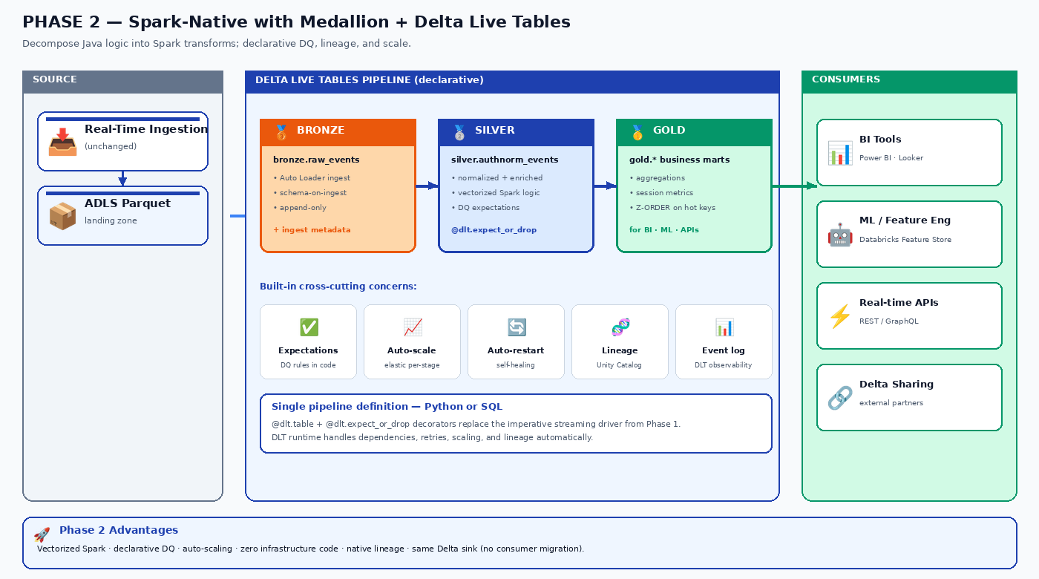
Figure 3 — Phase 2 architecture: Medallion (Bronze → Silver → Gold) inside a Delta Live Tables pipeline, with declarative DQ, auto-scaling, lineage, and observability.

4.3 Medallion Layers

Bronze Layer — bronze.raw_events
- Auto Loader incrementally ingests Parquet files from the ADLS landing zone.
- Schema-on-ingest with schema evolution enabled (addNewColumns mode).
- Append-only; preserves exactly what arrived, including malformed records.
- Adds ingestion metadata columns: _ingest_ts, _source_file, _file_modification_ts.

Silver Layer — silver.authnorm_events
- The Phase 1 Java logic is decomposed into Spark transformations: case statements, joins to reference data (broadcast or stream-static), column rewrites, type coercions.
- Residual non-vectorizable logic remains as Pandas UDFs or Scala UDFs — but the surface area is small and isolated.
- Declarative data-quality expectations are attached at this layer:
# DLT silver layer (Python)
import dlt
from pyspark.sql import functions as F
@dlt.table(
name="silver_authnorm_events",
comment="Normalized events; per-event schema-enforced, quality-gated.",
table_properties={"quality": "silver"},
partition_cols=["event_date"]
)
@dlt.expect_or_drop("valid_event_id", "event_id IS NOT NULL")
@dlt.expect_or_drop("valid_timestamp", "event_ts BETWEEN '2020-01-01' AND current_timestamp()")
@dlt.expect("known_event_type", "event_type IN ('login','logout','token','refresh')")
def silver_authnorm_events():
bronze = dlt.read_stream("bronze_raw_events")
return (
bronze
.withColumn("event_ts", F.to_timestamp("raw_ts"))
.withColumn("event_date", F.to_date("event_ts"))
.transform(normalize_user_fields) # vectorized DataFrame transforms
.transform(enrich_with_reference_data) # broadcast-joined lookups
.transform(apply_normalization_rules) # remaining UDFs only where unavoidable
)

Gold Layer — gold.* (business marts)
- Aggregations, daily roll-ups, session reconstructions, anomaly flags.
- Partitioned and Z-ordered for the most common analytical predicates.
- This layer is what BI tools, ML feature pipelines, and downstream APIs consume.

4.4 What Changes Between Phase 1 and Phase 2
DIMENSION | PHASE 1 (RE-HOST) | PHASE 2 (SPARK-NATIVE)
Logic execution | Row-by-row Java in JVM via mapPartitions | Vectorized DataFrame / SQL with selective UDFs
Code reuse | 100% of legacy Java code retained | Logic rewritten in Spark; legacy JAR deprecated
Data quality | Application-level checks inside Java | Declarative expect_or_drop expectations; tracked in DLT event log
Schema management | Manual via Auto Loader schemaEvolutionMode | DLT-managed schema with expectations and constraints
Orchestration | Databricks Workflow runs the Scala/PySpark wrapper | Delta Live Tables pipeline; declarative, auto-restart, auto-scaling
Lineage / observability | Custom dashboards; metrics from streaming UI | Unity Catalog automatic lineage + DLT event log + Lakehouse Monitoring
Scale-out behavior | Limited by Java logic; JVM contention possible | Native Spark parallelism; scales horizontally to TB/hour
Maintenance | Two code paths (Spark wrapper + legacy JAR) | Single pipeline definition; clear separation of layers

5. Functional Requirements
Requirements use the convention F-### for functional and N-### for non-functional. All requirements apply to Phase 1 unless explicitly marked Phase 2.

5.1 Source / Ingestion
ID | REQUIREMENT | PRIORITY
F-101 | The system shall consume new Parquet files from the configured ADLS landing path incrementally, processing each file exactly once. | MUST
F-102 | The system shall use Auto Loader (cloudFiles) with cloudFiles.format = parquet for source discovery. | MUST
F-103 | The system shall preserve source ordering on a best-effort basis, ordering rows within each micro-batch by an event-timestamp column when defined. | SHOULD
F-104 | The system shall support schema evolution in the Parquet source — new columns added upstream shall be automatically picked up and surfaced. | MUST
F-105 | The system shall reject files that fail schema validation and route them to a dead-letter location, with file path and error logged. | MUST
F-106 | The system shall support back-fill of historical Parquet partitions through a one-time batch run that uses the same AuthNorm logic. | MUST

5.2 Processing
ID | REQUIREMENT | PRIORITY
F-201 | The system shall produce normalized events that are bit-for-bit equivalent to the existing Kafka-based AuthNorm output for the same input record. | MUST
F-202 | The system shall preserve all per-event transformation semantics defined in the legacy Java code (normalization, enrichment, validation). | MUST
F-203 | The system shall apply transformations using the legacy Java JAR (Phase 1) or equivalent Spark transformations (Phase 2). | MUST
F-204 | The system shall log and route to a dead-letter table any record that the legacy logic flags as invalid or unprocessable. | MUST
F-205 | The system shall expose record-count metrics: read, processed, written, dropped, errored — per micro-batch and cumulative. | MUST
F-206 | Phase 2 — Data-quality expectations shall be expressed declaratively (DLT @expect / @expect_or_drop / @expect_or_fail). | MUST (Phase 2)

5.3 Sink / Output
ID | REQUIREMENT | PRIORITY
F-301 | The system shall write the normalized output to a managed Delta table registered in Unity Catalog. | MUST
F-302 | The system shall partition the output Delta table by event_date and (optionally) event_type for query performance. | MUST
F-303 | The system shall apply OPTIMIZE and Z-ORDER on the output Delta table on a scheduled cadence (daily by default). | MUST
F-304 | The system shall enforce schema on write — incompatible records are rejected and routed to a quarantine table, not silently coerced. | MUST
F-305 | The output Delta table shall be append-only in Phase 1; merge / SCD-style updates are out of scope. | MUST
F-306 | Downstream consumers shall be able to subscribe to the output Delta table using Change Data Feed (CDF) once enabled. | SHOULD

5.4 Configuration & Catalog
ID | REQUIREMENT | PRIORITY
F-401 | All file paths, table names, and tunables (trigger interval, max files per trigger) shall be externalized via Databricks job parameters and/or Unity Catalog volumes. | MUST
F-402 | All sensitive values (storage keys, service principal secrets) shall be retrieved through Databricks Secret Scopes backed by Azure Key Vault. | MUST
F-403 | Source and target tables shall be registered in Unity Catalog with documented descriptions, owners, and PII/sensitivity tags. | MUST
F-404 | Access to source bronze, silver, and gold layers shall be governed by Unity Catalog grants — readers cannot bypass to raw files. | MUST

6. Non-Functional Requirements

6.1 Performance & Scalability
ID | REQUIREMENT | TARGET
N-101 | End-to-end latency from Parquet file landing to Delta row available shall not exceed the trigger interval + 60 seconds. | ≤ trigger + 60s
N-102 | The system shall sustain the peak throughput of the existing AuthNorm pipeline. | [confirm: events/sec]
N-103 | The system shall scale horizontally to handle a 3× burst above peak without operator intervention. | Auto-scale 1× → 3×
N-104 | Memory and CPU per worker shall be sized to avoid GC pauses > 200 ms. | GC pause P99 < 200ms

6.2 Reliability & Recovery
ID | REQUIREMENT | TARGET
N-201 | The streaming job shall provide exactly-once write semantics to the Delta sink through Spark checkpoint + Delta transactional writes. | Exactly-once
N-202 | Job restart from checkpoint shall resume processing without duplicating or losing data. | Zero-loss
N-203 | Recovery Time Objective (RTO) after an unrecoverable cluster failure shall not exceed 30 minutes. | RTO ≤ 30 min
N-204 | Recovery Point Objective (RPO) — maximum data loss tolerated — shall be zero, given checkpointed state. | RPO = 0
N-205 | The job shall auto-restart on transient cluster failures and surface failures > N retries to alerting. | Auto-retry x 3

6.3 Observability
ID | REQUIREMENT | TARGET
N-301 | All micro-batch metrics shall be published to Databricks system tables (system.billing, system.lakeflow) and/or Azure Monitor. | All batches
N-302 | Lineage from source Parquet → Delta target shall be visible in Unity Catalog. | Automatic
N-303 | Alerts shall fire when input lag, output backlog, or DLQ row count breach configured thresholds. | ≤ 5 min detection
N-304 | Audit logs (who read / wrote what) shall be retained for 90 days in Unity Catalog. | 90 days

6.4 Security & Compliance
ID | REQUIREMENT | PRIORITY
N-401 | All data at rest on ADLS shall be encrypted using customer-managed keys (CMK) where available. | MUST
N-402 | All data in flight between Databricks and ADLS shall use TLS 1.2+. | MUST
N-403 | Workspace access shall be governed via Azure AD / Entra ID; service principals are used for production jobs. | MUST
N-404 | PII columns shall be tagged in Unity Catalog and access shall be controlled via column-level masking or row-level filters. | MUST
N-405 | Cluster traffic shall traverse private endpoints / VNet injection where applicable. | MUST

7. Integration Points & Dependencies
SYSTEM | INTERACTION | OWNERSHIP
Real-Time Ingestion App | Produces Parquet files at the agreed ADLS path; file layout and naming contract must be stable. | Upstream data engineering team
ADLS Gen2 (landing) | Source for Auto Loader; AuthNorm has read-only access. | Platform / Storage team
ADLS Gen2 (silver/gold) | Sink; Databricks writes Delta files here. | AuthNorm team
Unity Catalog | Catalogs all bronze/silver/gold tables; governs access. | Platform team
Azure Key Vault | Holds secrets (storage keys, SP credentials); accessed via Databricks Secret Scopes. | Security / Platform team
Azure Monitor / Log Analytics | Receives cluster logs and pipeline metrics for alerting. | Platform / Operations team
Downstream Consumers | Read silver.authnorm_events (Delta) directly, or via Power BI / Synapse / external Delta Sharing. | Downstream teams (BI, ML, services)
Existing Cloudera AuthNorm | Decommission target — runs in parallel through cut-over, then retired. | AuthNorm team

8. Data Model

8.1 Source — bronze.raw_events (Parquet, surfaced as Delta)
Schema is inherited from the upstream Real-Time Ingestion App. The exact column list is owned by the upstream team; the contract below is illustrative and must be validated against the live schema.
COLUMN | TYPE | NOTES
event_id | STRING | Unique per source event; usually a UUID or composite key.
event_type | STRING | login | logout | token | refresh | ... — drives normalization rules.
event_ts | TIMESTAMP | Event time as produced by source system; UTC.
user_id | STRING | Subject of the event; nullable for anonymous events.
payload | STRING / MAP | Free-form JSON or struct carrying event-specific fields.
source_system | STRING | Producer identifier.
_ingest_ts | TIMESTAMP | Added by Auto Loader / ingestion job.
_source_file | STRING | Added by Auto Loader; full ADLS path of the Parquet file.

8.2 Target — silver.authnorm_events (Delta)
COLUMN | TYPE | NOTES
event_id | STRING | Carried through from source.
event_type | STRING | Normalized event_type (controlled vocabulary).
event_ts | TIMESTAMP | UTC, canonicalized.
event_date | DATE | Partition column derived from event_ts.
user_id_norm | STRING | Normalized subject identifier (e.g., lowercased, padded).
user_email | STRING | Enrichment from reference data (nullable).
tenant_id | STRING | Enrichment from reference data.
normalized_payload | STRUCT | Strongly-typed normalized payload per event_type.
risk_score | DOUBLE | If computed by AuthNorm rules.
status | STRING | OK | FLAGGED | REJECTED — controlled vocabulary.
error_code | STRING | Set when status != OK.
source_system | STRING | Pass-through.
authnorm_version | STRING | Version stamp of the AuthNorm logic that produced the row.
_processed_ts | TIMESTAMP | When AuthNorm wrote this row.

8.3 Dead-Letter — silver.authnorm_events_dlq
Same schema as the target plus error_message (STRING) and original_row (STRING — JSON of the source row). Records flagged as unprocessable by AuthNorm logic land here for triage.

9. Security & Governance

9.1 Identity & Access
- Production jobs run as a dedicated Azure service principal with least-privilege scopes on storage and Unity Catalog.
- Human read access is granted through Unity Catalog grants on the silver / gold schemas; raw Parquet bypass is disallowed.
- Secrets (storage account keys, service principal credentials) live only in Azure Key Vault and are referenced through Databricks Secret Scopes; they never appear in notebooks or job configs.

9.2 Data Classification
- user_email, user_id_norm are tagged as PII in Unity Catalog.
- Column-level masking applied for non-privileged readers.
- Audit logs retained for 90 days; queries against PII columns are flagged in system.access.audit.

9.3 Network
- Databricks workspace deployed with VNet injection; cluster outbound traffic restricted via Network Security Groups (NSGs).
- Private endpoints used for ADLS Gen2 and Key Vault.
- No public Storage Account access; firewall whitelist by VNet subnet.

10. Migration Plan

10.1 Phased Approach
PHASE | DURATION | OUTCOME | KEY ACTIVITIES
Phase 0 — Foundation | 1–2 weeks | Platform ready | Provision Databricks workspace + Unity Catalog; configure ADLS containers; set up secrets; baseline cluster + job templates.
Phase 1 — Re-host | 3–5 weeks | AuthNorm on Databricks (JAR-based) | Package legacy JAR; write Spark wrapper; integration test against historical Parquet partitions; parallel run vs Cloudera AuthNorm; reconcile output.
Phase 1.5 — Cut-over | 1–2 weeks | Cloudera AuthNorm decommissioned | Switch downstream consumers from Kafka topic to Delta table; freeze legacy app; monitor; retire.
Phase 2 — Spark-native rewrite | 6–10 weeks | Logic decomposed; DLT pipeline live | Translate Java rules → DataFrame / SQL; introduce DQ expectations; build DLT pipeline; A/B against Phase 1 output; deprecate legacy JAR.
Phase 3 — Optimization | Ongoing | SLA-tuned, fully governed | OPTIMIZE / Z-ORDER cadence; Lakehouse Monitoring; chargeback; access reviews; performance tuning.

10.2 Parallel-Run Strategy (Reconciliation)
During Phase 1, the new Databricks pipeline runs in parallel with the existing Cloudera AuthNorm app. The two outputs are reconciled daily through a comparison job:
- Both outputs are loaded into a comparison schema.
- Records are joined on event_id.
- A diff-by-column report identifies any per-column discrepancies.
- Acceptance criterion: < 0.01% per-column drift over a 14-day window, with all drift explained.
- Only after acceptance is the Cloudera AuthNorm app decommissioned.

10.3 Roll-back
If a critical defect surfaces after cut-over, the rollback path is to re-enable the Cloudera AuthNorm app (kept in cold standby for at least 30 days post-cutover). The new Delta sink retains its history (time travel) so downstream consumers can be temporarily re-routed back to the Kafka topic.

11. Risks & Mitigations
ID | RISK | PROBABILITY × IMPACT | MITIGATION
R-01 | Output drift vs legacy Kafka pipeline due to subtle differences in row-by-row processing. | Medium × High | Parallel run + per-column reconciliation; do not decommission Cloudera path until drift ≤ 0.01% for 14 days.
R-02 | Latency floor — Parquet landing is committed in batches, not row-by-row, increasing minimum end-to-end latency. | High × Medium | Confirm acceptable latency target with stakeholders; if sub-second is required, retain Kafka direct read as an option.
R-03 | Upstream Parquet schema changes silently break downstream. | Medium × High | Enable schema evolution + DLT expectations + alerting on new columns; contractual schema review with upstream team.
R-04 | Java logic depends on cluster-only resources (e.g., HDFS paths, JNDI lookups) that don't exist on Databricks. | Medium × High | Run a dependency audit during Phase 0; refactor or proxy any non-portable dependency.
R-05 | Cost overrun on Databricks due to under-tuned cluster sizing. | Medium × Medium | Set job-cluster (not all-purpose) defaults; enable auto-scale + auto-terminate; budget alerts on workspace level.
R-06 | Two code paths (Phase 1 JAR + Phase 2 Spark logic) drift before Phase 2 lands. | Medium × Medium | Strict feature freeze on legacy JAR after Phase 1 cut-over; all enhancements go into Phase 2 Spark logic only.
R-07 | Auto Loader file-discovery lag on very large directories. | Low × Medium | Use file-notification mode (event grid) instead of directory listing once file count > 100k per partition.
R-08 | Unity Catalog permissions misconfigured at cut-over — downstream consumers locked out. | Medium × High | Dry-run grants in a staging catalog; rehearse cut-over; have a roll-back grant script ready.

12. Success Criteria & Acceptance
The migration is considered successful when all of the following conditions hold for a continuous 14-day window after Phase 1 cut-over:
- Functional parity: < 0.01% per-column drift between the Databricks Delta output and the legacy Kafka output, with all drift explained and accepted by data owners.
- Latency: 95th percentile end-to-end latency (file landing → Delta row visible) meets the configured SLA (initial target: ≤ 5 minutes).
- Reliability: zero data loss; all checkpoint-recovery scenarios validated in staging.
- Observability: alerts wired into the on-call channel; dashboards in place for input lag, output backlog, and DLQ count.
- Governance: all tables registered in Unity Catalog with owners, descriptions, and PII tags; access reviewed and approved by the data governance lead.
- Decommissioning plan signed off: a documented date for Cloudera AuthNorm retirement, with downstream consumers all confirmed migrated.

13. Appendices

13.1 Glossary
TERM | DEFINITION
ADLS Gen2 | Azure Data Lake Storage Gen2 — hierarchical-namespace blob storage used as the data lake substrate.
Auto Loader | Databricks streaming source (cloudFiles) that incrementally discovers and ingests new files from cloud storage.
AuthNorm | The legacy event-normalization application that is the subject of this migration.
Bronze / Silver / Gold | Medallion architecture layers — raw, refined, and business-curated data respectively.
Delta Lake | Open-source storage layer adding ACID, schema enforcement, and time travel on top of Parquet.
DLT | Delta Live Tables — Databricks framework for declarative ETL pipelines on Delta Lake.
foreachBatch | Spark Structured Streaming sink operator that lets the user supply a function applied to each micro-batch DataFrame.
Unity Catalog | Databricks' centralized governance layer for data, metadata, and AI assets.
Z-ORDER | Delta Lake data layout that co-locates related information in the same set of files; speeds up queries that filter on Z-ordered columns.

13.2 Open Questions
- Confirm peak and average throughput of the existing AuthNorm app (events/sec, MB/sec).
- Confirm acceptable end-to-end latency SLA. Sub-second? Few minutes? This sizes Phase 1 viability.
- Inventory of downstream consumers of the existing Kafka output topic and their preferred consumption pattern (Delta read, Kafka, both).
- Schema-registry usage on the upstream Kafka topic — Avro / JSON / Protobuf?
- Reference data sources used by AuthNorm (lookups, caches) — where will they live in Databricks?
- Approved Databricks workspace, Unity Catalog catalog name, ADLS account names, secret-scope names.
- Compliance posture for PII columns — masking strategy, retention policy on DLQ data.
- Capacity / cost envelope for the new pipeline.

13.3 References
- Databricks Auto Loader — https://docs.databricks.com/ingestion/auto-loader/index.html
- Spark Structured Streaming Programming Guide — https://spark.apache.org/docs/latest/structured-streaming-programming-guide.html
- Delta Lake documentation — https://docs.delta.io/latest/index.html
- Delta Live Tables — https://docs.databricks.com/delta-live-tables/index.html
- Unity Catalog — https://docs.databricks.com/data-governance/unity-catalog/index.html
- Medallion Architecture — https://www.databricks.com/glossary/medallion-architecture

— End of document —

