MULTI-EXAM PREPARATION AND RESOURCE EXCHANGE PLATFORM
23CS54C – MODERN WEB TECHNOLOGIES
Submitted by
HARENI T 2403957610422005
In partial fulfillment for the award of the degree
of
BACHELOR OF ENGINEERING
in
COMPUTER SCIENCE AND ENGINEERING

NATIONAL ENGINEERING COLLEGE
(An Autonomous Institution affiliated to Anna University, Chennai)
K.R.NAGAR, KOVILPATTI - 628503
OCTOBER - 2026

NATIONAL ENGINEERING COLLEGE
(An Autonomous Institution affiliated to Anna University, Chennai)
K.R.NAGAR, KOVILPATTI – 628503
BONAFIDE CERTIFICATE
This is to certify that this project report, “MULTI-EXAM PREPARATION AND RESOURCE EXCHANGE PLATFORM”, is the bonafide work of T HARENI (2403957610422005) who carried out the project work under my supervision.
Course Instructor/Guide
Submitted to the 23CS54C – MODERN WEB TECHNOLOGIES Viva-Voce examination held at National Engineering College, K.R.Nagar, Kovilpatti on ___________________
Internal Examiner | Co Examiner

TABLE OF CONTENTS
CH NO | TITLE | PAGE NO
1 | INTRODUCTION | 3
2 | OBJECTIVES | 4
3 | DESCRIPTION | 5
4 | CLASS DIAGRAM | 6
5 | TABLE STRUCTURES | 7
6 | ER DIAGRAM | 16
7 | TECH STACK & | 18
8 | MODULES | 19
9 | CONCLUSION | 46

CHAPTER 1
INTRODUCTION
In the modern education ecosystem, the structured preparation for competitive examinations plays a vital role in determining student career progression and higher academic achievements. Millions of aspirants preparing for engineering, medical, civil services, management, and technical examinations in India—including GATE, UPSC, JEE, NEET, and CAT—face severe fragmentation of learning resources, prohibitive textbook expenses, lack of personalized progress tracking, and disconnected mentorship. Managing preparation across isolated syllabus PDFs, disparate practice portals, physical book purchases, and manual revision logs is time-consuming, disorganized, and lacks real-time academic accountability.
The Multi-Exam Preparation and Resource Exchange Platform is a comprehensive, full-stack web application designed to digitize and unify the complete lifecycle of competitive examination preparation. The platform establishes a cohesive ecosystem integrating official examination roadmaps, hierarchical subject and chapter syllabus tracking, multi-attempt mock test evaluation, automated academic mentor monitoring with real-time WhatsApp and SMS notifications, a circular peer-to-peer textbook marketplace, and doorstep delivery logistics.
The application is organized into three major functional domains: Academic & Examination Management, which covers foundational exam catalogs, official syllabus roadmaps with weightage prioritization,interactive revision flashcards, and automated quiz generation; Student Progress & Mentorship Tracking, which provides continuous topic status tracking, daily study streaks, mock test analytics, and instant notification alerts dispatched to assigned academic mentors; and Circular Commerce & Logistics, which facilitates peer-to-peer textbook resale, free material donations, cart checkout with multiple payment modes, and doorstep delivery partner fulfillment protected by verification OTPs.The system is developed using modern web engineering principles featuring React.js with Vite for a high-performance single-page application frontend, Node.js with Express.js for the RESTful API backend, and MongoDB with Mongoose for resilient NoSQL persistence.
CHAPTER 2
OBJECTIVES
- To Digitize Competitive Exam Preparation: Replace fragmented study logs and manual tracking with a unified, digital roadmap platform that provides complete syllabus transparency and structured guidance.
- To Enforce Multi-Role Security & RBAC: Secure user accounts using JSON Web Tokens (JWT) and salted bcrypt password hashing, supporting distinct roles for Student, Academic Mentor, Administrator, and Delivery Partner with protected route boundaries.
- To Provide Weightage-Based Syllabus Roadmaps: Organize complex technical syllabi into hierarchical subjects, chapters, and topics ordered by weightage (High, Medium, Low) while retaining every topic to ensure structured preparation without content omission.
- To Automate Academic Mentor Notifications: Ensure continuous student supervision by automatically dispatching alerts to assigned mentors via WhatsApp, SMS, Email, and in-app feeds whenever a student completes a mock test, logs in for daily study, or finishes an entire subject.
- To Track Multi-Attempt Mock Analytics & Streaks: Capture test scores, maximum marks, attendance dates, and percentage progressions across repeated attempts, computing daily study streaks and performance trends.
- To Build a Circular Economy Resource Marketplace: Allow students to purchase pre-owned verified reference books, list surplus study materials for resale, or donate physical textbooks to junior aspirants.
- To Streamline Doorstep Order Fulfillment: Provide a dedicated delivery partner interface to accept orders, manage route dispatch, and confirm physical deliveries and donation pickups using mandatory 4-digit OTP verification.
- To Foster Peer Learning and AI Guidance: Incorporate a student community discussion board with question upvoting and best-reply badges, complemented by a context-aware AI chatbot assisting students with study roadmaps.
- To Ensure System Security and High Performance: Implement HTTP hardening (CORS, Cache-Control: no-store), rate limiting (180 requests per minute), payload size limits (25 MB), and automated database seeders.
- To Support Continuous Integration via CI/CD: Automate application testing, linting, and containerized deployment pipelines using Jenkins and Docker for consistent production deployments.

CHAPTER 3
DESCRIPTION
The Multi-Exam Preparation and Resource Exchange Platform is a full-stack web application developed to modernize examination preparation and academic resource circulation. The system consists of five major functional areas:
1. Academic & Syllabus Exploration Management
This module maintains verified profiles for national competitive examinations (such as GATE CSE, UPSC Civil Services, JEE Advanced, NEET, CAT, and State PSCs). Each examination maintains conduction authority information, eligibility criteria, and official portal links. Syllabi are decomposed into hierarchical subjects and chapters categorized by examination weightage (High, Medium, Low). Students track individual topic statuses (Pending, In Progress, Completed), while maintaining full visibility over remaining requirements.
2. Continuous Assessment & Academic Mentorship
This module records multi-attempt mock test evaluations, automated quizzes generated dynamically from study notes, and active revision flashcards. When a student submits a mock test or completes the final topic of a subject, the backend immediately triggers automated communication dispatch across WhatsApp (via direct click-to-chat gateway links), SMS, and Email to the student's assigned academic mentor. Mentors access a dedicated portal to review student progress bars, test score histories, and initiate direct guidance.
3. Circular Resource Marketplace & Cart Engine
This module manages peer-to-peer textbook exchange, addressing educational affordability. Students can list pre-owned reference books with condition grading (New, Like New, Good, Fair), price, and preview images, or mark materials as 100% free donations. The module provides a full shopping cart and multi-tier checkout supporting Cash on Delivery, UPI, Google Pay, Net Banking, and Credit/Debit Cards, alongside resale return and donation request workflows.
4. Doorstep Logistics Fulfillment & Audit Control
The logistics module provides end-to-end shipment traceability. When orders or donation pickups are generated, unique tracking identifiers (e.g. TRK-XXXXXX) and 4-digit verification OTPs are created. Delivery personnel manage orders through stages (Dispatched, In Transit, Out for Delivery, Delivered) and cannot mark an order completed without entering the customer's verification OTP, preventing delivery disputes.
5. Security, System Access, and Automated Deployment
The application secures user accounts using bcrypt password hashing and 12-hour signed JSON Web Tokens. Axios client interceptors handle session expiry and authorization headers. A centralized rate-limiting middleware defends against API abuse. The application uses React with Vite, Node.js with Express, and MongoDB with Mongoose, packaged and deployed using automated Jenkins pipelines.

CHAPTER 4
CLASS DIAGRAM
The class diagram models the object-oriented structure of the platform, specifying entity attributes, method signatures, inheritance structures, and inter-model associations across the academic and commerce domains. The User model acts as the foundational account entity, supporting specialized capabilities for Student, Mentor, Administrator, and Delivery Partner roles. Progress entities maintain dynamic mappings of topic completion states linked to hierarchical Exam definitions. Orders connect buyers, delivery partners, and marketplace products with strict encapsulation.
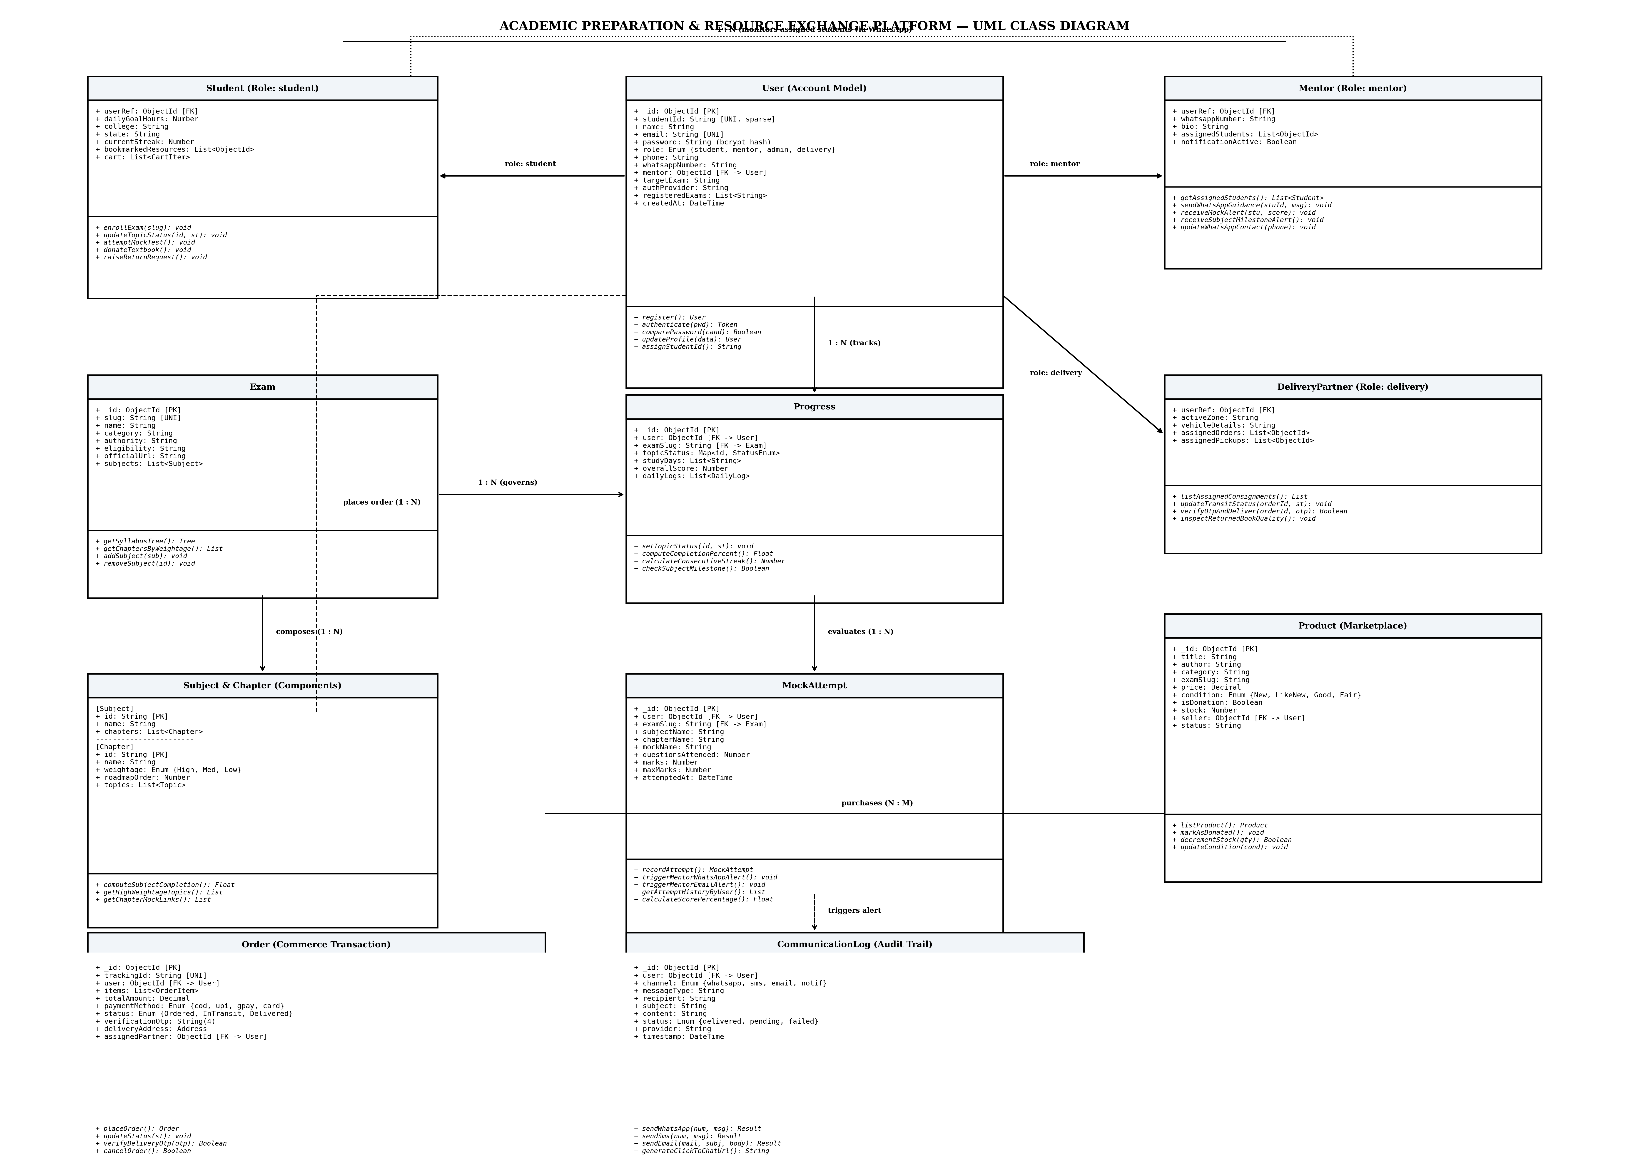
Fig 4.1 UML Class Diagram (Academic Models, Mentorship & Commerce)

CHAPTER 5
TABLE STRUCTURES
The platform persists structured entities in MongoDB collections governed by strictly validated Mongoose schemas. Primary keys are defined by unique ObjectIds and indexed alphanumeric identifiers. Below are the structural specifications of the operational collections:
Table 5.1: Users Collection Schema (User Accounts & Roles)
Field | Type | Null | Key / Index | Default | Description
_id | ObjectId | NO | PRI | UUID | Unique document identifier
name | String(120) | NO | None | None | Full user display name
email | String | NO | UNI | None | Unique email address for login
password | String(255) | YES | None | None | Salted bcrypt hash (select: false)
role | Enum | NO | None | student | student | mentor | admin | delivery
studentId | String | YES | UNI (sparse) | None | Unique auto-generated student identifier
phone | String | YES | None | '' | Contact telephone number
whatsappNumber | String | YES | None | '' | Phone number for WhatsApp alert dispatch
mentor | ObjectId | YES | FK / MUL | null | Reference to assigned mentor user
assignedStudents | Array[ObjectId] | YES | MUL | [] | List of student IDs assigned to mentor
targetExam | String | YES | None | GATE CSE | Primary goal competitive examination
registeredExams | Array[String] | YES | None | [] | Slugs of actively enrolled exams
authProvider | Enum | NO | None | local | local | google | apple
createdAt / updatedAt | Date | NO | None | Date.now | System auditing timestamps

Table 5.2: Exams Collection Schema (Examination Metadata)
Field | Type | Null | Key / Index | Default | Description
_id | ObjectId | NO | PRI | UUID | Unique document identifier
slug | String | NO | UNI | None | URL-safe unique identifier (e.g. gate-cse)
name | String | NO | None | None | Full examination title
category | String | NO | None | None | Discipline category (e.g. engineering)
authority | String | NO | None | None | Conducting body or examination commission
officialUrl | String | NO | None | None | Official examination authority portal link
subjects | Array[SubDoc] | NO | None | [] | Embedded hierarchy of subjects & chapters
createdAt / updatedAt | Date | NO | None | Date.now | Auditing timestamps

Table 5.3: Progress Collection Schema (Syllabus & Streak Tracking)
Field | Type | Null | Key / Index | Default | Description
_id | ObjectId | NO | PRI | UUID | Unique document identifier
user | ObjectId | NO | FK / MUL | None | Reference to User account
examSlug | String | NO | FK / MUL | None | Reference to Exam slug
topicStatus | Map[String, Enum] | NO | None | {} | Map of topicId -> pending | in_progress | completed
studyDays | Array[String] | YES | None | [] | ISO date strings (YYYY-MM-DD) for streak calculation
dailyLogs | Array[SubDoc] | YES | None | [] | Audit trail of topic updates and test scores
createdAt / updatedAt | Date | NO | None | Date.now | Record timestamps

Table 5.4: Mock Attempts Collection Schema (Test Evaluations)
Field | Type | Null | Key / Index | Default | Description
_id | ObjectId | NO | PRI | UUID | Unique document identifier
user | ObjectId | NO | FK / MUL | None | Reference to Student user
examSlug | String | NO | MUL | None | Associated examination slug
subjectName | String | NO | None | None | Name of subject tested
chapterName | String | NO | None | None | Name of chapter tested
mockName | String | NO | None | None | Mock test title or CBT identifier
questionsAttended | Number | NO | None | 0 | Total questions attempted
marks | Number | NO | None | 0 | Marks obtained by student
maxMarks | Number | NO | None | 100 | Maximum attainable marks
attemptedAt | Date | NO | MUL | Date.now | Timestamp of test submission

Table 5.5: Products Collection Schema (Marketplace Resources)
Field | Type | Null | Key / Index | Default | Description
_id | ObjectId | NO | PRI | UUID | Unique document identifier
title | String | NO | None | None | Book title or material description
author | String | YES | None | '' | Book author or publisher name
category | String | NO | MUL | None | Textbook | Notes | Solved Papers
examSlug | String | YES | MUL | '' | Associated competitive exam
price | Number(10,2) | NO | None | 0.00 | Listing price in INR (0 for donations)
condition | Enum | NO | None | Good | New | Like New | Good | Fair
isDonation | Boolean | NO | MUL | false | Flags 100% free community donations
stock | Number | NO | None | 1 | Available inventory quantity
seller | ObjectId | NO | FK / MUL | None | Reference to listing student
status | Enum | NO | None | available | available | sold | claimed

Table 5.6: Orders Collection Schema (Commerce Transactions)
Field | Type | Null | Key / Index | Default | Description
_id | ObjectId | NO | PRI | UUID | Unique document identifier
trackingId | String | NO | UNI | None | Human-readable order tracking ID (TRK-XXXXXX)
user | ObjectId | NO | FK / MUL | None | Reference to purchasing Student
items | Array[SubDoc] | NO | None | [] | Array of purchased products, price & quantities
totalAmount | Number(10,2) | NO | None | 0.00 | Total payable order amount
paymentMethod | Enum | NO | None | cod | cod | upi | gpay | card | netbanking
status | Enum | NO | MUL | Ordered | Ordered | Dispatched | In Transit | Out for Delivery | Delivered
verificationOtp | String(4) | NO | None | None | 4-digit security OTP required for delivery
deliveryAddress | SubDoc | NO | None | None | Recipient address, city, pincode & phone
assignedPartner | ObjectId | YES | FK / MUL | null | Reference to delivery partner account

Table 5.7: Communication Logs Collection Schema (Notification Dispatch)
Field | Type | Null | Key / Index | Default | Description
_id | ObjectId | NO | PRI | UUID | Unique document identifier
user | ObjectId | YES | FK / MUL | null | Recipient user reference
channel | Enum | NO | MUL | None | whatsapp | sms | email | notification
messageType | String | NO | MUL | None | mentor_mock_test_alert | mentor_subject_completed_alert
recipient | String | NO | None | None | Destination phone number or email
subject | String | YES | None | '' | Subject header or brief title
content | String | NO | None | None | Full dispatched message body with WhatsApp link
status | Enum | NO | MUL | pending | delivered | pending | failed
provider | String | YES | None | '' | Gateway used (WhatsApp Cloud API, Ethereal, SMS)
timestamp | Date | NO | MUL | Date.now | Message dispatch timestamp

CHAPTER 6
ER DIAGRAM
The Entity-Relationship (ER) diagram models data semantics and relationship constraints between persistent collections. The central USER entity maintains role-based linkages: Students generate Progress documents across registered Exam entities, submit Mock Attempts, and place Orders for Marketplace Products. Academic Mentors are directly linked to Students through a 1:N mentoring association, receiving real-time Communication Logs. Orders maintain parent-child references with Order Items and assigned Delivery Partners, enforcing strict referential integrity.
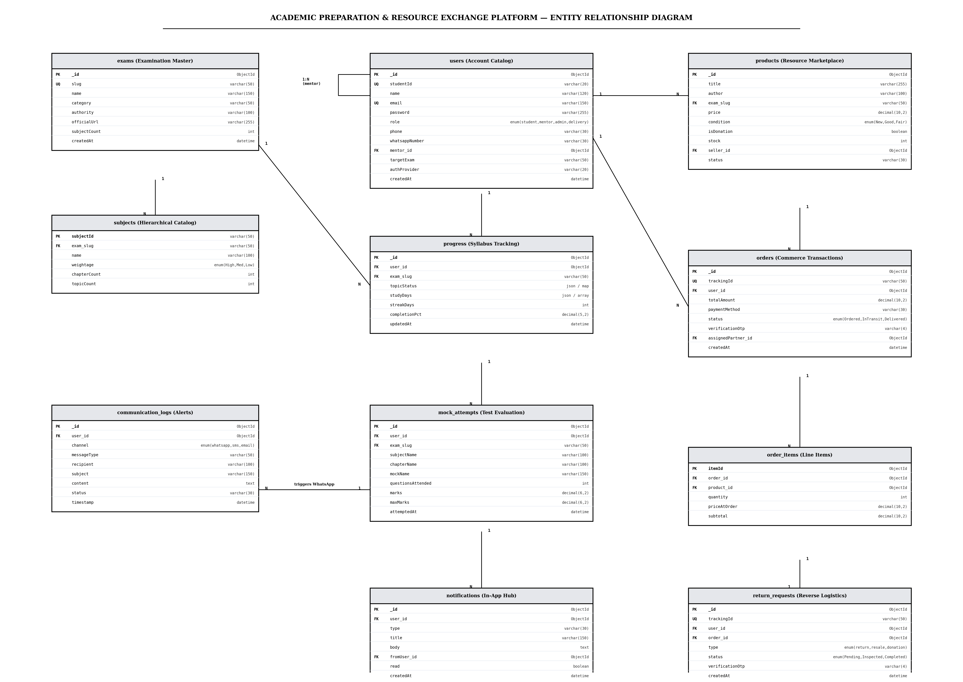
Fig 6.1 Entity-Relationship Diagram (Academic, Mentorship & Logistics Schema)

CHAPTER 7
TECH STACK
7.1 Tech Stack
Layer | Technology | Purpose & Architectural Role
Frontend | React.js 18 + Vite | High-performance Single-Page Application (SPA) with fast modular hot-reload.
Routing & Guards | React Router DOM v6 | Declarative client-side routing with role-based ProtectedRoute boundaries.
State & Client Store | Context API + LocalStorage | Authentication session, linguistic localization, and persistent shopping cart.
Styling & 3D Engine | CSS3 Variables + Three.js | Responsive layout system with hardware-accelerated 3D login background canvas.
Backend Runtime | Node.js (ES Modules) + Express | RESTful API server coordinating route handlers and asynchronous middleware.
Database & ODM | MongoDB + Mongoose ODM | Document persistence with indexing, schema validation, and lifecycle hooks.
Security & Token Auth | JWT + bcryptjs | Stateless bearer token authentication and salted cryptographic password hashing.
Notification Gateway | WhatsApp Click-to-Chat + Nodemailer | Multi-channel notification dispatch for academic mentors and order updates.
Traffic Hardening | CORS + Rate Limiter Middleware | Request throttling (180 req/min) and HTTP header defense against scraping.
CI/CD Automation | Jenkins (Jenkinsfile) + Docker | Automated syntax validation, frontend bundling, and containerized deployment.

7.2 Architecture Overview
Layer | Technology | Purpose
Model | Mongoose ODM + MongoDB | Defines schema rules, handles index lookups, manages document relationships and data sanitization.
View | React.js + Context API | Renders the UI, manages component state, captures input events, and communicates via fetch/Axios.
Controller | Node.js + Express Controllers | Receives HTTP requests, validates payloads, enforces role authorization, and coordinates DB operations.

8.1 USER AUTHENTICATION & ACCESS CONTROL
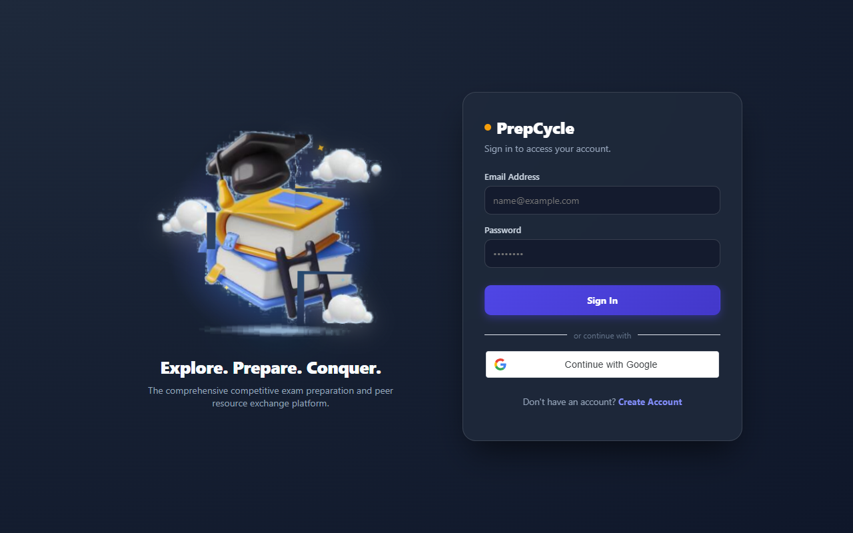
Fig 8.1: User Authentication & Access Control Interface
8.1.1 Purpose & Scope
Provides tokenized authentication, credential management, Google OAuth integration, and Role-Based Access Control (RBAC) across Student, Mentor, Administrator, and Delivery Partner accounts without hardcoding role distinctions into the public interface.
8.1.2 Functional Requirements
- Unified Sign-In & Registration: Users authenticate using email and password or Google OAuth on a single unified interface featuring an interactive Three.js 3D geometric background.
- Dynamic Role-Based Redirection: Upon token generation, the client evaluates user role claims and routes Students to /exam-explorer, Mentors to /mentor, Admins to /admin, and Delivery Partners to /delivery.
- Student ID Generation: Auto-generates unique, non-colliding student identifiers (e.g. PC-STU-100001) upon account registration for academic tracking.
- Route Protection: Client-side ProtectedRoute wrappers prevent cross-role dashboard traversal, rejecting unauthorized access attempts.
8.1.3 Non-Functional Requirements
- Cryptographic Security: Passwords are encrypted using bcryptjs with 10 salt rounds; password hashes are excluded from API payloads by default.
- Stateless Session Scaling: JSON Web Tokens are signed with a 12-hour expiry, enabling stateless horizontally scalable authorization verification.
- Rate Limiting Defence: Centralized rate-limiting protects authentication routes against brute-force credential stuffing.
8.1.4 API Design
Method | Endpoint | Purpose / Contract
POST | /api/auth/login | Authenticates credentials, returns signed JWT and user role profile.
POST | /api/auth/register | Registers new user, assigns role, and generates unique Student ID.
GET | /api/auth/me | Validates bearer token and returns current active user profile.

8.1.5 Database Design
Collection | Key Attributes | Indexing Strategy
Users | _id, email, password, role, studentId, mentor, authProvider | Unique index on email; sparse unique index on studentId; MUL index on mentor reference.

8.2 EXAM EXPLORER & SYLLABUS ROADMAP MANAGEMENT
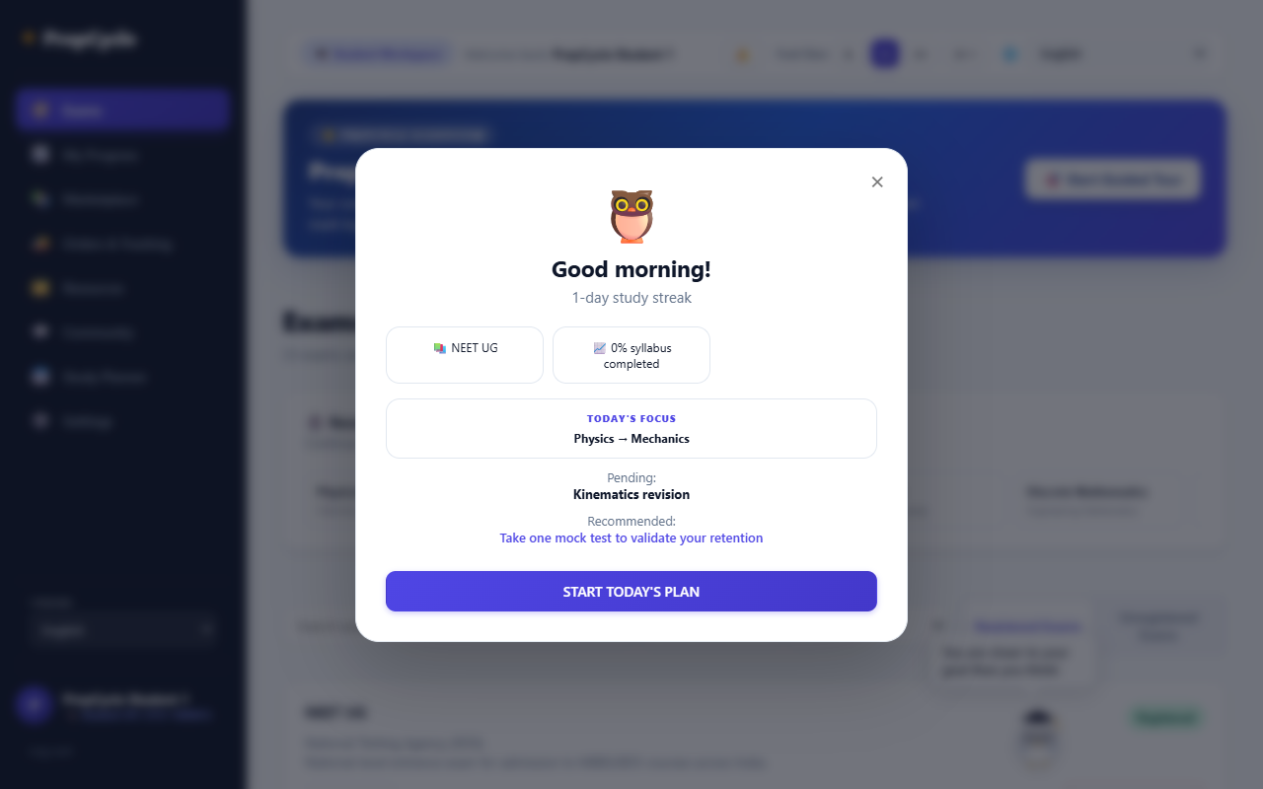
Fig 8.2: Exam Explorer & Syllabus Roadmap Management Interface
8.2.1 Purpose & Scope
Centralizes comprehensive examination profiles, conducting authority information, registration eligibility, and hierarchical weightage-ordered syllabi to give students structured preparation roadmaps.
8.2.2 Functional Requirements
- Catalog Exploration: Displays accredited national competitive examinations (GATE CSE, UPSC, JEE, NEET, CAT) categorized by discipline with search and filter controls.
- Weightage Prioritization: Organizes syllabus chapters into High, Medium, and Low weightage groups to optimize preparation sequence without omitting any topics.
- Exam Registration: Allows students to enroll in targeted examinations, initializing personalized progress records in the database.
- Official Authority Portals: Provides verified direct links to official examination conducting bodies and announcement portals.
8.2.3 Non-Functional Requirements
- Read Performance: Optimized caching headers and indexed slugs ensure catalog responses deliver in under 80 ms.
- Data Integrity: Embedded subject and chapter sub-documents maintain immutable syllabus trees linked to exam slugs.
8.2.4 API Design
Method | Endpoint | Purpose / Contract
GET | /api/exams | Lists all available examinations with subject counts and category tags.
GET | /api/exams/:slug | Returns complete syllabus tree, subject chapters, and conducting authority info.
POST | /api/exams/:slug/register | Enrolls student in examination and initializes topic tracking record.

8.2.5 Database Design
Collection | Key Attributes | Indexing Strategy
Exams | _id, slug, name, category, authority, officialUrl, subjects | Unique index on slug; text index on name and category for search exploration.

8.3 STUDY PROGRESS TRACKING & REVISION ENGINE
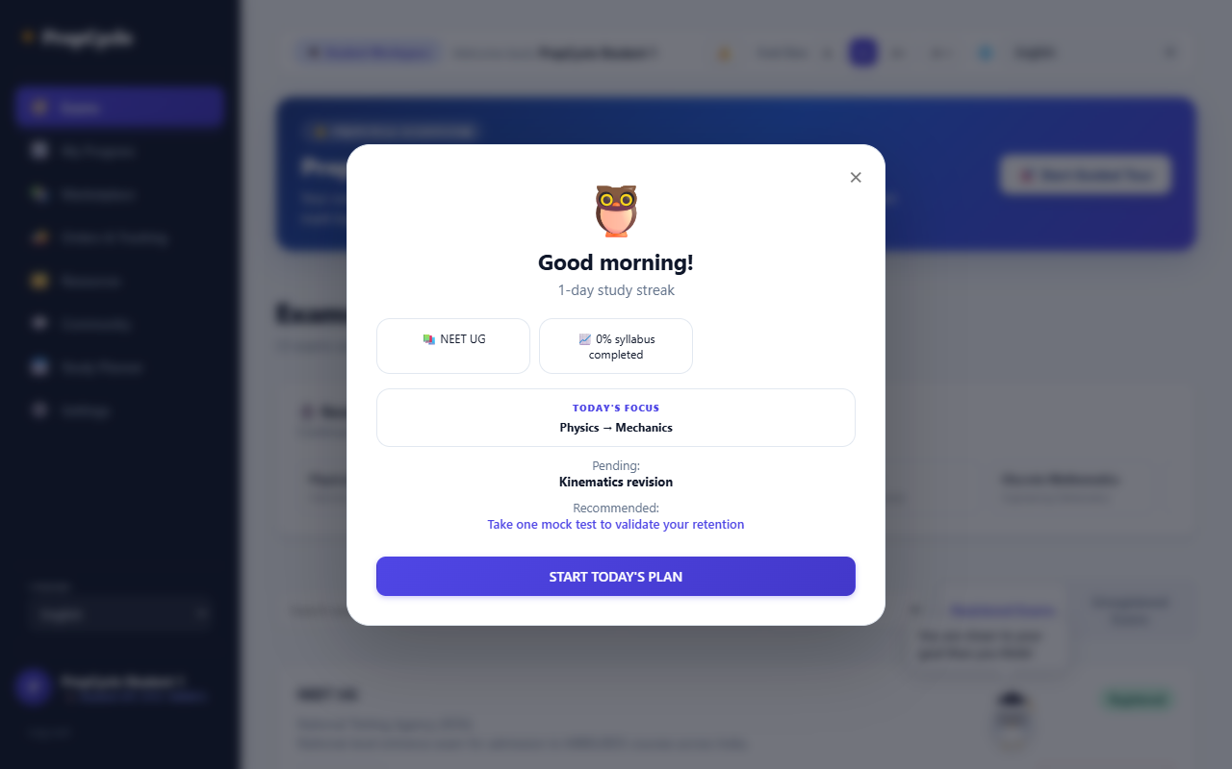
Fig 8.3: Study Progress Tracking & Revision Engine Interface
8.3.1 Purpose & Scope
Tracks granular topic-level completion states, computes daily study streaks, logs revision activity, and drives active recall through interactive flashcards and dynamic note quizzes.
8.3.2 Functional Requirements
- Interactive Topic Tracking: Provides three-state status selectors (Pending, In Progress, Completed) for every syllabus topic.
- Progress Analytics: Computes dynamic completion percentages across chapters, subjects, and the aggregate examination curriculum.
- Daily Study Streaks: Maintains consecutive daily study streaks using ISO date logs and renders an interactive activity heatmap.
- Flashcard Revision: Enables students to create, flip, and review subject-specific active recall flashcards.
8.3.3 Non-Functional Requirements
- Atomic State Updates: Mongoose document updates use atomic Map modifications to prevent race conditions during rapid checkbox toggles.
- Responsiveness: State mutations update client UI optimistically with background reconciliation to ensure zero perceived latency.
8.3.4 API Design
Method | Endpoint | Purpose / Contract
GET | /api/progress/:examSlug | Retrieves student topic statuses, completion stats, streak, and daily audit logs.
PATCH | /api/progress/:examSlug/topic/:topicId | Updates topic completion state and recalculates study streak.
GET / POST | /api/flashcards | Lists or persists subject revision flashcards with question and answer pairs.

8.3.5 Database Design
Collection | Key Attributes | Indexing Strategy
Progress | _id, user, examSlug, topicStatus, studyDays, dailyLogs | Compound index on (user, examSlug) ensuring single progress record per student-exam pair.

8.4 MOCK TEST EVALUATION & ACADEMIC MENTOR MONITORING
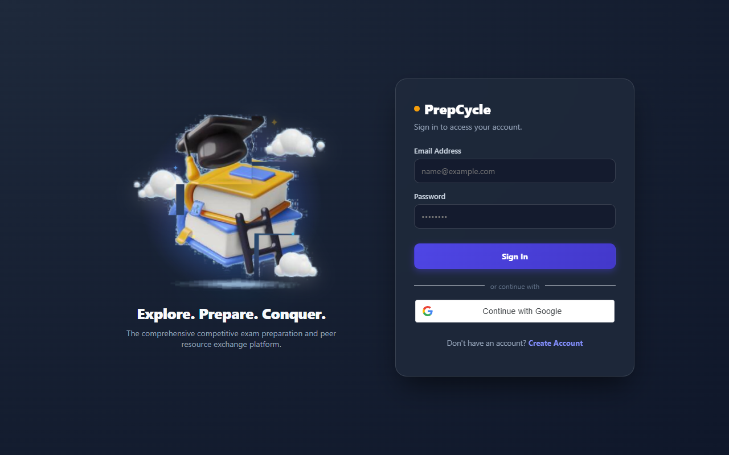
Fig 8.4: Academic Mentor Monitoring & Evaluation Interface
8.4.1 Purpose & Scope
Evaluates student mock test attempts, computes performance trends, and bridges students with dedicated academic mentors through automated WhatsApp alerts, SMS notifications, and a mentor portal.
8.4.2 Functional Requirements
- Mock Attempt Recording: Captures scores, questions attended, maximum marks, and percentage progressions across repeated test attempts.
- Automated WhatsApp & SMS Alerts: Dispatches real-time notification alerts with click-to-chat links directly to assigned mentors when students complete tests or finish subjects.
- Mentor Supervision Dashboard: Provides mentors a dedicated view of assigned students, progress completion bars, mock score histories, and lagging student indicators.
- Direct Mentor Guidance: Enables mentors to initiate motivational messages or guidance conversations directly with students via WhatsApp or SMS.
8.4.3 Non-Functional Requirements
- Communication Resilience: Multi-channel fallback dispatches alerts across WhatsApp, SMS, and in-app feeds, logging delivery status in the database.
- Audit Logging: All mock evaluations are recorded with immutable timestamps to maintain longitudinal academic progress records.
8.4.4 API Design
Method | Endpoint | Purpose / Contract
POST | /api/mock-attempts/:examSlug/chapter/:chapterId | Records mock attempt score and triggers automated mentor notification.
GET | /api/mentor/students | Retrieves assigned students, syllabus completion percentages, and test history.
PATCH | /api/mentor/profile | Updates mentor phone and WhatsApp alert destination number.
POST | /api/admin/assign-mentor | Assigns or transfers a student to an academic mentor.

8.4.5 Database Design
Collection | Key Attributes | Indexing Strategy
MockAttempts | _id, user, examSlug, subjectName, marks, maxMarks, attemptedAt | Compound index on (user, attemptedAt); index on examSlug.
CommunicationLogs | _id, user, channel, messageType, recipient, status, timestamp | Indexes on channel, status, and timestamp for auditing.

8.5 PEER-TO-PEER RESOURCE MARKETPLACE & BOOK CIRCULATION
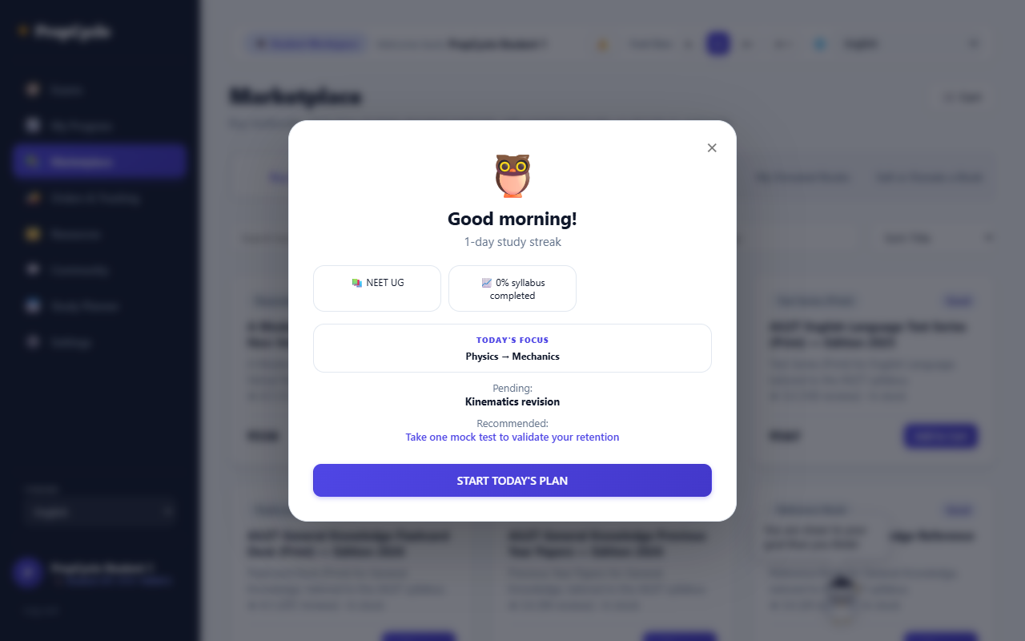
Fig 8.5: Resource Marketplace & Textbook Circulation Interface
8.5.1 Purpose & Scope
Promotes a circular student economy by facilitating peer-to-peer textbook resale, verified student listings, buyback returns, and 100% free study material donations to reduce education expenses.
8.5.2 Functional Requirements
- Textbook Listings: Students create listings specifying title, author, competitive exam tag, condition grade (New, Like New, Good, Fair), and listing price.
- Free Donation Feed: Maintains a dedicated zero-rupee donation feed allowing junior aspirants to claim textbooks at ₹0.
- Multi-Payment Cart: Shopping cart with persistent local storage supporting Cash on Delivery (COD), UPI, Google Pay, Net Banking, and Cards.
- Return Policies & Resale: Provides structured buyback and resale return workflows for textbooks previously purchased through the platform.
8.5.3 Non-Functional Requirements
- Stock Concurrency: Inventory decrement operations execute atomically during order creation to prevent overselling.
- Search Indexing: Text indexes on book title, author, and exam tag ensure responsive autocomplete filtering.
8.5.4 API Design
Method | Endpoint | Purpose / Contract
GET | /api/marketplace/products | Returns available products with condition, exam, and price filters.
POST | /api/marketplace/products | Publishes a new textbook resale or free donation listing.
POST | /api/orders | Processes shopping cart checkout, generating tracking ID and verification OTP.

8.5.5 Database Design
Collection | Key Attributes | Indexing Strategy
Products | _id, title, author, category, examSlug, price, condition, isDonation, seller, status | Text index on (title, author); index on examSlug; index on isDonation and status.

8.6 ORDER FULFILLMENT & DELIVERY PARTNER LOGISTICS
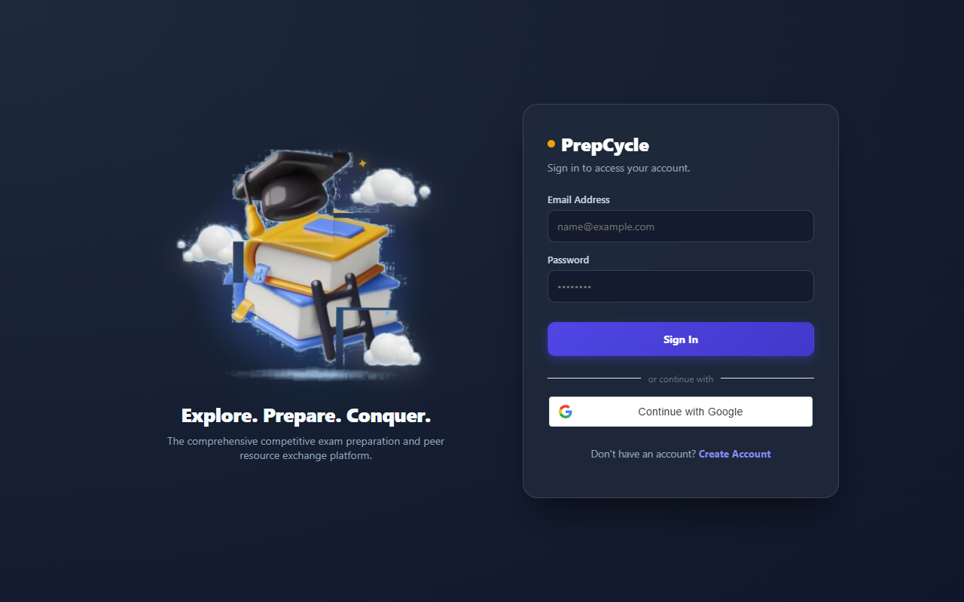
Fig 8.6: Delivery Partner Fulfillment & OTP Verification Interface
8.6.1 Purpose & Scope
Orchestrates physical doorstep order deliveries, return evaluations, and donation pickups with delivery partner assignment, 10-second live status updates, and mandatory 4-digit OTP verification.
8.6.2 Functional Requirements
- Lifecycle Stage Tracking: Monitors shipments through structured stages: Ordered → Dispatched → In Transit → Out for Delivery → Delivered.
- Delivery Partner Dashboard: Dedicated interface (/delivery) showing assigned consignments, customer addresses, contact numbers, and delivery instructions.
- Mandatory OTP Handover: Delivery personnel cannot mark an order completed without entering the customer's 4-digit verification OTP, eliminating false deliveries.
- Real-Time Polling: Client order tracking views poll updates every 10 seconds to maintain synchronized status visibility.
8.6.3 Non-Functional Requirements
- Delivery Verification: Cryptographic validation ensures OTP checks are executed server-side with strict attempt limits.
- Audit Trail: Order stage changes record delivery partner ID, timestamp, and location coordinates.
8.6.4 API Design
Method | Endpoint | Purpose / Contract
GET | /api/delivery/orders | Returns shipments assigned to the authenticated delivery partner.
PATCH | /api/delivery/orders/:id/status | Advances delivery stage; verifies 4-digit OTP before marking Delivered.
GET | /api/orders/track/:trackingId | Public endpoint providing real-time order tracking stage updates.

8.6.5 Database Design
Collection | Key Attributes | Indexing Strategy
Orders | _id, trackingId, user, items, totalAmount, paymentMethod, status, verificationOtp, assignedPartner | Unique index on trackingId; compound index on (assignedPartner, status); index on user.

8.7 COMMUNITY DISCUSSION FORUMS & AI STUDY ASSISTANT
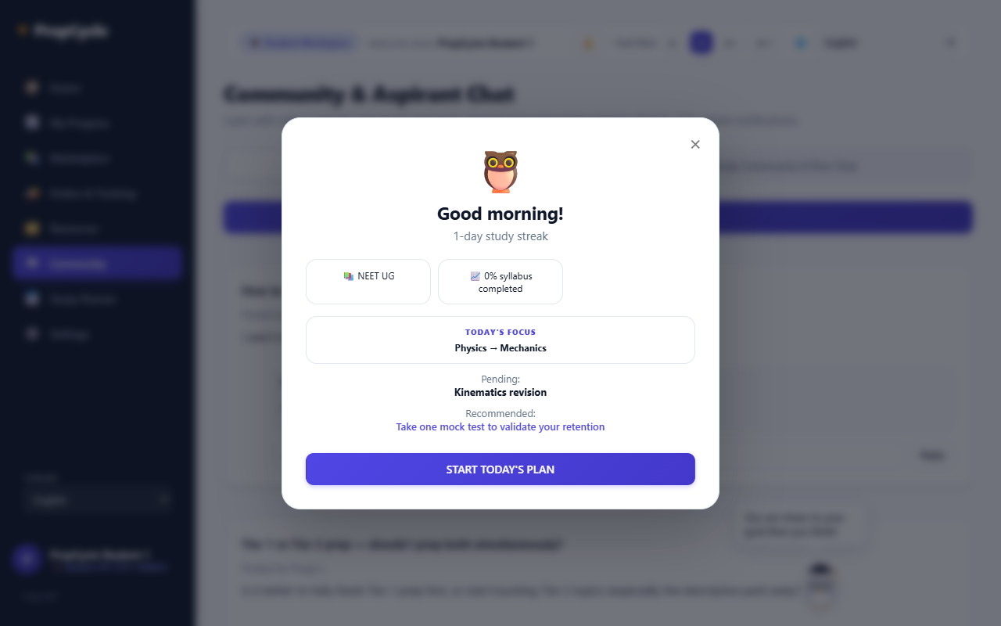
Fig 8.7: Community Discussion & AI Assistant Interface
8.7.1 Purpose & Scope
Fosters collaborative peer learning through exam-specific discussion threads and provides an integrated AI study assistant offering context-aware roadmap advice and daily motivation.
8.7.2 Functional Requirements
- Categorized Q&A Forums: Discussion threads organized by examination discipline (GATE, UPSC, JEE, NEET) with question upvoting and accepted answers.
- Contextual AI Study Assistant: Interactive chat assistant that personalizes study advice based on the student's target examination and syllabus progress.
- Daily Motivational Greeting: Greets students upon login with an inspirational academic quote dynamically served from the backend.
- Community Moderation: Admins and community moderators can flag inappropriate content or highlight verified solutions.
8.7.3 Non-Functional Requirements
- Low Latency Chat: AI chatbot queries stream responses with graceful fallback to cached study strategy templates.
- Thread Scalability: Thread replies are paged in increments of 20 to maintain high rendering efficiency.
8.7.4 API Design
Method | Endpoint | Purpose / Contract
GET / POST | /api/community | Retrieves peer discussion threads or posts a new question.
POST | /api/community/:id/reply | Appends a student answer to an existing discussion thread.
POST | /api/chat | Generates contextual AI study advice grounded in student exam syllabus context.

8.7.5 Database Design
Collection | Key Attributes | Indexing Strategy
Discussions | _id, title, author, examSlug, content, upvotes, replies, isAnswered | Index on examSlug; index on upvotes for popularity sorting; text index on title and content.

8.8 UNIVERSAL ACCESSIBILITY & SETTINGS CUSTOMIZATION
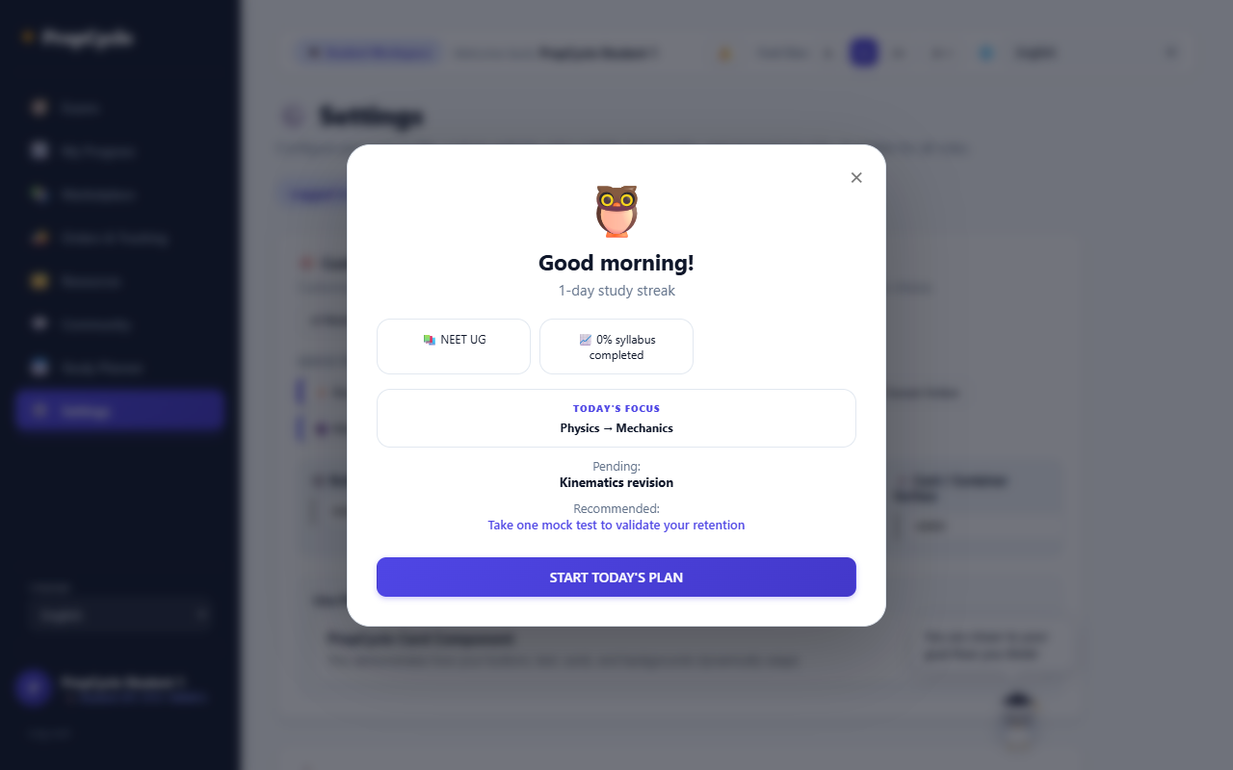
Fig 8.8: Universal Accessibility & Color Palette Settings Interface
8.8.1 Purpose & Scope
Empowers all user roles (Students, Mentors, Admins, Delivery Partners) to customize their visual interface through custom color palettes, font scaling, dark/light theme switching, and linguistic localization.
8.8.2 Functional Requirements
- Full Website Color Customization: Allows users to independently customize button color, text color, and background color with live previews.
- Universal Accessibility: Settings page is identically accessible to all user roles (Student, Mentor, Admin, Delivery Partner).
- Dark & Light Theme Switching: Instant high-contrast dark mode and clean paper light mode toggles across all views.
- Font Size & Multilingual Controls: Dynamic font scaling (Small, Medium, Large) and language selection (English, Tamil, Hindi) with persistent client storage.
8.8.3 Non-Functional Requirements
- CSS Custom Properties: All color selections map to dynamic CSS variables, enabling instantaneous re-theming without page refreshes.
- Cross-Session Persistence: Preferences persist across sessions using LocalStorage and synchronize with user database profiles upon login.
8.8.4 API Design
Method | Endpoint | Purpose / Contract
PATCH | /api/users/preferences | Persists user color palette, theme, font size, and language settings.
GET | /api/users/preferences | Fetches saved user interface preferences upon session initialization.

8.8.5 Database Design
Collection | Key Attributes | Indexing Strategy
Users | preferences.theme, preferences.palette, preferences.fontSize, preferences.language | Embedded sub-document inside Users collection with zero additional join overhead.

8.9 SYSTEM ADMINISTRATION & MULTI-CHANNEL COMMUNICATION
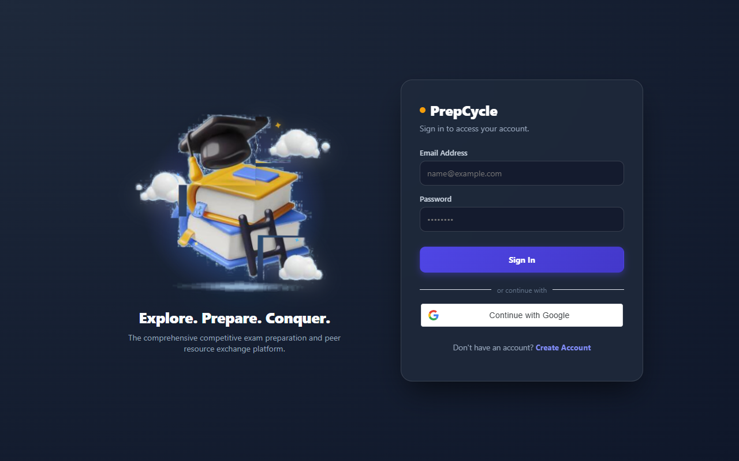
Fig 8.9: System Administration & Communication Engine Interface
8.9.1 Purpose & Scope
Provides administrators full control over platform operations, including user auditing, exam catalog authoring, order dispatching, mentor-student matching, and an active multi-channel communication engine.
8.9.2 Functional Requirements
- User & Role Governance: Inspect and manage student, mentor, and delivery partner accounts with activation and deactivation toggles.
- Mentor-Student Assignment: Allocate students to designated academic mentors to activate automated supervision and notifications.
- Multi-Channel Communication Engine: Send real emails, WhatsApp messages, and SMS notifications directly from the platform to users with live delivery status confirmation.
- Catalog & Order Management: Add new competitive examinations, update syllabus roadmaps, and monitor fulfillment of marketplace orders.
8.9.3 Non-Functional Requirements
- Operational Auditing: All administrative modifications and dispatched communication logs are recorded with administrative user attribution.
- Security Clearance: Strict RBAC middleware blocks non-admin users from accessing /api/admin endpoints.
8.9.4 API Design
Method | Endpoint | Purpose / Contract
GET | /api/admin/users | Lists all registered accounts with role filters and account status.
POST | /api/admin/assign-mentor | Links a student account to a designated academic mentor.
POST | /api/admin/communicate | Dispatches an active Email, WhatsApp message, or SMS to target users.
GET | /api/admin/analytics | Aggregates total students, mock attempts, active orders, and mentor coverage.

8.9.5 Database Design
Collection | Key Attributes | Indexing Strategy
Users, CommunicationLogs, Orders | _id, role, channel, recipient, status, timestamp | Compound indexes on (channel, status) and (role, createdAt).

CHAPTER 9
CONCLUSION
The Multi-Exam Preparation and Resource Exchange Platform delivers an end-to-end, modern digital solution that resolves the major challenges of competitive exam preparation and academic resource scarcity. By uniting multi-tier syllabus exploration, weightage-based roadmaps, continuous mock test tracking, real-time academic mentorship via automated WhatsApp alerts, a circular peer-to-peer textbook marketplace, and doorstep logistics with OTP verification, the system replaces fragmented, manual workflows with an integrated, data-driven web environment.
The application was architected following robust full-stack engineering standards utilizing React.js with Vite for the frontend presentation tier, Node.js with Express.js for the RESTful API service tier, and MongoDB with Mongoose for resilient, scalable NoSQL document persistence. JWT authentication, salted bcrypt password encryption, role-based access control across four distinct user roles, request rate limiting, and HTTP security headers ensure enterprise-grade security.
The completed platform demonstrates how modern web technologies can optimize academic learning, reduce educational expenditure through textbook circulation, foster student-mentor connectivity, and improve examination performance outcomes. Its modular architecture supports high maintainability and lays the foundation for future enhancements such as automated machine-learning question recommendations and mobile application deployment. Overall, the project successfully fulfills all technical objectives, delivering a secure, performant, and reliable web platform.

