**WEEK – 1(Hands-on)**

**Design Principles & Patterns**

**Exercise 1: Implementing the Singleton Pattern**

**Code:**

**Logger.java**

package com.example.singleton;

public class Logger {

private static Logger *instance*;

private Logger() {

System.*out.*println("Logger instance created");}

public static Logger getInstance() {

if (*instance* == null) {

*instance* = new Logger(); }

return *instance*;}

public void log(String message) {

System.*out*.println("Log: " + message);

}}

**LoggerTest.java**

public class Main {

public static void main(String[] args) {

Logger logger1 = Logger.*getInstance*();

Logger logger2 = Logger.*getInstance*();

logger1.log("This is the first log message.");

logger2.log("This is the second log message.");

if (logger1 == logger2) {

System.*out*.println("Both logger1 and logger2 refer to the same instance.");

} else {

System.*out*.println("Different instances exist! Singleton not implemented correctly.");}}}

**OUTPUT:**

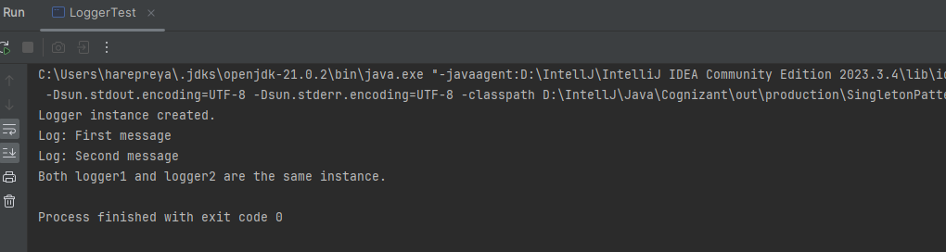

**Exercise 2: Implementing the Factory Method Pattern**

**Code:**

**Document.java**

package com.example.factory;

public interface Document {

void open();

}

public class WordDocument implements Document {

@Override

public void open() {

System.out.println("Opening a Word Document.");

}

}

public class PdfDocument implements Document {

@Override

public void open() {

System.out.println("Opening a PDF Document.");

}

}

public class ExcelDocument implements Document {

@Override

public void open() {

System.out.println("Opening an Excel Document.");

}} }

public abstract class DocumentFactory {

public abstract Document createDocument();

}

public class WordFactory extends DocumentFactory {

@Override

public Document createDocument() {

return new WordDocument();

}

}

public class PdfFactory extends DocumentFactory {

@Override

public Document createDocument() {

return new PdfDocument();

}

}

public class ExcelFactory extends DocumentFactory {

@Override

public Document createDocument() {

return new ExcelDocument();

}

}

**DocumentTest.java**

public class DocumentTest {

public static void main(String[] args) {

DocumentFactory wordFactory = new WordFactory();

Document wordDoc = wordFactory.createDocument();

wordDoc.open();

DocumentFactory pdfFactory = new PdfFactory();

Document pdfDoc = pdfFactory.createDocument();

pdfDoc.open();

DocumentFactory excelFactory = new ExcelFactory();

Document excelDoc = excelFactory.createDocument();

excelDoc.open();

}}

**OUTPUT:**

