**Digital Nurture 4.0 Deep Skilling - Java FSE  
WEEK – 6 React HandsOn**

**1) Create a new React Application with the name “myfirstreact”, Run the application to print “welcome to the first session of React” as heading of that page.**

**Commands:**







**App.js**

import logo from './logo.svg';

import './App.css';

function App() {

  return (

    <h1>Welcome the first session of react</h1>

  );

}

export default App;

**OUTPUT**

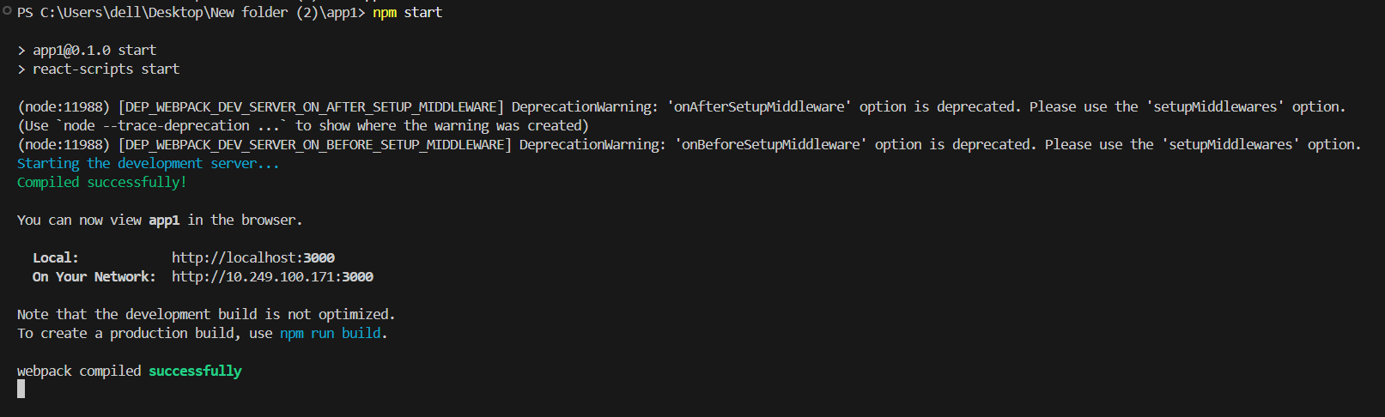

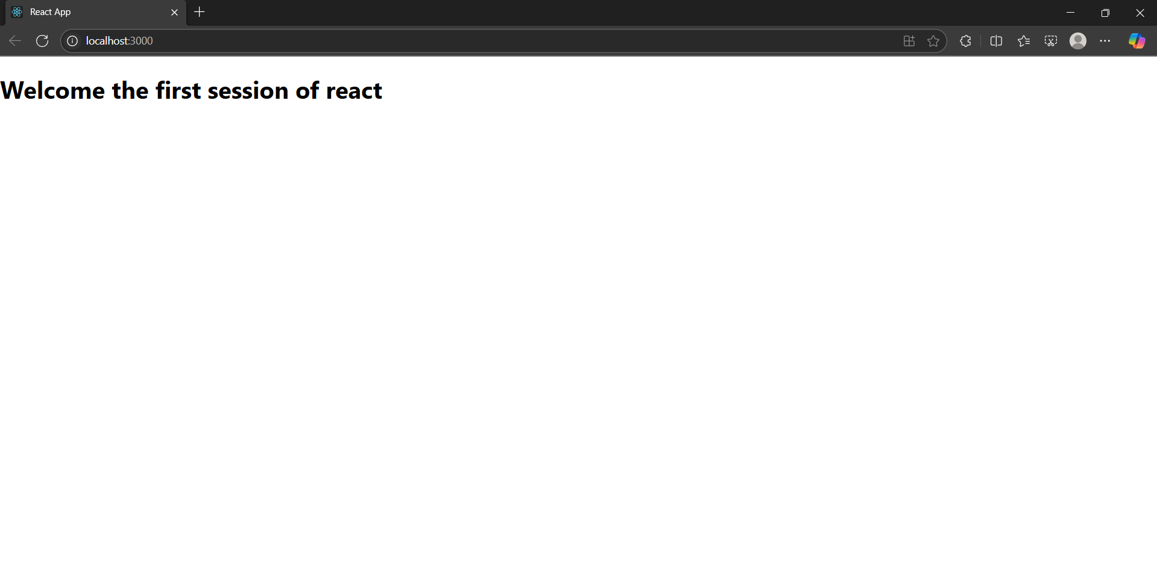

**2)**  **Create a react app for Student Management Portal named StudentApp and create a component named Home which will display the Message “Welcome to the Home page of Student Management Portal”. Create another component named About and display the Message “Welcome to the About page of the Student Management Portal”. Create a third component named Contact and display the Message “Welcome to the Contact page of the Student Management Portal”. Call all the three components.**

**Home.js**

import React, { Component } from 'react';

export class Home extends Component {

render() {

return (

<div>

<h3>Welcome to the Home Page of Student Management Portal</h3>

</div>

);

}

}

**About.js**

import React, { Component } from 'react';

export class About extends Component {

render() {

return (

<div>

<h3>Welcome to the About Page of Student Management Portal</h3>

</div>

);

}

}

**Contact.js**

import React, { Component } from 'react';

export class Contact extends Component {

render() {

return (

<div>

<h3>Welcome to the Contact Page of Student Management Portal</h3>

</div>

);

}

}

**App.js**

import logo from './logo.svg';

import './App.css';

import { Home } from './Components/Home';

import { About } from './Components/About';

import { Contact } from './Components/Contact';

function App() {

return (

<div className="container">

<Home />

<About />

<Contact />

</div>

);

}

export default App;

**Output:**

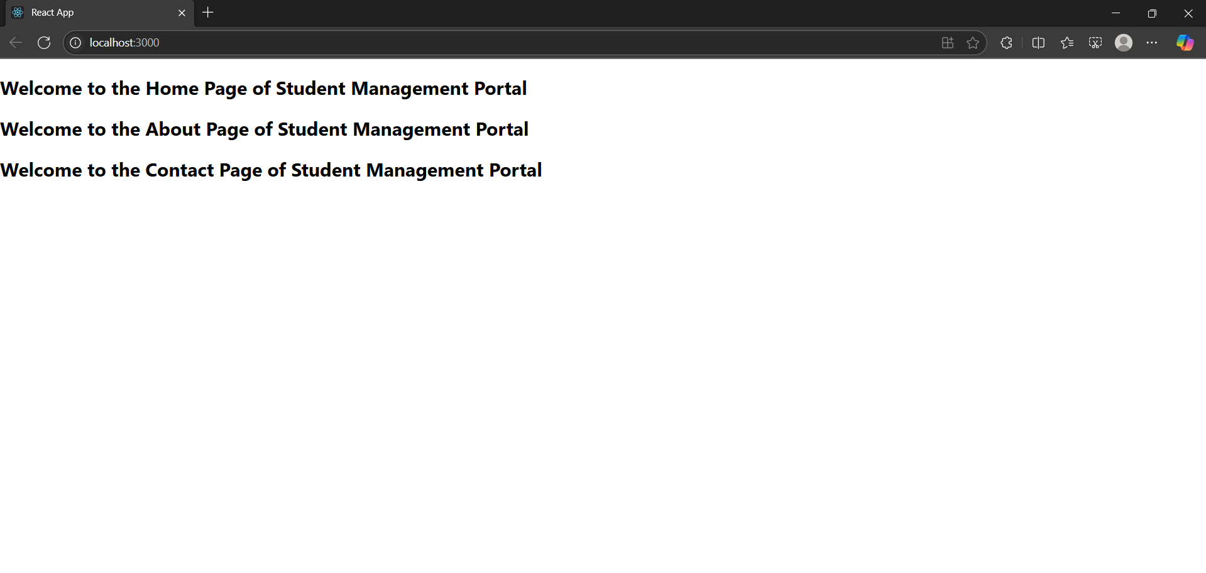

**3)** **Create a react app for Student Management Portal named scorecalculatorapp and create a function component named “CalculateScore” which will accept Name, School, Total and goal in order to calculate the average score of a student and display the same.**

**CalculateScore.js**

import React from 'react';

import '../Stylesheets/mystyle.css';

const CalculateScore = ({ Name, School, Total, goal }) => {

const studentScore = (Total / goal) * 100;

let message = '';

if (studentScore >= 90) {

message = 'Excellent';

} else if (studentScore >= 80) {

message = 'Very Good';

} else if (studentScore >= 70) {

message = 'Good';

} else if (studentScore >= 60) {

message = 'Average';

} else if (studentScore >= 50) {

message = 'Below Average';

} else {

message = 'Needs Improvement';

}

return (

<div className="score-container">

<h2>Student Score Details</h2>

<div className="student-info">

<p><strong>Name:</strong> {Name}</p>

<p><strong>School:</strong> {School}</p>

<p><strong>Total Marks:</strong> {Total}</p>

<p><strong>Goal:</strong> {goal}</p>

</div>

<div className="score-result">

<p><strong>Percentage:</strong> {studentScore.toFixed(2)}%</p>

<p><strong>Remarks:</strong> {message}</p>

</div>

</div>

);

};

export default CalculateScore;

**mystyle.css**

.score-container {

font-family: Arial, sans-serif;

max-width: 600px;

margin: 20px auto;

padding: 20px;

border-radius: 8px;

box-shadow: 0 0 10px rgba(0, 0, 0, 0.1);

background-color: #f9f9f9;

}

.score-container h2 {

color: #2c3e50;

text-align: center;

margin-bottom: 20px;

}

.student-info, .score-result {

background-color: white;

padding: 15px;

margin-bottom: 15px;

border-radius: 5px;

border-left: 4px solid #3498db;

}

.student-info p, .score-result p {

margin: 8px 0;

color: #34495e;

}

.score-result {

border-left-color: #2ecc71;

}

.score-result p:last-child {

font-weight: bold;

color: #e74c3c;

}

**App.js**

import React from 'react';

import './Stylesheets/mystyle.css';

import CalculateScore from './Components/CalculateScore';

function App() {

return (

<div className="App">

<CalculateScore

Name="Steeve"

School="DNV Public School"

Total={284}

goal={94.67}

/>

</div>

);

}

export default App;

**Output:**

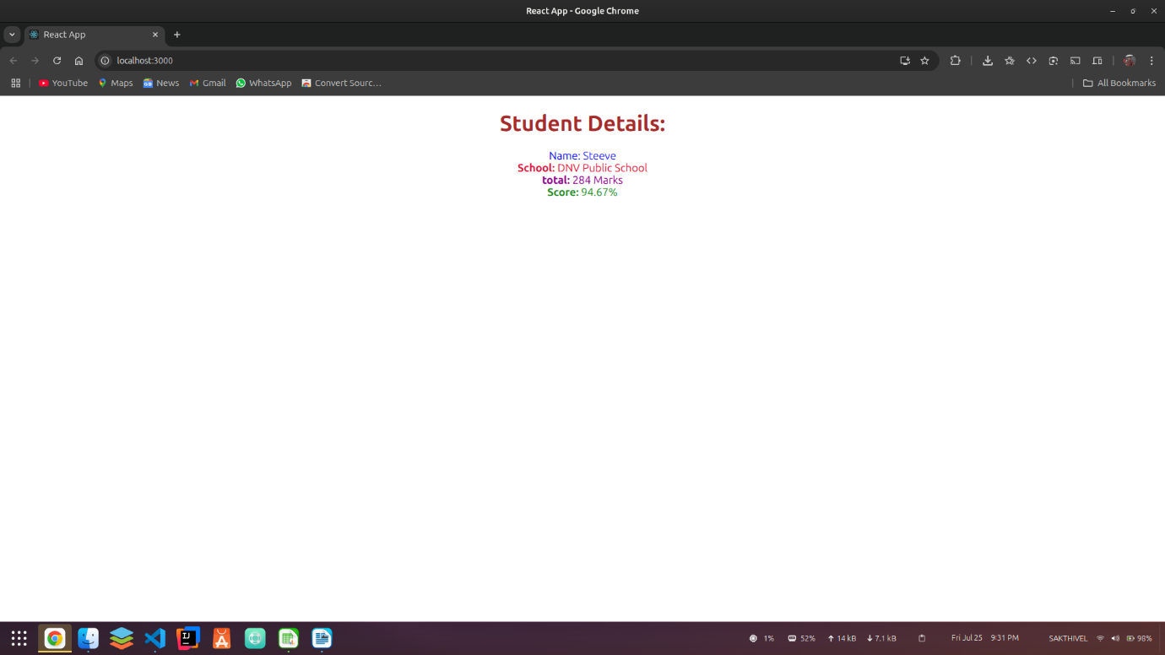

**4)** **Create a new react application using create-react-app tool with the name as “blogapp”. Create a new file named as Post.js in src folder with following properties. Create a new class based component named as Posts inside Posts.js file. Implement the componentDidMount() hook to make calls to loadPosts() which will fetch the posts.**

**Post.js**

class Post {

constructor( id, title, body ) {

this.id = id;

this.title = title;

this.body = body;

}

}

export default Post;

**Posts.js**

import React from "react";

import Post from "./Post";

class Posts extends React.Component {

state = {

posts : [],

error : null,

success : false

}

loadPosts() {

fetch("https://jsonplaceholder.typicode.com/posts")

.then(posts => posts.json())

.then(posts => {

const postObjects = posts.map(postData => new Post(postData.id, postData.title, postData.body))

this.setState({

posts : postObjects,

success : true

})

})

.catch(error => {

this.setState({

error : error.message

})

})

}

componentDidMount() {

this.loadPosts();

}

render() {

return (

<div>

<h1>Posts</h1>

<div>

{

this.state.success && this.state.posts.map((post, index) => {

return (

<div key={index} style={{border: "2px solid black", padding: "10px", margin: "10px", display: "flex"}}>

<div style={{paddingRight: "50px", alignSelf: "center"}}>

<p>{post.id}</p>

</div>

<div style={{display: "flex", flexDirection: "column", textAlign: "left"}}>

<p style={{fontWeight: 800, fontSize: "1.5rem"}}>{post.title}</p>

<p>{post.body}</p>

</div>

</div>

)

})

}

</div>

</div>

);

}

componentDidCatch(error, info) {

console.log(error);

console.log(info);

}

}

export default Posts;

**App.js**

import './App.css';

import Posts from './Posts';

function App() {

return (

<div className="App">

<Posts />

</div>

);

}

export default App;

**Output:**

