**Median of two sorted arrays of same size**

There are 2 sorted arrays A and B of size n each. Write an algorithm to find the median of the array obtained after merging the above 2 arrays(i.e. array of length 2n). The complexity should be O(log(n)).

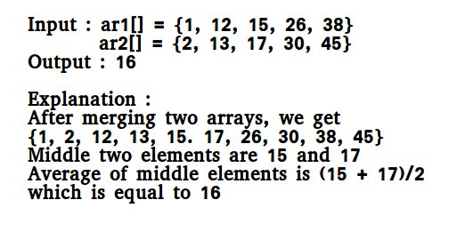

**Note:**Since the size of the set for which we are looking for the median is even (2n), we need to take the average of the middle two numbers and return the floor of the average.  
**Method 1 (Simply count while Merging)**   
Use the merge procedure of merge sort. Keep track of count while comparing elements of two arrays. If count becomes n(For 2n elements), we have reached the median. Take the average of the elements at indexes n-1 and n in the merged array.

**Method 2 (By comparing the medians of two arrays)**   
This method works by first getting medians of the two sorted arrays and then comparing them.  
Let ar1 and ar2 be the input arrays.   
**Algorithm :**

1) Calculate the medians m1 and m2 of the input arrays ar1[]

and ar2[] respectively.

2) If m1 and m2 both are equal then we are done.

return m1 (or m2)

3) If m1 is greater than m2, then median is present in one

of the below two subarrays.

a) From first element of ar1 to m1 (ar1[0...|_n/2_|])

b) From m2 to last element of ar2 (ar2[|_n/2_|...n-1])

4) If m2 is greater than m1, then median is present in one

of the below two subarrays.

a) From m1 to last element of ar1 (ar1[|_n/2_|...n-1])

b) From first element of ar2 to m2 (ar2[0...|_n/2_|])

5) Repeat the above process until size of both the subarrays

becomes 2.

6) If size of the two arrays is 2 then use below formula to get

the median.

Median = (max(ar1[0], ar2[0]) + min(ar1[1], ar2[1]))/2

**Examples :**

ar1[] = {1, 12, 15, 26, 38}

ar2[] = {2, 13, 17, 30, 45}

For above two arrays m1 = 15 and m2 = 17  
For the above ar1[] and ar2[], m1 is smaller than m2. So median is present in one of the following two subarrays.

[15, 26, 38] and [2, 13, 17]

Let us repeat the process for above two subarrays:

m1 = 26 m2 = 13.

m1 is greater than m2. So the subarrays become

[15, 26] and [13, 17]

Now size is 2, so median = (max(ar1[0], ar2[0]) + min(ar1[1], ar2[1]))/2

= (max(15, 13) + min(26, 17))/2

= (15 + 17)/2

= 16