**Naive algorithm for Pattern Searching**

Given a text *txt[0..n-1]*and a pattern *pat[0..m-1]*, write a function *search(char pat[], char txt[])* that prints all occurrences of *pat[]*in *txt[]*. You may assume that *n > m*.   
**Examples:**

Input: txt[] = "THIS IS A TEST TEXT"

pat[] = "TEST"

Output: Pattern found at index 10

Input: txt[] = "AABAACAADAABAABA"

pat[] = "AABA"

Output: Pattern found at index 0

Pattern found at index 9

Pattern found at index 12

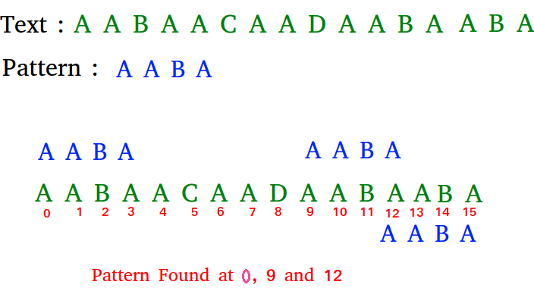

Pattern searching is an important problem in computer science. When we do search for a string in notepad/word file or browser or database, pattern searching algorithms are used to show the search results. 

[Recommended: Please solve it on “***PRACTICE*** ” first, before moving on to the solution.](https://practice.geeksforgeeks.org/problems/subsequence-matching/0)

**Naive Pattern Searching:**   
Slide the pattern over text one by one and check for a match. If a match is found, then slides by 1 again to check for subsequent matches.