**463. Island Perimeter**

You are given row x col grid representing a map where grid[i][j] = 1 represents land and grid[i][j] = 0 represents water.

Grid cells are connected **horizontally/vertically** (not diagonally). The grid is completely surrounded by water, and there is exactly one island (i.e., one or more connected land cells).

The island doesn't have "lakes", meaning the water inside isn't connected to the water around the island. One cell is a square with side length 1. The grid is rectangular, width and height don't exceed 100. Determine the perimeter of the island.

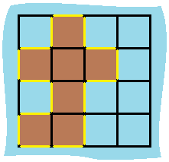

**Input:** grid = [[0,1,0,0],[1,1,1,0],[0,1,0,0],[1,1,0,0]]

**Output:** 16

**Explanation:** The perimeter is the 16 yellow stripes in the image above.

**733. Flood Fill**

An image is represented by an m x n integer grid image where image[i][j] represents the pixel value of the image.

You are also given three integers sr, sc, and color. You should perform a **flood fill** on the image starting from the pixel image[sr][sc].

To perform a **flood fill**, consider the starting pixel, plus any pixels connected **4-directionally** to the starting pixel of the same color as the starting pixel, plus any pixels connected **4-directionally** to those pixels (also with the same color), and so on. Replace the color of all of the aforementioned pixels with color.

Return *the modified image after performing the flood fill*.

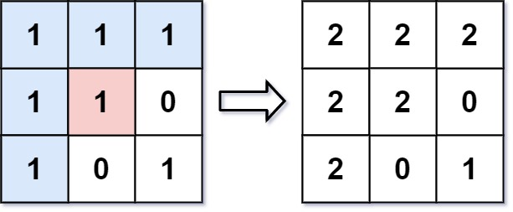

**Input:** image = [[1,1,1],[1,1,0],[1,0,1]], sr = 1, sc = 1, color = 2

**Output:** [[2,2,2],[2,2,0],[2,0,1]]

**Explanation:** From the center of the image with position (sr, sc) = (1, 1) (i.e., the red pixel), all pixels connected by a path of the same color as the starting pixel (i.e., the blue pixels) are colored with the new color.

Note the bottom corner is not colored 2, because it is not 4-directionally connected to the starting pixel.