**Introduction Of Graph Data Structure**

A graph is a data structure that consists of the following two components:   
**1. A finite set of vertices also called as nodes.**  
**2.** **A finite set of ordered pair of the form (u, v) called as edge**. The pair is ordered because (u, v) is not the same as (v, u) in case of a directed graph(di-graph). The pair of the form (u, v) indicates that there is an edge from vertex u to vertex v. The edges may contain weight/value/cost.  
Graphs are used to represent many real-life applications: Graphs are used to represent networks. The networks may include paths in a city or telephone network or circuit network. Graphs are also used in social networks like linkedIn, Facebook. For example, in Facebook, each person is represented with a vertex(or node). Each node is a structure and contains information like person id, name, gender, and locale.   
Following is an example of an undirected graph with 5 vertices. 



The following two are the most commonly used representations of a graph.   
**1.** **Adjacency Matrix**   
**2.** **Adjacency List**   
There are other representations also like, Incidence Matrix and Incidence List. The choice of graph representation is situation-specific. It totally depends on the type of operations to be performed and ease of use.

**Adjacency Matrix:**   
Adjacency Matrix is a 2D array of size V x V where V is the number of vertices in a graph. Let the 2D array be adj[][], a slot adj[i][j] = 1 indicates that there is an edge from vertex i to vertex j. Adjacency matrix for undirected graph is always symmetric. Adjacency Matrix is also used to represent weighted graphs. If adj[i][j] = w, then there is an edge from vertex i to vertex j with weight w. 

The adjacency matrix for the above example graph is:

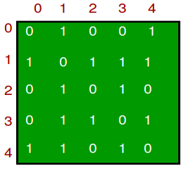

*Pros:* Representation is easier to implement and follow. Removing an edge takes O(1) time. Queries like whether there is an edge from vertex ‘u’ to vertex ‘v’ are efficient and can be done O(1).  
*Cons:* Consumes more space O(V^2). Even if the graph is sparse(contains less number of edges), it consumes the same space. Adding a vertex is O(V^2) time.   
  
**Adjacency List:**   
An array of lists is used. The size of the array is equal to the number of vertices. Let the array be an array[]. An entry array[i] represents the list of vertices adjacent to the***i***th vertex. This representation can also be used to represent a weighted graph. The weights of edges can be represented as lists of pairs. Following is the adjacency list representation of the above graph.

Lightbox

<https://github.com/hareramcse/Datastructure/blob/master/Graph/src/com/hs/introduction/AdjacencyMatrix.java>

<https://github.com/hareramcse/Datastructure/blob/master/Graph/src/com/hs/introduction/AdjacenyListGraph.java>

**Breadth First Search or BFS for a Graph**

[Breadth-First Traversal (or Search)](http://en.wikipedia.org/wiki/Breadth-first_search) for a graph is similar to Breadth-First Traversal of a tree. The only catch here is, unlike trees, graphs may contain cycles, so we may come to the same node again. To avoid processing a node more than once, we use a boolean visited array. For simplicity, it is assumed that all vertices are reachable from the starting vertex.

For example, in the following graph, we start traversal from vertex 2. When we come to vertex 0, we look for all adjacent vertices of it. 2 is also an adjacent vertex of 0. If we don’t mark visited vertices, then 2 will be processed again and it will become a non-terminating process. A Breadth-First Traversal of the following graph is 2, 0, 3, 1.

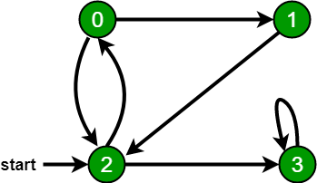

<https://github.com/hareramcse/Datastructure/blob/master/Graph/src/com/hs/introduction/BFS.java>

**Depth First Search or DFS for a Graph**

[Depth First Traversal (or Search)](http://en.wikipedia.org/wiki/Depth-first_search) for a graph is similar to [Depth First Traversal of a tree.](https://www.geeksforgeeks.org/tree-traversals-inorder-preorder-and-postorder/) The only catch here is, unlike trees, graphs may contain cycles (a node may be visited twice). To avoid processing a node more than once, use a boolean visited array.

**Approach:**   
Depth-first search is an algorithm for traversing or searching tree or graph data structures. The algorithm starts at the root node (selecting some arbitrary node as the root node in the case of a graph) and explores as far as possible along each branch before backtracking. So the basic idea is to start from the root or any arbitrary node and mark the node and move to the adjacent unmarked node and continue this loop until there is no unmarked adjacent node. Then backtrack and check for other unmarked nodes and traverse them. Finally, print the nodes in the path.

**Algorithm:**   
Create a recursive function that takes the index of the node and a visited array.

1. Mark the current node as visited and print the node.
2. Traverse all the adjacent and unmarked nodes and call the recursive function with the index of the adjacent node.

**Implementation:**

<https://github.com/hareramcse/Datastructure/blob/master/Graph/src/com/hs/introduction/DFS.java>

**Applications of Depth First Search**

Depth-first search (DFS) is an algorithm (or technique) for traversing a graph.

Following are the problems that use DFS as a building block.

**1) Detecting cycle in a graph**  
A graph has cycle if and only if we see a back edge during DFS. So we can run DFS for the graph and check for back edges.

**2) Path Finding**   
We can specialize the DFS algorithm to find a path between two given vertices u and z.   
i) Call DFS(G, u) with u as the start vertex.   
ii) Use a stack S to keep track of the path between the start vertex and the current vertex.   
iii) As soon as destination vertex z is encountered, return the path as the   
contents of the stack

**3)**[**Topological Sorting**](https://www.geeksforgeeks.org/topological-sorting/)   
Topological Sorting is mainly used for scheduling jobs from the given dependencies among jobs. In computer science, applications of this type arise in instruction scheduling, ordering of formula cell evaluation when recomputing formula values in spreadsheets, logic synthesis, determining the order of compilation tasks to perform in makefiles, data serialization, and resolving symbol dependencies in linkers [2].

**4) To test if a graph is**[**bipartite**](http://en.wikipedia.org/wiki/Bipartite_graph)   
We can augment either BFS or DFS when we first discover a new vertex, color it opposited its parents, and for each other edge, check it doesn’t link two vertices of the same color. The first vertex in any connected component can be red or black!

**5) Finding Strongly Connected Components of a graph** A directed graph is called strongly connected if there is a path from each vertex in the graph to every other vertex.

**6) Solving puzzles with only one solution**, such as mazes. (DFS can be adapted to find all solutions to a maze by only including nodes on the current path in the visited set.)

**Applications of Breadth First Traversal**

**1) Shortest Path and Minimum Spanning Tree for unweighted graph** In an unweighted graph, the shortest path is the path with least number of edges. With Breadth First, we always reach a vertex from given source using the minimum number of edges. Also, in case of unweighted graphs, any spanning tree is Minimum Spanning Tree and we can use either Depth or Breadth first traversal for finding a spanning tree.

**2) Peer to Peer Networks.** In Peer to Peer Networks like [BitTorrent](https://www.geeksforgeeks.org/how-bittorrent-works/), Breadth First Search is used to find all neighbor nodes.

**3) Crawlers in Search Engines:** Crawlers build index using Breadth First. The idea is to start from source page and follow all links from source and keep doing same. Depth First Traversal can also be used for crawlers, but the advantage with Breadth First Traversal is, depth or levels of the built tree can be limited.

**4) Social Networking Websites:**In social networks, we can find people within a given distance ‘k’ from a person using Breadth First Search till ‘k’ levels.

**5) GPS Navigation systems:** Breadth First Search is used to find all neighbouring locations.

**6) Broadcasting in Network:** In networks, a broadcasted packet follows Breadth First Search to reach all nodes.

**7) In Garbage Collection:** Breadth First Search is used in copying garbage collection using [Cheney’s algorithm](http://en.wikipedia.org/wiki/Cheney%27s_algorithm). Breadth First Search is preferred over Depth First Search because of better locality of reference:

**8)**[**Cycle detection in undirected graph:**](https://www.geeksforgeeks.org/detect-cycle-undirected-graph/) In undirected graphs, either Breadth First Search or Depth First Search can be used to detect cycle. We can use [BFS to detect cycle in a directed graph](https://www.geeksforgeeks.org/detect-cycle-in-a-directed-graph-using-bfs/) also,

**9)** [**Ford–Fulkerson algorithm**](https://www.geeksforgeeks.org/ford-fulkerson-algorithm-for-maximum-flow-problem/) In Ford-Fulkerson algorithm, we can either use Breadth First or Depth First Traversal to find the maximum flow. Breadth First Traversal is preferred as it reduces worst case time complexity to O(VE2).

**10)**[**To test if a graph is Bipartite**](https://www.geeksforgeeks.org/bipartite-graph/) We can either use Breadth First or Depth First Traversal.

**11) Path Finding** We can either use Breadth First or Depth First Traversal to find if there is a path between two vertices.

**12) Finding all nodes within one connected component:** We can either use Breadth First or Depth First Traversal to find all nodes reachable from a given node.

Many algorithms like [Prim’s Minimum Spanning Tree](https://www.geeksforgeeks.org/greedy-algorithms-set-5-prims-minimum-spanning-tree-mst-2/) and [Dijkstra’s Single Source Shortest Path](https://www.geeksforgeeks.org/greedy-algorithms-set-6-dijkstras-shortest-path-algorithm/) use structure similar to Breadth First Search.

There can be many more applications as Breadth First Search is one of the core algorithms for Graphs.

**Find a Mother Vertex in a Graph**

**What is a Mother Vertex?**   
A mother vertex in a graph G = (V, E) is a vertex v such that all other vertices in G can be reached by a path from v.

Example :

Input : Below Graph

Output : 5

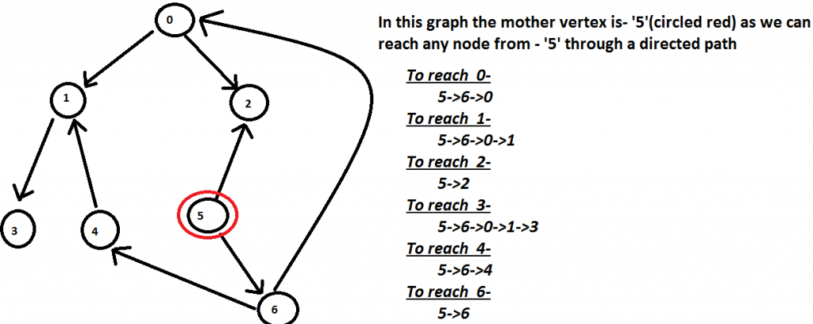

**How to find mother vertex?**

* ***Case 1:- Undirected Connected Graph :***In this case, all the vertices are mother vertices as we can reach to all the other nodes in the graph.
* ***Case 2:- Undirected/Directed Disconnected Graph*** : In this case, there is no mother vertices as we cannot reach to all the other nodes in the graph.
* ***Case 3:- Directed Connected Graph*** : In this case, we have to find a vertex -v in the graph such that we can reach to all the other nodes in the graph through a directed path.

If there exist mother vertex (or vertices), then one of the mother vertices is the last finished vertex in DFS. (Or a mother vertex has the maximum finish time in DFS traversal).  
A vertex is said to be finished in DFS if a recursive call for its DFS is over, i.e., all descendants of the vertex have been visited.

**How does the above idea work?**   
Let the last finished vertex be v. Basically, we need to prove that there cannot be an edge from another vertex u to v if u is not another mother vertex (Or there cannot exist a non-mother vertex u such that u-→v is an edge). There can be two possibilities.

1. Recursive DFS call is made for u before v. If an edge u-→v exists, then v must have finished before u because v is reachable through u and a vertex finishes after all its descendants.
2. Recursive DFS call is made for v before u. In this case also, if an edge u-→v exists, then either v must finish before u (which contradicts our assumption that v is finished at the end) OR u should be reachable from v (which means u is another mother vertex).

**Algorithm :**

1. Do DFS traversal of the given graph. While doing traversal keep track of last finished vertex ‘v’. This step takes O(V+E) time.
2. If there exist mother vertex (or vertices), then v must be one (or one of them). Check if v is a mother vertex by doing DFS/BFS from v. This step also takes O(V+E) time.

<https://github.com/hareramcse/Datastructure/blob/master/Graph/src/com/hs/introduction/FindMotherVertex.java>

**Transitive Closure of a Graph using DFS**

Given a directed graph, find out if a vertex v is reachable from another vertex u for all vertex pairs (u, v) in the given graph. Here reachable means that there is a path from vertex u to v. The reach-ability matrix is called transitive closure of a graph.  
 For example, consider below graph

Transitive closure of above graphs is

1 1 1 1

1 1 1 1

1 1 1 1

0 0 0 1

<https://github.com/hareramcse/Datastructure/blob/master/Graph/src/com/hs/introduction/TransitiveClosure.java>

**Count the number of nodes at given level in a tree using BFS.**

Given a tree represented as an undirected graph. Count the number of nodes at a given level l. It may be assumed that vertex 0 is the root of the tree.

Input : 7

0 1

0 2

1 3

1 4

1 5

2 6

2

Output : 4

Input : 6

0 1

0 2

1 3

2 4

2 5

2

Output : 3

<https://github.com/hareramcse/Datastructure/blob/master/Graph/src/com/hs/introduction/CountNoOfNodesOfBinaryTreeAtGivenLevel.java>

**Count all possible paths between two vertices**

Count the total number of ways or paths that exist between two vertices in a directed graph. These paths don’t contain a cycle, the simple enough reason is that a cycle contains an infinite number of paths and hence they create a problem.

**Examples:**

**For the following Graph:**

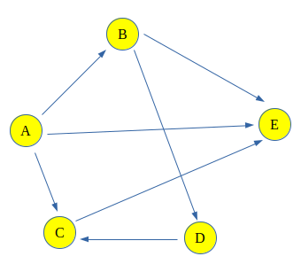

**Input:** Count paths between A and E

**Output :** Total paths between A and E are 4

**Explanation:** The 4 paths between A and E are:

A -> E

A -> B -> E

A -> C -> E

A -> B -> D -> C -> E

**Input :** Count paths between A and C

**Output :** Total paths between A and C are 2

**Explanation:** The 2 paths between A and C are:

A -> C

A -> B -> D -> C

**Algorithm:**

1. Create a recursive function that takes index of node of a graph and the destination index. Keep a global or a static variable count to store the count. Keep a record of the nodes visited in the current path by passing a visited array by value (instead of reference, which would not be limited to the current path).
2. If the current nodes is the destination increase the count.
3. Else for all the adjacent nodes, i.e. nodes that are accessible from the current node, call the recursive function with the index of adjacent node and the destination.
4. Print the Count.

<https://github.com/hareramcse/Datastructure/blob/master/Graph/src/com/hs/introduction/CountPossiblePathBetweenTwoVertex.java>

**Water Jug problem using BFS**

You are given a m liter jug and a n liter jug. Both the jugs are initially empty. The jugs don’t have markings to allow measuring smaller quantities. You have to use the jugs to measure d liters of water where d is less than n.

(X, Y) corresponds to a state where X refers to amount of water in Jug1 and Y refers to amount of water in Jug2   
Determine the path from initial state (xi, yi) to final state (xf, yf), where (xi, yi) is (0, 0) which indicates both Jugs are initially empty and (xf, yf) indicates a state which could be (0, d) or (d, 0).

The operations you can perform are:

1. Empty a Jug, (X, Y)->(0, Y) Empty Jug 1
2. Fill a Jug, (0, 0)->(X, 0) Fill Jug 1
3. Pour water from one jug to the other until one of the jugs is either empty or full, (X, Y) -> (X-d, Y+d)

**Examples:**

Input : 4 3 2

Output : {(0, 0), (0, 3), (3, 0), (3, 3), (4, 2), (0, 2)}

<https://github.com/hareramcse/Datastructure/blob/master/Graph/src/com/hs/introduction/WaterJugProblemUsingBFS.java>

**Count number of trees in a forest**

Given n nodes of a forest (collection of trees), find the number of trees in the forest.  
**Examples :**

Input : edges[] = {0, 1}, {0, 2}, {3, 4}

Output : 2

Explanation : There are 2 trees

0 3

/ \ \

1 2 4

**Approach :**   
1. Apply DFS on every node.   
2. Increment count by one if every connected node is visited from one source.   
3. Again perform DFS traversal if some nodes yet not visited.   
4. Count will give the number of trees in forest.

<https://github.com/hareramcse/Datastructure/blob/master/Graph/src/com/hs/introduction/CountNoOfTreesInForest.java>

**Transpose graph**

[Transpose](https://en.wikipedia.org/wiki/transposeGraph) of a directed graph G is another directed graph on the same set of vertices with all of the edges reversed compared to the orientation of the corresponding edges in G. That is, if G contains an edge (u, v) then the converse/transpose/reverse of G contains an edge (v, u) and vice versa.  
Given a [graph (represented as adjacency list)](https://www.geeksforgeeks.org/graph-and-its-representations/), we need to find another graph which is the transpose of the given graph.

**Example:**

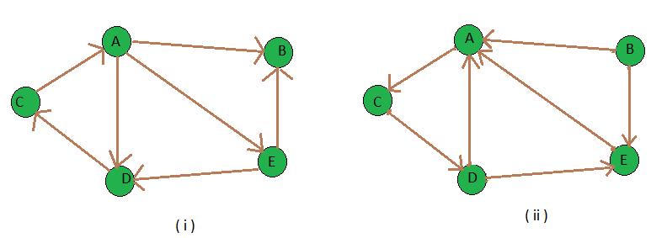

Input : figure (i) is the input graph.

Output : figure (ii) is the transpose graph of the given graph.

We traverse the adjacency list and as we find a vertex v in the adjacency list of vertex u which indicates an edge from u to v in main graph, we just add an edge from v to u in the transpose graph i.e. add u in the adjacency list of vertex v of the new graph. Thus traversing lists of all vertices of main graph we can get the transpose graph. Thus the total time complexity of the algorithm is O(V+E) where V is number of vertices of graph and E is the number of edges of the graph.  
Note : It is simple to get the transpose of a graph which is stored in adjacency matrix format, you just need to get the [transpose](https://www.geeksforgeeks.org/program-to-find-transpose-of-a-matrix/) of that matrix.

<https://github.com/hareramcse/Datastructure/blob/master/Graph/src/com/hs/introduction/Transpose.java>

**Print all paths from a given source to a destination using BFS**

Given a directed graph, a source vertex ‘src’ and a destination vertex ‘dst’, print all paths from given ‘src’ to ‘dst’.

Consider the following directed graph. Let the src be 2 and dst be 3. There are 3 different paths from 2 to 3.

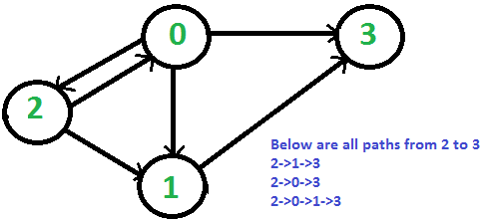

**Algorithm :**

create a queue which will store path(s) of type vector

initialise the queue with first path starting from src

Now run a loop till queue is not empty

get the frontmost path from queue

check if the lastnode of this path is destination

if true then print the path

run a loop for all the vertices connected to the

current vertex i.e. lastnode extracted from path

if the vertex is not visited in current path

a) create a new path from earlier path and

append this vertex

b) insert this new path to queue

<https://github.com/hareramcse/Datastructure/blob/master/Graph/src/com/hs/introduction/PrintAllPathsFromSourceToDestinationUsingBFS.java>

**Print all paths from a given source to a destination**

Given a directed graph, a source vertex ‘s’ and a destination vertex ‘d’, print all paths from given ‘s’ to ‘d’.   
Consider the following directed graph. Let the s be 2 and d be 3. There are 3 different paths from 2 to 3.  
 

1. The idea is to do [Depth First Traversal](https://www.geeksforgeeks.org/depth-first-traversal-for-a-graph/) of given directed graph.
2. Start the DFS traversal from source.
3. Keep storing the visited vertices in an array or HashMap say ‘path[]’.
4. If the destination vertex is reached, print contents of path[].
5. The important thing is to mark current vertices in the path[] as visited also so that the traversal doesn’t go in a cycle.

<https://github.com/hareramcse/Datastructure/blob/master/Graph/src/com/hs/introduction/PrintAllPathsFromSourceToDestinationUsingDFS.java>

**BFS for Disconnected Graph**

In previous [post](https://www.geeksforgeeks.org/breadth-first-traversal-for-a-graph/), BFS only with a particular vertex is performed i.e. it is assumed that all vertices are reachable from the starting vertex. But in the case of disconnected graph or any vertex that is unreachable from all vertex, the previous implementation will not give the desired output, so in this post, a modification is done in BFS.

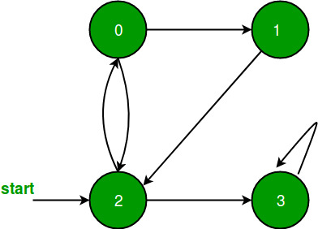

All vertices are reachable. So, for above graph simple [BFS](https://www.geeksforgeeks.org/breadth-first-traversal-for-a-graph/) will work.

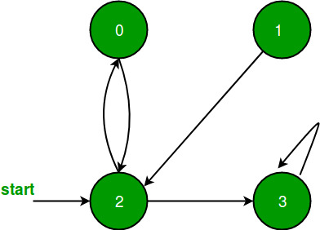

As in above graph a vertex 1 is unreachable from all vertex, so simple BFS wouldn’t work for it.

Just to modify BFS, perform simple BFS from each

unvisited vertex of given graph.

<https://github.com/hareramcse/Datastructure/blob/master/Graph/src/com/hs/introduction/BfsDisconnectedGraph.java>