**Easy**

**232. Implement Queue using Stacks**

**225. Implement Stack using Queues**

**496. Next Greater Element I**

**150. Evaluate Reverse Polish Notation**

**Medium**

**735. Asteroid Collision**

**Abc. Celebrity Problem**

**146. LRU Cache**

**155. Min Stack**

**503. Next Greater Element II**

**901. Online Stock Span**

**402. Remove K Digits**

**Hard**

**84. Largest Rectangle in Histogram**

**460. LFU Cache**

**85. Maximal Rectangle**

**42. Trapping Rain Water**

**Maximum area in histogram:**

**int**[] arr = { 6, 2, 5, 4, 5, 1, 6 };

Array element is nothing but height of the building. Width will be same 1 unit for all building.

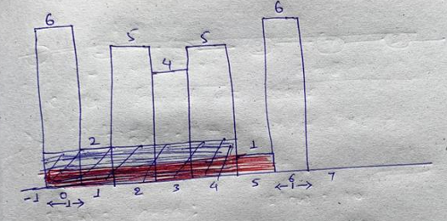

We need to find out maximum area by the rectangle.

**Solution:**

We can expand the rectangle iff height of the next smaller building height is greater than current element. Once we get the next smaller left and next smaller right we stop expanding the rectangle.

For NSL if we don’t find any smaller element in left then we can think of that at -1 index there is building with height 0. So we will put index of this building that is -1

For NSR if we don’t find any smaller element in right then we can assume that input.length index there is a building with height 0. So we will put index of this building that is input.length;

In the above example 2nd element is 2 so we check left and right of the 2 and find NSL, NSR

NSL = -1

NSR = 1 ( index of 1 is 5)

Width of the rectangle will be ( as we can see in the above image) this 5 will come by doing

width[i] = NSR[i] - NSL[i] - 1;

width of the 2 will 5 – ( -1 ) – 1 = 5

So area of element 2 histogram will be 5 * 2 = 10

Similarly do the same operation for each element and find the max area.

**Max Rectangle area in binary matrix:**

**char**[][] matrix = { { '0', '1', '1', '0' },

{ '1', '1', '1', '1' },

{ '1', '1', '1', '1' },

{ '1', '1', '0', '0' } };

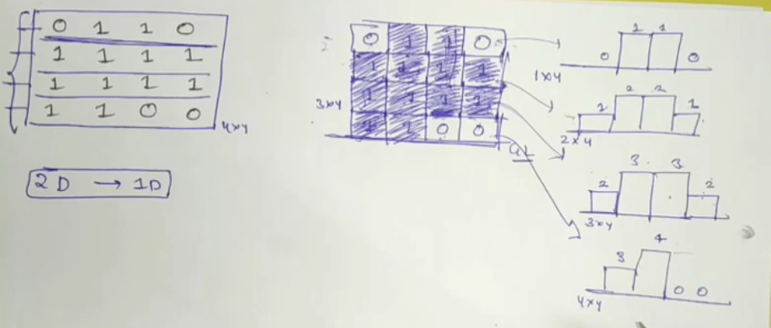

So now this binary matrix is converted into 4 histograms. Max area of binary matrix will be the max area from all these 4 histograms.

For this first we find out the histogram for the 1st row.

**int** result = maxHistogram(matrix[0]);

Then we iterate from the 2nd row and add the element if element == 1 and after adding the elements we need to find out MAH on this 2nd row elements…and so on

**for** (**int** i = 1; i < row; i++) {

**for** (**int** j = 0; j < column; j++) {

**if** (matrix[i][j] == 1)

matrix[i][j] += matrix[i - 1][j];

}

result = Math.*max*(result, maxHistogram(matrix[i]));

}

**Rain Trapping problem:**

**int**[] arr = { 6, 2, 5, 4, 5, 1, 6 };

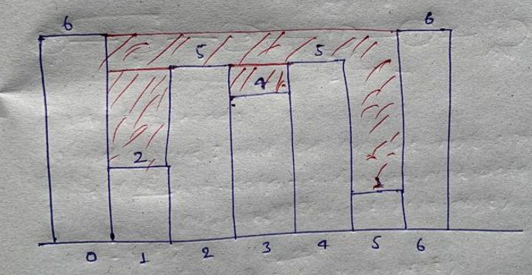

Here we need to find out the total amount of water stored in between buildings.

Here we need to find out max value in left and right for each building.

Once we find max from left and right we need to find min from this left and right because water amount will depend on min building height only. and amount of water for each building will be total amount of water on that building – building height

Eg:

For building 2, max value in left = 6 and max value in right = 6

So min of(6, 6) is 6

So height of water is 6 – 2(height of building)

And in last sum up all the amount of water and return the result.