1. Go to docker\sharding and open git bash
   1. Run the command bash build_and_run_db.bash, it will run the postgres db with 3 shards



* 1. Run the command docker exec -it postgres-shard-0 psql -U postgres to go inside postgres pod
  2. Run the command select count(*) from todo;

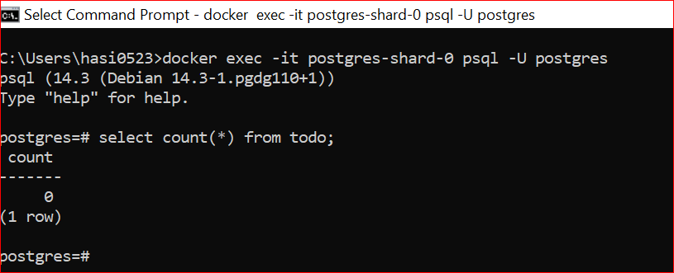

Similarly connect to all the shards in three command prompt.

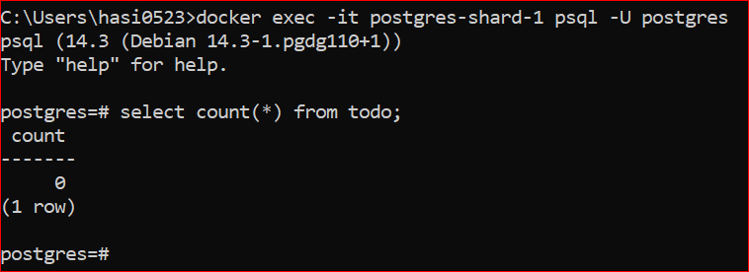

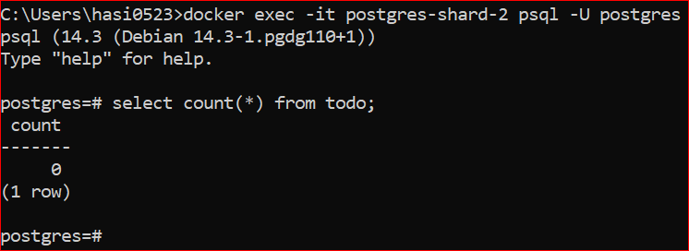

Now run the ShardingApp main method

It will insert 100000 record to these shards.

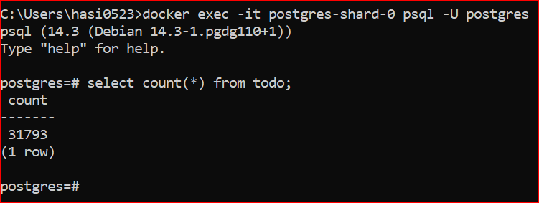

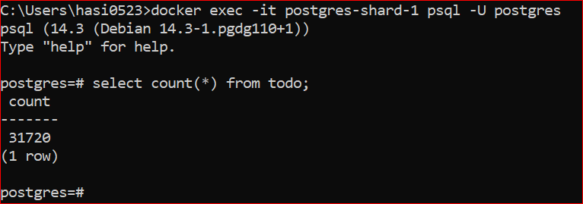

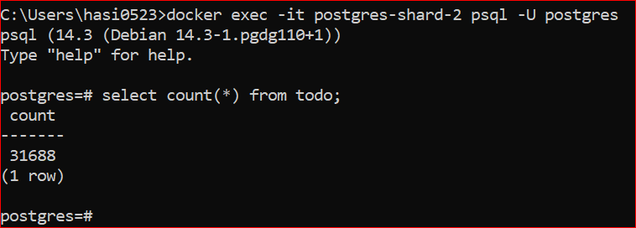

Here we can see 100000 data is sharded into 3 shard.

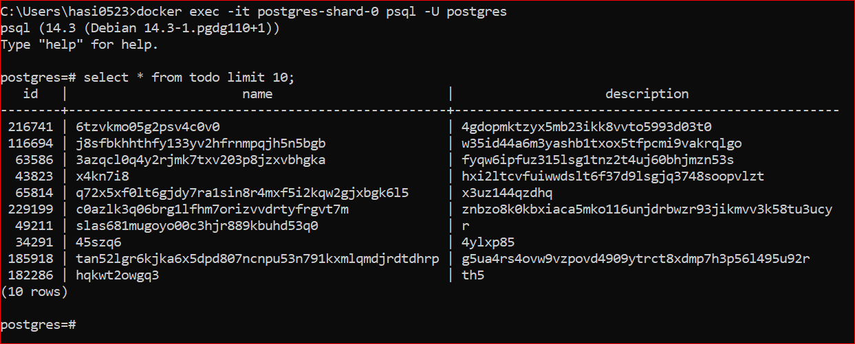

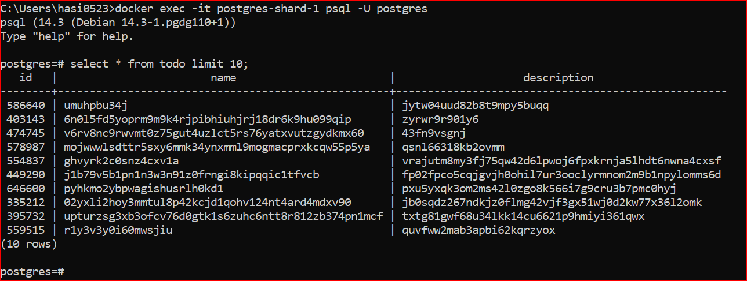

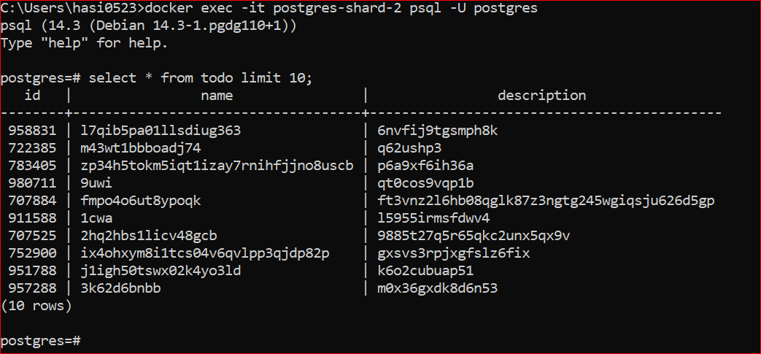

Here we can see Id is different in each shard

Data feed is done now….let get the id and check from which shard data is coming.

Just comment the data insertion part of the code in main method and re-run main method

