10. Scenario: You are working on a data visualization project and need to create basic plots using Matplotlib. You have a dataset containing the monthly sales data for a company, including the month and corresponding sales values. Your task is to develop a Python program that generates line plots and bar plots to visualize the sales data. Question: 1. How would you develop a Python program to create a line plot of the monthly sales data? 2: How would you develop a Python program to create a bar plot of the monthly sales data?--for this

CODE:

import pandas as pd

import matplotlib.pyplot as plt

data = pd.read_excel(r"C:\Users\hares\Downloads\q10_30.xlsx")

df = pd.DataFrame(data)

plt.figure(figsize=(10, 5))

plt.plot(df['Month'], df['Sales'], marker='o', color='blue', linestyle='-')

plt.title('Monthly Sales - Line Plot')

plt.xlabel('Month')

plt.ylabel('Sales')

plt.grid(True)

plt.xticks(rotation=45)

plt.tight_layout()

plt.show()

plt.figure(figsize=(10, 5))

plt.bar(df['Month'], df['Sales'], color='green')

plt.title('Monthly Sales - Bar Plot')

plt.xlabel('Month')

plt.ylabel('Sales')

plt.xticks(rotation=45)

plt.tight_layout()

plt.show()

output :

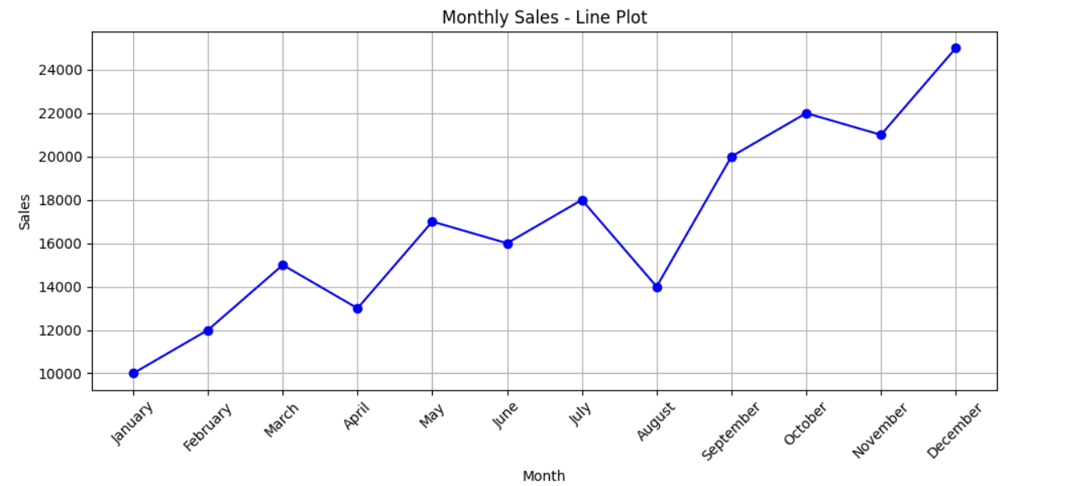

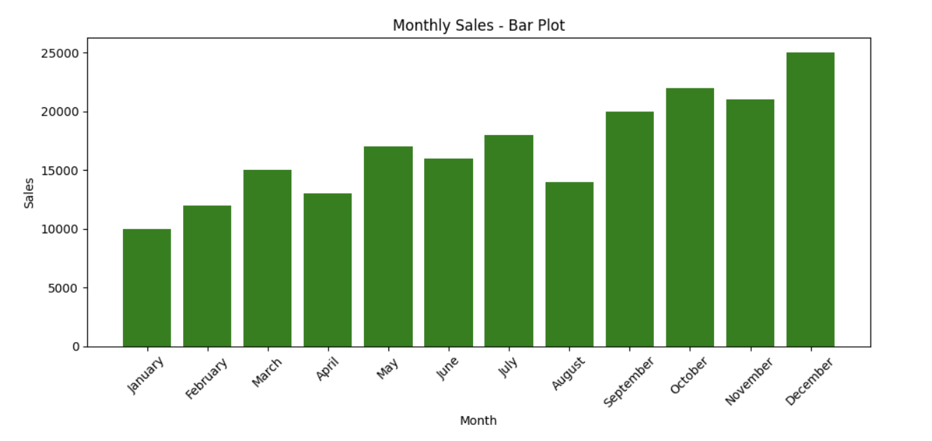

Dataset :

| **Month** | **Sales** |
| --- | --- |

|  |  |
| --- | --- |
| January | 10000 |

|  |  |
| --- | --- |
| February | 12000 |

|  |  |
| --- | --- |
| March | 15000 |

|  |  |
| --- | --- |
| April | 13000 |

|  |  |
| --- | --- |
| May | 17000 |

|  |  |
| --- | --- |
| June | 16000 |

|  |  |
| --- | --- |
| July | 18000 |

|  |  |
| --- | --- |
| August | 14000 |

|  |  |
| --- | --- |
| September | 20000 |

|  |  |
| --- | --- |
| October | 22000 |

|  |  |
| --- | --- |
| November | 21000 |

|  |  |
| --- | --- |
| December | 25000 |