11. Scenario : You are a data scientist working for a company that sells products online. You have

been tasked with creating a simple plot to show the sales of a product over time.

Question:

1. Write code to create a simple line plot in Python using Matplotlib to predict sales happened in a

month?

2. Write code to create a scatter plot in Python using Matplotlib to predict sales happened in a

month?

3. Develop a Python program to create a bar plot of the monthly sales data

Code:

#11

import pandas as pd

import matplotlib.pyplot as plt

df = pd.read_excel(r"C:\Users\hares\Downloads\q10_30.xlsx")

# Extract data

months = df['Month']

sales = df['Sales']

plt.figure(figsize=(12, 10))

plt.subplot(3, 1, 1)

plt.plot(months, sales, marker='o', color='blue')

plt.title('Monthly Sales Trend (Line Plot)')

plt.xlabel('Month')

plt.ylabel('Sales')

plt.grid(True)

plt.subplot(3, 1, 2)

plt.scatter(months, sales, color='green')

plt.title('Monthly Sales (Scatter Plot)')

plt.xlabel('Month')

plt.ylabel('Sales')

plt.grid(True)

plt.subplot(3, 1, 3)

plt.bar(months, sales, color='orange')

plt.title('Monthly Sales (Bar Plot)')

plt.xlabel('Month')

plt.ylabel('Sales')

plt.tight_layout()

plt.show()

output :

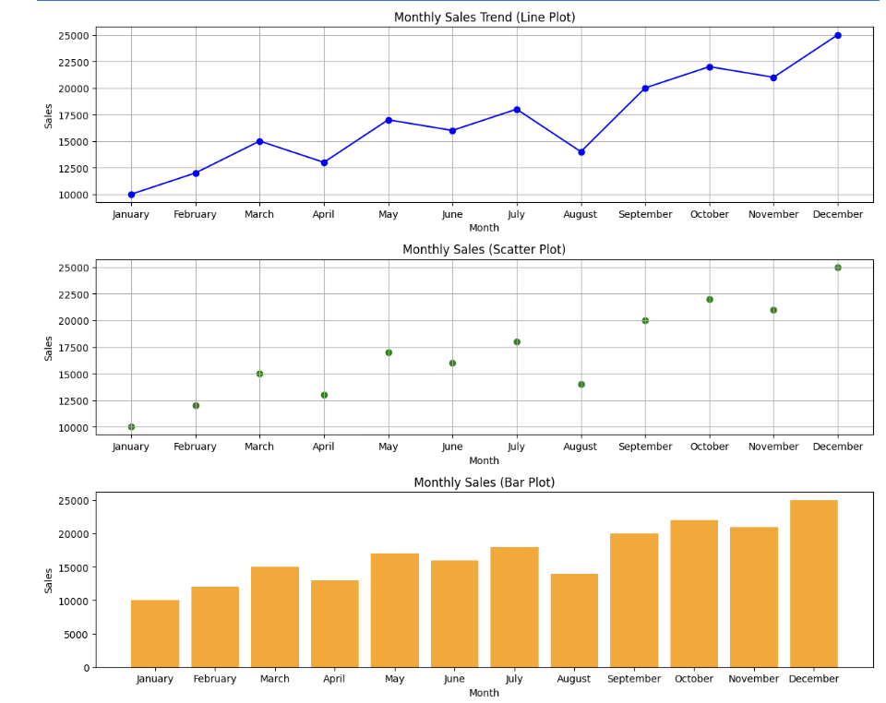

Dataset:

|  |  |
| --- | --- |
| **Month** | **Sales** |
| January | 10000 |
| February | 12000 |
| March | 15000 |
| April | 13000 |
| May | 17000 |
| June | 16000 |
| July | 18000 |
| August | 14000 |
| September | 20000 |
| October | 22000 |
| November | 21000 |
| December | 25000 |