23.Scenario:

You are a researcher working in a medical lab, investigating the effectiveness of a new treatment

for a specific disease. You have collected data from a clinical trial with two groups: a control group

receiving a placebo, and a treatment group receiving the new drug.Your goal is to analyze the data

using hypothesis testing and calculate the p-value to determine if the new treatment has a

statistically significant effect compared to the placebo. You will use the matplotlib library to

visualize the data and the p-value.

Code :

#23

import pandas as pd

import scipy.stats as stats

import matplotlib.pyplot as plt

# Function to perform hypothesis testing and calculate p-value

def hypothesis_testing(control_group, treatment_group, alpha=0.05):

# Perform a two-sample t-test

t_stat, p_value = stats.ttest_ind(control_group, treatment_group)

# Determine if the p-value is less than the significance level (alpha)

if p_value < alpha:

result = "Reject Null Hypothesis (significant effect)"

else:

result = "Fail to Reject Null Hypothesis (no significant effect)"

return p_value, result

# Main function

def main():

# Load data from an Excel file (replace 'data.xlsx' with your actual file path)

# Assuming the Excel file has columns: 'Placebo' for control group and 'Treatment' for the treatment group

data = pd.read_excel(r"C:\Users\hares\Downloads\q23_05.xlsx") # Replace with your file path

# Extract data for control (placebo) and treatment groups

control_group = data['Placebo'].dropna() # Drop any missing values

treatment_group = data['Treatment'].dropna() # Drop any missing values

# Perform hypothesis testing

p_value, result = hypothesis_testing(control_group, treatment_group)

# Output p-value and result of the hypothesis test

print(f"P-value: {p_value:.4f}")

print(f"Result: {result}")

# Visualizing the data with a boxplot

data_to_plot = [control_group, treatment_group]

group_names = ['Placebo', 'Treatment']

plt.figure(figsize=(8, 6))

plt.boxplot(data_to_plot, vert=True, patch_artist=True, labels=group_names)

plt.title('Comparison of Control (Placebo) vs Treatment Groups')

plt.ylabel('Effectiveness Measure (e.g., Blood Pressure Reduction)')

plt.show()

if __name__ == "__main__":

main()

output :

P-value: 0.0000

Result: Reject Null Hypothesis (significant effect)

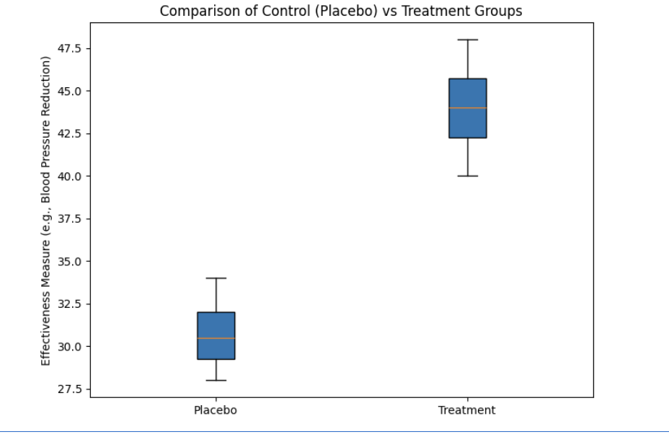

Dataset :

|  |  |
| --- | --- |
| **Placebo** | **Treatment** |
| 30 | 40 |
| 32 | 42 |
| 29 | 41 |
| 31 | 44 |
| 28 | 43 |
| 33 | 45 |
| 34 | 48 |
| 29 | 46 |
| 30 | 44 |
| 32 | 47 |