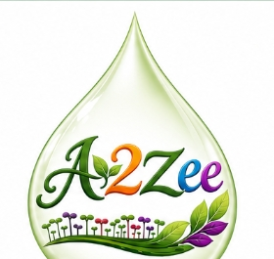 | A2Zee Microgreenz Pvt. Ltd.  No. 1, Sivaswamy Avenue, MGR Salai, Palavakkam, Chennai - 600041  Phone / WhatsApp: +91 73388 40084  FSSAI Lic No: 22426550001482 | INVOICE  ORGANIC SOIL-LESS HYDROPONIC SUPERFOODS

BILL TO  The Brews Brother  D4, MGR Salai, Palavakkam, Chennai - 600041  GST: 33AAQFT9606F1ZW | Invoice #: A2Z-1001  Invoice Date: 24/08/2026  Due Date: 31/08/2026  Payment Terms: Due within 7 days

QTY | DESCRIPTION | UNIT PRICE | UNIT | AMOUNT (₹)
5 | Organic Mustard Microgreens (50 gms box) | ₹ 75.00 | boxes | ₹ 375.00
1 | Organic Mung Sprouts | ₹ 350.00 | Kg | ₹ 350.00

 | Subtotal
 | ₹ 725.00
 | TOTAL | ₹ 725.00

TERMS & CONDITIONS
Payment is due within 7 days of invoice date.
Please make payments to A2Zee Microgreenz Pvt. Ltd. via bank transfer or UPI.

Thank you for supporting fresh, organic microgreens!

