Drupal LMS Chabot’s

User Section –

When bot is initiate, that time show welcome message as well as show search categories, this category configure by admin.

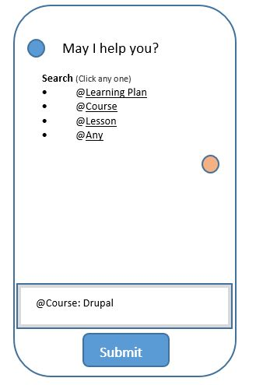

Then user click any one search category and type search course/learning plan/lesson/any name. (See above screen)

@Any – User can be search anything (like LMS content or 3rd party content (courses)).

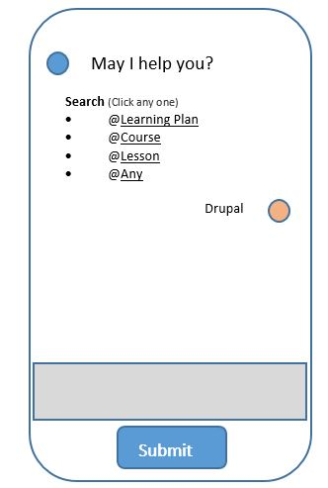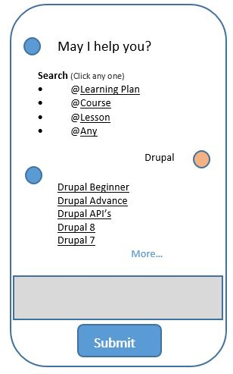

Admin Section

* Admin can set search category type like
  + Learning Plan
  + Course
  + Lesson

**Category**

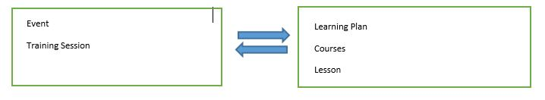

**Example** (Admin Configuration)

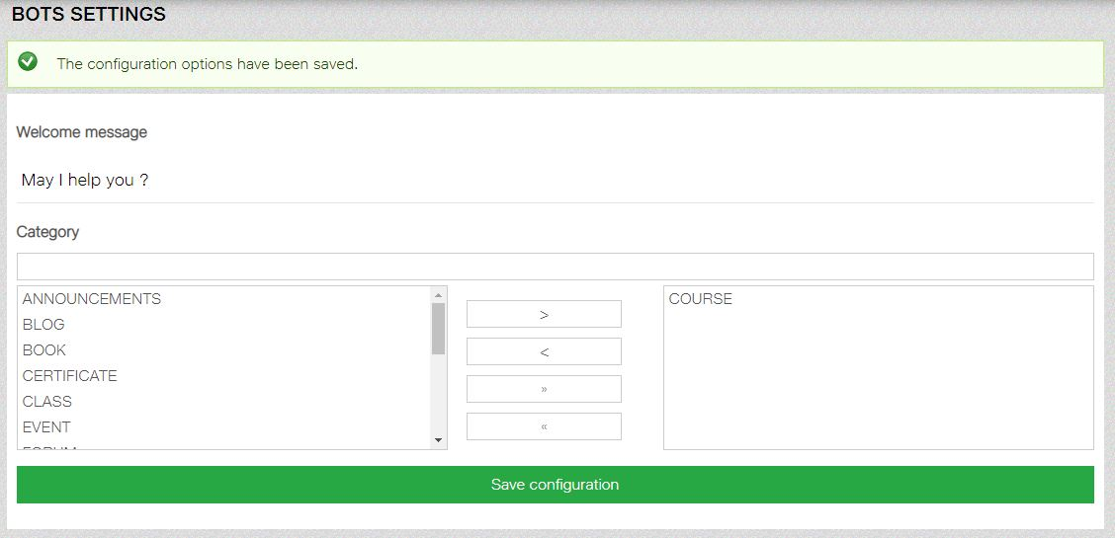

**Welcome API**

**API** [**URL:-**](URL:-) Base_url/chatbots/api/bots/welcome.json

**Endpoint:-** chatbots/api

**Header:-** content-type: application/json

**Methods:-** POST

**Output Json:-** {"status":200,"message":"Bots Data Successfully retrieved","data":{"welcome_msg":"May I help you ?","category":{"CLASS":"CLASS","COURSE":"COURSE"}}}

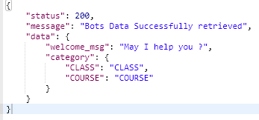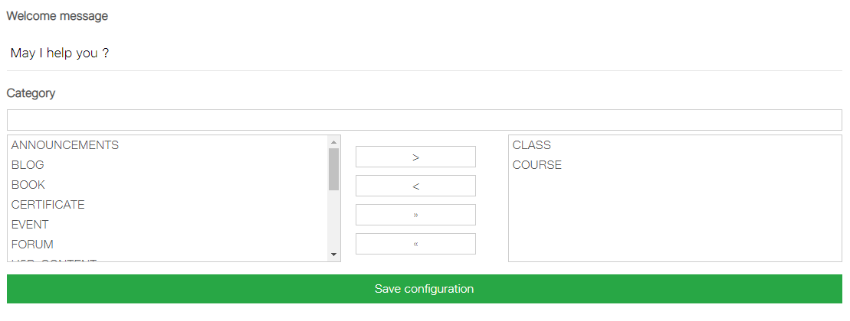

**User Request**

**API** [**URL:-**](URL:-) Base_url/chatbots/api/bots/request_data.json

**Endpoint: -** chatbots/api

**Header: -** content-type: application/json

**Methods: -** POST

**Body Type : -** row

**Post Data: -** {"user_request":{"uid":"1", "user_input": "Jio Store", "category": "course"}}

**Output:-**

