DIGITAL LOGIC DESIGN (ECN -104)

**AC REMOTE CONTROL DEVICE**

AC REMOTE CONTROL IMPLEMENTATION IN VHDL

horizontal line

# 

_______________________________________________________________________________________________

Akash Gupta [15114004]

Haresh Khanna [15114031]

Harjot Singh Oberai [15114032]

Ketan Gupta [15114039]

Piyush Mehrotra [15114050]

# 

# 

# Introduction

This project focuses on doing temperature and fan speed regulation of a centralised whether conditioner through a control panel with 5 buttons that are respectively: temperature up, temperature down, fan speed up, fan speed down and reset.

## Implementation

In this project, we design an AC controller with 5 inputs that are: temperature up, temperature down, fan up, fan down and reset. Temperature up button increments the temperature by 1 and temperature down button decrements the temperature by 1. High voltage that is logic 1 is assigned for the pressed button which implies that low voltage that is logic 0 is assigned for off state. The same assignment is applicable for fan control buttons. High Voltage input for reset input assigns default value for temperature and Fan speed. There are two outputs: temperature and fan speed. Output of temperature is provided in 6 bits whereas output of fan speed is given in 2 bits. Circuit design is laid on the logic that Temperature and Fan controllers use an incrementer and a decrementer (each individually). The incrementer has 2 inputs. One input says if the stored value has to be incremented or not and the other input carries the stored value of temperature. The same applies for Fan Speed Controller. Storage of temperature and fan control settings requires the use registers or small memory banks.

Reset logic can be seen in the code that it assigns the default value to temperature and fan controller. The default value of temperature is 25 degrees celsius and that of Fan’s speed is 2(medium). Use of Reset logic makes a circuit less prone to a bug or a malfunctioning. Every time some bad thing happens, the settings reset themselves to assigned default values. Also whenever the Air Conditioner starts, it initialises all the variables to their initial values that are their reset values.

### Future Prospects

The project can be further continued for the addition of various other functions. Some other function can be: Humidity controls, Some predefined user friendly key buttons like sleep mode, chill mode, etc. which can have some stored predefined values which can be further assigned by the same logic.

The idea can be further implemented for the construction of smart homes where one can control all the curtains, windows, doors, lights, whether conditioner settings at one or multiple controllers mounted at various rooms of a house.

**Github Link**

<https://github.com/hareshkh/VHDL-Project>

**Screenshots**

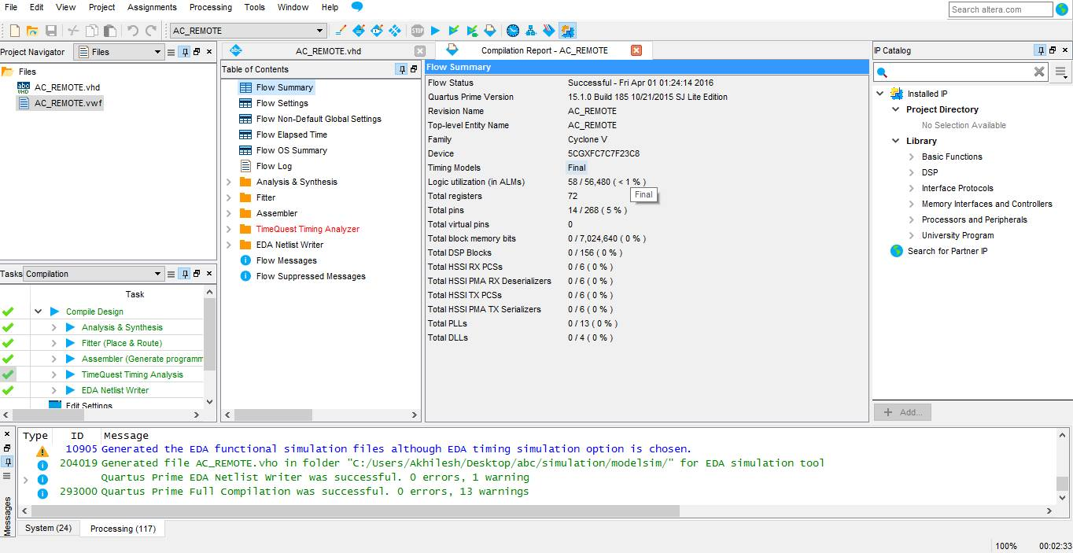

Compilation Report

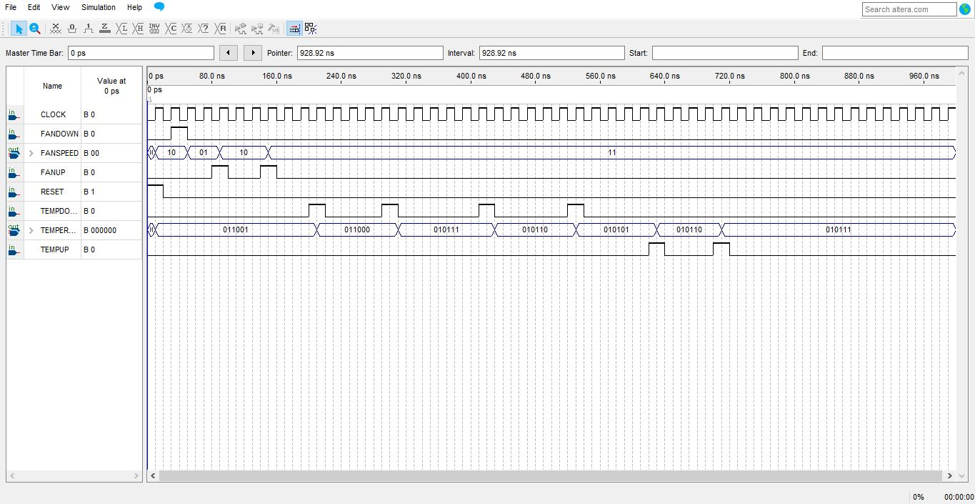

Vector Waveform

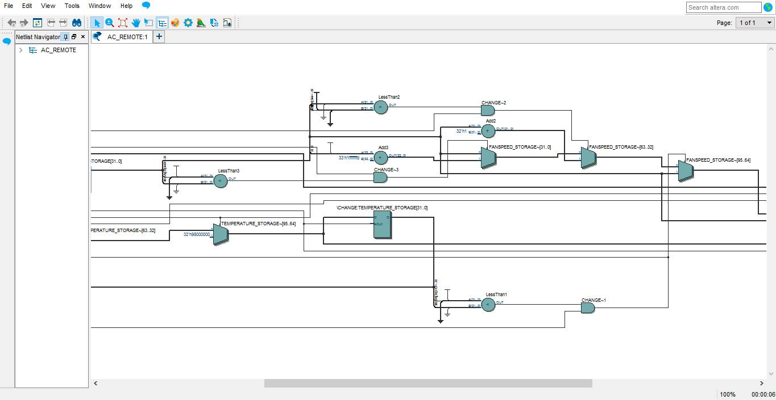

RTL View (Zoomed in)

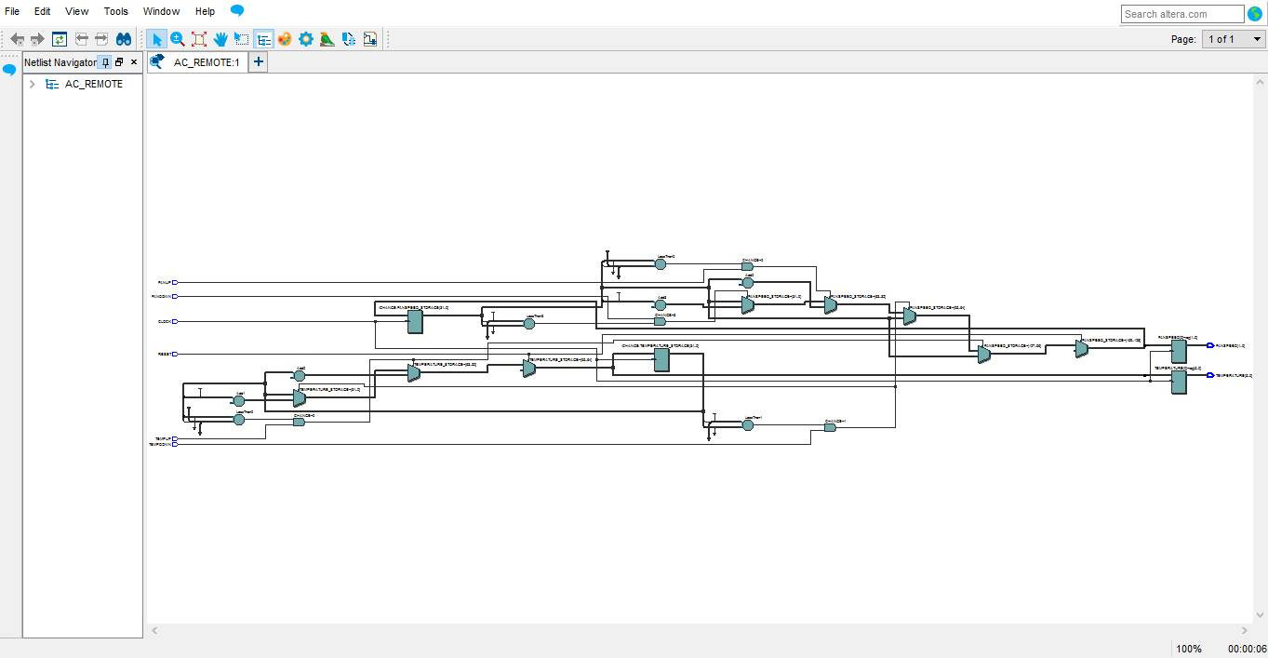

RTL View