Lab Exercise-(20/8/2020)
JavaScripts Objects-Basics(Arrays, Strings, Date,Math)

1. Following is the sample table of contents for a book
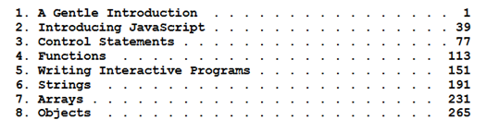
Define a function that takes as inputs chapter title and the page number on which that chapter begins.
Your function should return a string or display as an entry for the table of contents. Number of Chapters to display at the minimum is 3. Make sure that the chapter title and page numbers witl dots are aligned properly.

2. Using JS date, simulate and display the date and time in digital format. As an example(sample)
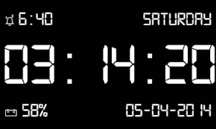
Also include options for Alarm and stopwatch.. Design of digital clock and option display is left to the programmers creativity.

3. Using JavaScript arrays and Math do the following. Assume there are 5 players each with different character role to play. The players are chosen randomly with their numbers from 1 to 5. The role they play is display with text and an image. Run for 10 trails and list the frequency of each player.

