Lab Exercise-(27/8/2020)
JavaScripts Objects and Form Validation

1. Following is the sample table of contents for a book
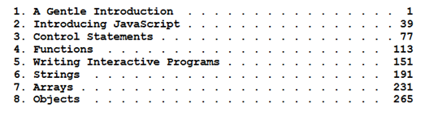
Define a function that takes as inputs chapter title and the page number on which that chapter begins.
Your function should return a string or display as an entry for the table of contents. Number of Chapters to display at the minimum is 3. Make sure that the chapter title and page numbers witl dots are aligned properly.

2. Perform form validation using javascript for the following
a. Accept input field to contain hyphens only and alphanumeric values.
b. Validate a drop down lists with single and multiple selections
c. Validate a check box whether it is checked or not
d. Display the value selected by the Radio buttons
e. Password validation using Regular expressions.
f. Date(dd/mm/yyyy) and Time format(15:30 or 03:30 pm) using regular expressions

