EDMLDS - C4 - Regularisation Assignment - Final Submission (HarGagan Sahai)

Data Understanding
  - Data Loading
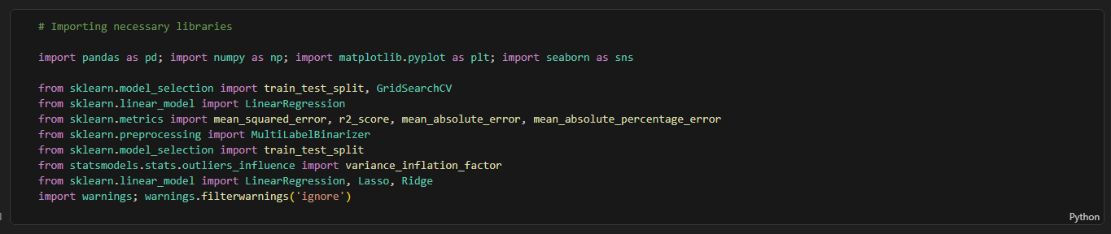

    - Load the dataset
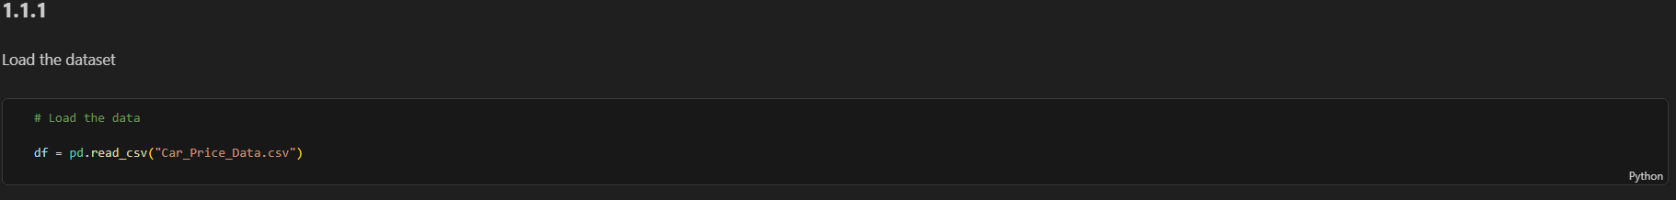
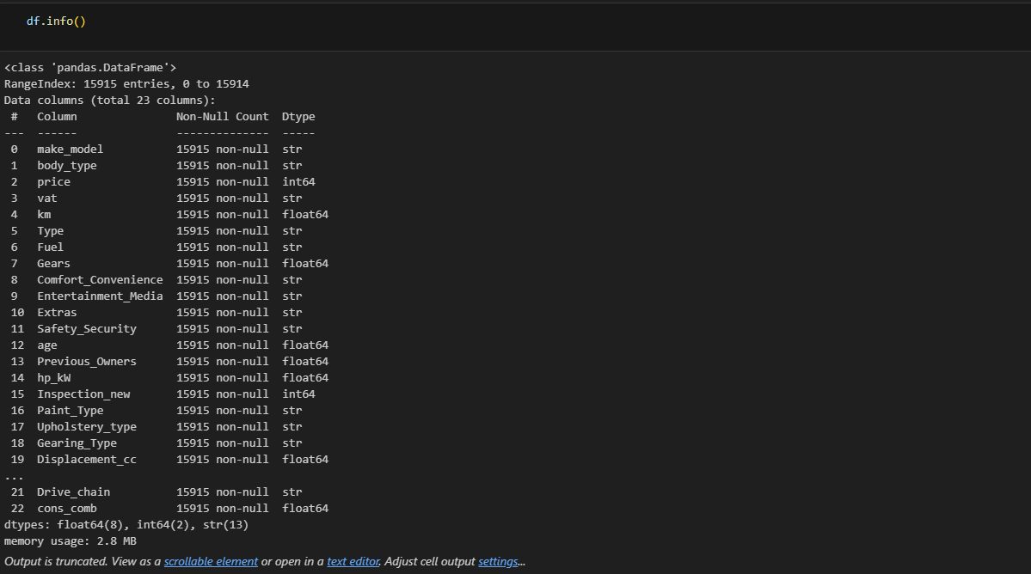

Changed the columns to lowercase for ease of access later.

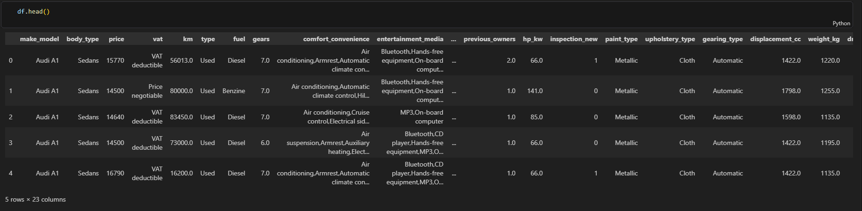

- Analysis and Feature Engineering
  - Preliminary Analysis and Frequency Distributions
    - Check and fix missing values

    - Identify numerical predictors and plot their frequency distributions

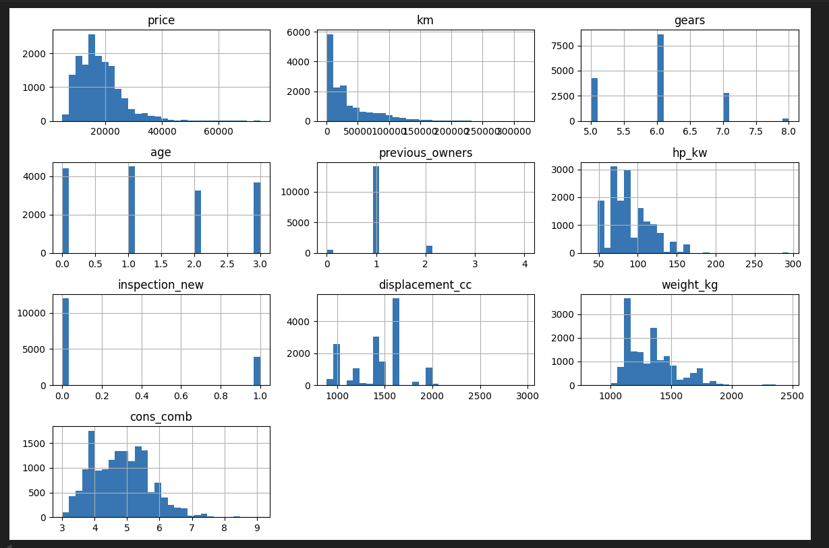
    - Identify categorical predictors and plot their frequency distributions
The categorical columns are identified here. These are :
'make_model', 'body_type', 'vat', 'type', 'fuel', 'comfort_convenience', 'entertainment_media', 'extras', 'safety_security', 'paint_type', 'upholstery_type', 'gearing_type', 'drive_chain'
Individual frequency distribution of these columns –
For ‘make model’ -
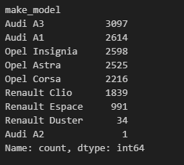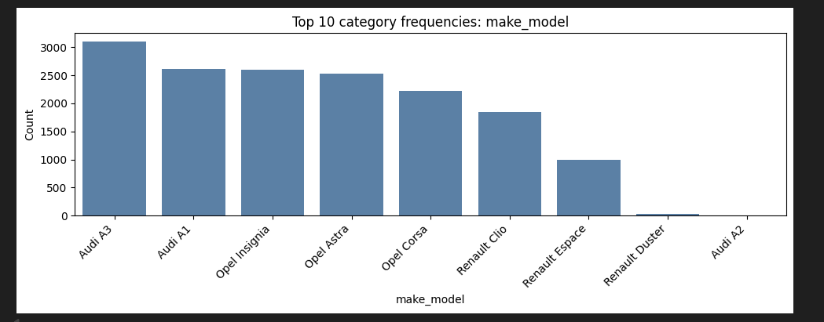

For body_type:
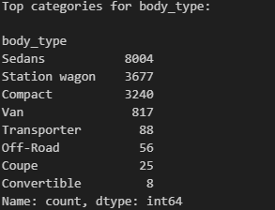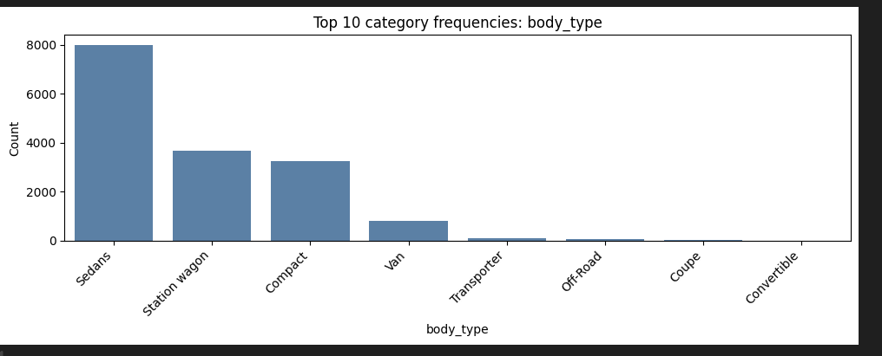

For Vat:
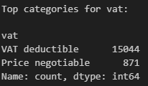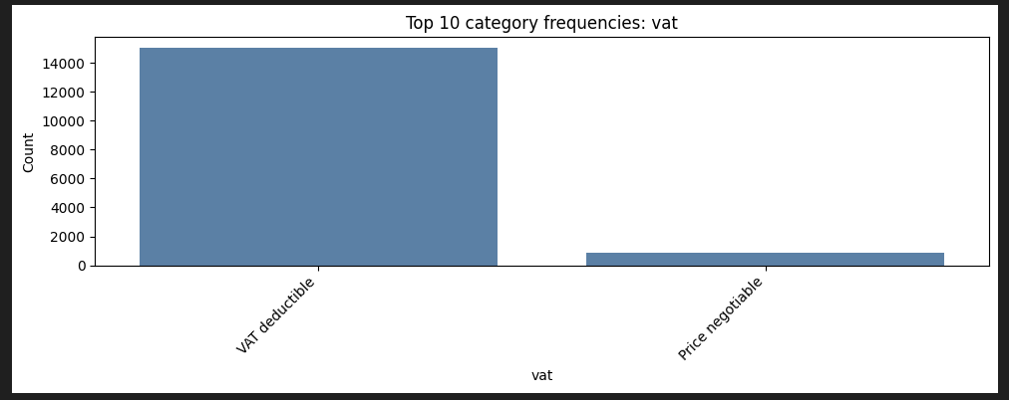
For Type:
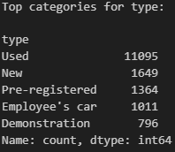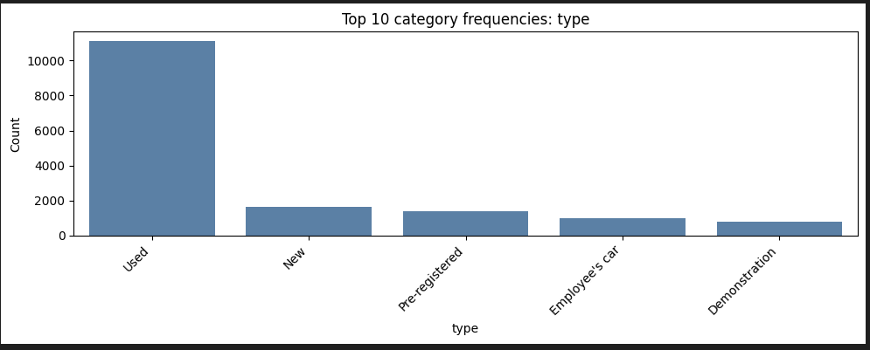

For Fuel:
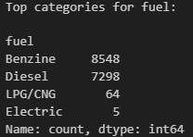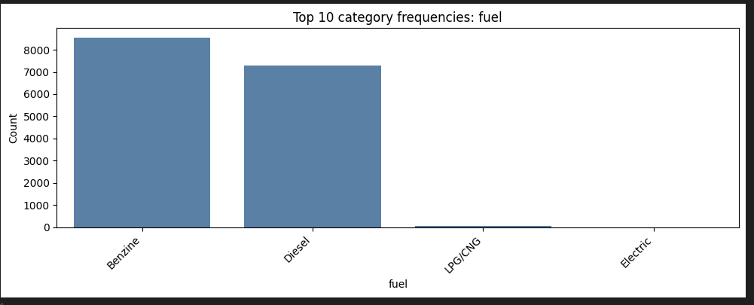

For comfort_convenience:
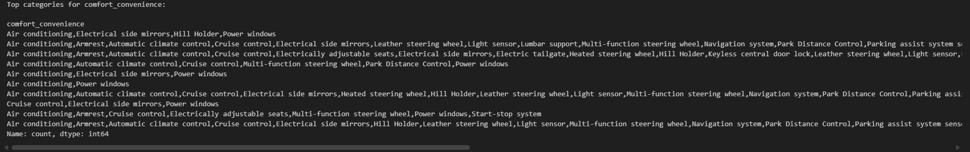
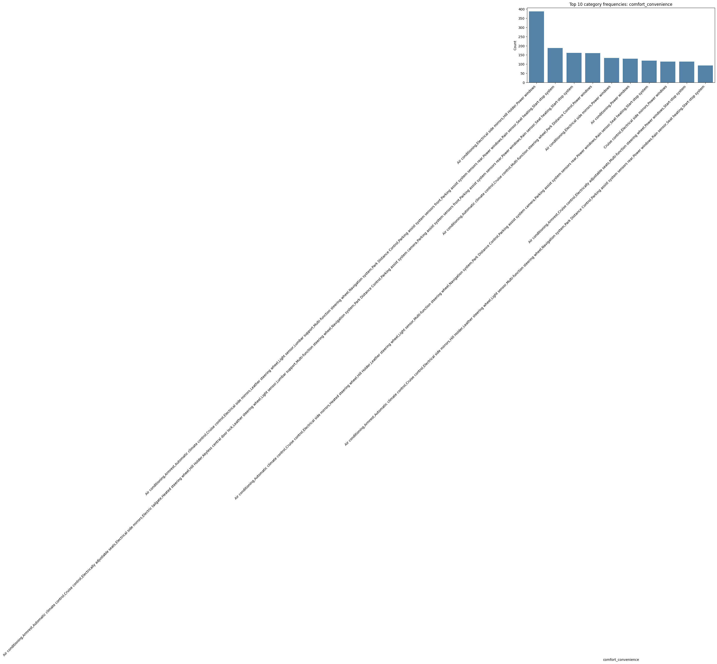

For entertainment_media:

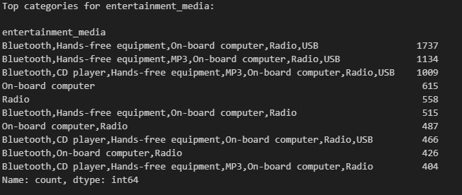

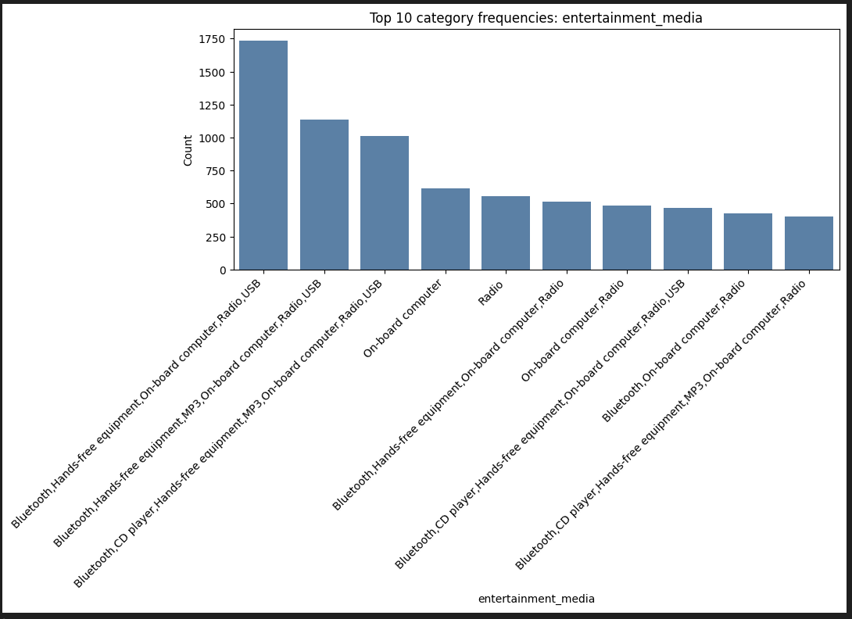

For extras:
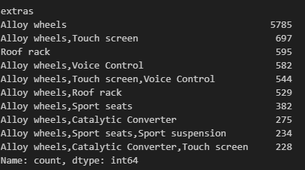
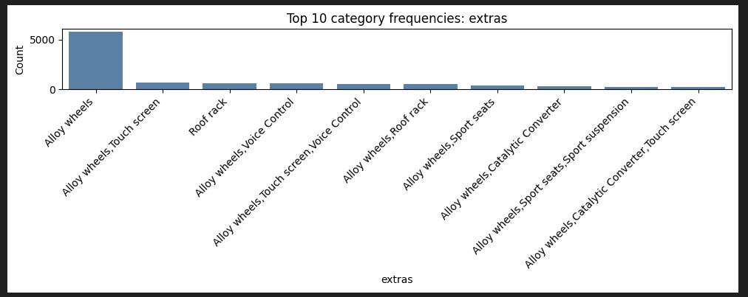

For safety_security:
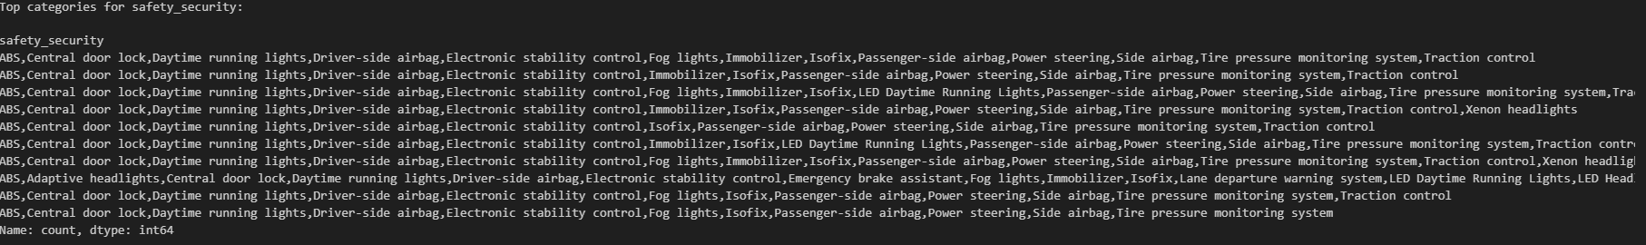

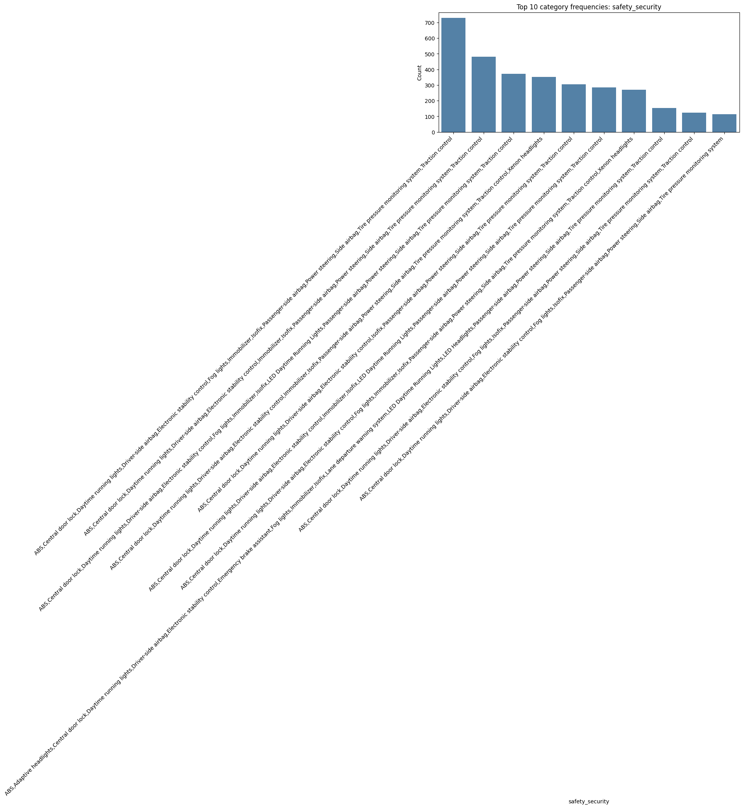

For paint_type:

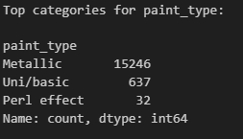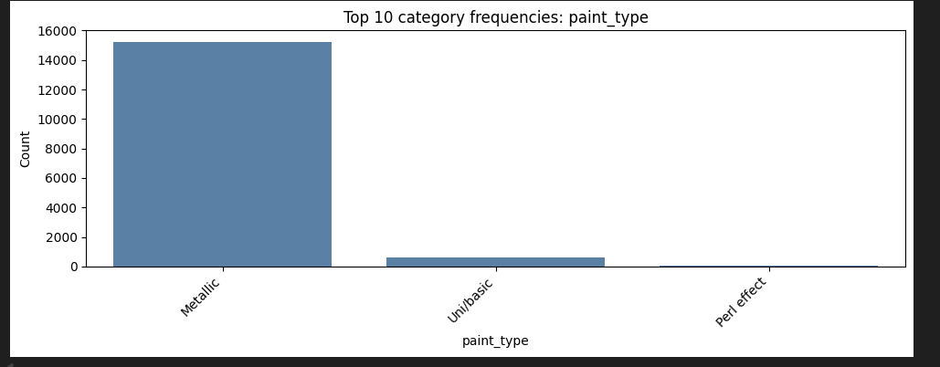

For upholstery_type

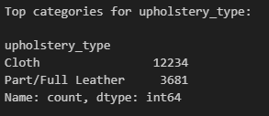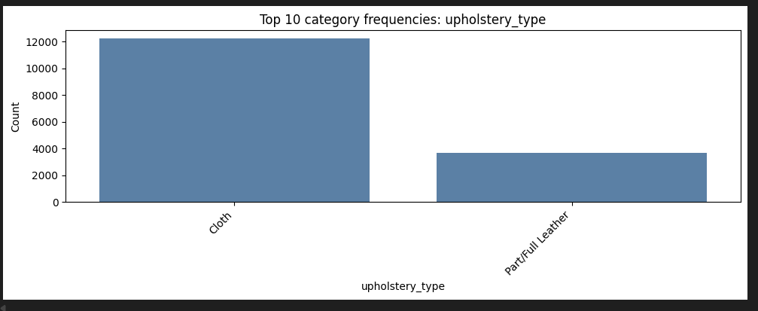

For gearing_type:

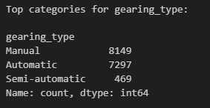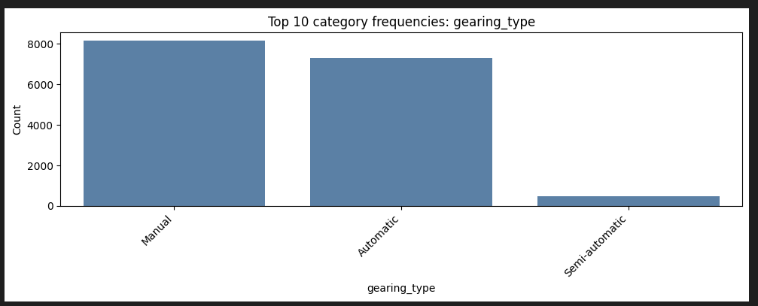

For drive_chain:
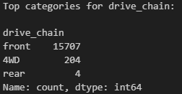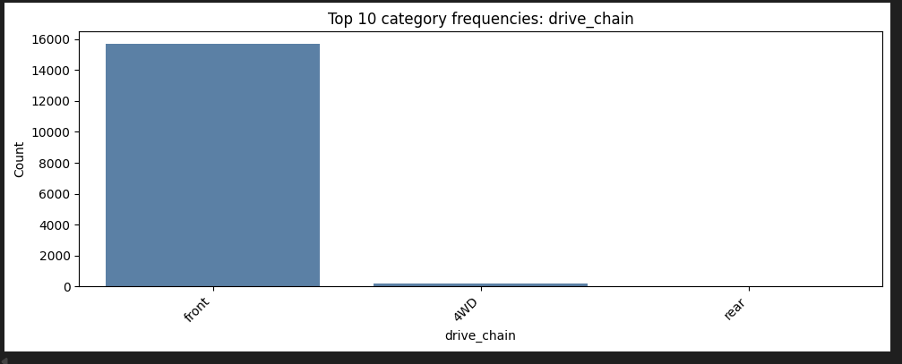

For features comfort_convenience, entertainment_media, extras, and safety_security, analyzed their individual entries and got frequency of each feature inside the multi-valued column entries:
Top 10 individual features count for comfort_convenience:
- Air conditioning 15095
- Power windows 14756
- Electrical side mirrors 12488
- Multi-function steering wheel 11744
- Cruise control 11622
- Park Distance Control 10655
- Parking assist system sensors rear 10086
- Leather steering wheel 9735
- Start-stop system 9455
- Automatic climate control 9197

Top 10 individual features count for entertainment_media:
- On-board computer 13222
- Radio 13196
- Bluetooth 12685
- Hands-free equipment 10371
- USB 9019
- MP3 6258
- CD player 5024
- Sound system 2244
- Digital radio 2241
- Television 39
Top 10 individual features count for ‘extras’:
- Alloy wheels 13994
- Voice Control 4338
- Touch screen 4050
- Sport seats 3104
- Roof rack 3053
- Catalytic Converter 2262
- Sport suspension 1622
- Sport package 1201
- Trailer hitch 658
- Shift paddles 508
Top 10 individual features count for safety_security:
- ABS 15022
- Driver-side airbag 14801
- Power steering 14489
- Passenger-side airbag 14333
- Electronic stability control 14077
- Side airbag 13998
- Central door lock 13575
- Isofix 12689
- Traction control 11845
- Tire pressure monitoring system 11577
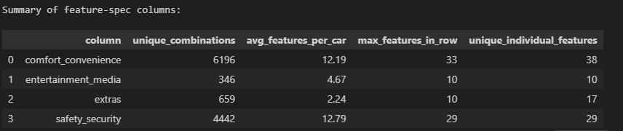

    - Fix columns with low frequency values and class imbalances
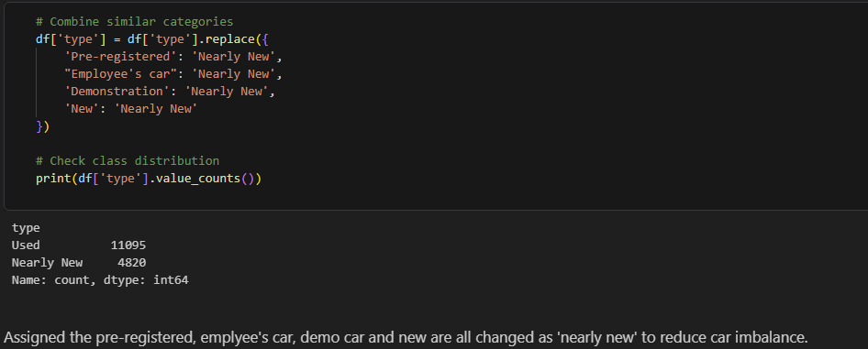

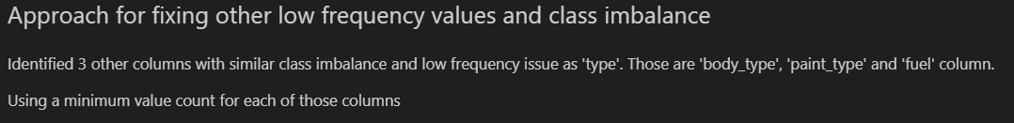
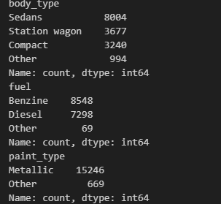

    - Identify target variable and plot the frequency distributions. Apply necessary transformations.
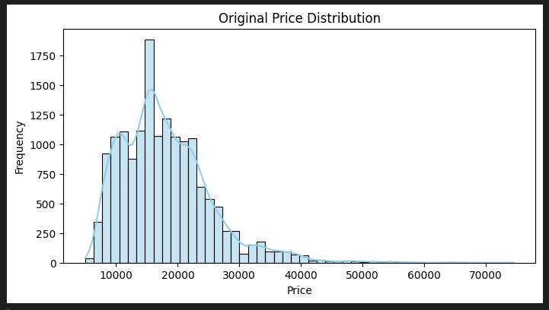

Above graph shows price is pretty skewed, with most of them falling in the range of 10k to 40k.

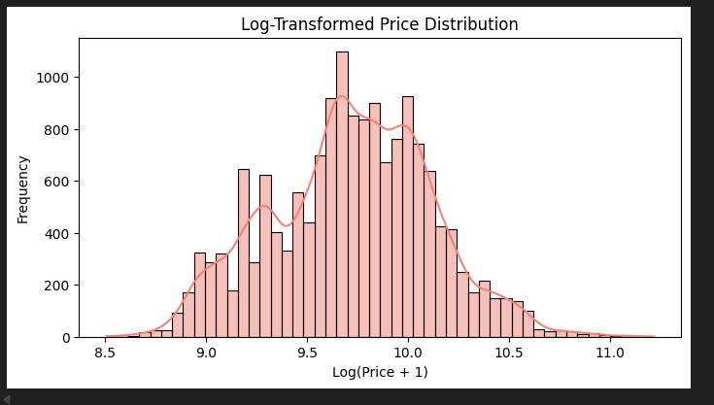
Log transformation applied to reduce the skewedness and it look much more normalized now. Using that feature (price_log) in further analysis as target feature.

  - Correlation analysis
    - Plot the correlation map between features and target variable
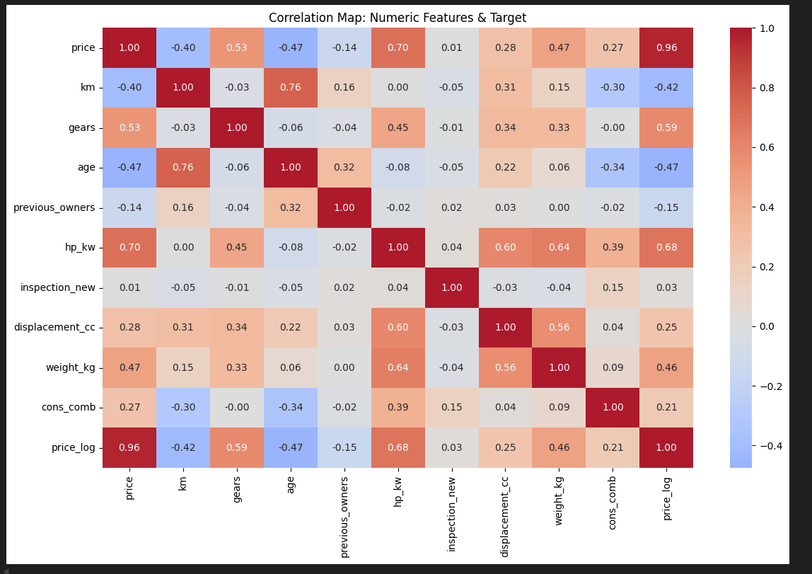
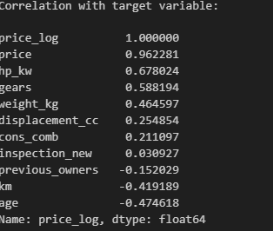

    - Analyse correlation between categorical features and target variable
Considering the target variable as price_log, correlation analysis between other categorical features with that is given below:
For price_log vs make_model:
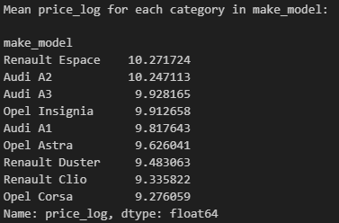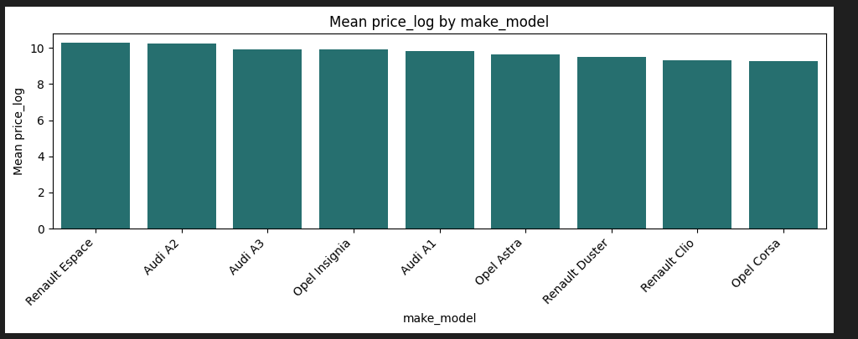

For price_log vs body_type:
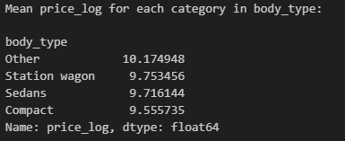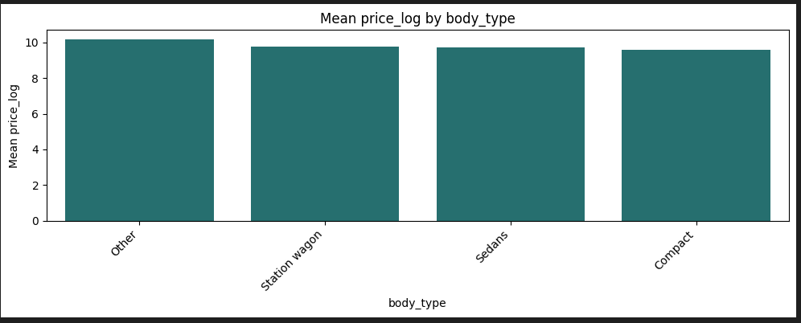

For price_log vs vat:
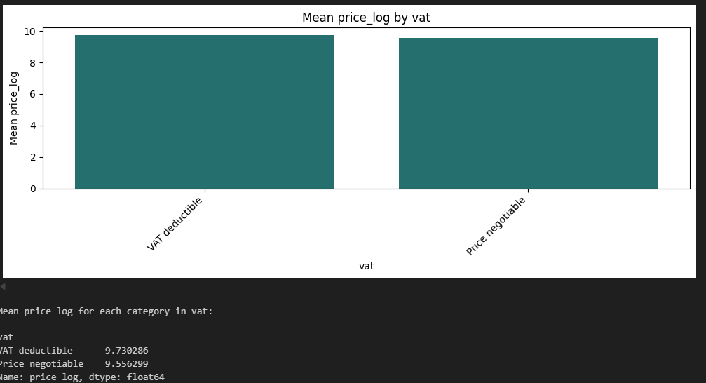

For price_log vs type (condition):
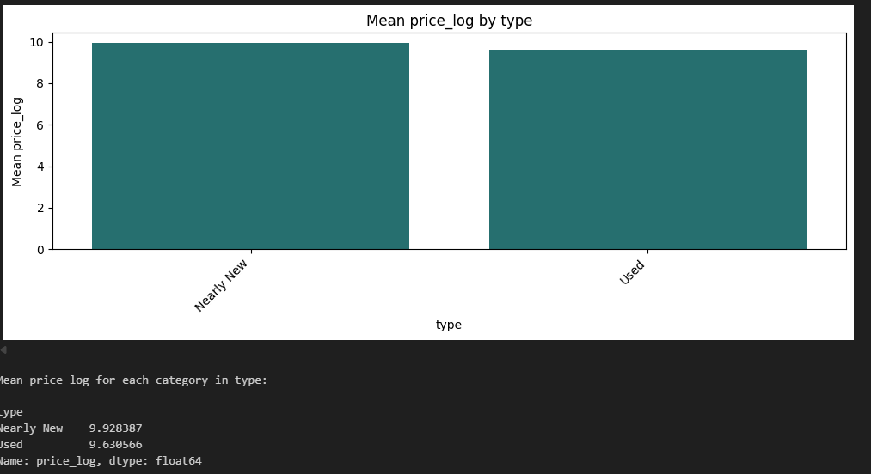

For price_log vs fuel:
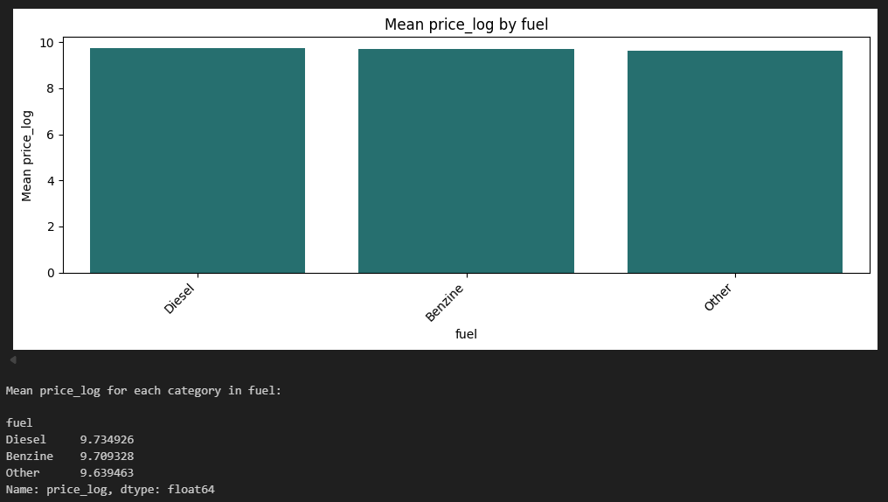
For price_log vs paint_type:
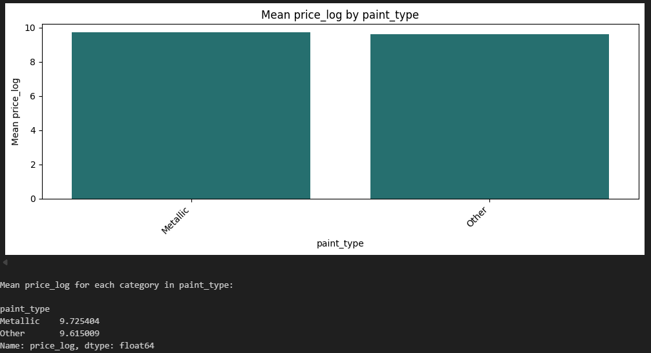

For price_log vs upholstery_type:
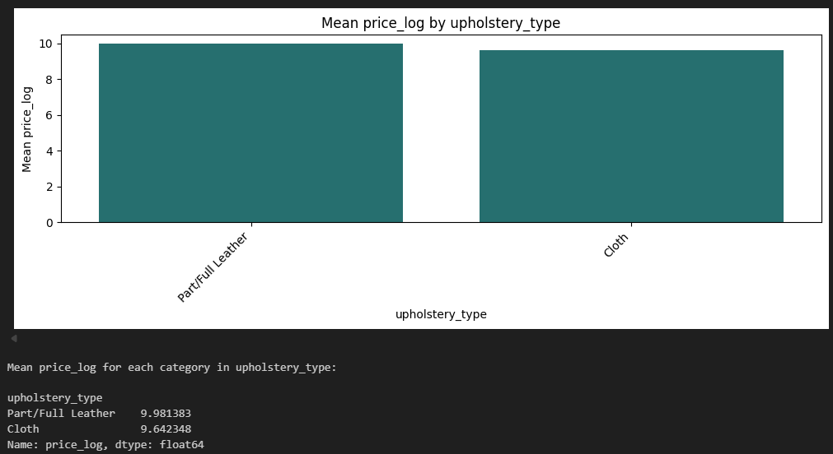

For price_log vs gearing_type:

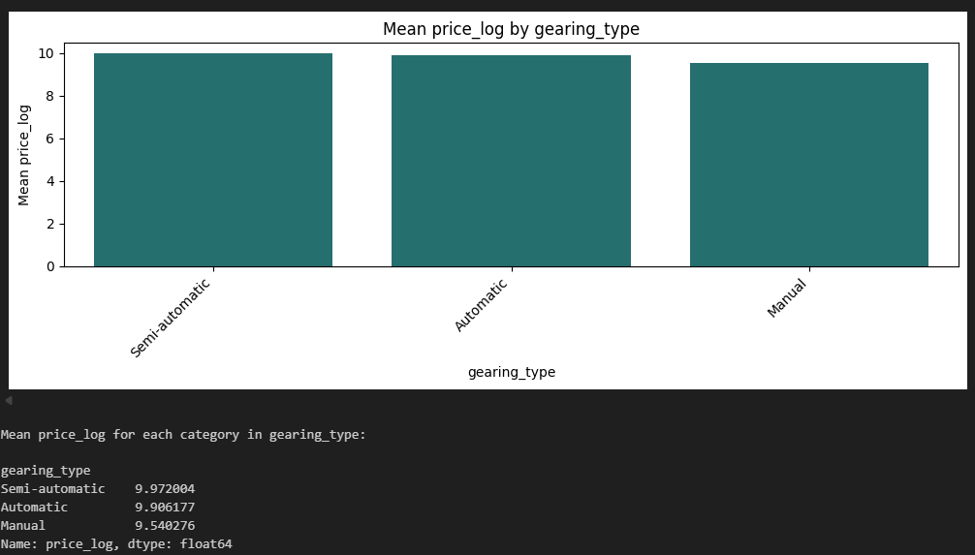

For drive_chain:
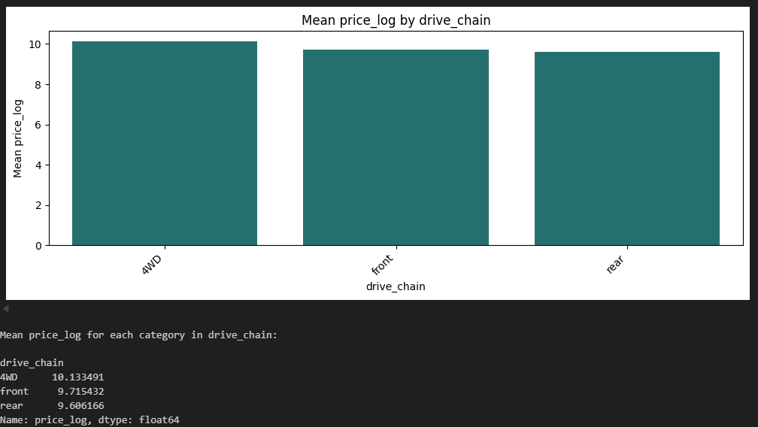

  - Outlier analysis
    - Identify potential outliers in the data

Below box-plots shows the outlier analysis for different numerical features in the dataset. This analysis is used later to get rid of the outliers.

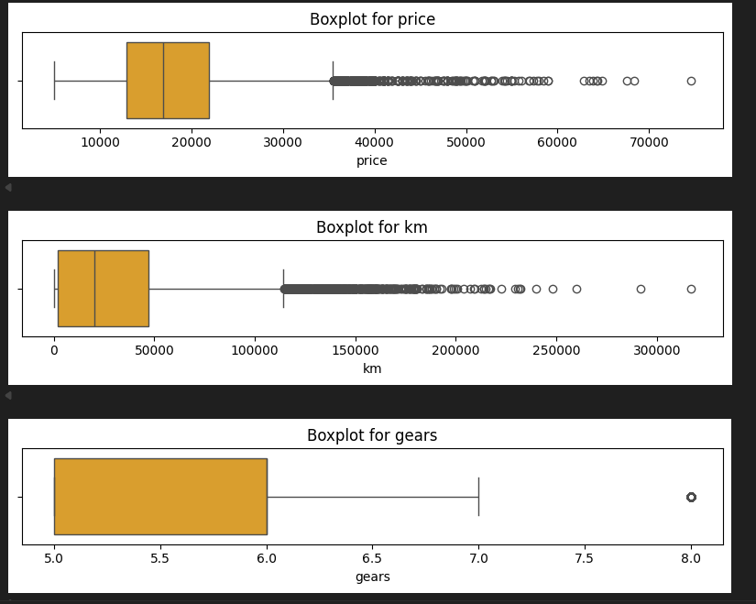

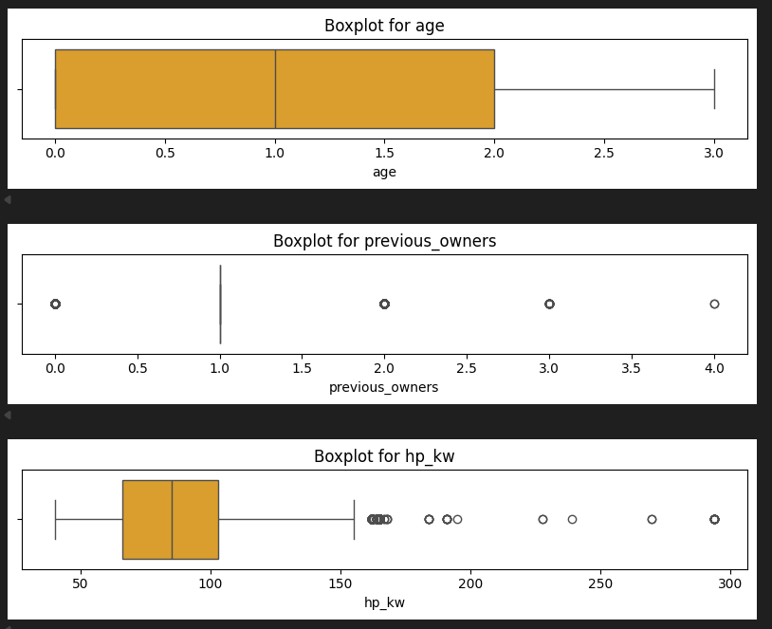
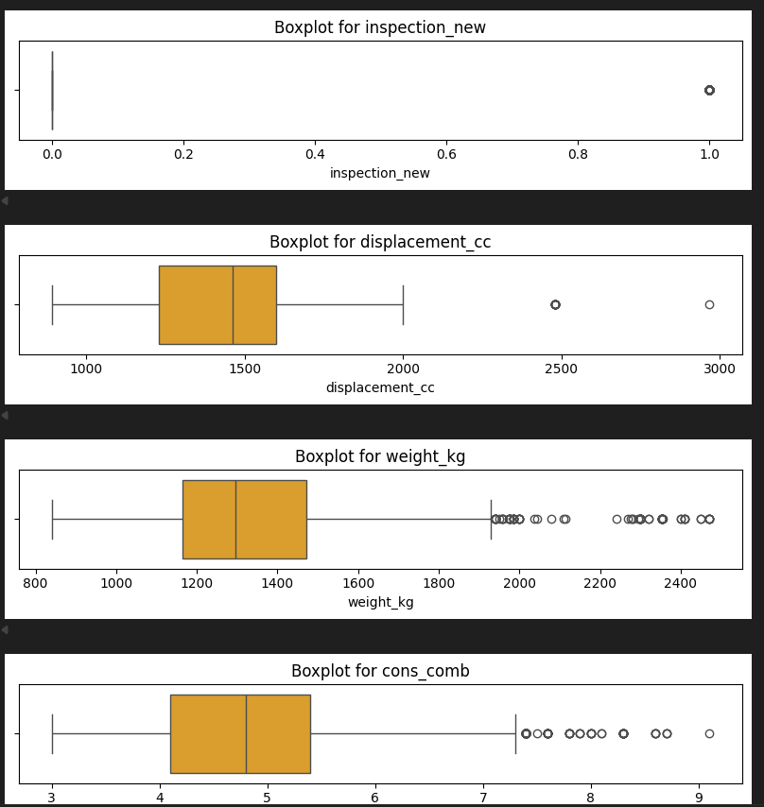
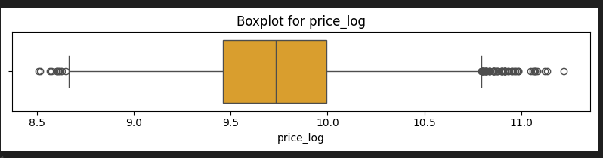
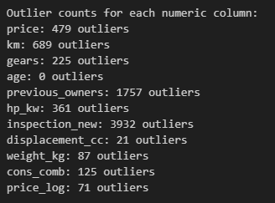
    - Handle the outliers suitably

  - Feature Engineering
    - Fix any redundant columns and create new ones if needed
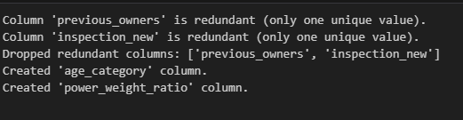

    - Analysis and feature engineering on ['Comfort_Convenience', 'Entertainment_Media', 'Extras', 'Safety_Security']
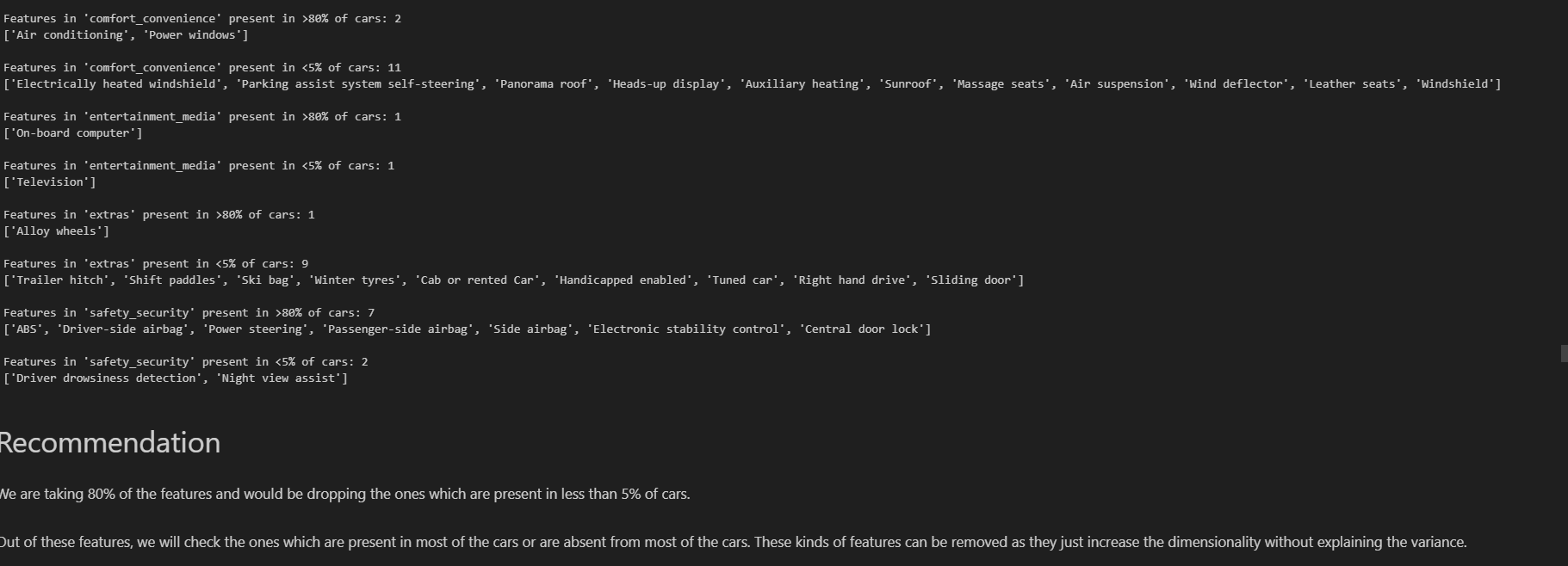
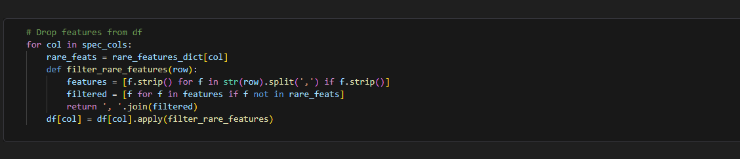
    - Perform feature encoding
    - Split the data into training and testing sets
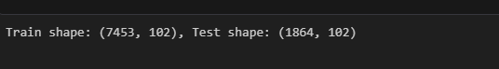
    - Scale the features
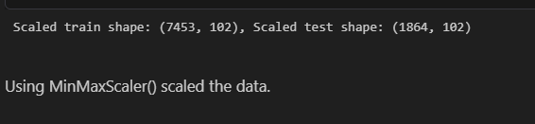
- Linear Regression Models
  - Baseline Linear Regression Model
    - Build and fit a basic linear regression model. Perform evaluation using suitable metrics
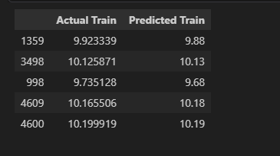

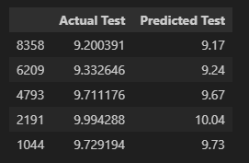
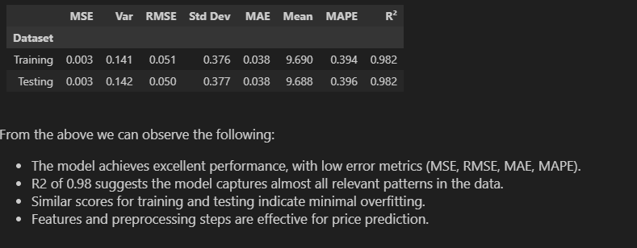

    - Analyze residuals and check other assumptions of linear regression
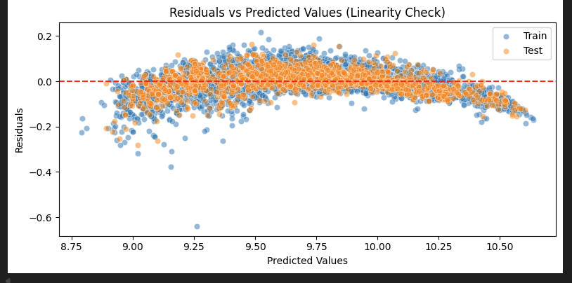
Few observations from the plot:

- The model is systematically underpredicting in the middle and overpredicting at the extremes.
- The model shows non-linearity— the model is missing some curvature in the relationship between features and the target.
- Both Train (blue) and Test (orange) follow the same pattern, and it suggests the issue has model bias, not overfitting
- The vertical spread of residuals is:
  - Wider around the middle (≈ 9.3–9.8)
  - Narrower toward the extremes (low and high predictions)
  - Shows mild heteroscedasticity

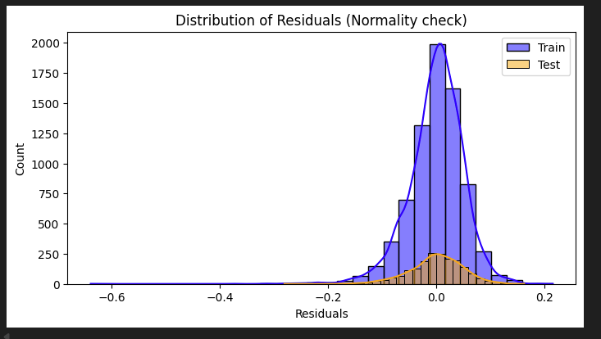
Few observations from the plot:
- Residuals are roughly centered around 0
- Shape is approximately bell-shaped,
- But there is a:
  - slight skewness where the left tail is longer
  - A few outliers (notably around -0.6)
  - Slight peaked-ness / non-perfect normality

Combined analysis:
- Because the model overpredicts at extremes and underpredicts in the middle in the Test vs Train scatter plot
- We are getting systematic negative residuals in some regions
- This creates the longer left tail in the histogram

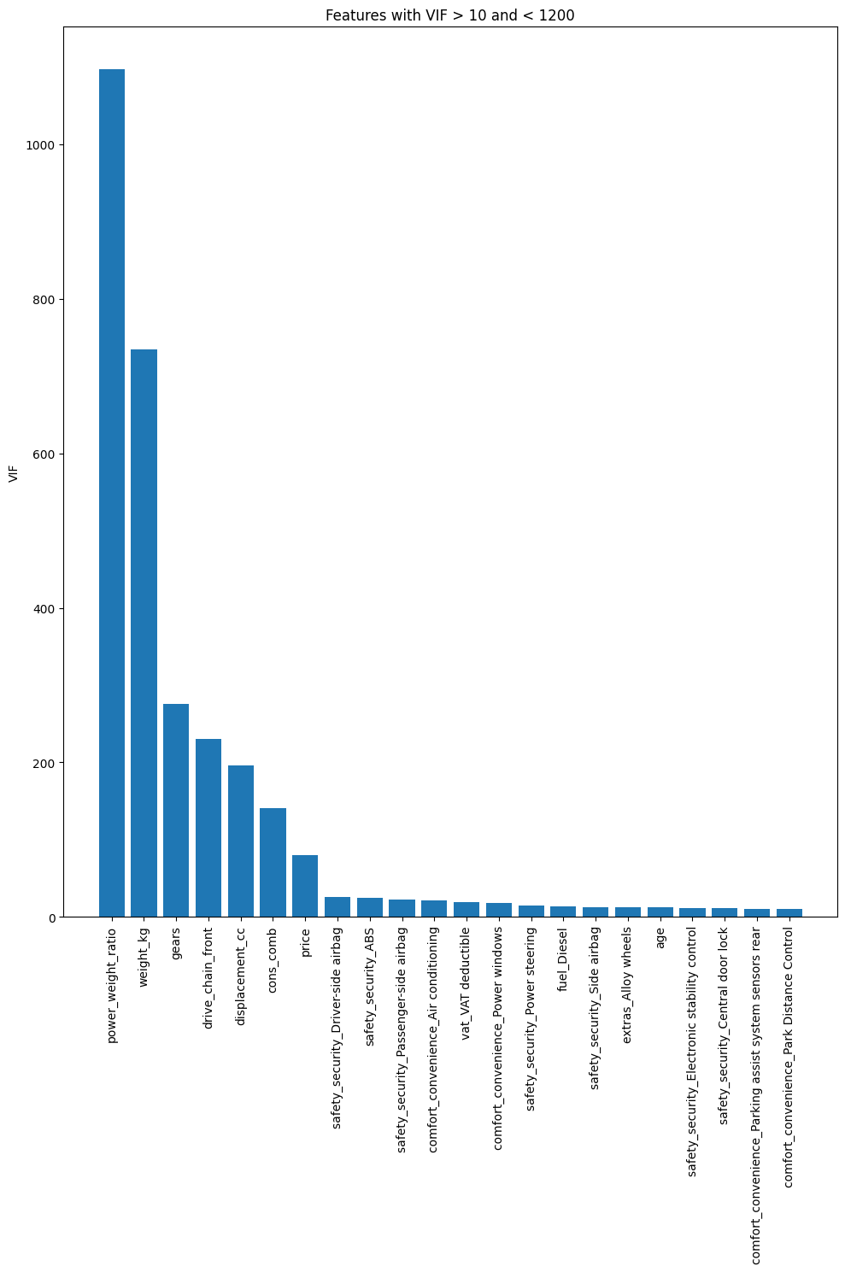
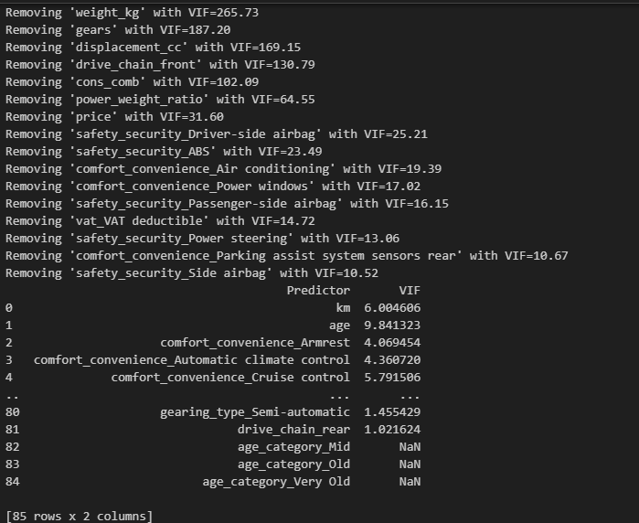

  - Ridge Regression Implementation
    - Define a list of random alpha values
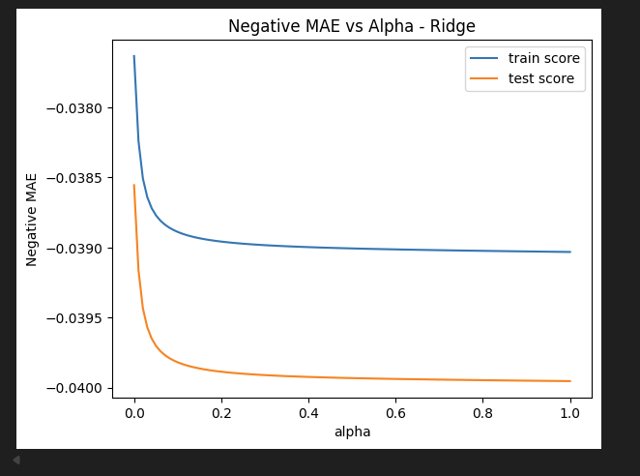
    - Apply Ridge Regularisation and find the best value of alpha from the list
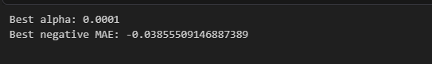
We will get some best value of alpha above. This however is not the most accurate value but the best value from the given list. Now we have a rough estimate of the range that best alpha falls in. Let us do another iteration over the values in a smaller range.

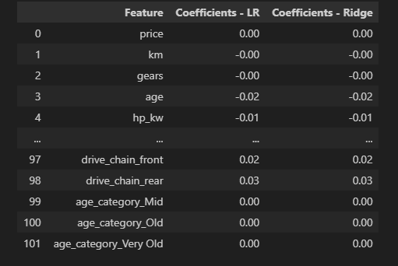

    - Fine tune by taking a closer range of alpha based on the previous result

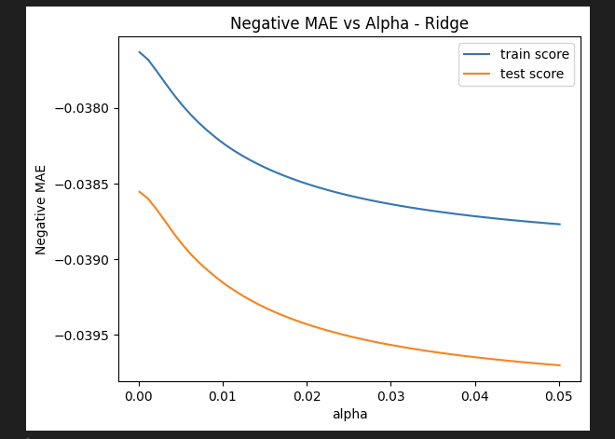
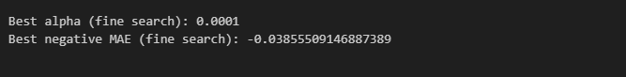
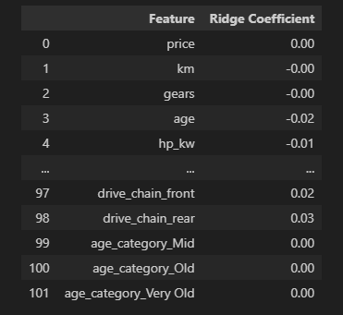

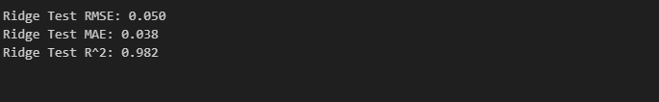
  - Lasso Regression Implementation
    - Define a list of random alpha values
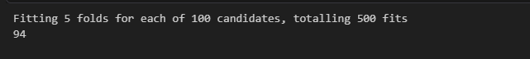
    - Apply Lasso Regularisation and find the best value of alpha from the list
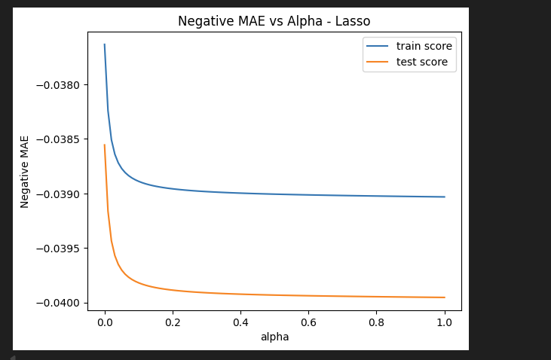

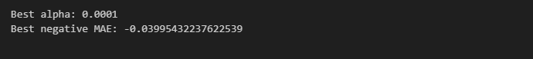
    - Fine tune by taking a closer range of alpha based on the previous result

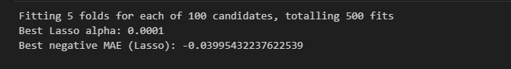
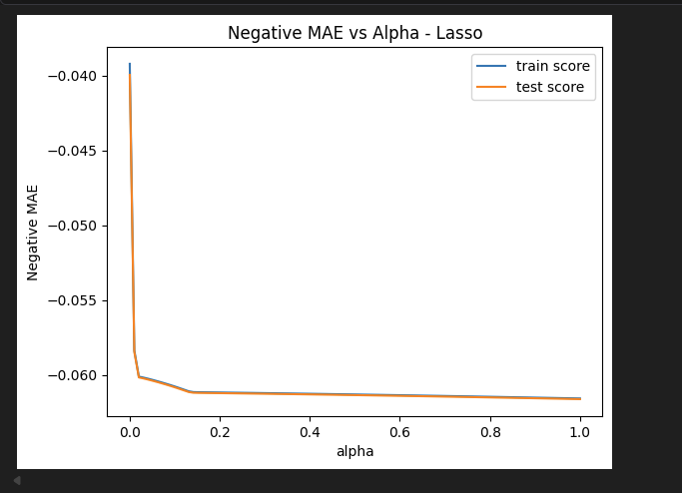

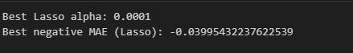

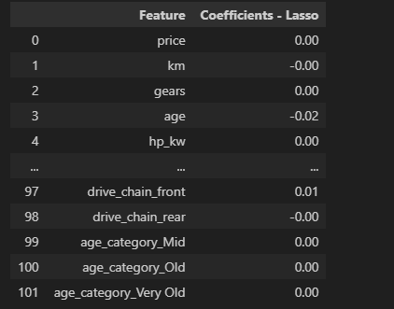
  - Regularisation Comparison & Analysis
    - Compare the evaluation metrics for each model
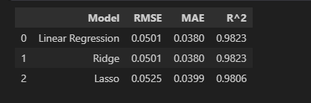

    - Compare the coefficients for the three models
Top 5 Linear Regression coefficients:
- power_weight_ratio 11.758838
- make_model_Opel Corsa 0.204346
- make_model_Renault Clio 0.169152
- make_model_Renault Espace 0.107370
- make_model_Audi A2 0.066087

Top 5 Ridge coefficients:
- power_weight_ratio 11.629635
- make_model_Opel Corsa 0.204402
- make_model_Renault Clio 0.169182
- make_model_Renault Espace 0.106772
- make_model_Audi A2 0.066353
Top 5 Lasso coefficients:
- make_model_Opel Corsa 0.196972
- make_model_Renault Clio 0.162966
- make_model_Opel Astra 0.058974
- gearing_type_Manual 0.046381
- body_type_Other 0.041583

Features eliminated by Lasso: 24
['power_weight_ratio', 'comfort_convenience_Automatic climate control', 'comfort_convenience_Hill Holder', 'comfort_convenience_Light sensor', 'comfort_convenience_Lumbar support', 'comfort_convenience_Parking assist system sensors front', 'comfort_convenience_Tinted windows', 'entertainment_media_Digital radio', 'extras_Catalytic Converter', 'safety_security_ABS', 'safety_security_Alarm system', 'safety_security_Electronic stability control', 'safety_security_Head airbag', 'safety_security_Isofix', 'safety_security_Side airbag', 'safety_security_Xenon headlights', 'make_model_Audi A2', 'vat_VAT deductible', 'fuel_Diesel', 'fuel_Other', 'drive_chain_rear', 'age_category_Mid', 'age_category_Old', 'age_category_Very Old']

Conclusions and key takeaways
  - Conclude with outcomes and insights gained

- Performing regularization did not materially improve predictive performance in this notebook. The baseline Linear Regression and Ridge Regression produced almost identical test results, with RMSE around 0.0501, MAE around 0.0380, and $R^2$ around 0.9823.
- Ridge selected an alpha value very close to zero (`0.0001`), which indicates that only a negligible amount of shrinkage was needed. This suggests the original linear model was already well-regularized by the data and preprocessing steps.
- Lasso produced a slightly worse test performance, with RMSE around 0.0525, MAE around 0.0399, and $R^2$ around 0.9806. However, it eliminated 24 out of 102 coefficients, so it gave a sparser and more interpretable model at the cost of a small drop in accuracy.
- There is no strong evidence of overfitting. The baseline model already showed nearly identical training and testing performance, which means the model generalized well even before applying Ridge or Lasso.
- The data appears sufficient for a linear model. The very high test $R^2$ and low error values indicate that the available predictors explain most of the variation in the target.
- - A linear model is sufficient for this problem based on the current results. Regularization was still useful as a diagnostic tool and for feature selection, but it was not necessary for improving accuracy in this case.

