**LAYOUT OF WEBSITE**

**LAYOUT OF WEBSITE**

1. **HOME TAB**
2. **ABOUT US TAB**

* ABOUT COLLEGE
* VISION
* MISSION
* OBJECTIVE
* FOUNDERS MESSAGE
* CHAIRMANS MESSAGE
* DIRECTORS MESSAGE
* PRINCIPALS MESSAGE

1. **ACADEMICS**

* GRADUATION COURSES

1. B.A.
2. B.COM
3. B.Sc. (Maths/Bio)

* EDUCATION COURSES

1. B.ED.
2. B.EL.ED
3. D.EL.ED
4. **ADMISSIONS**

* REGISTRATION STARTS FOR NEW SESSION 2024-25

1. **LIFE AT MODERN COLLEGE**

* FACILITIES

1. LEARNING RESOURCE CENTRE
2. WIFI FACILITY
3. SCHOLARSHIP FACILITY

* STUDENTS ACTIVITY

1. SPORTS ACTIVITY
2. CULTURAL ACTIVITY
3. **MANDATORY DISCLOSURES**
4. **CONTACT US / GET IN TOUCH**
5. **GALLERY**
6. **SOCIAL MEDIA TAB**
7. HOME PAGE THEME , COLOR AND FONT SIZE ( check reference website below. )

**Website Modifications**

1. **ABOUT US TAB**

Modern College Jhansi, a constituent college of Bundelkhand University Jhansi & SCERT Lucknow, offers B. Ed. & D.El.Ed. and Graduation Programs approved by National Council of Teacher Education (NCTE).

Modern College Jhansi, has qualified and experienced faculty members, equipped with expertise in various academic disciplines such as Languages & Literature, Natural, Biological & Applied Sciences, Social Sciences & Humanities and Research as well as Technological skills.

The college experiments with innovative methodology of teaching that suits the different learning styles of the students and sustains their interest in learning. School Internship is at the heart of any Teacher Education Institution.

The College has introduced an innovative and modern assessment system which allows Students to choose the type of assessment that gives them maximum scope of doing their best. The college also provides ample opportunities to students, teachers to showcase their creativity & artistic talents through Co-curricular activities organized throughout the academic year. Community Work too is an integral component of our Teacher Education Programs wherein students get opportunities of Service Learning through Collaborating with various NGOs.

The College is proud to have good infrastructure with a well equipped Computer Lab & Language Lab along with rich Educational Resource Room to provide the Student Teachers adequate training in Educational Technology.

**Photograph of college**

**VISION -** To provide the students with knowledge, skills, values and sensitivity to face the challenges in life both in academic field as well as in their personal life. To develop the human potentials to achieve different opportunities in future. To enhance the new teaching learning process for students, faculties and staff. Our College will be a Good leader in the integration of teaching and learning advancement of the knowledge-base through research, scholarship, leadership in service and outreach. Further, the college will be involved in preparing teachers who provides leadership, exemplary educational and related services to improve the lives in a changing and complex global society

* **MISSION-** The mission of the College is to prepare outstanding educators, scholars, researchers and to advance the profession of education, as broadly defined, through research on science and art of teaching and learning, the application of clinical processes, the effective uses of technology, the analysis, development of leadership and educational policy. To provide quality education and allied disciplines.

To organize and arrange innovative courses in field of education. To arrange vocational courses in the upcoming fields and innovative subjects to meet global advancement. To promote research in the fields of education and Science.

**Significant Achievement**  All the achievements and events details with respective photographs.

Participation details with chronological order.

(photographs are attached in folder kindly check and proceed)

**Principal´s message** – all the matter is correct. Just one change (Add recent photograph of Asad sir )

**Founder´s Message -**  increase the font size and colors of the fonts.

**Chairman´s Message –**  No change is needed.

**Director´s Message - –**  No change is needed.

**Infrastructure Details -**  are not accurate .

**ADD A TAB OF VIRTUAL TOUR OF CAMPUS WITH 360 DEGREE VIDEO.**

**2.ACADEMIC DETAILS TAB**

**COURSES OFFERED -** Graduation courses - B.A. , B.Com., B.Sc. ¼Maths & Bio).

|  |  |  |
| --- | --- | --- |
| NAME OF THE PROGRAM | | TOTAL SEATS |
| B.A. | | 160 |
| B.COM | 80 | |
| B.Sc. (MATHS /BIO) | 60 | |

**EDUCATION COURSES -**

|  |  |  |
| --- | --- | --- |
| NAME OF PROGRAM | TOTAL SEATS | ELIGIBILTY CRITERIA |
| B.ED. |  | Graduation in any stream |
| D.EL.ED. |  | 10+2 with first division |
| B.EL.ED. |  | 10+2 in any stream with first division |

**Learning Resourse Centre -** Welcome to Library, MODERN COLLEGE JHANSI , a very special place in the Modern college Campus with its rich collection of books and journals in the field of Education and science related disciplines. Central Library currently houses around 5000 books, comprises of collection includes textbooks and Reference books for Science Graduates, commerce graduates ,arts graduates etc. Library collection also includes documents in Computer Science, History of Science, Fictions, Stories, General books, Encyclopaedias and Dictionaries, Magazines etc.

|  |  |  |
| --- | --- | --- |
| **Library at a glance** | | |
| **Sr No.** | **Item** | **Quantity** |
| 1 | Text Books | 4107 |
| 2 | Reference books | 570 |
| 3 | Encyclopedia | 02 |
| 4 | Education journals + Periodicals | 08 |
| 5 | Online journal | 02 |
| 6 | News paper ( Hindi National-02,English National - 02) | 04 |
| 7 | Computer with LAN | 25 |
| 8 | Photocopier/ Printer | 1/03 |
| 9 | Seating Capacity | 50 |

Add photos library and reading room .

(written matter is correct )

**3.ADMISSIONS TAB**

**Registration -** all the details about registration of academic session 2024-2025.

( new session registration starts 2024-25 )

B.ED. ENTRANCE EXAMINATION ( UPJEE) FORMS ARE OUT FROM 10 FEBRUARY TO 10 MARCH.

**Services & IQAC**- Guidance & Counselling cell

|  |  |  |
| --- | --- | --- |
| **SN.** | **NAME OF FACULTY** | **DESIGNATION** |
| 1 | DR. ASAD AHMAD | CHAIRMEN |
| 2 | DR. SATYENDRA KUMAR UPADHYAY | CO-ORDINATOR |
| 3 | BRIJESH SHUKLA | MEMBER |
| 4 | MR. KRISHN GOPAL | MEMBER |

Placement Cell- SAME AS IT IS

Internal Complain Committee- SAME AS IT IS

Alumni Association- SAME AS IT IS

Public Information committee-

|  |  |  |
| --- | --- | --- |
| **SN.** | **NAME OF FACULTY** | **DESIGNATION** |
| 1 | DR. ASAD AHMAD | INCHARGE |
| 2 | DR. SATYENDRA KUMAR UPADHYAY | CO-ORDINATOR |
| 3 | ANANYA GOSWAMI | MEMBER |
| 4 | PRIYANSH BHALLA | MEMBER |

Anti Ragging Committee- SAME AS IT IS

Scholarship Committee- SAME AS IT IS

(NEW COMMMITTEE MEMBERS NAMES SHOULD BE UPDATED)

**4.LIFE AT MODERN COLLEGE TAB –**

1. **FACILITIES** –

* LEARNING RESOURSE CENTRE - Details about library will be added here.
* SPORTS CELL – outdoors and indoors games.
* WIFI FACILITY –
* SCHOLARSHIP FACILITY –

**B)STUDENTS ACTIVITIES –**

**Sports Activity -**

MODERN COLLEGE, JHANSI propagates sporting activities, as an energy booster, since the development of mental and physical faculties is equally essential. The college has thus constituted a sports cell with guidance provided by coaches and sports persons of professional repute. College promotes several indoor and outdoor sports activities to keep the students physically fit and mentally alert. All the activities done by college should be added with respective photographs.

**Cultural Events –**

For example- ( photos of all the activity are in folders)

**5.PHOTO & MEDIA TAB –**

All the new photographs of events need to be added here.

(photos are provided in folders )

**6.NOTIFICATION TAB –**

Notifications tab is not updated. It should be highlighted with all the current news up to date.

REFERENCE WEBSITE-

* <https://web.mitsgwalior.in/>
* <https://www.gla.ac.in/>
* <https://www.galgotiasuniversity.edu.in/>
* https://sgsuniversity.ac.in

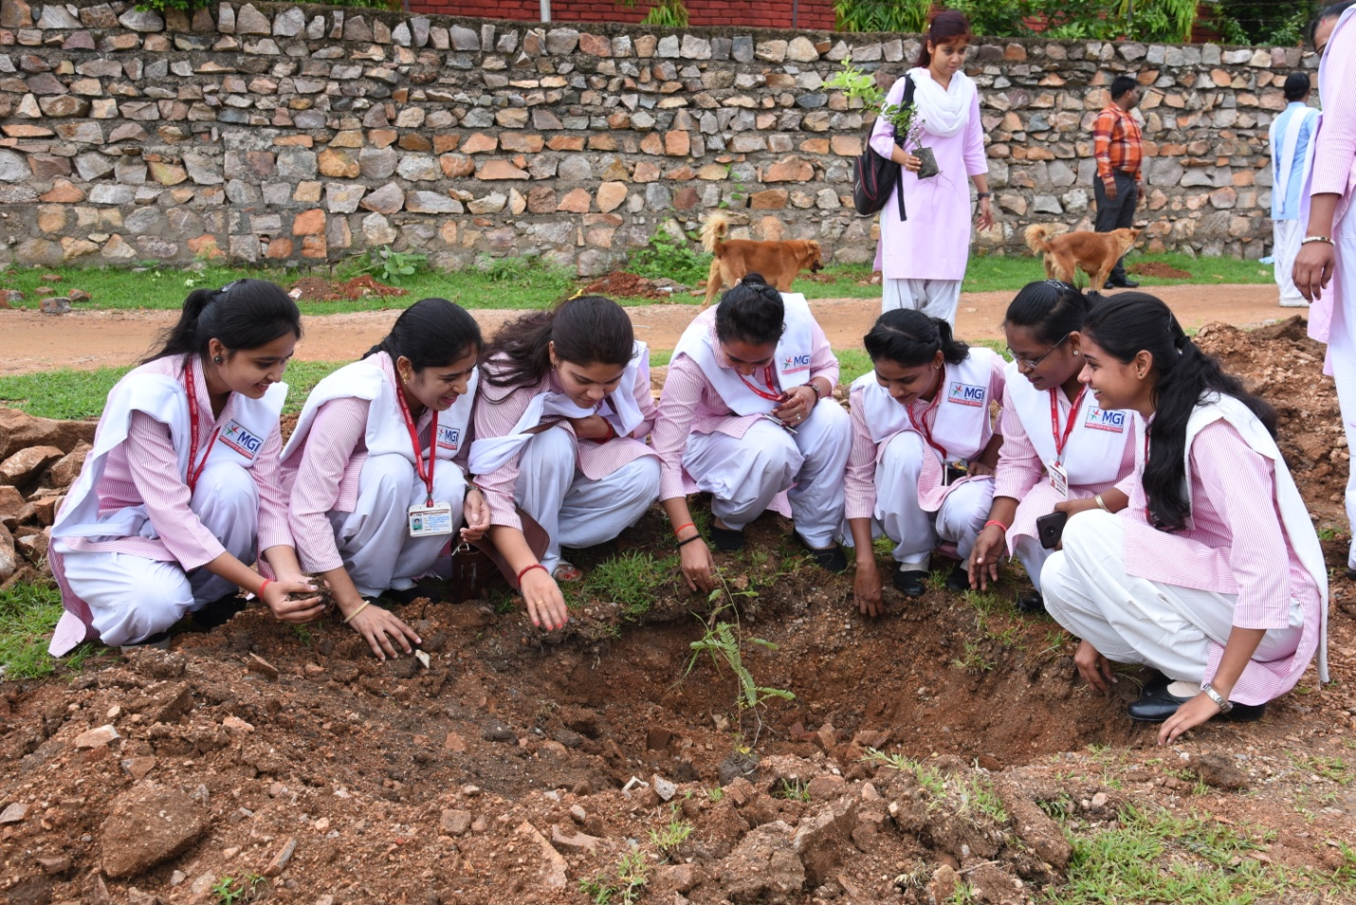

**PLANTATION IN CAMPUS**

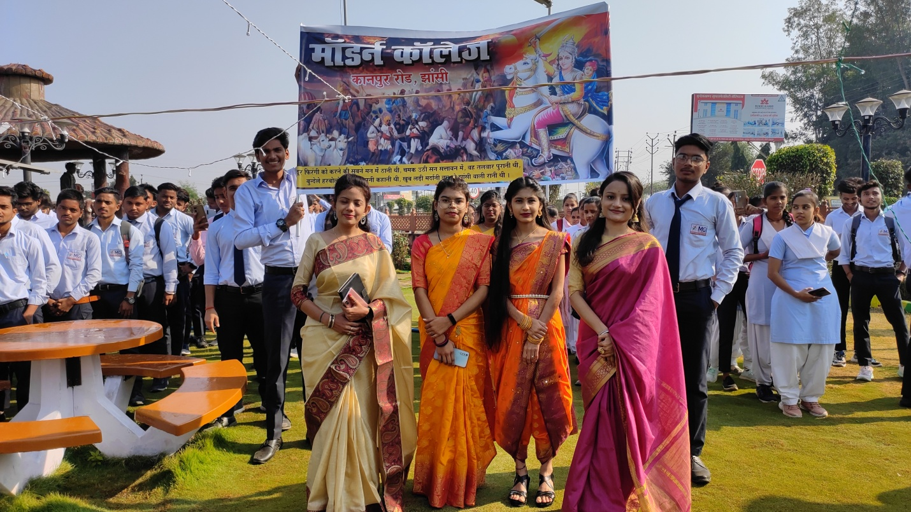

RANI LAKSHMI BAI JAYANTI CELEBRATION

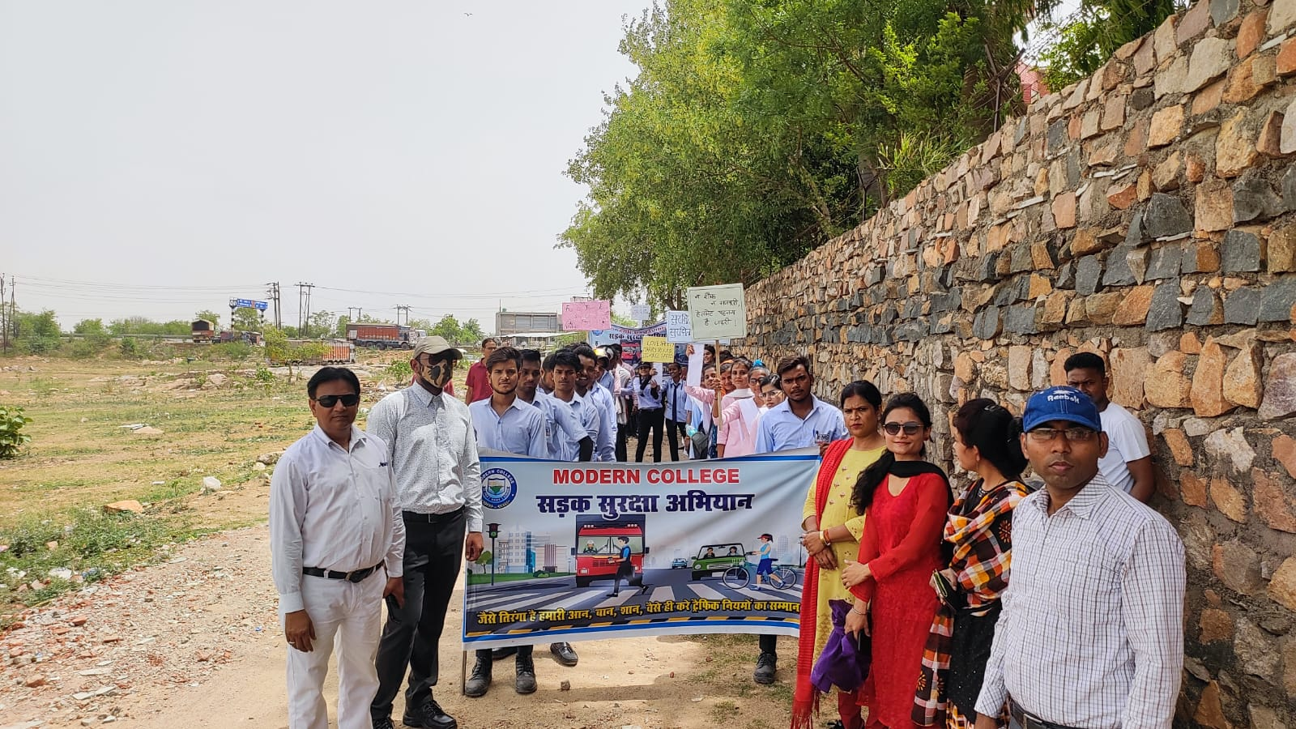

**ROAD SAFETY CAMPAIGN (** THIS IS ONLY FOR EXAMPLE )

All the photos are in folder add from there.

**7.CONTACT US TAB –** address is correct just change the font size and style and change the backgound .

Use symbols of contact while writing the address.

**NOTIFICATIONS TAB -** add a notification slider on the bottom of the home page, in which daily news and updates should be added. ( color of notification bar is in Red )

**8.SOCIAL MEDIA HANDLES TAB** –

In this tab add all the social media links with their symbols at the very side of the home page.

For example – facebook , instagram, twitter, linkdin, etc.