Speaker PhoneEnvelopeHouse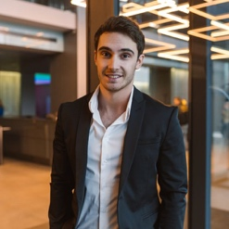

(123) 456-7890 harrytechcraft@gmail.com 123 Main Street, [City, State], [Zip Code]

**PERSONAL INFO**

**Name** TechByHarry

**Date of Birth** 15-01-1990

**Gender** Male

**Marital Status** Single

**Religion** Hindu

**Caste** Brahmin

**Height** 5 feet 10 inches

**Complexion** Fair

**Blood Group** A+

**CAREER**

**Job** Software Engineer

**Company** Tech Solutions Inc.

**Work Location** [City, State]

**Yearly Income** $75,000

**FAMILY DETAILS**

**Father's Name** James Doe

**Father's Job** Engineer

**Mother's Name** Mary Doe

**Mother's Job** Teacher

**Siblings** 2 brothers, 1 sister

**EDUCATION**

**Highest Degree** Bachelor's in Computer Science

**College** XYZ University

**Graduation Year** 2012

**OTHER QUALIFICATIONS**

**High School** ABC School (2008)

**Intermediate** DEF College (2010)

**HOBBIES**

**Hobbies** Reading, Playing Guitar, Painting

**Interests** Traveling, Photography

**Favorite Food** Italian

**John Doe**