TECH GURU PLUS

COURT OFFICE

**Address**

123 Anywhere St Any City, ST 12345

+123-456-7890

**Phone**

+123-456-7890

# To

**Mr. Nazim Khan Njibabad**

This Template is downloaded from TechGuruPlus.com, we have more than 2000 templates on our website.

If you are searching for any type of template, you can visit our website page <https://techguruplus.com/letterhead-templates> and view all template galleries there.

If you want a template that is not in our gallery then you can leave a comment in the comment box on a website page and we will make new templates for you and upload them on our website, after 1 week you will be able to download those templates free.

Sincerely,

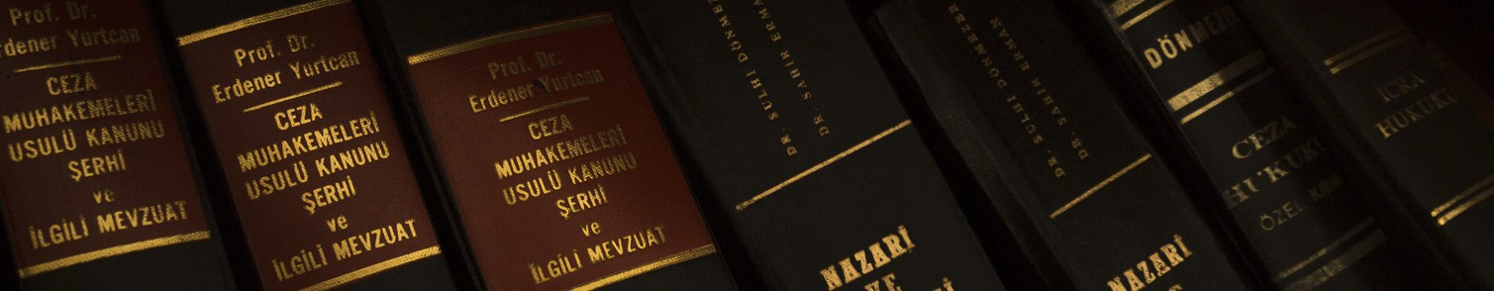

# Nazim Khan General Manager

123-456-7890

[hello@techguruplus.com](mailto:hello@techguruplus.com) Najibabad, District Bijnor