# ABOUT ME

I am a Data Scientist with experience in the development and implementation of data-driven solutions. I have a strong background in statistics, machine learning, and software engineering. I am comfortable working independently as well as part of a team, and I have excellent communication and interpersonal skills.

# EDUCATION: EXPERIENCE:

2010 - 2014

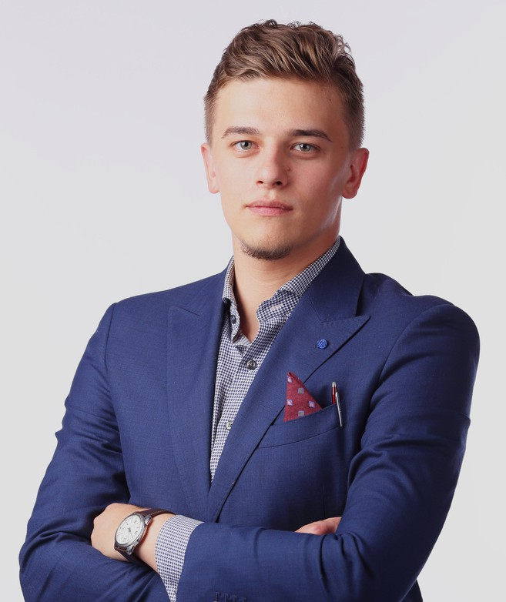

**PETER SAMUEL**

Data Scientist

123-456-7890

[hello@techguruplus.com](mailto:hello@techguruplus.com) [www.techguruplus.com](http://www.techguruplus.com/) 123 Anywhere St., Any City

*Fauget University* **Bachelor of Science in Data Science**

# SKILLS:

1. Strong background in statistics
2. Machine learning
3. Software engineering
4. Comfortable working independently and as part of a team
5. Excellent communication and interpersonal skills

*Mar 2015 - Present*

## Salford & Co. Data Scientist

 Develop and implement data-driven solutions

 Design and conduct experiments

 Build and evaluate machine learning models

*Nov 2013 - Feb 2015*

## Wardiere Inc. Data Scientist

 Developed and implemented data- driven solutions

 Designed and conducted experiments  Built and evaluated machine learning

models