**AWARDS &**

**SCHOLARSHIP**

Australian Postgraduate Award in

Academic Excellence 2020

Warner & Spencer Scholarship

Program 2016

Best Essay Writing Thnyk Unlimited

Education Award 2018

**REFERENCES**

Professor Rufus Stewart

Department Head, Experimental Psychology Fauget University hello@reallygreatsite.com +12-3456-7890

Juliana Silva, B.A., M.A

Lecturer, Developmental Psychology Warner & Spencer University hello@reallygreatsite.com +12-3456-7890

**PUBLICATIONS**

2021 - Journal of Toddler

Developmental Psychology

2018 - Journal of Digital

Technology

2016 - Journal of New Psychology

Fauget University

123 Anywhere St., Any City, ST 12345

+12-3456-7890 hello@reallygreatsite.com @reallygreatsite

**Olivia Marie Thompson**

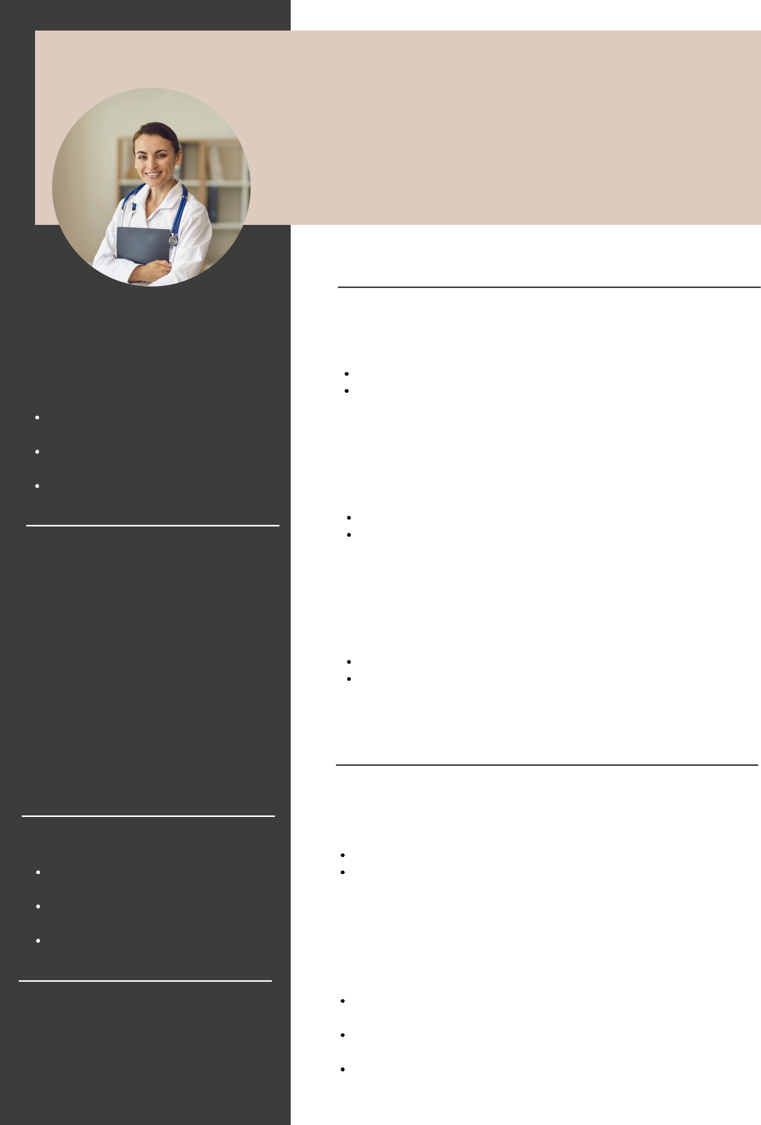

PHD IN PSYCHOLOGY

**EDUCATIONAL SUMMARY**

**Warner & Spencer University**

PhD in Developmental Psychology | October 2019-May 2021

Graduated with Distinction

Doctoral thesis titled “How Digital Technology Affect Toddler Development: An Experimental Study”

**Warner & Spencer University**

Master’s Degree in Developmental Psychology | October 2016-May 2018

Graduated with Distinction

Dissertation titled “Toddler Developmental Psychology Issues in Digital Era”

**Fauget University**

Bachelor’s Degree in Psychology | August 2013-February 2016

GPA of 3.73

Top 3 Undergraduate Thesis, titled "Digital Technology and Its Effects on Developmental Psychology"

**ACADEMIC EMPLOYMENT**

**LECTURER**

Warner & Spencer University | July 2019-Current

Head of the Developmental Psychology Department Taught Introduction to Developmental Psychology and Experimental Psychology to first-year level students for two semesters

**RESEARCH ASSISTANT TO PROFESSOR RUFUS STEWART**

Department of Experimental Psychology

Prepared interview questions for Focus Group Discussion to research participants

Assisted experimental research through observation methods

Conducted pre-post test for research participants