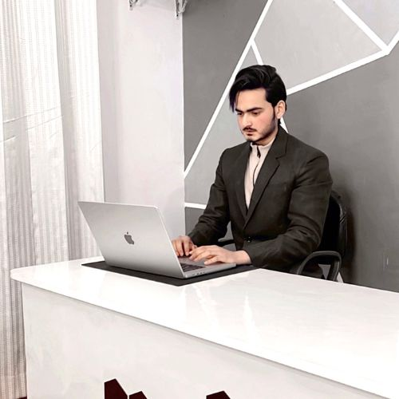

**ABOUT ME**

My Name Is SAHIB KHAN. Lorem Ipsum is simply dummy text of the printing and typesetting industry. Lorem Ipsum has been the industry's standard dummy text ever since the 1500s, when an unknown printer took a galley of type and scrambled it to make a type specimen book. It has survived not only five centuries, but also the leap into electronic typesetting, remaining essentially ever since the 1500s, when an unknown unchanged. but also the leap into electronic It was popularized.

**EXPERIENCE**

**WORK NAME 1** JUNE 2008 - DEC 2014

Lorem ipsum dolor: sit amet consectet gelit. it ellentesque eleife ornare ipsun enunc pulvinati ncidunt. quis pul vinar mellu.

**WORK NAME 2** JUNE 2008 - DEC 2014

Lorem ipsum dolor: sit amet consectet gelit. it ellentesque eleife ornare ipsun enunc pulvinati ncidunt. quis pul vinar mellu.

**WORK NAME 3** JUNE 2008 - DEC 2014

Lorem ipsum dolor: sit amet consectet gelit. it ellentesque eleife ornare ipsun enunc pulvinati ncidunt. quis pul vinar mellu.

**SKILLS**

|  |  |
| --- | --- |
| * PHOTOSHOP | * PHOTOSHOP |
| * HTML | * HTML |
| * CSS | * CSS |
| * JAVA SCRPT | * JAVA SCRPT |
| * DREAMVIWER | * DREAMVIWER |
| * ILLUSTRATOR | * ILLUSTRATOR |

**REFERENCE**

**JEAN DAVID**

Manger of Techno Media

Contact: +909 3940 3309 3

**CONTACT**

🖀 Phone

+91 8954400000

🖄 Email

24billions@mail.com

🌍 Address

New Delhi, India

**EDUCATION**

**SCHOOL NAME 1**

JUNE 2008 - DEC 2014

Lorem ipsum dolor: sit amet consectet gelit. it ellentesque eleife ornare ipsun.

**SCHOOL NAME 2**

JUNE 2008 - DEC 2014

Lorem ipsum dolor: sit amet consectet gelit. it ellentesque eleife ornare ipsun sit amet consectet

**SCHOOL NAME 3**

JUNE 2008 - DEC 2014

Lorem ipsum dolor: sit amet consectet gelit. it ellentesque eleife ornare ipsun sit amet consectet.

**HOBBIES**

Photography Swimming

Music Driving

**SAHIB KHAN**

Graphic Designer