SUPERADMIN
Theme toggle should be on navbar
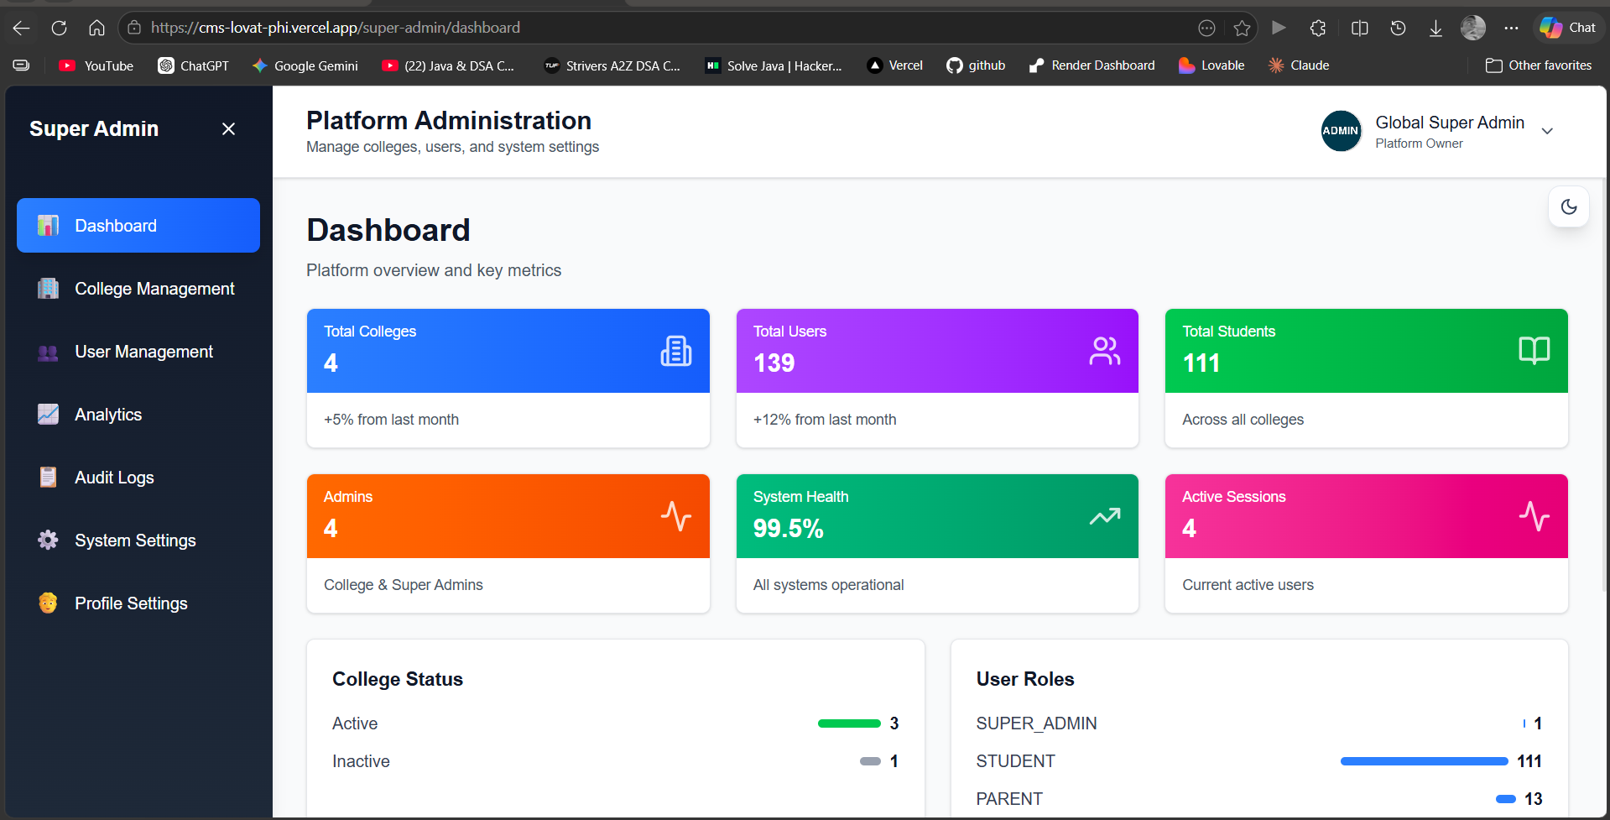
WHY logout button removed ??
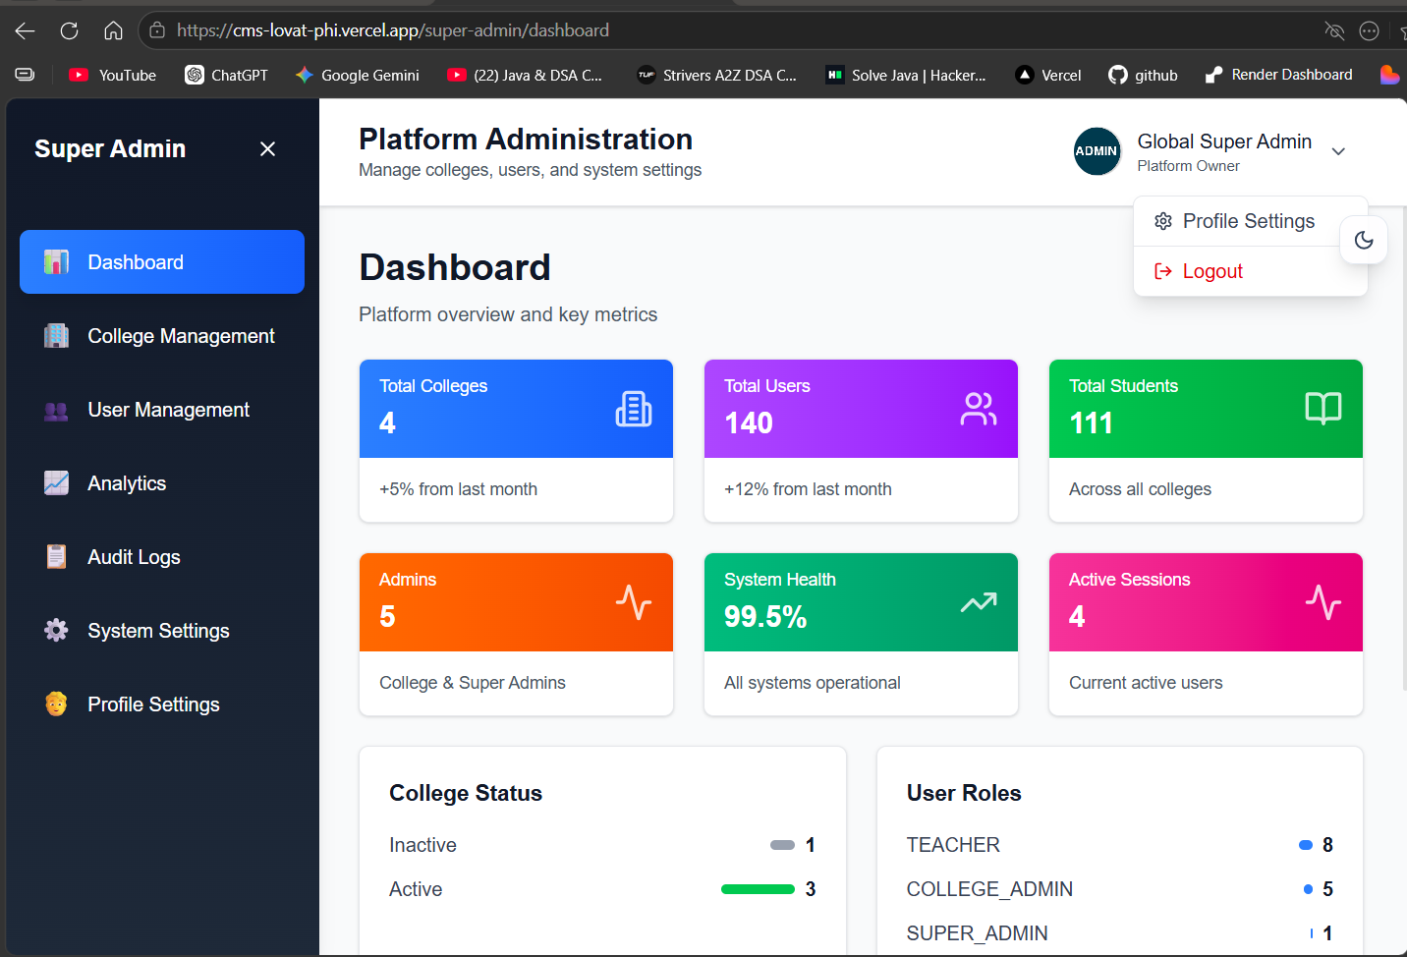
ADMIN 1 LPU
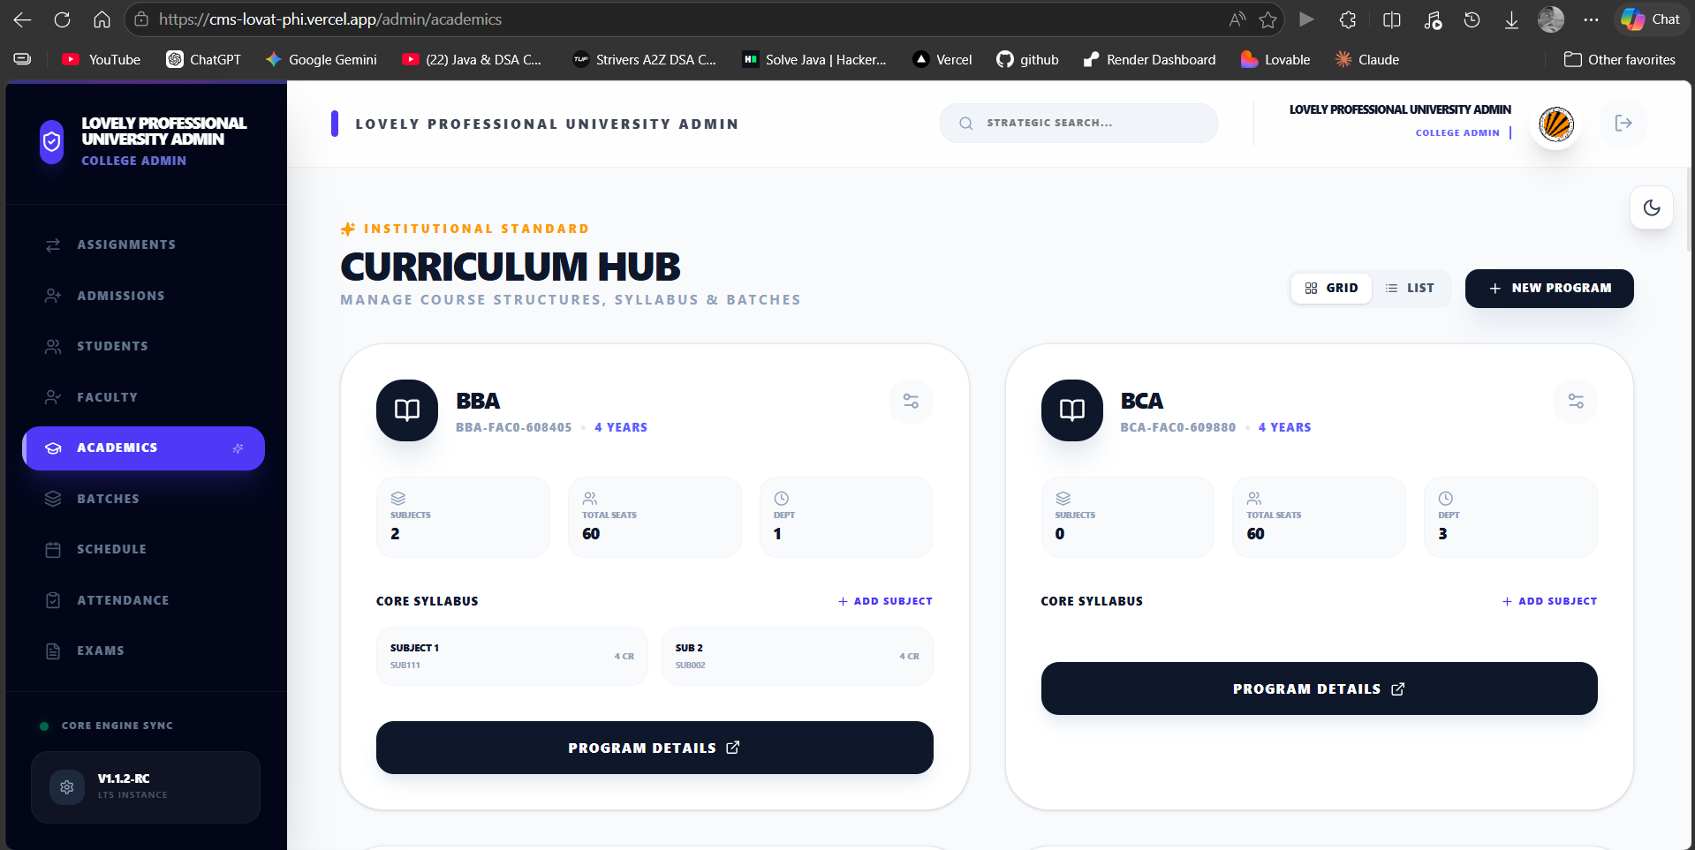
WHEN CLICKING ON NEW EXAM
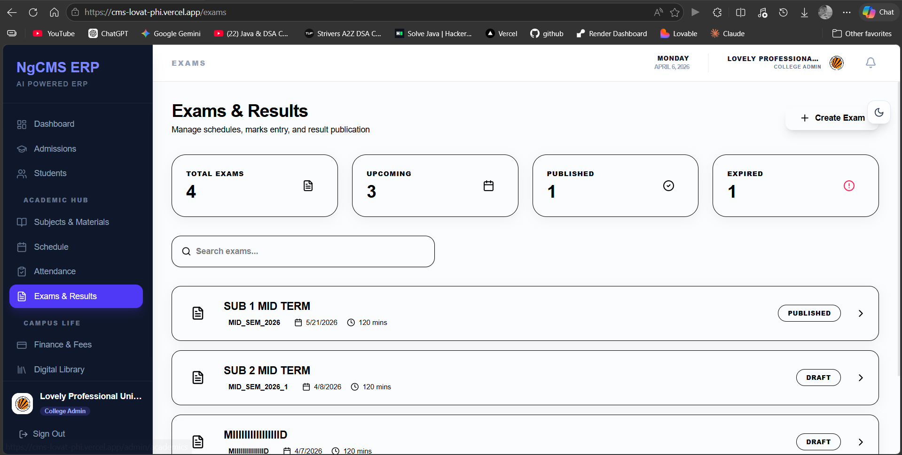
THIS IS SHOWING THE DASHBOARD AND SIDEBAR CHANGES
GOVERNENCE NOT WORKING
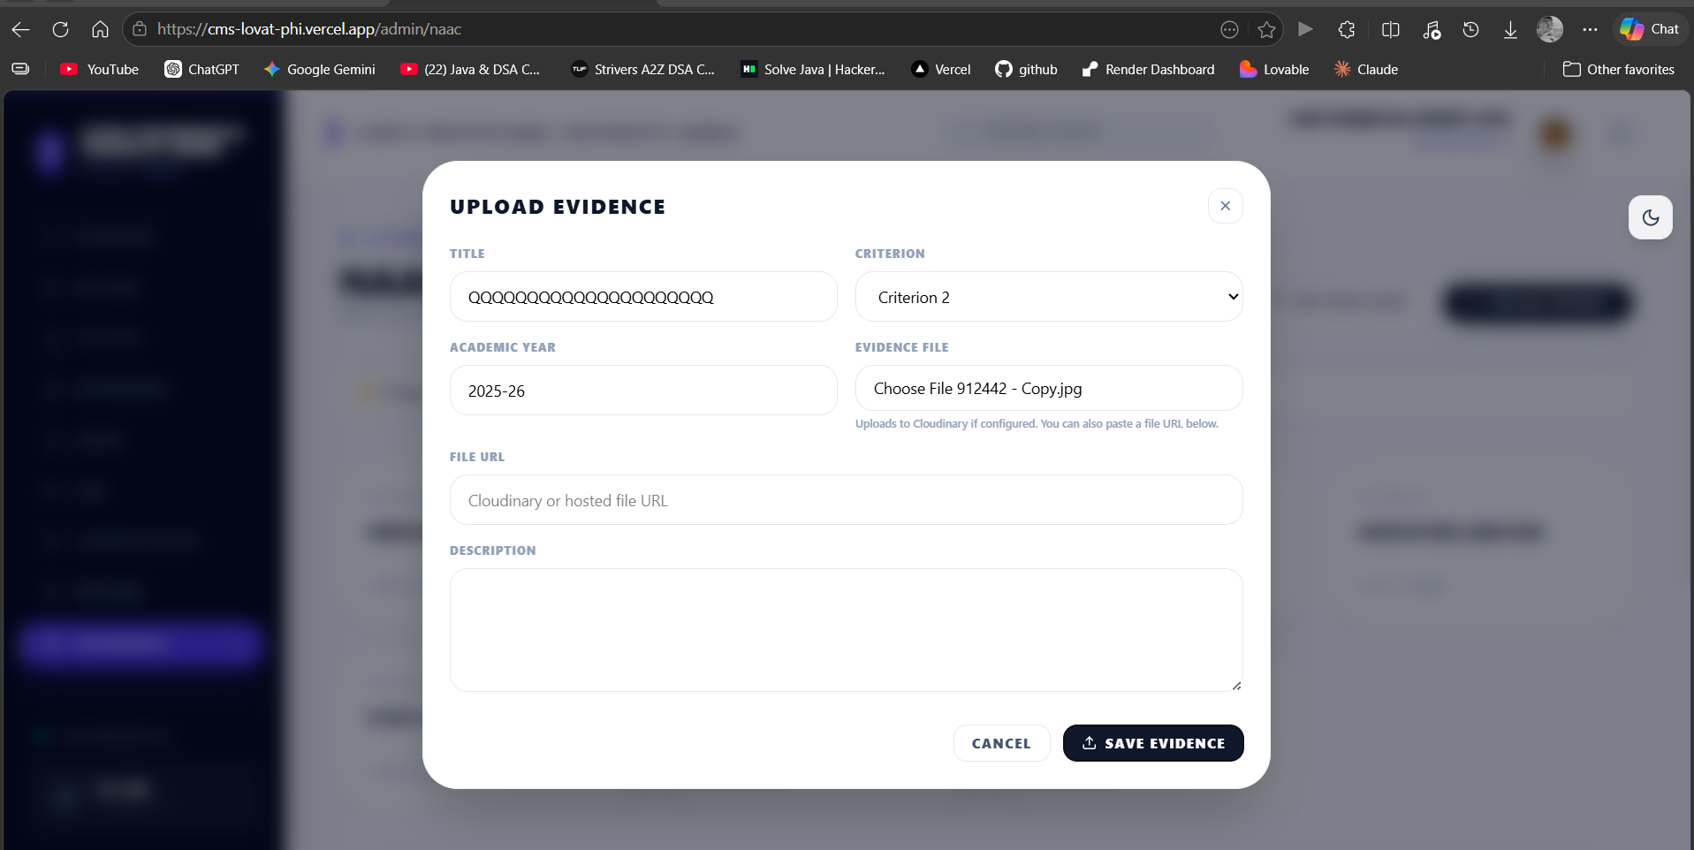
TEACHER
ONLY BROWSE ACCES WHY
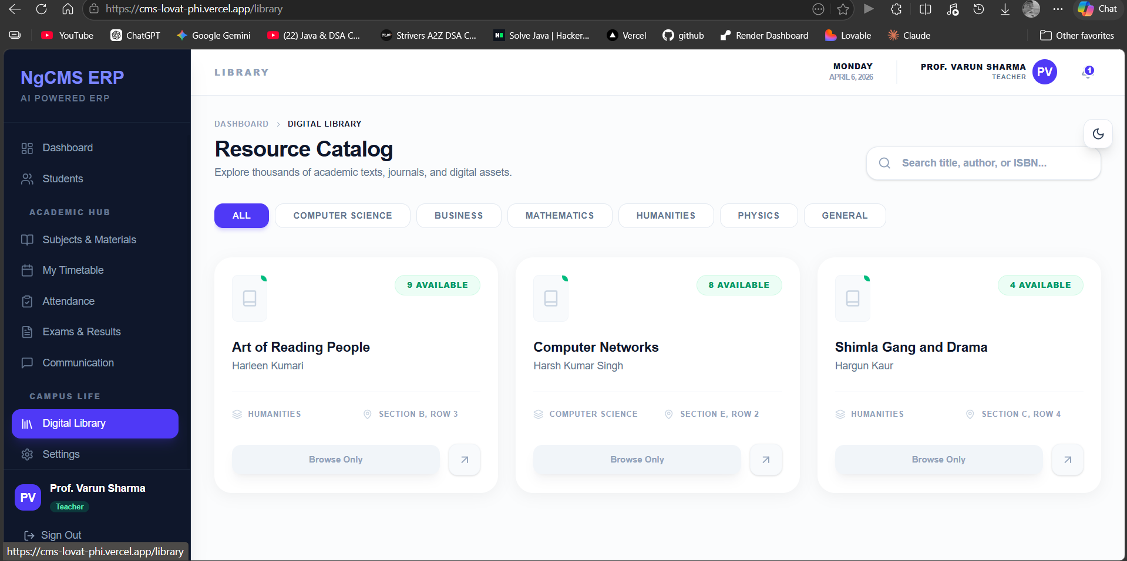
HERE DASHBOARD IS LAGGING AND DASHBOARD UI ERROR IN THE SIDEBAR IT SHOULD SHOW THAT IT IS SELECTED BUT IT TAKES AND REFRESH EVERYTIME CLICKED ON IN
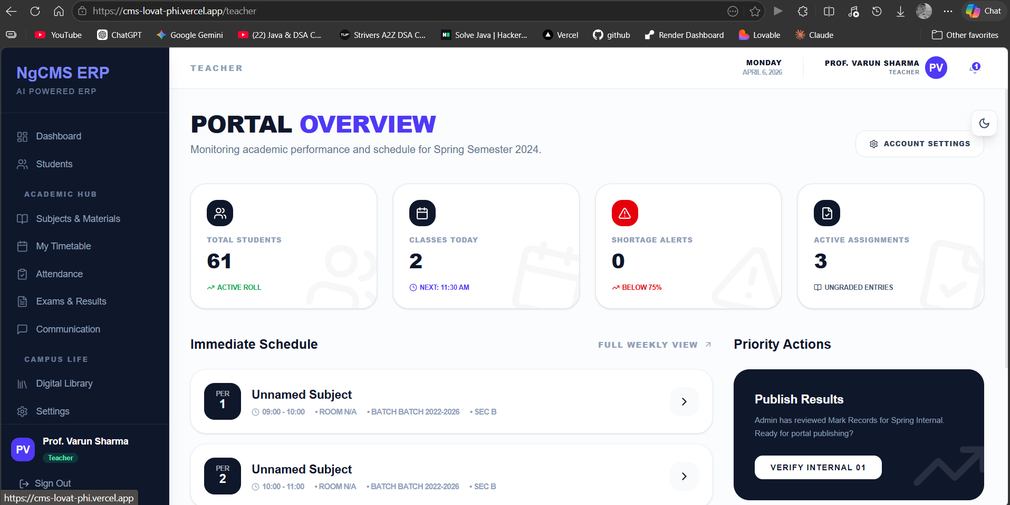
HERE IT SHOULD HAVE SERIAL NUMBER ALSO
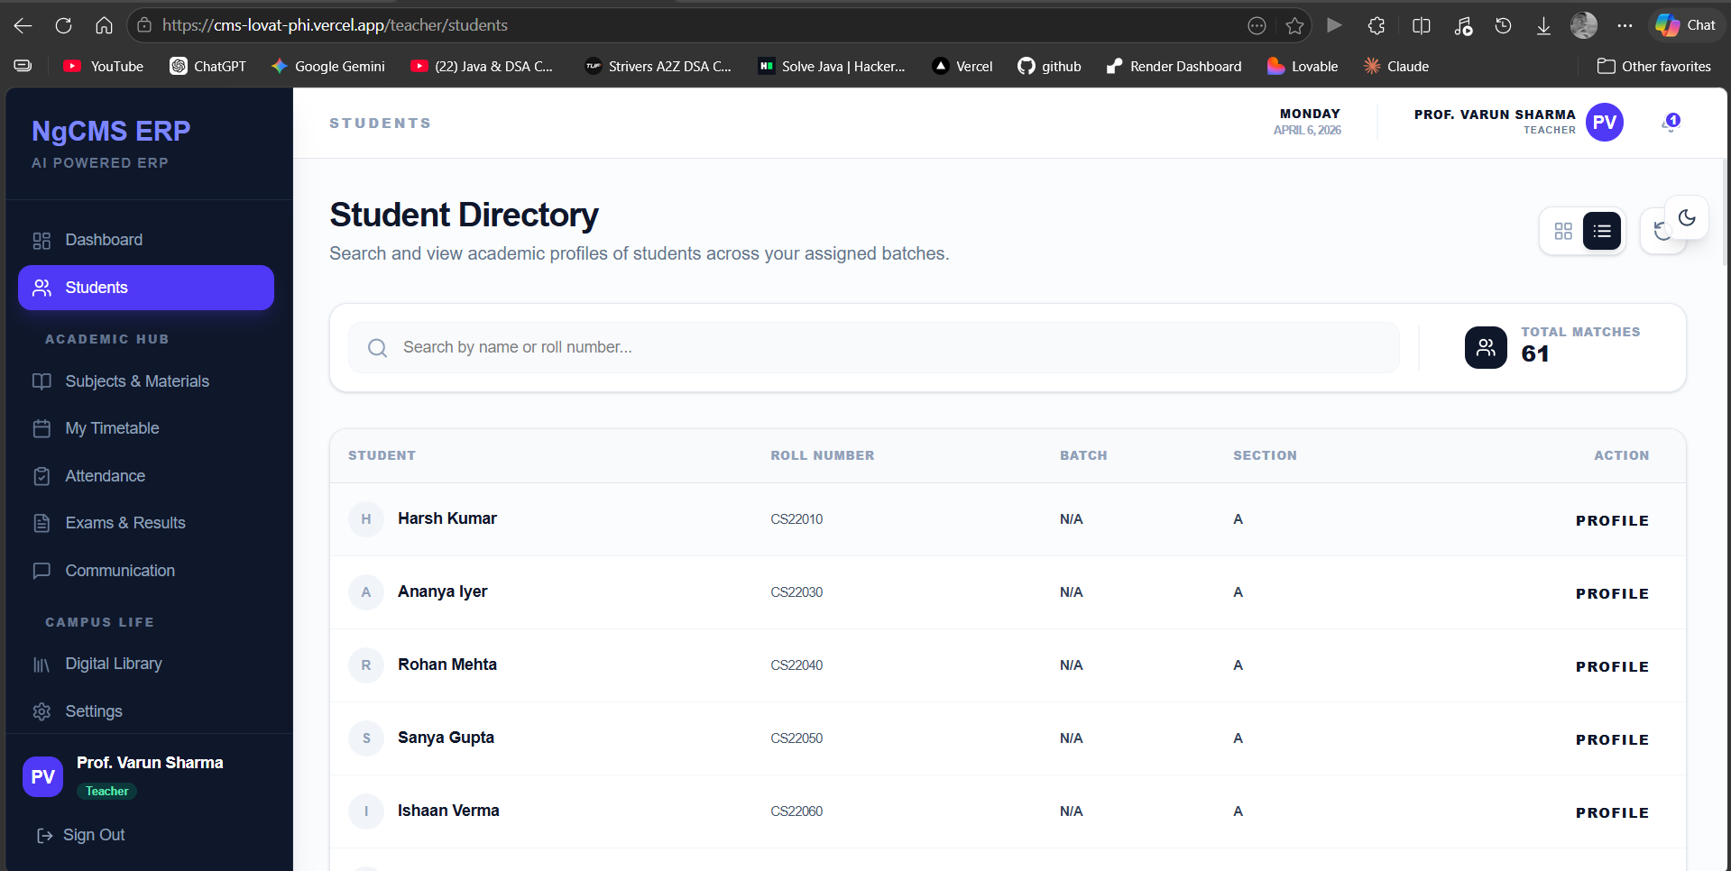
AGER WAHA HI DEKHNA PADEGA TOH YAHA SE OPTION HATA DO AUR WRNA SHOW A ATTENDANCE LIKE GITHUB STREAK TYPE
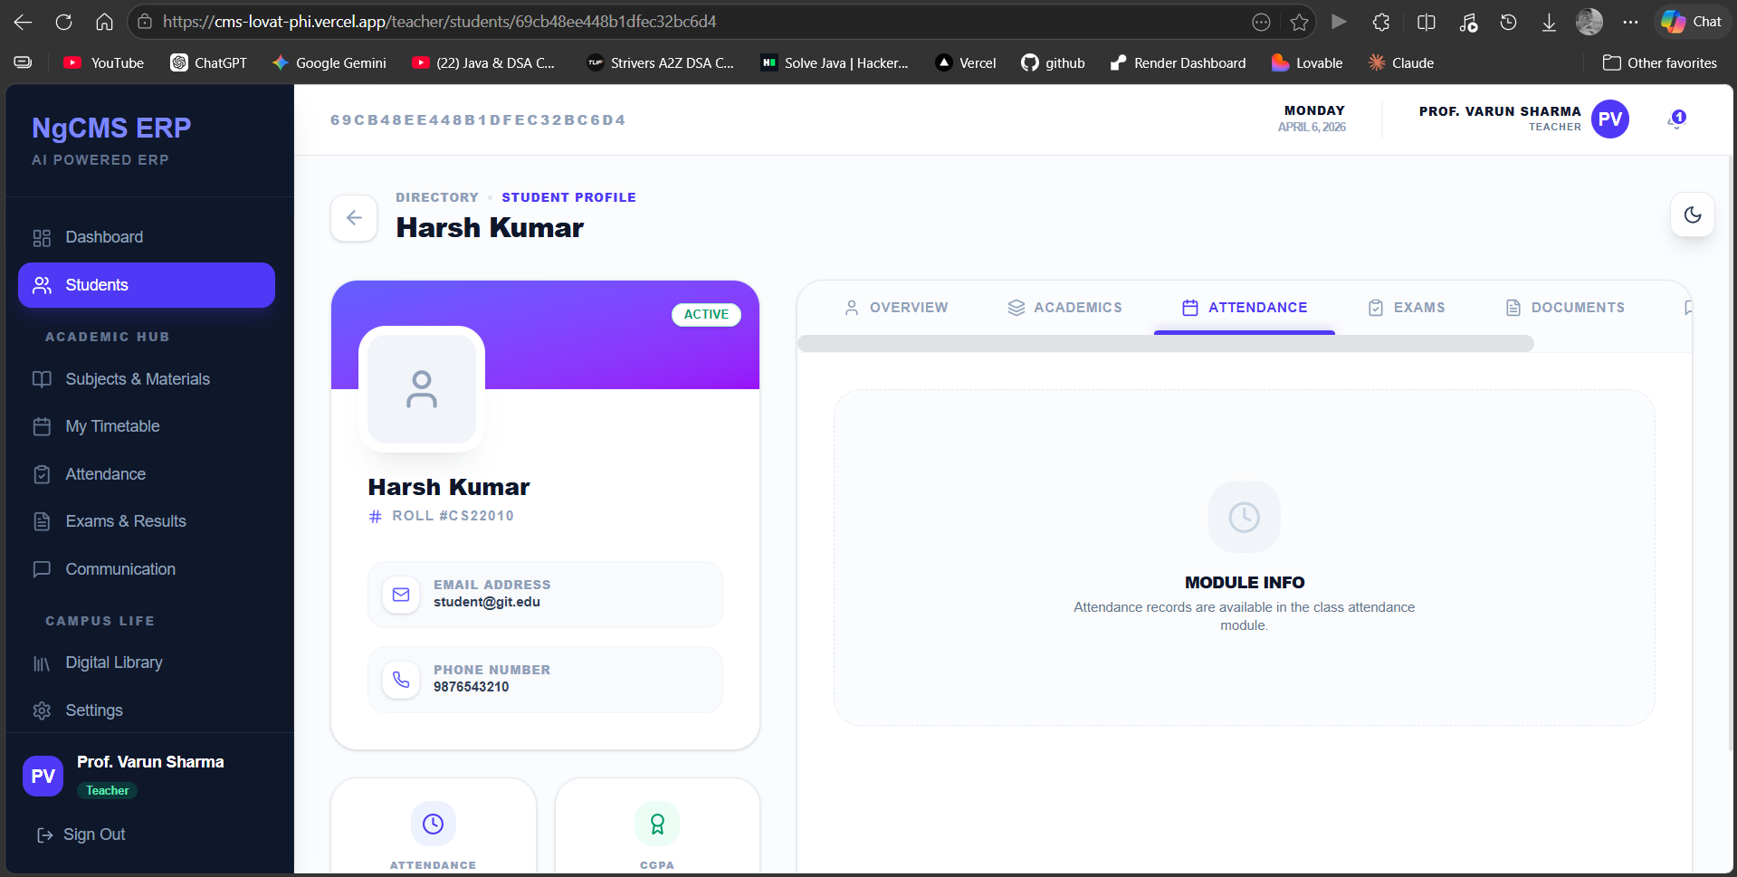
ATTENDANCE ERROR
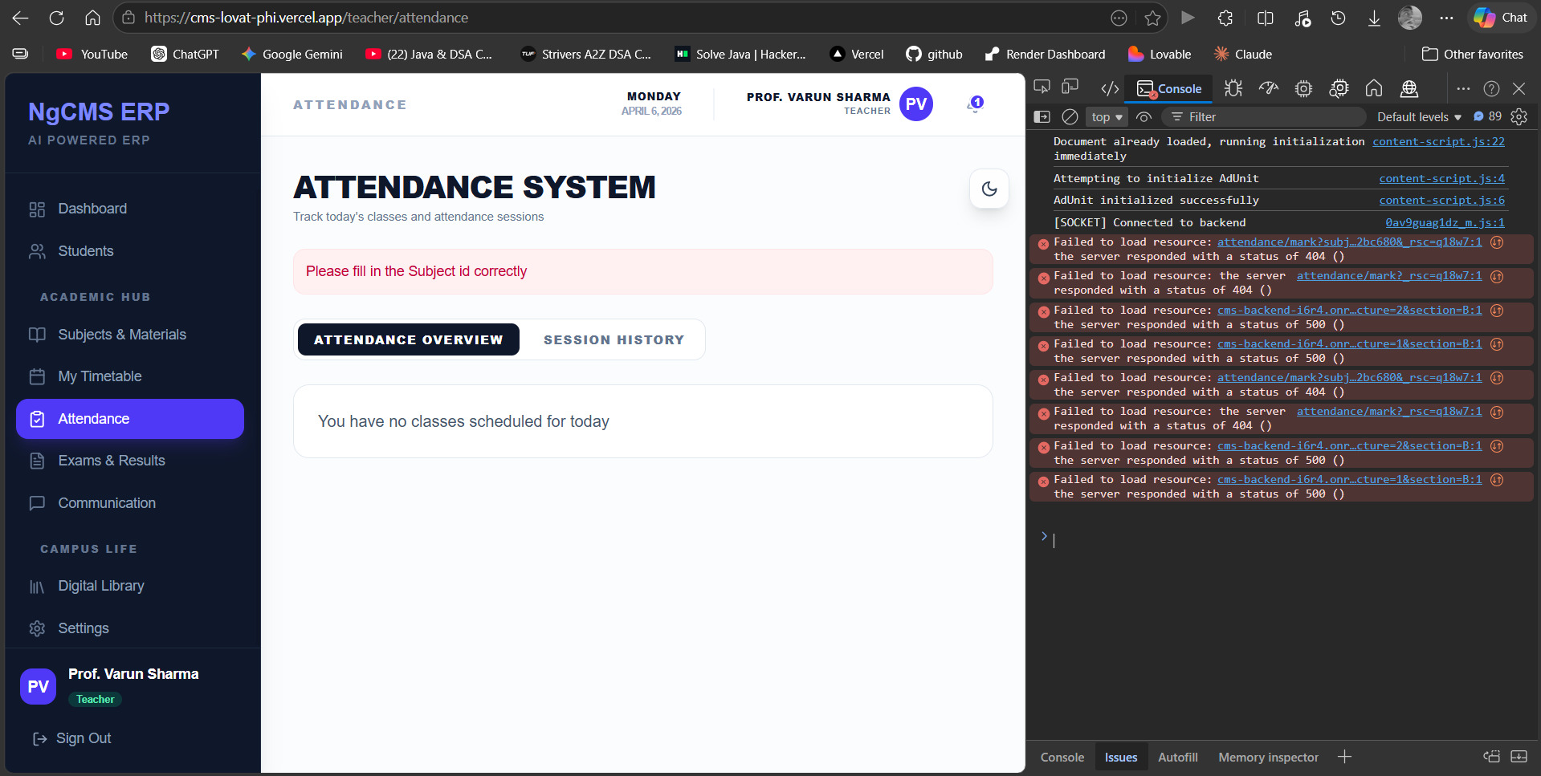
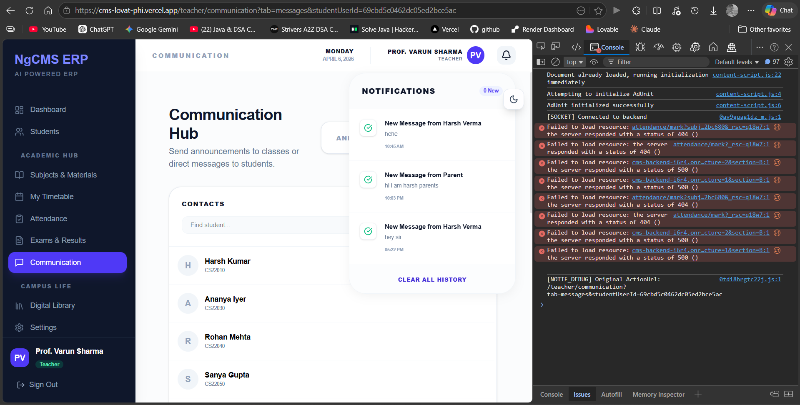
CLEAR ALL NOT WORKING STILL
WHEN SIGNING OUT WHY DOES THEME CHANGES??
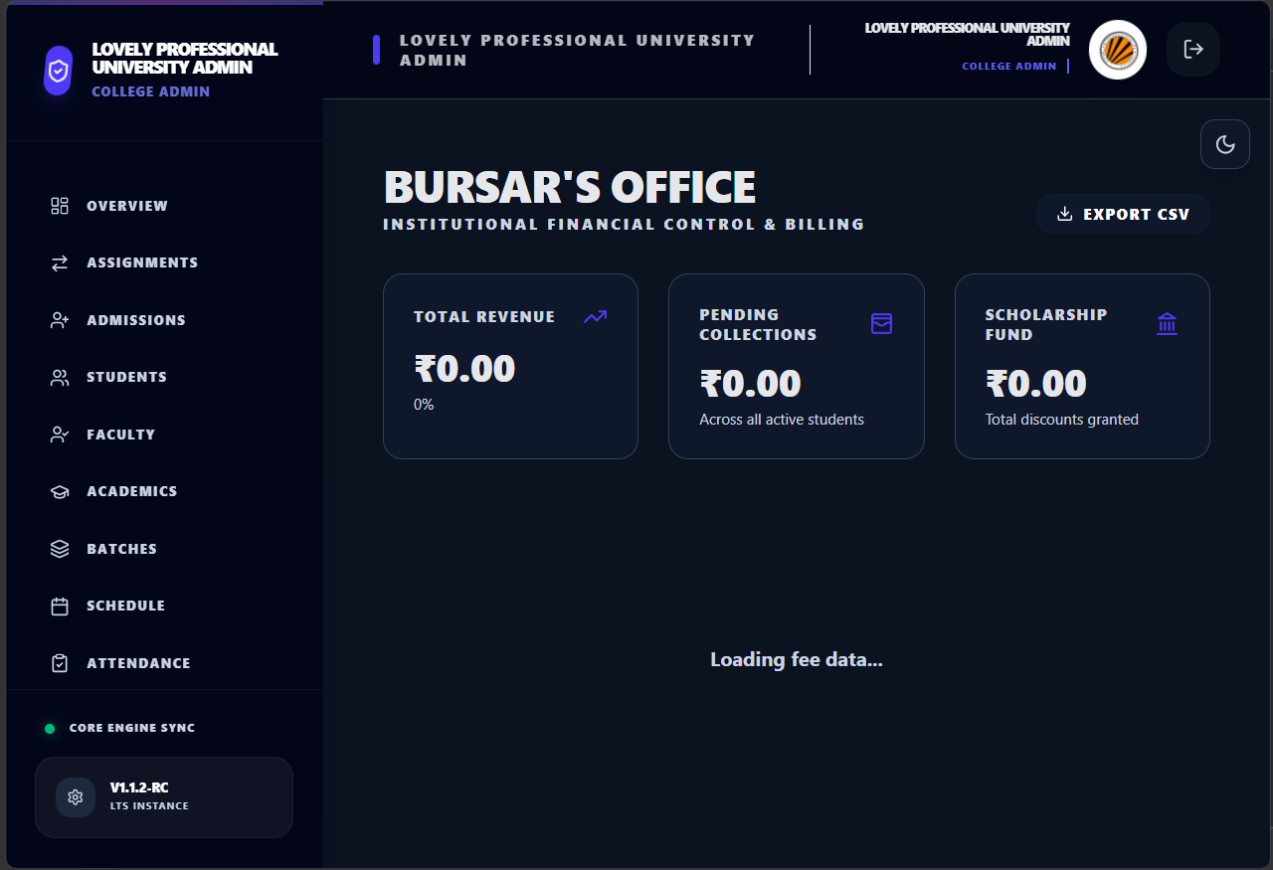
FEES MODULE IS NOT CONNECTED PROPERLY
STUDENT LOGIN
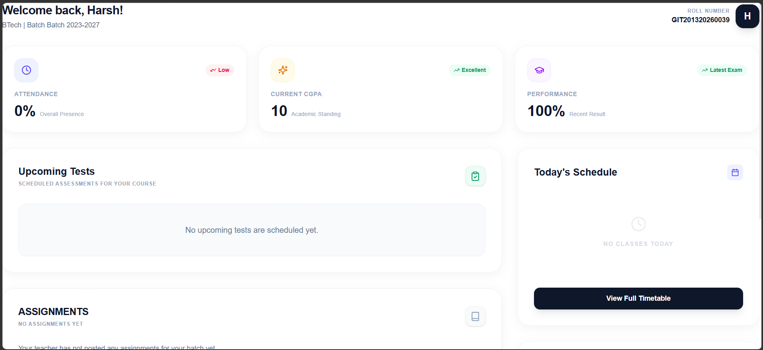
WHERE IS SIDEBAR??
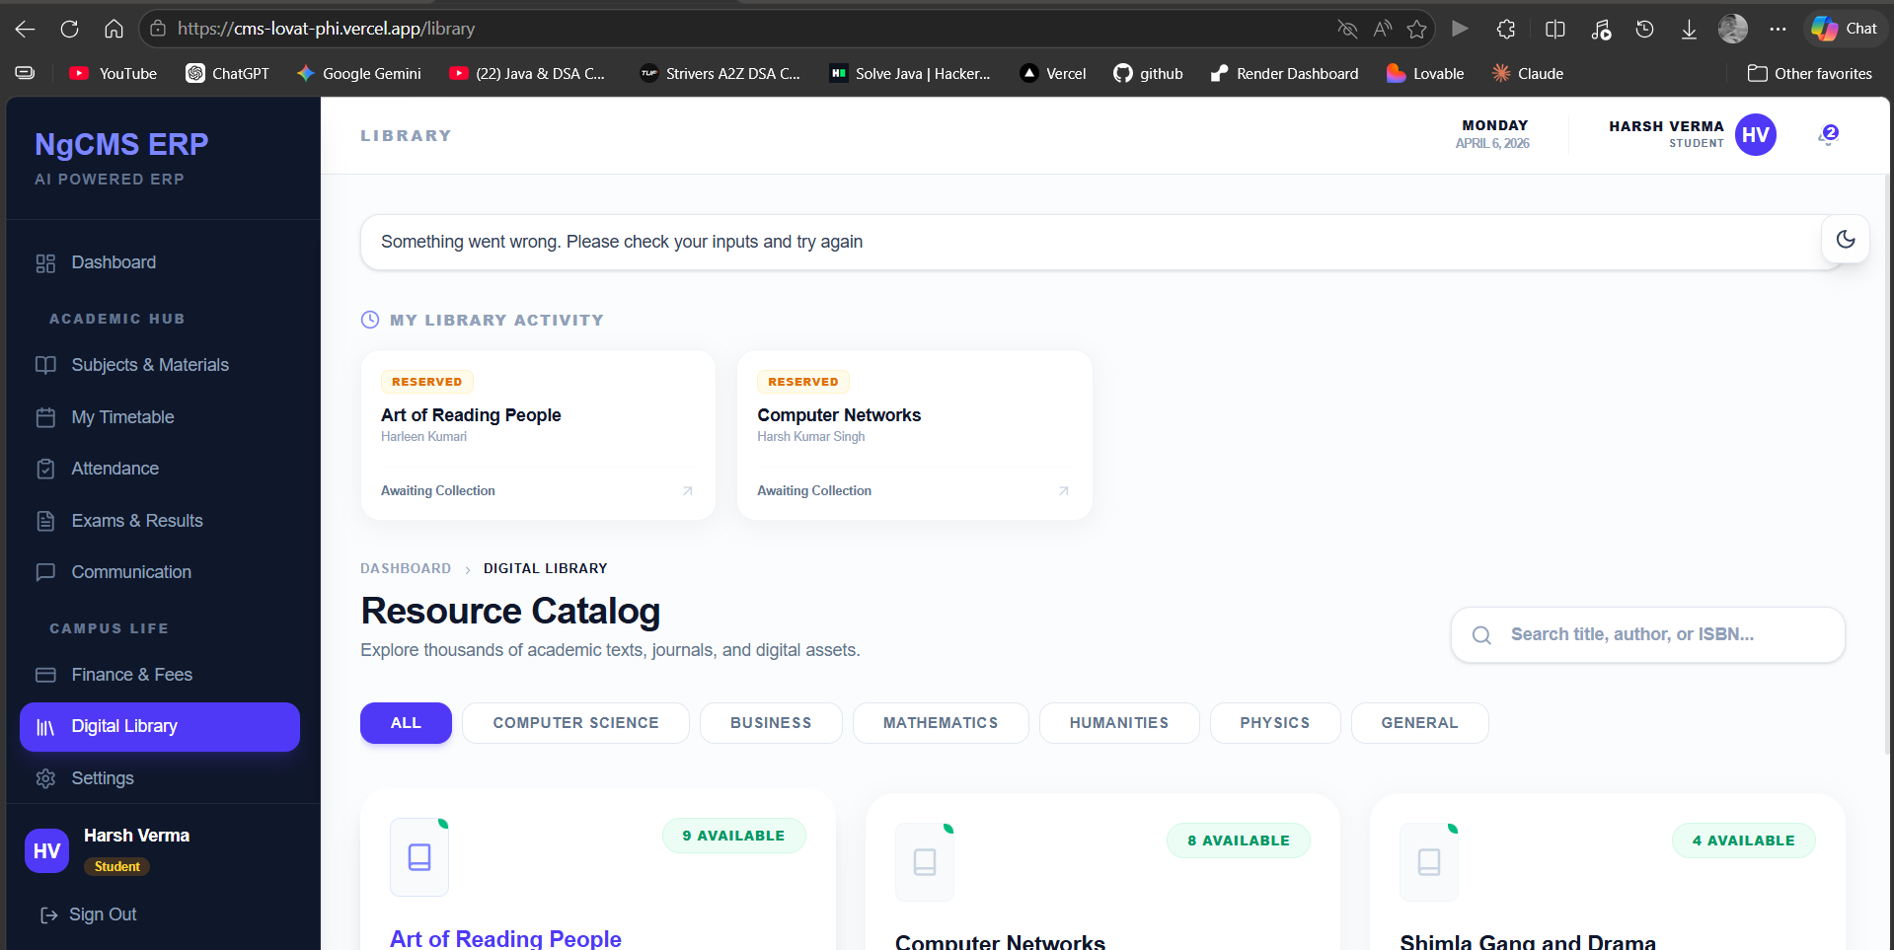
ALREADY RESERVE SHOULD COME HERE
PARENT LOGIN
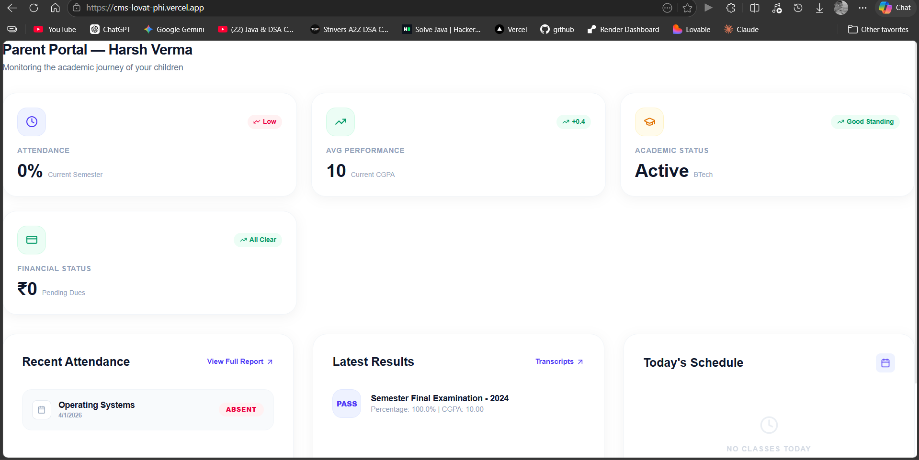
SEE SAME HERE ALSO DASHBOARD PANEL ERROR
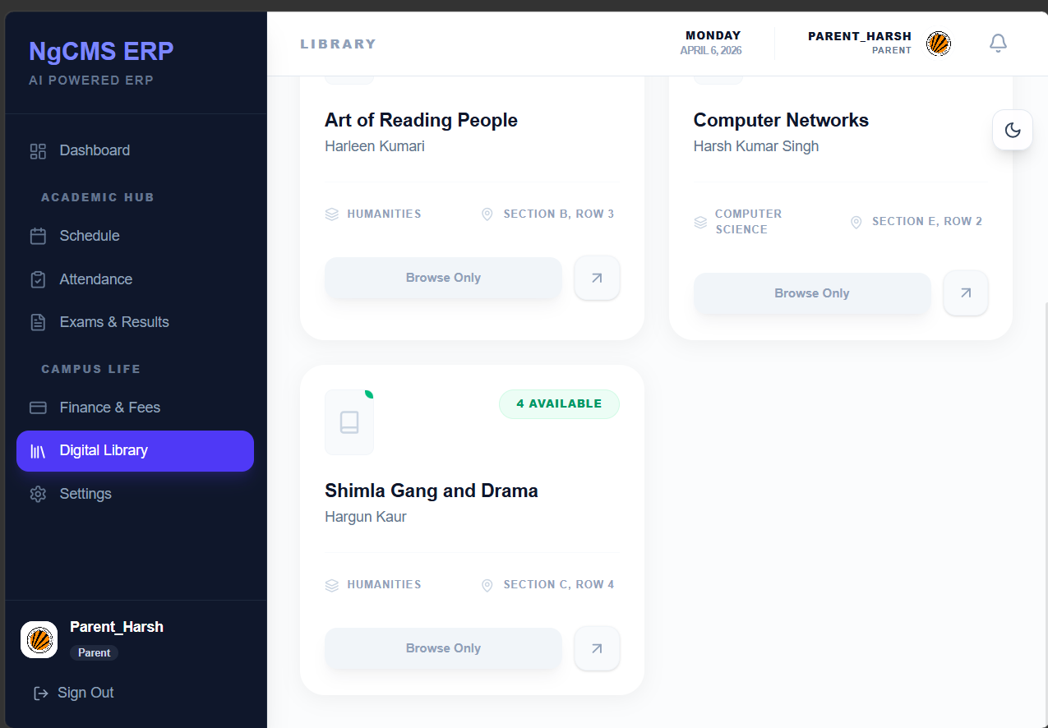
WHY DIGITAL LIBRARY FOR PARENT??
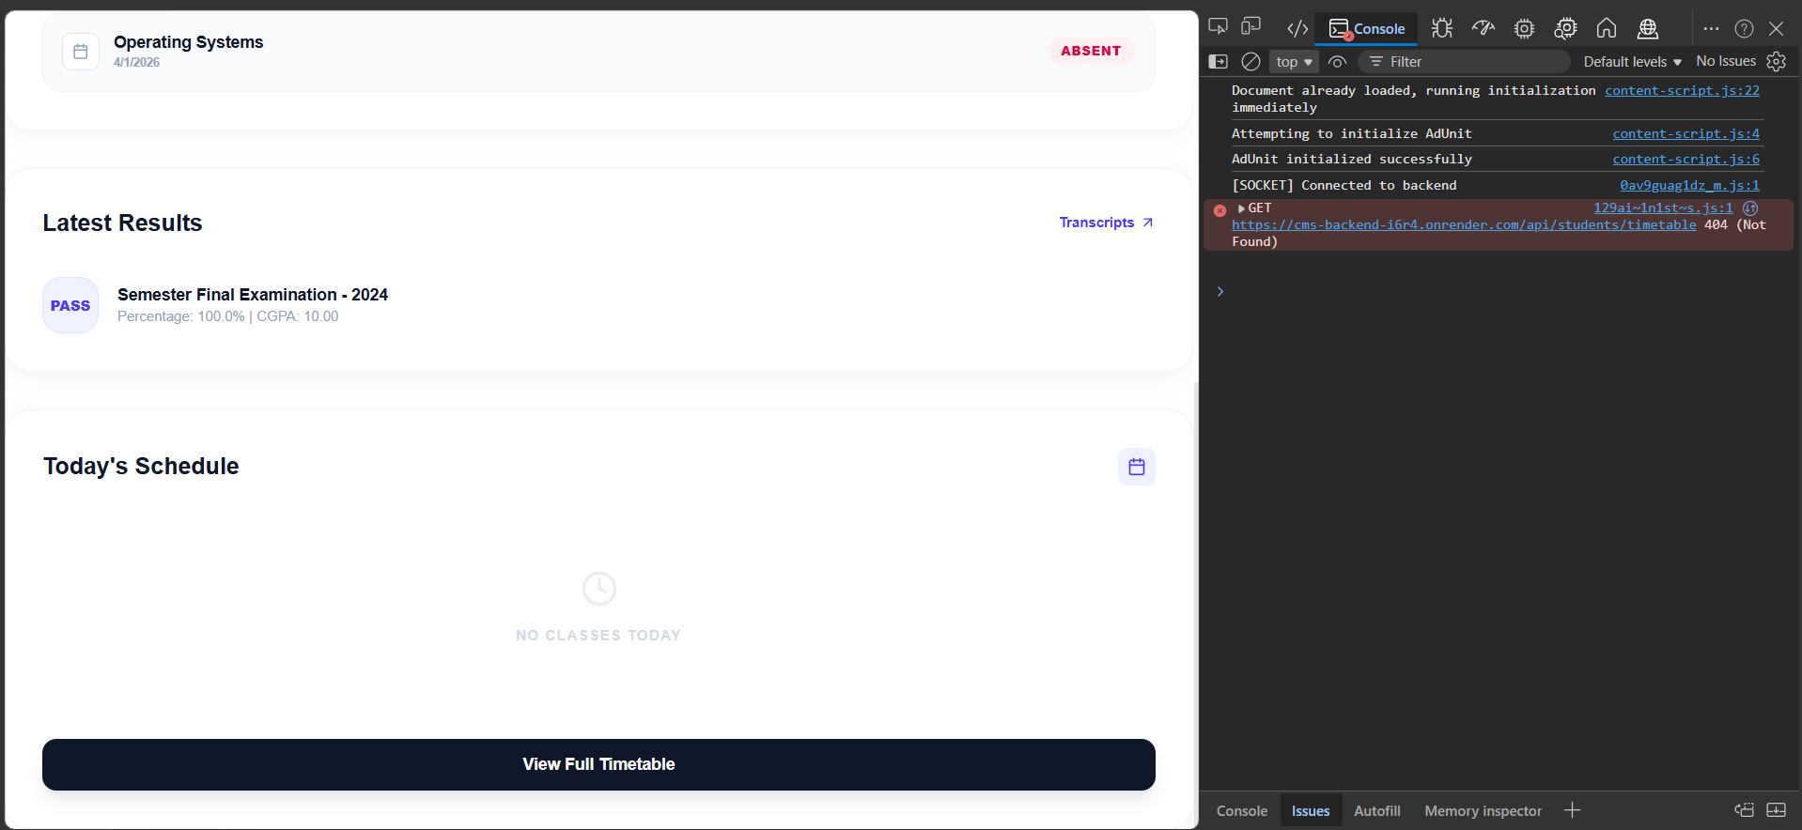
WHEN CLICKING ON VIEW TIMETABLE ERROR
AND
DASHBOARD AND SIDEBAR ARE ALMOST SAME AS STUDENT

