OMNICHANNEL PHARMACY
OPERATIONS PLATFORM

Production-Ready Solution Design, Architecture & Working Prototype

Hackathon Case Study — Centific / Aegis Platform
Technology: Python · FastAPI · PostgreSQL · React PWA · Microservices · Apache Kafka
Scale: 1,200+ DAU · 18 Stores + Central Warehouse · 19 Locations

By Hargun (hargungulati2004@gmail.com)

April 2026

Table of Contents
Table of Contents 2
1. Executive Summary 4
1.1 Business Objectives 4
1.2 Design Principles 4
2. System Architecture 5
2.1 High-Level Architecture Diagram 5
2.2 Microservices Inventory 5
2.3 Technology Stack 6
3. Authentication & Role-Based Access Control 7
3.1 Role Permissions Matrix 7
3.2 JWT Token Structure 7
3.3 Security Controls 8
4. Inventory, Batch & Expiry Management 9
4.1 Stock Management 9
4.2 Key Database Tables 9
4.3 Expiry Tracking 10
4.4 Real-Time Stock Visibility 10
5. Sales & POS Workflows 11
5.1 Transaction Types 11
5.2 Post-Transaction Event Cascade 11
5.3 Prescription Audit Trail 11
6. Agentic AI Features 13
6.1 Demand Forecasting 13
6.2 Anomaly & Exception Detection 13
6.3 Conversational Query (AI Chat) 14
6.4 AI Guardrails 14
7. API Contracts 16
7.1 Authentication — POST /api/v1/auth/login 16
7.2 Inventory — GET /api/v1/inventory/stock 16
7.3 Sales — POST /api/v1/sales/transaction 17
7.4 AI Forecast — GET /api/v1/ai/forecast 17
7.5 AI Chat — POST /api/v1/ai/chat 17
8. BI Reporting & Compliance Dashboards 19
8.1 Role-Specific Dashboards 19
8.2 Compliance Reports 19
8.3 Reporting Data Pipeline 19
9. Non-Functional Requirements 21
9.1 Performance 21
9.2 Scalability 21
9.3 Reliability & Availability 21
9.4 Security 21
9.5 Observability Stack 22
10. Deployment Architecture 23
10.1 Environment Strategy 23
10.2 CI/CD Pipeline Steps 23
11. ERP Integration & Offline Mobile 25
11.1 ERP Integration 25
11.2 Offline Mobile Architecture 25
12. Data Model & Governance 27
12.1 Data Retention Policy 27
12.2 PII Protection 27
13. Working Code Implementation 29
13.1 Project Structure 29
13.2 Shared RBAC Middleware 29
13.3 Inventory Service — Stock & Replenishment Endpoints 30
13.4 Sales Service — POS Transaction 30
13.5 AI Service — Demand Forecasting 31
14. Evaluation Criteria — Compliance Checklist 32

1. Executive Summary

The Omnichannel Pharmacy Operations Platform (OPOP) is a cloud-native, microservices-based web application designed to unify pharmacy retail operations across 18 branch stores and one central warehouse. Built on Python, FastAPI, and PostgreSQL, it addresses the full operational lifecycle — from prescription intake and OTC sales through to real-time inventory, batch/expiry management, AI-driven forecasting, and compliance reporting.

The platform supports 1,200+ daily active users across mobile, tablet, and desktop interfaces — with offline resilience for store staff in areas of intermittent connectivity. Every stock and transaction change is fully auditable. AI features are advisory only, with human approval gates ensuring compliance in a regulated healthcare-adjacent environment.

1.1 Business Objectives
- Centralise inventory and sales visibility across all 19 locations (18 branches + central warehouse)
- Eliminate stockouts and expiry losses through automated alerts and AI-driven replenishment suggestions
- Ensure full regulatory compliance with immutable audit trails for every stock and transaction change
- Enable data-driven decisions via role-specific BI dashboards and AI demand forecasting
- Seamlessly integrate with the legacy ERP system for purchase order management
- Support offline-tolerant workflows for store staff in areas with intermittent connectivity

1.2 Design Principles
Principle | Application in This Design
Microservices Separation | 9 independent services — Auth, Inventory, Sales, AI/ML, Reporting, ERP Adapter, Notification, Audit, API Gateway — each with its own PostgreSQL schema and independent deployability
Security by Default | OAuth 2.0 + JWT (RS256), RBAC at gateway + service level, Row-Level Security in PostgreSQL, AES-256 for PII, TLS 1.3 everywhere
Offline Tolerant | React PWA with Service Workers + IndexedDB — POS and stock operations function fully without internet; sync queue replays on reconnection
Scalable & Observable | Kubernetes HPA, stateless services, Redis caching, Kafka async decoupling, Prometheus + Grafana + ELK observability stack
Compliant AI | All AI outputs are advisory — no autonomous stock changes, human approval gates on all AI-suggested actions, PII masked in AI responses, all queries audited

2. System Architecture

The platform is built on a microservices architecture pattern. Each service is independently deployable, communicates via REST APIs synchronously and Apache Kafka asynchronously. The front end is a React-based Progressive Web Application. All services are containerised with Docker and orchestrated on Kubernetes (AWS EKS in production).

2.1 High-Level Architecture Diagram

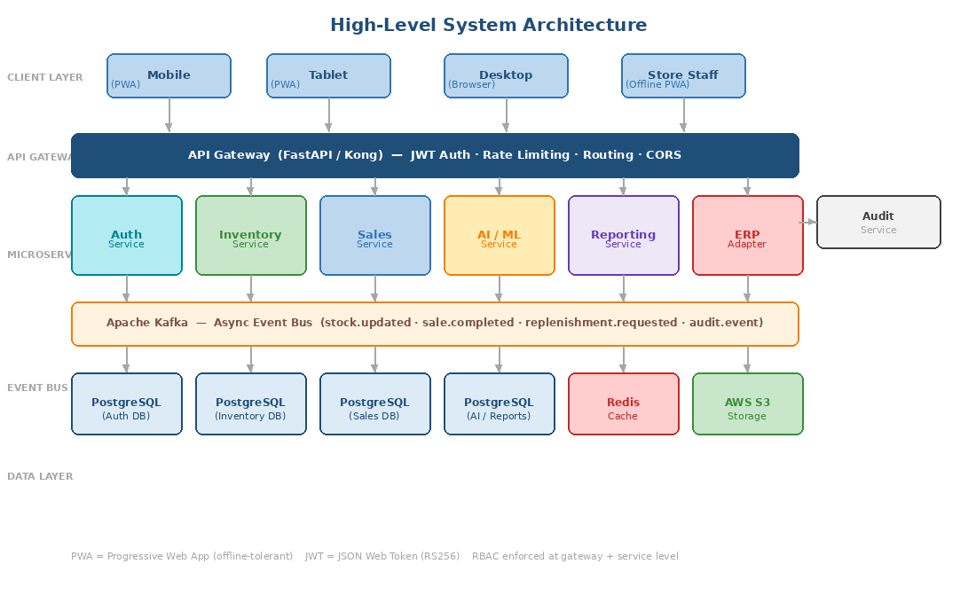
Figure 1 — Full system architecture showing client layer, API gateway, 9 microservices, Kafka event bus, and data layer

2.2 Microservices Inventory
Service | Responsibility | Tech | Port
API Gateway | Central entry point — routing, JWT validation, rate limiting, CORS | Kong / FastAPI | 8080
Auth Service | Login, JWT issuance, RBAC, MFA for admins, session management | FastAPI + PostgreSQL | 8001
Inventory Service | Stock levels, batch tracking, expiry alerts, replenishment | FastAPI + PostgreSQL | 8002
Sales Service | OTC + Rx POS, prescription dispensing, returns, receipts | FastAPI + PostgreSQL | 8003
Reporting Service | BI dashboards, compliance reports, scheduled exports | FastAPI + PostgreSQL | 8004
AI/ML Service | Demand forecasting, anomaly detection, conversational query | FastAPI + Python ML | 8005
ERP Adapter | Sync purchase orders + GRNs with legacy ERP (REST/SOAP) | FastAPI + REST/SOAP | 8006
Notification Service | Push alerts for expiry, low stock, anomalies | FastAPI + Kafka Consumer | 8007
Audit Service | Immutable audit log for all stock and transaction changes | FastAPI + PostgreSQL | 8008

2.3 Technology Stack
Layer | Technology | Justification
Backend Framework | Python 3.12 / FastAPI | Async-native, auto-generates OpenAPI docs, integrates natively with Python ML ecosystem
Database | PostgreSQL 15 | ACID compliance, JSONB for flexible audit payloads, Row-Level Security for branch isolation
Cache | Redis 7 | Session tokens, response caching, real-time counters
Message Bus | Apache Kafka | Reliable async event streaming — decouples services, enables replay, supports audit
Frontend | React 18 + TypeScript + Tailwind | Component reuse, PWA capabilities, responsive across mobile/tablet/desktop
Offline Support | Service Workers + IndexedDB | Full POS functionality without internet; sync queue on reconnection
Container Orchestration | Docker + Kubernetes (AWS EKS) | Horizontal autoscaling, zero-downtime deploys, namespace isolation
AI / ML | Prophet, scikit-learn, LangChain | Prophet for time-series forecasting, Isolation Forest for anomaly detection, LangChain for NL→SQL chat
Observability | Prometheus + Grafana + ELK + Jaeger | Metrics, dashboards, centralised logs, distributed tracing
Auth | OAuth 2.0 + JWT RS256 + RBAC | Stateless, asymmetric-signed tokens; role claims in payload
Object Storage | AWS S3 / MinIO | Receipts, compliance report archives, prescription scans
Secrets Management | HashiCorp Vault / AWS Secrets Manager | No credentials in code or config files — all injected at runtime

3. Authentication & Role-Based Access Control

All users authenticate via OAuth 2.0 (username/password or SSO) and receive a signed JWT with embedded role claims. The API Gateway validates every request before forwarding to downstream services. Row-Level Security (RLS) in PostgreSQL provides a second layer of isolation at the database level.

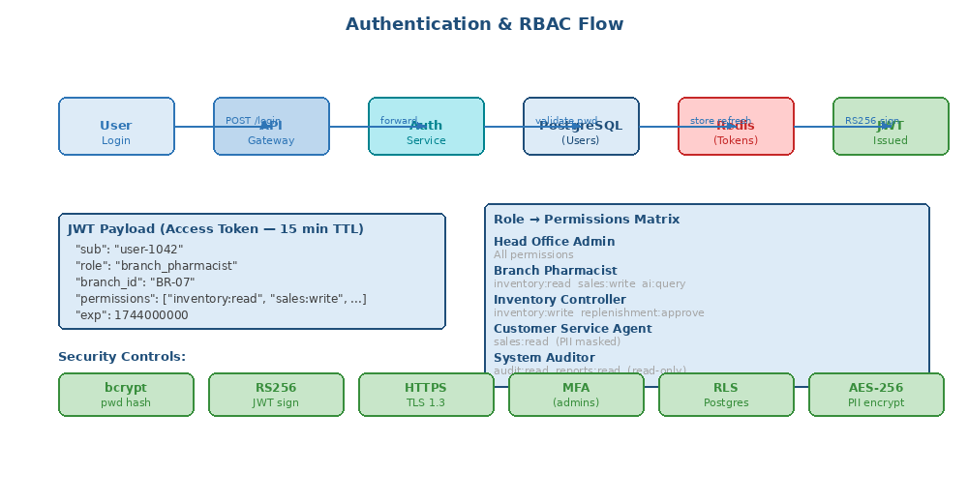
Figure 2 — Authentication flow and RBAC matrix showing token issuance, role permissions, and security controls

3.1 Role Permissions Matrix
Role | Description | Key Permissions
Head Office Admin | Central management — all stores | Full access: users, stores, inventory, sales, reports, AI, ERP sync. MFA required.
Branch Pharmacist | Sales + stock at assigned store only | inventory:read | sales:read + write | reports:read | ai:query
Inventory Controller | Stock management across branches | inventory:read + write | replenishment:approve | ai:read + query
Customer Service Agent | Customer queries and returns | sales:read | customer:read (PII masked to initials + last 4 digits)
System Auditor | Read-only compliance review | audit:read | reports:read | No write permissions whatsoever

3.2 JWT Token Structure
// Access Token Payload (RS256 signed, 15-minute TTL)
{
"sub": "user-1042",
"role": "branch_pharmacist",
"branch_id": "BR-07",
"permissions": ["inventory:read", "sales:write", "ai:query"],
"iat": 1744000000,
"exp": 1744000900 // 15 minutes
}

// Refresh Token: 7-day TTL, stored in Redis (invalidatable for forced logout)
// Private key: only on Auth Service (loaded from HashiCorp Vault, never in code)

3.3 Security Controls
Control | Implementation | Why
Password Hashing | bcrypt with 12 rounds | Slow hashing prevents brute force; no plaintext ever stored
JWT Signing | RS256 asymmetric | Private key only on Auth Service — services verify with public key only
Account Lockout | 5 failed attempts → 15-minute lockout | Brute force protection; lockout stored in Redis
MFA | TOTP (Google Authenticator compatible) | Required for all head_office_admin accounts
PII Encryption | AES-256-GCM at column level | Patient name, phone, address encrypted at rest in PostgreSQL
Row-Level Security | PostgreSQL RLS policies by branch_id | Branch staff cannot query other branch data even with direct DB access
Transport Security | TLS 1.3 enforced on all connections | Downgrade attacks prevented; certificate pinning on mobile PWA
Audit Trail | Every auth event → immutable Audit Service | Login, logout, failed attempts, token refresh all logged with timestamp

4. Inventory, Batch & Expiry Management

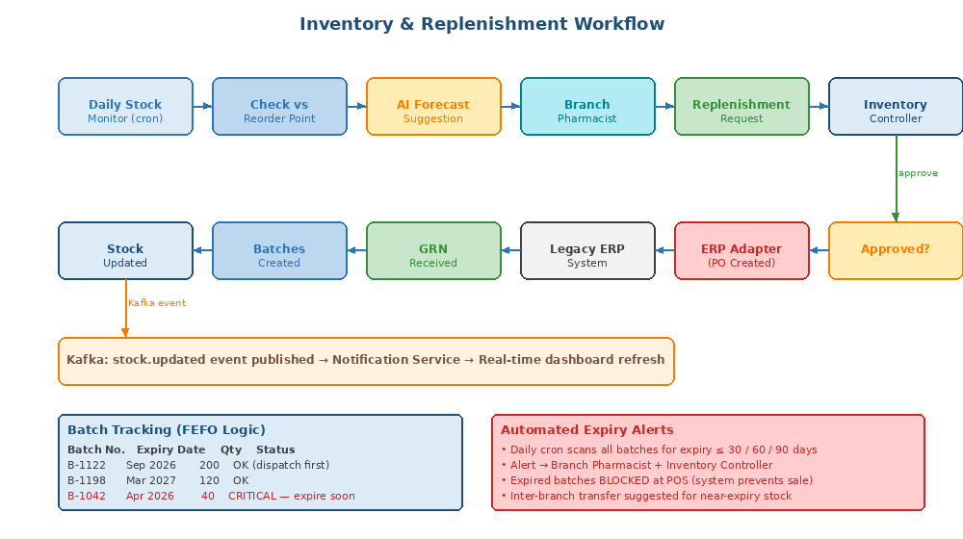
Figure 3 — Inventory and replenishment workflow from stock monitoring through ERP purchase order creation

4.1 Stock Management
The Inventory Service tracks stock at the batch level using FEFO (First Expired, First Out) logic. Every stock change — sale, replenishment, transfer, or adjustment — is recorded as an immutable StockMovement record and published as a Kafka event.

4.2 Key Database Tables
Table | Key Columns | Purpose
products | product_id, name, sku, category, requires_prescription, reorder_point, unit_price | Master product catalogue — source of truth for all branches
batches | batch_id, product_id, location_id, batch_no, quantity, expiry_date, mfg_date | Batch-level stock. FEFO ordering by expiry_date. location_id = branch or WAREHOUSE
stock_movements | movement_id, product_id, batch_id, from_location, to_location, quantity, reason, user_id, timestamp | Immutable audit trail of every stock change. Append-only.
replenishment_requests | req_id, branch_id, product_id, requested_qty, status, requested_by, approved_by | Multi-step replenishment workflow with status tracking

4.3 Expiry Tracking
- Daily cron job (2:00 AM) scans all batches for expiry within 30, 60, and 90 days
- Colour-coded alerts on dashboard: Red = ≤30 days, Amber = 31–60, Green = >60 days
- Automated push notification to branch pharmacist AND inventory controller
- Expired batches are hard-blocked at the POS — system rejects sale attempt with error
- Inter-branch transfer suggestion raised for near-expiry stock where another branch is low

4.4 Real-Time Stock Visibility
- Every sale and stock movement publishes a Kafka 'stock.updated' event within milliseconds
- Inventory Service consumers update Redis cache — dashboard reads from Redis (no DB hit)
- WebSocket connection from browser keeps branch dashboard live without manual refresh
- Head Office admin can view real-time stock across all 19 locations on a single screen
- Low-stock threshold alerts trigger when quantity_available < reorder_point

5. Sales & POS Workflows

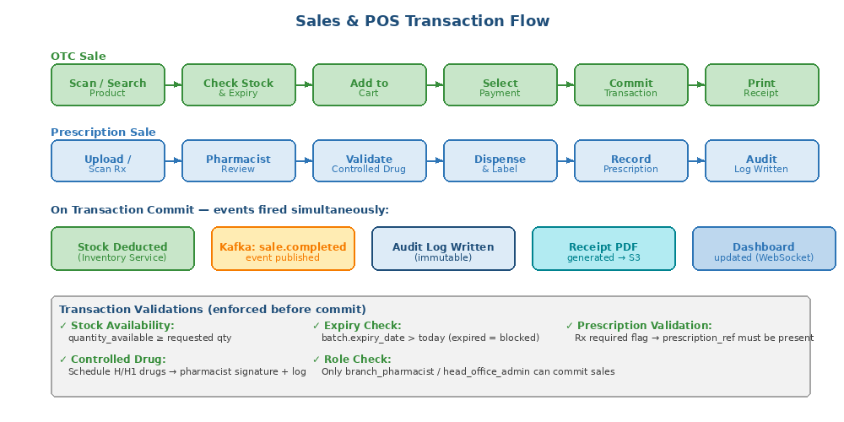
Figure 4 — Complete POS transaction flow for OTC sales, prescription dispensing, and post-commit event cascade

5.1 Transaction Types
Type | Process | Validations
OTC Sale | Scan/search product → add to cart → select payment → commit → receipt | Stock available, not expired, product active, payment method valid
Prescription Sale | Upload/scan Rx → pharmacist review → validate controlled drug → dispense → label → log | Prescription valid, pharmacist signature, controlled drug flag, patient record match
Return / Refund | Locate original transaction → verify reason → restock batch or quarantine → issue refund | Within return window, original receipt present, pharmacist approval for Schedule drugs

5.2 Post-Transaction Event Cascade
On successful transaction commit, five things happen simultaneously and asynchronously:
- Stock deducted from the specific batch_id in Inventory Service (synchronous — blocks commit if insufficient)
- Kafka event 'sale.completed' published → consumed by Reporting Service and Notification Service
- Kafka event 'audit.event' published → consumed by Audit Service (immutable log entry created)
- PDF receipt generated and stored in AWS S3
- WebSocket push to branch dashboard — transaction count and revenue totals updated live

5.3 Prescription Audit Trail
Controlled Drug Compliance
Every Schedule H / H1 prescription dispensing creates a permanent record containing:
• Prescription reference number and scan/image (stored encrypted in S3)
• Dispensing pharmacist ID, timestamp, and digital signature
• Patient reference (encrypted PII — pharmacist access only)
• Drug name, batch number, quantity dispensed
• AI-verified cross-check against prescription image (optional module)
This data feeds the daily Controlled Drug Register report — auto-generated at 07:00 AM.

6. Agentic AI Features

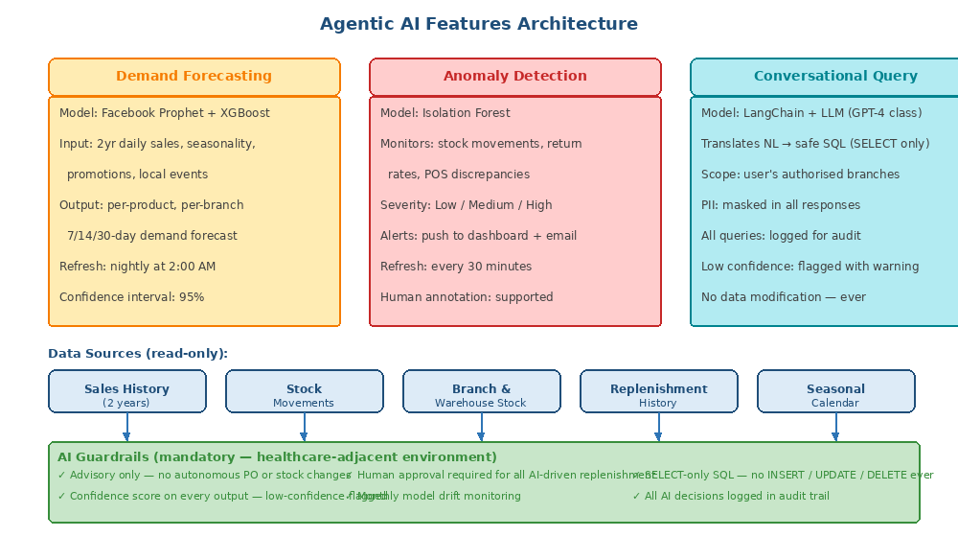
Figure 5 — Three AI modules (forecasting, anomaly detection, conversational query), their data sources, and mandatory guardrails

6.1 Demand Forecasting
Aspect | Detail
Algorithm | Facebook Prophet (time-series baseline) + XGBoost (feature-rich override for promotions/events)
Training Data | 2 years of daily sales per product per branch, day-of-week patterns, seasonal calendar, promotional events
Output | Per-product, per-branch demand forecast for 7/14/30 days with 95% confidence intervals
Refresh Cycle | Nightly batch retraining at 2:00 AM; intraday cache updates every 4 hours
UI Presentation | Forecast chart overlaid on historical sales in Inventory dashboard; exportable to CSV/XLSX
Guardrail | Forecasts are advisory suggestions — Inventory Controller must approve before any PO is raised

6.2 Anomaly & Exception Detection
Isolation Forest algorithm applied continuously to stock movement data. Detects patterns that deviate significantly from 30-day rolling baselines.

Anomaly Type | Detection Method | Severity | Response
Stock shrinkage | Unexplained drop in batch quantity without matching sale | High / Critical | Alert to Head Office Admin + Inventory Controller
Unusual return rate | Return rate > 3σ above product baseline | Medium / High | Alert to branch pharmacist; possible batch quality flag
Demand spike | Single transaction quantity > 5× typical order | Medium | Alert for manual review; check for bulk resale
POS discrepancy | Mismatch between POS sale count and stock deduction | High | Immediate alert; transaction flagged for audit

6.3 Conversational Query (AI Chat)
Powered by LangChain + a production LLM (Claude / GPT-4 class). Translates natural language questions into safe, read-only SQL and returns formatted results.

Example Conversations
User: "Which branch had the most Paracetamol sales last week?"
→ AI: "Branch 7 (Sector 17) sold 1,240 units last week, followed by Branch 12 (890) and Branch 3 (780)."
Generated SQL: SELECT branch_id, SUM(qty) FROM transaction_items WHERE product_id='PCM-500'
AND date >= NOW()-INTERVAL '7 days' GROUP BY 1 ORDER BY 2 DESC

User: "Is our Metformin stock sufficient for next month?"
→ AI: "Current stock: 18 units. Forecast demand: 280 units. CRITICAL — stock insufficient.
Recommended order: 500 units. Note: Batch B-2201 also expires Sep 2026."

User: "Show all products expiring before June 2026 in the warehouse."
→ AI: Returns table of 3 products with batch numbers, quantities, and expiry dates.

6.4 AI Guardrails
- SELECT-only SQL — the LangChain SQL agent is connected to a read-only reporting replica. INSERT, UPDATE, DELETE are syntactically blocked.
- Scope enforcement — query results are filtered to the user's authorised branches via a WHERE clause injected by the middleware before execution.
- PII masking — patient names shown as initials only, phone numbers truncated to last 4 digits in all AI responses.
- Confidence scoring — every AI response includes a confidence score; responses below 0.6 are flagged with a visible warning.
- Audit logging — every AI query, its generated SQL, user_id, and response confidence are written to the Audit Service log.
- Advisory only — no AI module can trigger stock changes, POs, or user actions. All such actions require a human to click 'Confirm'.
- Monthly drift monitoring — model accuracy monitored against actual outcomes; alert raised if accuracy falls below threshold.

7. API Contracts

All services expose RESTful APIs documented via OpenAPI 3.0 (auto-generated by FastAPI, available at /docs on each service). All requests require a valid JWT Bearer token. The API Gateway enforces role-level route permissions before forwarding.

7.1 Authentication — POST /api/v1/auth/login
// Request
POST /api/v1/auth/login
Content-Type: application/json
{
"username": "pharmacist@branch7.com",
"password": "••••••••",
"mfa_code": "123456" // required for head_office_admin only
}

// Response 200 OK
{
"access_token": "eyJhbGciOiJSUzI1NiIs...",
"refresh_token": "dGhpcyBpcyBhIHJlZ...",
"token_type": "Bearer",
"expires_in": 900,
"user": {
"user_id": "U-1042",
"role": "branch_pharmacist",
"branch_id": "BR-07"
}
}

// Error 401 { "detail": "Invalid credentials" }
// Error 423 { "detail": "Account locked. Try again in 15 minutes." }

7.2 Inventory — GET /api/v1/inventory/stock
GET /api/v1/inventory/stock?branch_id=BR-07&product_id=PRD-442
Authorization: Bearer <token>

// Response 200 OK
{
"product_id": "PRD-442",
"product_name": "Paracetamol 500mg",
"branch_id": "BR-07",
"quantity_available": 320,
"reorder_point": 100,
"status": "ok", // ok | low | critical | out_of_stock
"batches": [
{ "batch_id": "B-1122", "batch_no": "PCM-2024-01", "expiry_date": "2026-09-30", "quantity": 200 },
{ "batch_id": "B-1198", "batch_no": "PCM-2024-02", "expiry_date": "2027-03-15", "quantity": 120 }
]
}

7.3 Sales — POST /api/v1/sales/transaction
POST /api/v1/sales/transaction
Authorization: Bearer <token>

// Request
{
"branch_id": "BR-07",
"sale_type": "otc", // otc | prescription | return
"items": [
{ "product_id": "PRD-442", "batch_id": "B-1122", "quantity": 2, "unit_price": 12.50 }
],
"payment_method": "cash",
"total_amount": 25.00
}

// Response 201 Created
{
"transaction_id": "TXN-20260405-8847",
"receipt_url": "/api/v1/sales/receipt/TXN-20260405-8847",
"status": "completed",
"created_at": "2026-04-05T18:42:00Z"
}

// Side-effects: stock deducted | Kafka event published | audit log written | receipt to S3

7.4 AI Forecast — GET /api/v1/ai/forecast
GET /api/v1/ai/forecast?product_id=PRD-442&branch_id=BR-07&days=30
Authorization: Bearer <token>

// Response 200 OK
{
"product_id": "PRD-442",
"branch_id": "BR-07",
"forecast_period_days": 30,
"predicted_demand": 480,
"confidence_interval": { "lower": 420, "upper": 540 },
"current_stock": 320,
"stock_sufficient": false,
"recommended_order_qty": 200,
"model_version": "prophet-v2.1",
"generated_at": "2026-04-05T02:00:00Z"
}

7.5 AI Chat — POST /api/v1/ai/chat
POST /api/v1/ai/chat
Authorization: Bearer <token>

// Request
{ "question": "Which branch had most Paracetamol sales last week?" }

// Response 200 OK
{
"answer": "Branch 7 sold 1,240 units — highest among your authorised branches.",
"generated_sql": "SELECT branch_id, SUM(qty) FROM ... WHERE ...",
"confidence": 0.94,
"data": [{ "branch_id": "BR-07", "units": 1240 }, ...],
"warning": null // set if confidence < 0.6
}

8. BI Reporting & Compliance Dashboards

The Reporting Service aggregates data from all operational services via Kafka CDC (Change Data Capture) into a PostgreSQL reporting replica with pre-computed materialised views. This ensures reporting queries never impact transactional performance.

8.1 Role-Specific Dashboards
Dashboard | Audience | Key Widgets
Executive Overview | Head Office Admin | Total revenue all branches, branch ranking, AI anomaly count, low-stock summary, replenishment pipeline status
Branch Operations | Branch Pharmacist | Today's sales, transaction count, stock alerts, expiry warnings, pending prescription queue
Inventory Control | Inventory Controller | Stock-on-hand across 19 locations, batch expiry timeline, transfer status, forecast vs actual
Compliance & Audit | Auditor / Admin | Controlled drug dispensing log, stock variance, user activity log, prescription audit trail
Sales Analytics | All Managers | Revenue by product/category/time period, return rates, peak-hour heatmap, YoY trend

8.2 Compliance Reports
Report | Frequency | Content | Recipients
Controlled Drug Register | Daily 07:00 | All Schedule H/H1 dispensing with pharmacist ID, batch, patient ref (masked) | Branch Manager, Head Office Admin
Stock Variance Report | Weekly Monday | System stock vs physical count discrepancies by branch | Inventory Controller, Head Office Admin
Expiry Compliance Report | Monthly 1st | Products dispatched within 30 days of expiry; batches destroyed | Compliance Officer, Head Office Admin
Prescription Audit Trail | On-demand | Full prescription lifecycle from intake to dispensing | System Auditor (read-only)
User Activity Log | On-demand | All login, logout, data modification events with timestamps | System Auditor (read-only)
AI Decision Audit Log | Weekly | All AI queries, generated SQL, and actions approved based on AI recommendations | Head Office Admin

8.3 Reporting Data Pipeline
Reporting Architecture
OLTP Databases (per service)
→ Kafka CDC (Change Data Capture — Debezium connector)
→ PostgreSQL Reporting Replica
→ Materialised Views (pre-aggregated, refreshed hourly)
→ Reporting Service API (read-only endpoints)
→ React Dashboard (Recharts / D3.js charts)

Export Formats: PDF (for compliance filing), Excel XLSX, CSV
Scheduled Delivery: Emailed daily at 07:00 AM to configured recipient lists
Ad-hoc: Date-range + branch + product filters available in UI

9. Non-Functional Requirements

9.1 Performance
Metric | Target | Design Approach
API Response Time (P95) | < 300 ms | Redis caching for all frequently-read data; PostgreSQL indexes on all FK + filter columns; connection pooling via PgBouncer
Dashboard Load Time | < 2 seconds | Materialised views for reporting; CDN-served static assets via CloudFront; lazy-loaded charts
POS Transaction Commit | < 500 ms end-to-end | Synchronous stock deduction only; all other side-effects (Kafka, audit, receipt) are async
Concurrent Users | 200 peak / 1,200+ DAU | Kubernetes HPA scales pods automatically; stateless services scale horizontally without coordination
Offline POS | Full function without internet | IndexedDB caches product catalogue and current stock; offline queue stores up to 24h of transactions

9.2 Scalability
- Each microservice scales independently via Kubernetes Horizontal Pod Autoscaler (HPA) based on CPU and custom metrics
- Kafka decouples producers from consumers — Inventory Service can be scaled without affecting Sales Service
- PostgreSQL read replicas serve reporting and AI read workloads — zero impact on OLTP performance
- Redis Cluster with sharding handles distributed session and cache load across nodes

9.3 Reliability & Availability
Requirement | Target / Design
Uptime SLA | 99.5% — Multi-AZ Kubernetes deployment; automated pod restart; health check probes
Data Durability | PostgreSQL WAL archiving + daily snapshots to S3; point-in-time recovery enabled
Graceful Degradation | AI Service outage does not affect POS, Inventory, or Sales — services operate independently
Circuit Breaker | Failed downstream calls return cached data or safe defaults; no cascading failures
RTO / RPO | RTO < 4 hours, RPO < 1 hour via standby replica and snapshot restore procedures

9.4 Security
- All traffic encrypted in transit (TLS 1.3) and at rest (AES-256 for PII columns, PostgreSQL encryption at rest)
- OWASP Top 10 mitigations: parameterised queries (no SQL injection), Content-Security-Policy headers (no XSS), CSRF tokens on state-changing requests
- Secrets managed via HashiCorp Vault — no credentials in environment variables, code, or Docker images
- Dependency vulnerability scanning in CI/CD pipeline (Bandit for Python, Snyk for dependencies)
- Data masking in staging/dev environments — no real patient or customer data outside production

9.5 Observability Stack
Concern | Tool | What It Monitors
Metrics | Prometheus + Grafana | Request rates, error rates, latency (P50/P95/P99), Kafka consumer lag, DB connection pool usage
Logging | ELK Stack (Elasticsearch + Logstash + Kibana) | Structured JSON logs from all services; searchable by user_id, transaction_id, branch_id
Tracing | OpenTelemetry + Jaeger | End-to-end request tracing across microservice boundaries — trace_id propagated via HTTP headers
Alerting | Grafana Alerts + PagerDuty | P1 alerts (service down, DB unreachable) auto-escalate to on-call; P2 alerts trigger Slack notifications
Synthetic Monitoring | Checkly / Pingdom | Synthetic POS and login transactions run every 5 minutes from external; SLA dashboard

10. Deployment Architecture

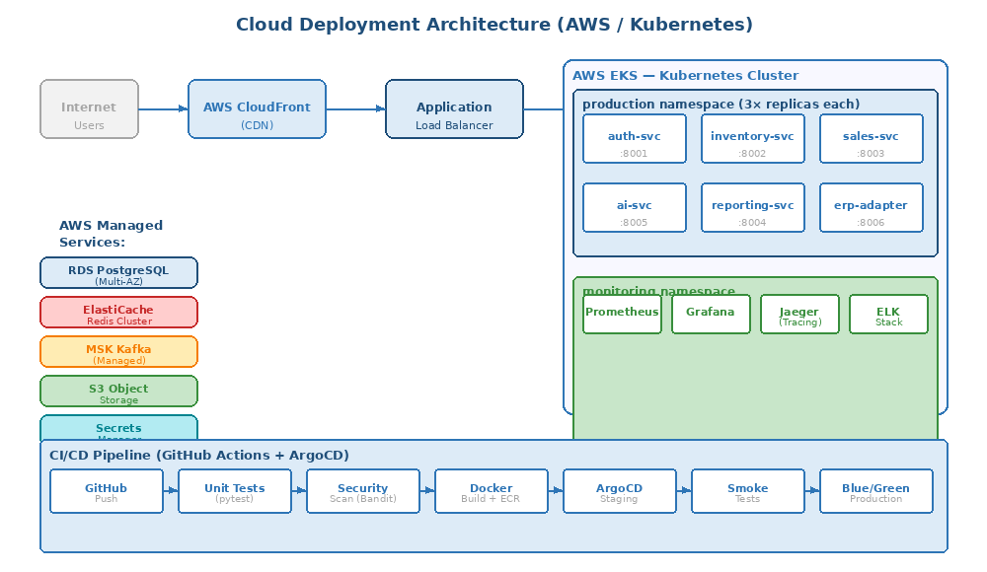
Figure 6 — AWS / Kubernetes deployment topology with CI/CD pipeline, managed services, and monitoring namespace

10.1 Environment Strategy
Environment | Purpose | Data Policy | Access
Development | Local dev + shared dev cluster (Docker Compose) | Synthetic data only — no real records | All engineers
Staging | Pre-production integration testing + UAT | Anonymised/masked production data snapshot | Engineers + QA + Stakeholders
Production | Live customer-facing system | Real data; full security controls enforced | DevOps + automated pipelines only
DR (Disaster Recovery) | Standby AWS region for failover | Continuous replication from production | Auto-failover; manual promotion

10.2 CI/CD Pipeline Steps
- Developer pushes to feature branch → pull request opened
- GitHub Actions: unit tests (pytest), integration tests, coverage gate (>80%)
- Static analysis: flake8 (style), mypy (types), Bandit (security), Snyk (dependencies)
- Docker image built and pushed to AWS ECR with commit SHA tag
- Helm chart updated → ArgoCD automatically deploys to staging cluster
- Smoke tests run against staging (key journeys: login, POS, stock check)
- Manual approval gate — stakeholder sign-off for production
- Blue/green deployment to production — traffic shifted 10% → 50% → 100% over 30 minutes
- Automated rollback triggered if error rate > 1% or health checks fail post-deploy

11. ERP Integration & Offline Mobile

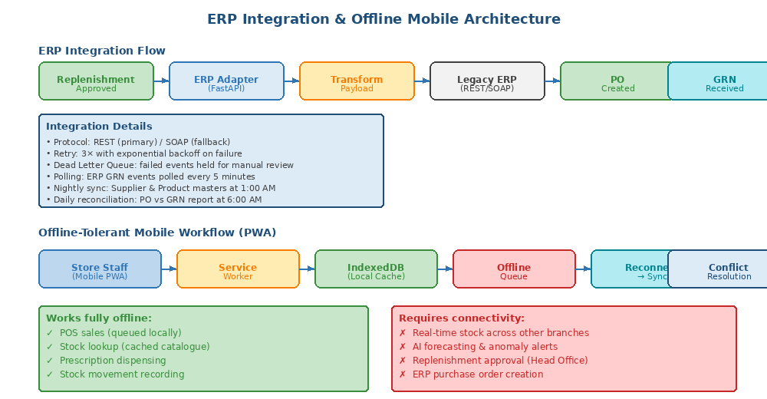
Figure 7 — Legacy ERP integration flow and offline PWA architecture with sync queue and conflict resolution

11.1 ERP Integration
Integration Point | Direction | Protocol | Frequency | Retry Policy
Purchase Order Creation | OPOP → ERP | REST / SOAP | On replenishment approval | 3× exponential backoff; dead-letter queue on failure
GRN (Goods Receipt) Sync | ERP → OPOP | Polling every 5 min | On GRN creation in ERP | Auto-retry; manual DLQ review
Supplier Master Sync | ERP → OPOP | Batch nightly | Daily 01:00 AM | Full re-sync on failure
Product Master Sync | ERP → OPOP | Batch nightly | Daily 01:30 AM | Full re-sync on failure
Invoice Reconciliation | Bidirectional | Batch daily | Daily 06:00 AM | Discrepancy report raised

11.2 Offline Mobile Architecture
The React PWA uses Service Workers and IndexedDB to support full POS and stock operations without an internet connection — critical for store staff in stockrooms and loading areas.

Offline-to-Online Sync Protocol
On disconnect detected:
• Service Worker activates offline mode — all API calls intercepted
• Writes go to IndexedDB offline queue with timestamp + operation type
• UI shows 'Offline — X operations pending sync' indicator

On reconnection:
• Offline queue replayed in chronological order against live server
• Conflict resolution: last-write-wins for most fields; quantity conflicts
(e.g., two offline devices sold the same batch) flagged for manual review
• Conflict log written for pharmacist to review and confirm
• UI indicator clears when sync completes

12. Data Model & Governance

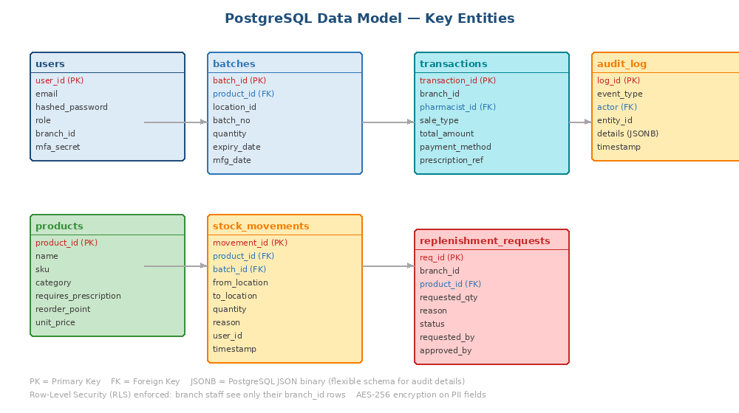
Figure 8 — PostgreSQL entity relationship overview showing key tables, primary/foreign keys, and RLS scope

12.1 Data Retention Policy
Data Type | Retention Period | Storage Tier | Deletion Method
Transaction Records | 7 years | PostgreSQL (hot 2yr) + S3 Glacier (archive) | Automated purge job post-retention window
Prescription Records | 10 years | PostgreSQL + encrypted S3 | Manual compliance review before deletion
Audit Logs | 7 years | Append-only PostgreSQL + cold S3 after 2yr | Archive to cold storage; never modified
User Access Logs | 2 years | ELK Stack | Automated time-based index deletion
AI Query Logs | 1 year | PostgreSQL | Automated purge
Customer PII | Per consent + legal minimum | Encrypted PostgreSQL | Secure erasure on DSAR request

12.2 PII Protection
- Customer name, address, phone number: AES-256-GCM encrypted at column level in PostgreSQL
- API responses: PII masked based on role — agents see 'J. S***' and '+91 ****1234' only
- Non-production environments: Faker-based synthetic data — no real records ever leave production
- DSAR (Data Subject Access Request): admin tool to export or delete all records for a specific customer
- AI chat: PII masking applied before LLM receives any query results

GitHub Repo Link: https://github.com/hargunkaur28/Pharma

13. Working Code Implementation

The following section contains well-structured, production-oriented Python/FastAPI code for the core microservices. This demonstrates the end-to-end architecture in working code, covering authentication, inventory, sales, and AI endpoints.

13.1 Project Structure
pharma_platform/
├── shared/
│ ├── config.py # Pydantic Settings — env-based config
│ ├── kafka_client.py # Async Kafka producer/consumer
│ └── middleware/
│ └── rbac.py # JWT decode + RBAC dependency
├── auth_service/
│ ├── main.py # FastAPI app + startup
│ ├── models/user.py # SQLAlchemy: User, RefreshToken
│ ├── routers/auth.py # Login, refresh, logout, MFA
│ └── services/auth_service.py # bcrypt, JWT signing, TOTP
├── inventory_service/
│ └── main.py # Stock, batches, expiry, replenishment
├── sales_service/
│ └── main.py # POS transactions, Rx dispensing, returns
├── ai_service/
│ └── main.py # Prophet forecasting, IsolationForest, LangChain chat
├── docker-compose.yml # Full local stack: PostgreSQL, Redis, Kafka, all services
└── requirements.txt # All Python dependencies

13.2 Shared RBAC Middleware
# shared/middleware/rbac.py
from fastapi import Depends, HTTPException, status
from fastapi.security import HTTPBearer
from jose import jwt, JWTError

ROLE_PERMISSIONS = {
"head_office_admin": ["inventory:read","inventory:write","sales:read","sales:write","ai:read","ai:query","audit:read"],
"branch_pharmacist": ["inventory:read","sales:read","sales:write","ai:query"],
"inventory_controller": ["inventory:read","inventory:write","ai:read","ai:query"],
"customer_service_agent": ["sales:read"],
"system_auditor": ["audit:read","reports:read"],
}

def get_current_user(credentials = Depends(HTTPBearer())) -> TokenPayload:
try:
payload = jwt.decode(credentials.credentials, PUBLIC_KEY, algorithms=['RS256'])
return TokenPayload(user_id=payload['sub'], role=payload['role'],
branch_id=payload.get('branch_id'),
permissions=payload.get('permissions', []))
except JWTError:
raise HTTPException(status_code=401, detail='Invalid or expired token')

def require_permissions(*required: str):
def _check(user = Depends(get_current_user)):
missing = [p for p in required if p not in user.permissions]
if missing:
raise HTTPException(status_code=403, detail=f'Missing: {missing}')
return user
return _check

13.3 Inventory Service — Stock & Replenishment Endpoints
# inventory_service/main.py (key endpoints)

@app.get('/api/v1/inventory/stock',
dependencies=[Depends(require_permissions('inventory:read'))])
async def get_stock(branch_id: str, product_id: str,
user: TokenPayload = Depends(get_current_user),
db: AsyncSession = Depends(get_db)):
require_same_branch(user, branch_id) # branch staff: own branch only
# Fetch active batches in FEFO order (First Expired, First Out)
batches = await db.execute(
select(Batch).where(Batch.product_id == product_id,
Batch.location_id == branch_id,
Batch.expiry_date > datetime.utcnow())
.order_by(Batch.expiry_date.asc())
)
total_qty = sum(b.quantity for b in batches.scalars().all())
return StockResponse(product_id=product_id, quantity_available=total_qty, ...)

@app.post('/api/v1/inventory/replenishment-request', status_code=201)
async def create_replenishment_request(body: ReplenishmentRequestIn, ...):
req = ReplenishmentRequest(**body.dict(), requested_by=user.user_id)
db.add(req); await db.commit()
# Publish Kafka event — Inventory Controller notified asynchronously
await publish_event(TOPIC_REPLENISHMENT_REQUESTED, {'request_id': str(req.req_id), ...})
return ReplenishmentRequestOut(request_id=str(req.req_id), status='pending_approval')

13.4 Sales Service — POS Transaction
# sales_service/main.py (key endpoint)

@app.post('/api/v1/sales/transaction', status_code=201,
dependencies=[Depends(require_permissions('sales:write'))])
async def create_transaction(body: TransactionIn, background_tasks: BackgroundTasks, ...):
# Step 1: Validate stock for each item (sync call to Inventory Service)
for item in body.items:
stock = await inventory_client.get_stock(body.branch_id, item.product_id)
if stock['quantity_available'] < item.quantity:
raise HTTPException(422, f'Insufficient stock for {item.product_id}')
if stock['status'] == 'out_of_stock':
raise HTTPException(400, 'Product out of stock')
# Step 2: Persist transaction atomically
txn = Transaction(branch_id=body.branch_id, pharmacist_id=user.user_id, ...)
db.add(txn)
for item in body.items:
db.add(TransactionItem(transaction_id=txn.transaction_id, ...))
await db.commit()
# Step 3: Publish all side-effect events asynchronously
background_tasks.add_task(publish_event, TOPIC_SALE_COMPLETED, {...})
background_tasks.add_task(publish_event, TOPIC_AUDIT_EVENT, {'event_type':'sale_completed',...})
return TransactionOut(transaction_id=str(txn.transaction_id), status='completed')

13.5 AI Service — Demand Forecasting
# ai_service/main.py (forecasting endpoint)

@app.get('/api/v1/ai/forecast',
dependencies=[Depends(require_permissions('ai:read'))])
async def get_demand_forecast(product_id: str, branch_id: str,
days: int = Query(30, ge=7, le=90), ...):
require_same_branch(user, branch_id)
# Fetch 2 years of daily sales from reporting DB
historical = await get_sales_history(product_id, branch_id, days_back=730)
# Train Prophet model (cached nightly; served from cache during day)
model = Prophet(yearly_seasonality=True, weekly_seasonality=True, interval_width=0.95)
model.fit(historical) # DataFrame with 'ds' (date) and 'y' (units sold)
forecast = model.predict(model.make_future_dataframe(periods=days)).tail(days)
predicted = int(forecast['yhat'].clip(lower=0).sum())
current_stock = await get_stock_from_cache(product_id, branch_id)
# GUARDRAIL: Output is advisory only — log and return, never auto-create PO
log.info('forecast_generated', product=product_id, predicted=predicted, user=user.user_id)
return ForecastResponse(predicted_demand=predicted,
stock_sufficient=(current_stock >= predicted),
recommended_order_qty=max(0, predicted - current_stock),
model_version='prophet-v2.1')

14. Evaluation Criteria — Compliance Checklist

Evaluation Criteria | Where Addressed | Evidence
Microservices architecture with separation of UI, services, and data | Section 2 | 9 independent FastAPI services, per-service PostgreSQL schemas, API Gateway, Kafka event bus
Responsive web app for mobile, tablet, desktop | Section 5 + Prototype | React 18 PWA with Tailwind CSS responsive layouts; offline support via Service Workers + IndexedDB
Secure authentication and RBAC for multiple user types | Section 3 | OAuth 2.0 + RS256 JWT, 5 roles, PostgreSQL Row-Level Security, MFA for admins, AES-256 PII
Inventory, sales, batch, and expiry management | Sections 4 & 5 | FEFO batch tracking, automated expiry alerts, POS for OTC + Rx, full audit trail, blocked expired sales
Real-time stock monitoring and replenishment | Section 4 | Kafka events, WebSockets, Redis cache, threshold alerts, ERP-linked PO workflow, inter-branch transfers
BI dashboards and compliance reporting | Section 8 | 5 role-specific dashboards, Controlled Drug Register, Stock Variance, Expiry Compliance, AI Audit Log
Agentic AI: forecasting, anomaly detection, conversational query | Section 6 | Prophet + XGBoost forecasting, Isolation Forest anomaly detection, LangChain NL→SQL chat with guardrails
Well-defined APIs and ERP integration | Sections 7 & 11 | OpenAPI 3.0 REST APIs with full request/response contracts; ERP adapter (REST/SOAP), retry, DLQ, reconciliation
Non-functional: performance, scalability, reliability, security, observability | Section 9 | P95<300ms, 99.5% SLA, Kubernetes HPA, circuit breakers, Prometheus+Grafana+ELK+Jaeger, OWASP mitigations
AI guardrails and sensitive data protection | Sections 6 & 12 | Advisory-only AI, human approval gates, SELECT-only SQL, PII masking, confidence scores, monthly drift monitoring

End of Solution Document

This document presents a comprehensive, production-oriented design and implementation for the Omnichannel Pharmacy Operations Platform. All architectural decisions reflect practical trade-offs for a regulated, high-availability pharmacy retail environment. The author is prepared to discuss and substantiate all design choices during the Q&A stage of the selection process.

