Day5

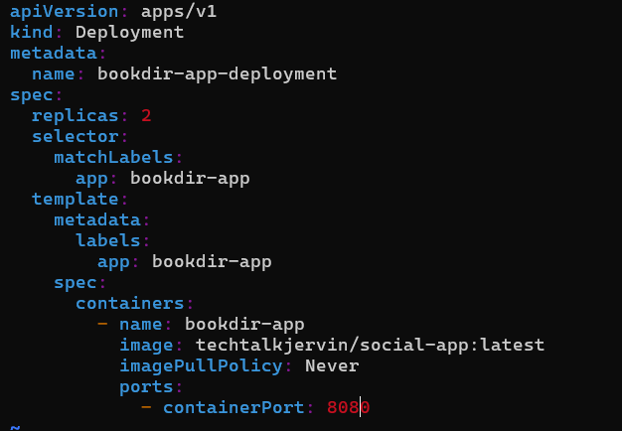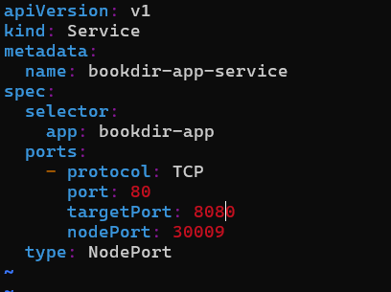

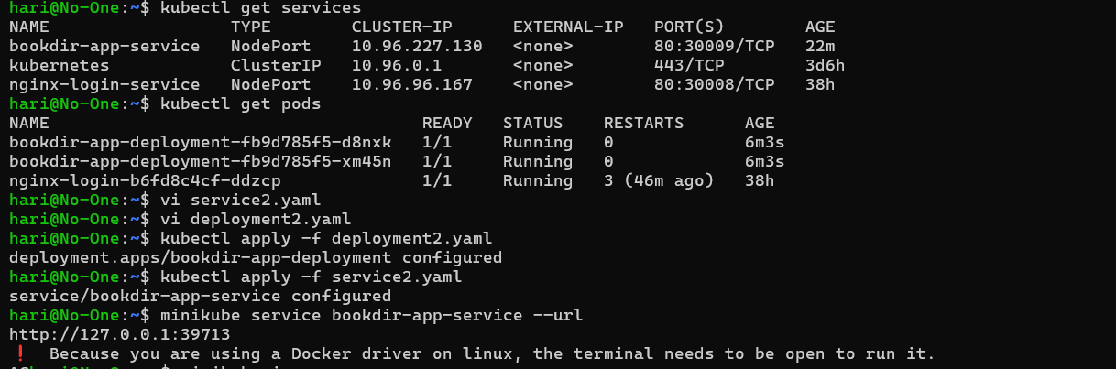

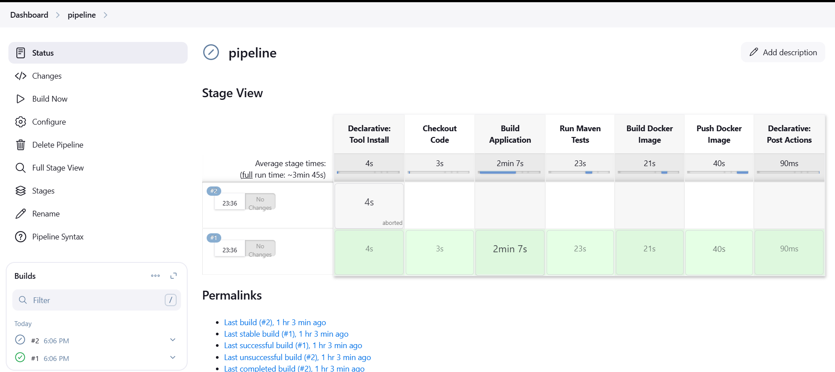pipeline {

agent any

environment {

DOCKER_IMAGE = "harikrishnan330/devops2"

DOCKER_TAG = "latest1"

DOCKER_CREDENTIALS_ID = "docker"

GITHUB_CREDENTIALS_ID = "github_secred"

KUBECONFIG = "/var/lib/jenkins/.kube/config"

}

tools{

maven 'mvn'

}

stages {

stage('Checkout Code') {

steps {

git credentialsId: GITHUB_CREDENTIALS_ID, url: 'https://github.com/hari-0330/devops2.git', branch: 'main'

}

}

stage('Build Application') {

steps {

script {

sh '${MAVEN_HOME}/bin/mvn clean package -DskipTests'

}

}

}

stage('Run Maven Tests') {

steps {

script {

try {

sh 'mvn test'

} catch (Exception e) {

echo "Tests failed, but proceeding..."

}

}

}

}

stage('Build Docker Image') {

steps {

script {

sh "docker build -t ${DOCKER_IMAGE}:${DOCKER_TAG} ."

}

}

}

stage('Push Docker Image') {

steps {

withDockerRegistry([credentialsId: DOCKER_CREDENTIALS_ID, url: '']) {

sh "docker push ${DOCKER_IMAGE}:${DOCKER_TAG}"

}

}

} }

post {

success {

echo "Deployment Successful!"

}

failure {

echo "Deployment Failed!"

}

}

}