DAY 2

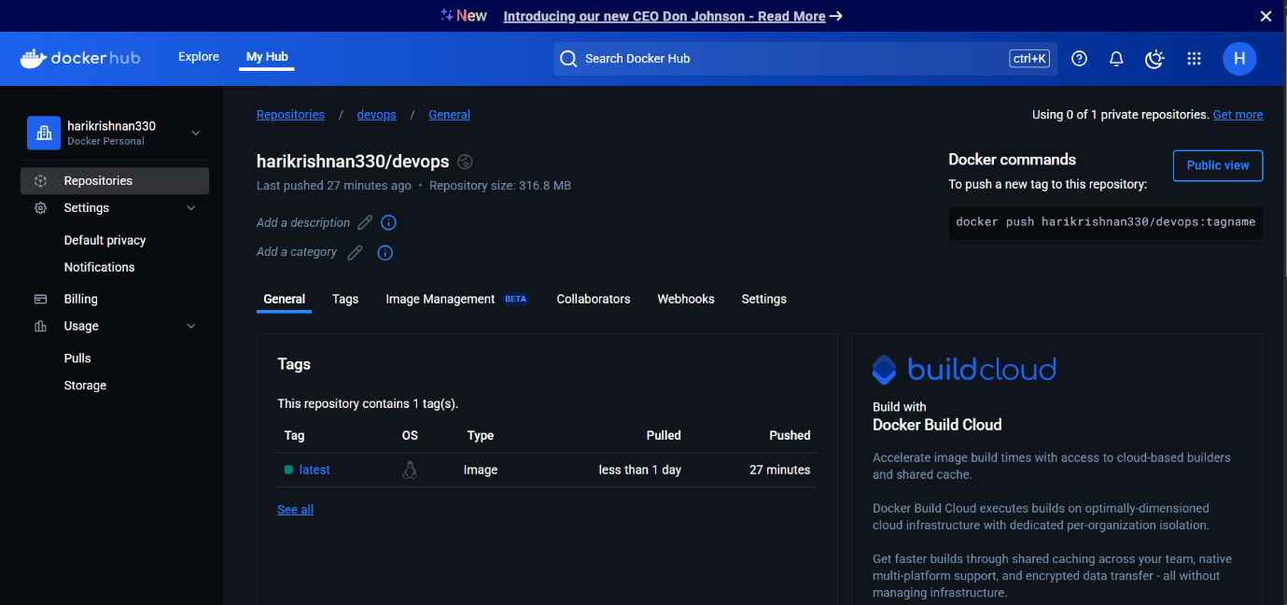

2.PIPELINE SCRIPT:

pipeline {

agent any

tools {

jdk 'jdk17' // Ensure this matches the installed JDK name in Jenkins

nodejs 'node' // Use the correct NodeJS tool name from Jenkins

}

stages {

stage('Clean Workspace') {

steps {

script {

echo "Cleaning workspace..."

deleteDir() // Deletes everything in the Jenkins workspace before starting

}

}

}

stage('Git Checkout') {

steps {

script {

git branch: 'main',

credentialsId: 'github_secred',

url: 'https://github.com/hari-0330/Devops.git'

}

}

}

stage('Install Node') {

steps {

script {

sh '''

if [ -f package.json ]; then

echo "package.json found. Running npm install..."

npm install

else

echo "ERROR: package.json is missing. Skipping npm install."

exit 1

fi

'''

}

}

}

stage('Docker Build & Push') {

steps {

script {

withDockerRegistry(credentialsId: 'docker', toolName: 'docker') {

def imageName = "harikrishnan330/devops"

def tag = "latest"

sh "docker build -t ${imageName}:${tag} ."

sh "docker push ${imageName}:${tag}"

}

}

}

}

stage('Deploy Docker Container') {

steps {

script {

// Stop and remove the existing container if it's running

sh "docker stop devops_container || true"

sh "docker rm devops_container || true"

// Run the new container

sh "docker run -d --name devops_container -p 3001:3000 harikrishnan330/devops:latest"

}

}

}

}

}

3. TOOLS CONFIG:

Java

Nodejs

Docker

4.Plugins:

Nodejs

Docker related(except build)

Eclipse

Pipeline

5.credentials:

Github&docker

For docker build &deploy

Sudo usemod -aG docker Jenkins

Sudo chmod 666 /var/run/docker.sock

Sudo systemctl restart Jenkins

Sudo systemctl status Jenkins

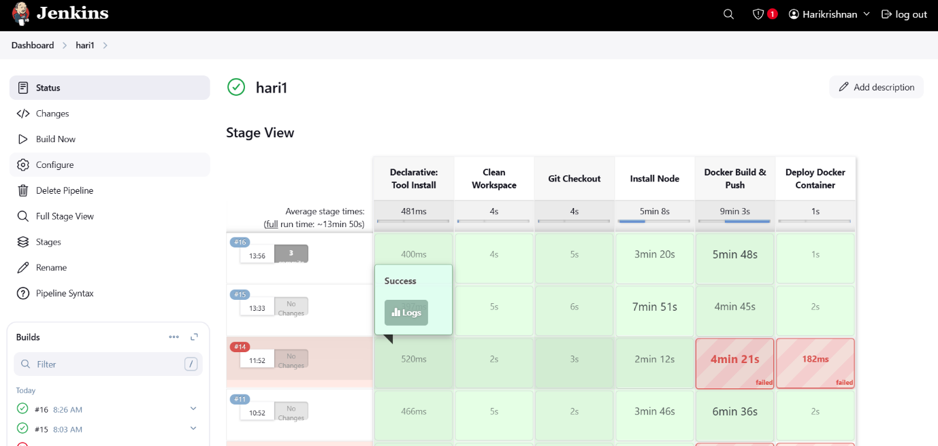

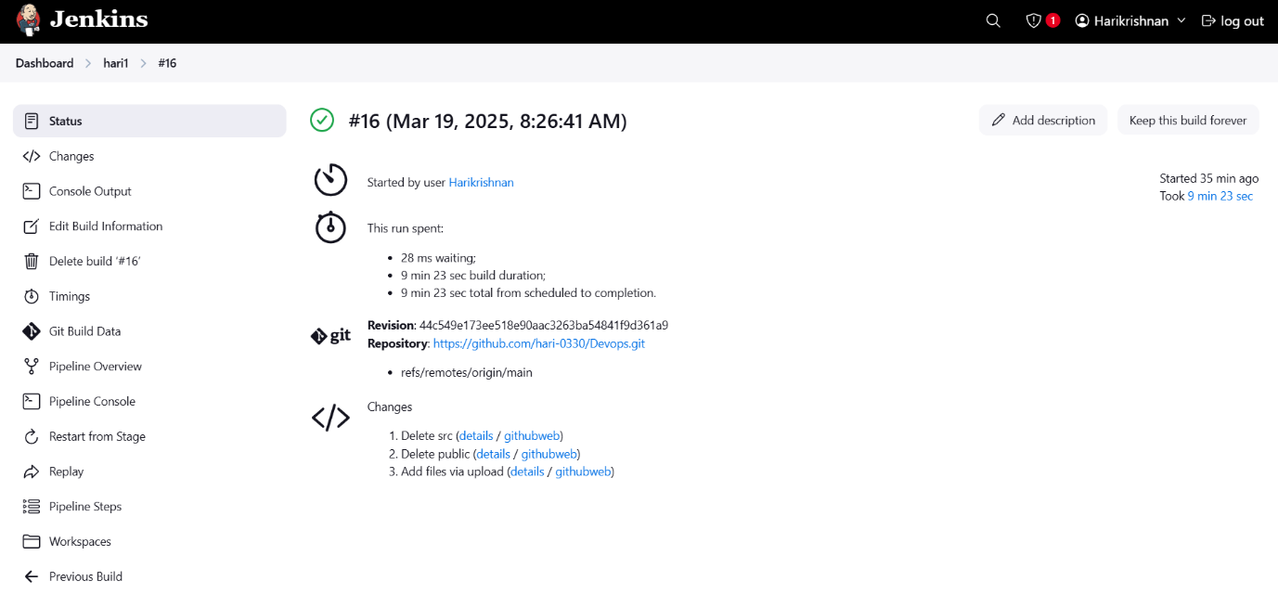

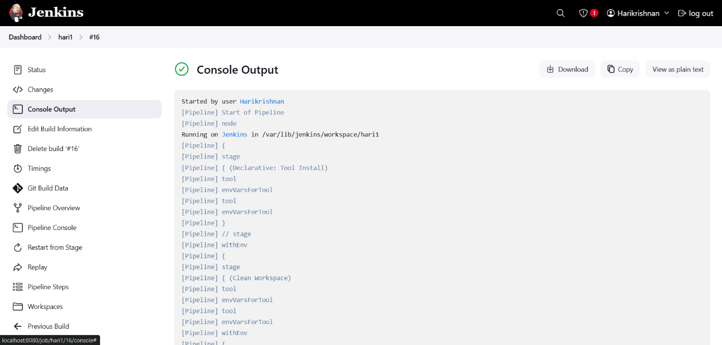

localhost:3001

