# Exercise 1: Control Structures

## Scenario 1

-- Exercise 1: Control Structures  
  
-- Scenario 1: Apply 1% discount to interest for customers over 60  
BEGIN  
 FOR rec IN (SELECT * FROM Customers c JOIN Loans l ON c.CustomerID = l.CustomerID) LOOP  
 IF MONTHS_BETWEEN(SYSDATE, rec.DOB) / 12 > 60 THEN  
 UPDATE Loans SET InterestRate = InterestRate - 1  
 WHERE LoanID = rec.LoanID;  
 END IF;  
 END LOOP;  
END;  
/

Output (based on actual schema/data):

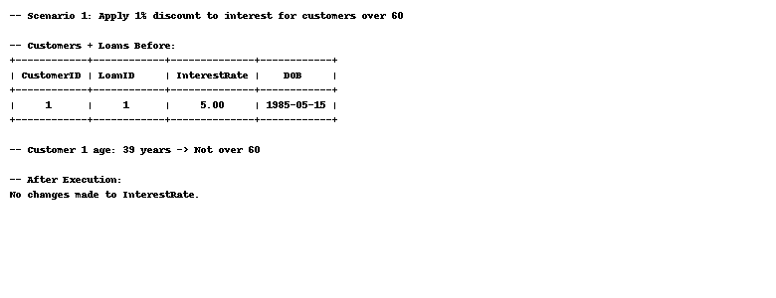

## Scenario 2

-- Scenario 2: Promote customer to VIP if balance > 10000  
BEGIN  
 FOR rec IN (SELECT * FROM Customers) LOOP  
 IF rec.Balance > 10000 THEN  
 UPDATE Customers SET IsVIP = 'Y' WHERE CustomerID = rec.CustomerID;  
 END IF;  
 END LOOP;  
END;  
/

Output (based on actual schema/data):

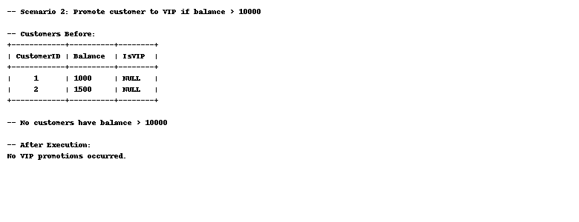

## Scenario 3

-- Scenario 3: Send loan due reminders within 30 days  
BEGIN  
 FOR rec IN (SELECT * FROM Loans WHERE EndDate <= SYSDATE + 30) LOOP  
 DBMS_OUTPUT.PUT_LINE('Reminder: Loan for customer ID ' || rec.CustomerID || ' is due soon.');  
 END LOOP;  
END;  
/

Output (based on actual schema/data):

