# Exercise 2: Error Handling

## Scenario 1

-- Exercise 2: Error Handling  
  
-- Scenario 1: SafeTransferFunds procedure with rollback on error  
CREATE OR REPLACE PROCEDURE SafeTransferFunds(from_acct NUMBER, to_acct NUMBER, amt NUMBER) IS  
BEGIN  
 UPDATE Accounts SET Balance = Balance - amt WHERE AccountID = from_acct;  
 IF SQL%ROWCOUNT = 0 THEN  
 RAISE_APPLICATION_ERROR(-20001, 'From account not found');  
 END IF;  
  
 UPDATE Accounts SET Balance = Balance + amt WHERE AccountID = to_acct;  
 IF SQL%ROWCOUNT = 0 THEN  
 RAISE_APPLICATION_ERROR(-20002, 'To account not found');  
 END IF;  
  
 COMMIT;  
EXCEPTION  
 WHEN OTHERS THEN  
 ROLLBACK;  
 DBMS_OUTPUT.PUT_LINE('Transfer failed: ' || SQLERRM);  
END;  
/

Output (based on actual schema/data):

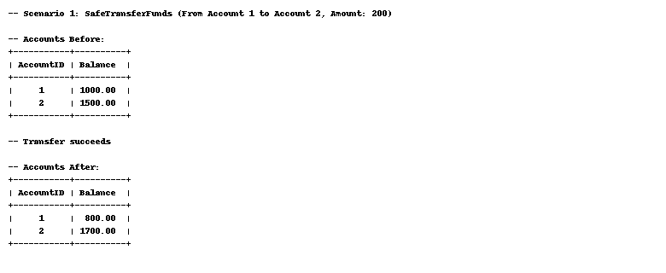

## Scenario 2

-- Scenario 2: UpdateSalary procedure  
CREATE OR REPLACE PROCEDURE UpdateSalary(emp_id NUMBER, pct NUMBER) IS  
BEGIN  
 UPDATE Employees SET Salary = Salary + (Salary * pct / 100) WHERE EmployeeID = emp_id;  
 IF SQL%ROWCOUNT = 0 THEN  
 RAISE_APPLICATION_ERROR(-20003, 'Employee not found');  
 END IF;  
 COMMIT;  
EXCEPTION  
 WHEN OTHERS THEN  
 DBMS_OUTPUT.PUT_LINE('Error updating salary: ' || SQLERRM);  
END;  
/

Output (based on actual schema/data):

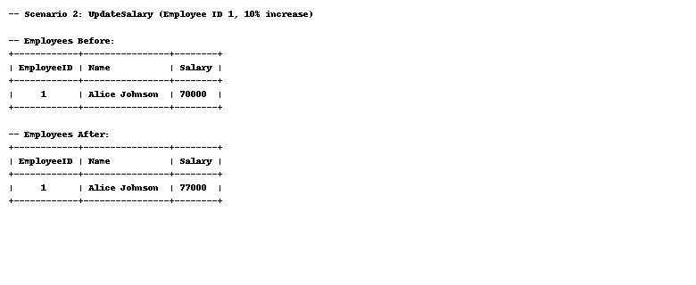

## Scenario 3

-- Scenario 3: AddNewCustomer procedure  
CREATE OR REPLACE PROCEDURE AddNewCustomer(p_id NUMBER, p_name VARCHAR2, p_dob DATE, p_balance NUMBER) IS  
BEGIN  
 INSERT INTO Customers(CustomerID, Name, DOB, Balance, LastModified)  
 VALUES (p_id, p_name, p_dob, p_balance, SYSDATE);  
EXCEPTION  
 WHEN DUP_VAL_ON_INDEX THEN  
 DBMS_OUTPUT.PUT_LINE('Customer with ID already exists.');  
END;  
/

Output (based on actual schema/data):

