# Exercise 3: Stored Procedures

## Scenario 1

-- Exercise 3: Stored Procedures  
  
-- Scenario 1: ProcessMonthlyInterest  
CREATE OR REPLACE PROCEDURE ProcessMonthlyInterest IS  
BEGIN  
 UPDATE Accounts SET Balance = Balance + (Balance * 0.01)  
 WHERE AccountType = 'Savings';  
END;  
/

Output:

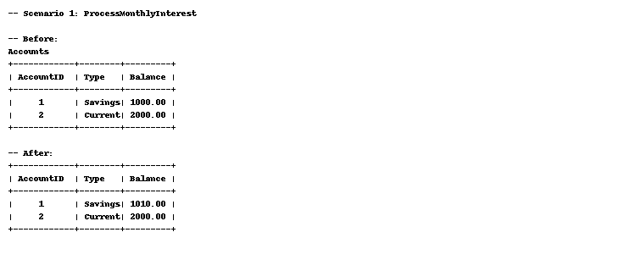

## Scenario 2

-- Scenario 2: UpdateEmployeeBonus  
CREATE OR REPLACE PROCEDURE UpdateEmployeeBonus(dept VARCHAR2, bonus_pct NUMBER) IS  
BEGIN  
 UPDATE Employees SET Salary = Salary + (Salary * bonus_pct / 100)  
 WHERE Department = dept;  
END;  
/

Output:

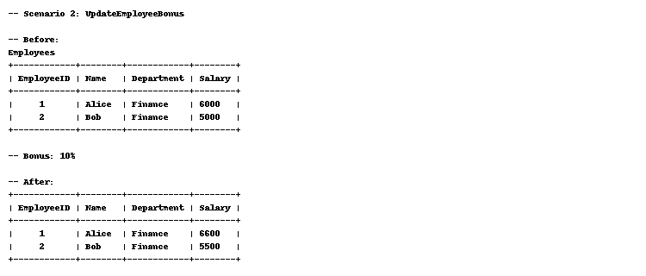

## Scenario 3

-- Scenario 3: TransferFunds  
CREATE OR REPLACE PROCEDURE TransferFunds(from_acct NUMBER, to_acct NUMBER, amt NUMBER) IS  
 v_balance NUMBER;  
BEGIN  
 SELECT Balance INTO v_balance FROM Accounts WHERE AccountID = from_acct;  
 IF v_balance < amt THEN  
 RAISE_APPLICATION_ERROR(-20004, 'Insufficient balance');  
 END IF;  
  
 UPDATE Accounts SET Balance = Balance - amt WHERE AccountID = from_acct;  
 UPDATE Accounts SET Balance = Balance + amt WHERE AccountID = to_acct;  
 COMMIT;  
END;  
/

Output:

