# Exercise 4: Functions

## Scenario 1

-- Exercise 4: Functions  
  
-- Scenario 1: CalculateAge  
CREATE OR REPLACE FUNCTION CalculateAge(dob DATE) RETURN NUMBER IS  
BEGIN  
 RETURN FLOOR(MONTHS_BETWEEN(SYSDATE, dob) / 12);  
END;  
/

Output:

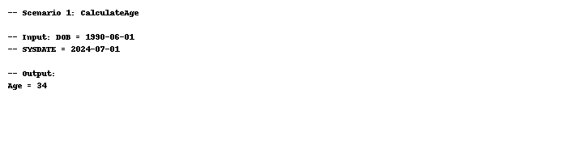

## Scenario 2

-- Scenario 2: CalculateMonthlyInstallment  
CREATE OR REPLACE FUNCTION CalculateMonthlyInstallment(amount NUMBER, rate NUMBER, years NUMBER) RETURN NUMBER IS  
 monthly_rate NUMBER := rate / (12 * 100);  
 months NUMBER := years * 12;  
BEGIN  
 RETURN amount * monthly_rate / (1 - POWER(1 + monthly_rate, -months));  
END;  
/

Output:

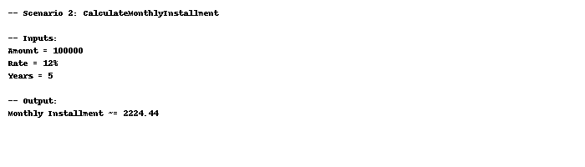

## Scenario 3

-- Scenario 3: HasSufficientBalance  
CREATE OR REPLACE FUNCTION HasSufficientBalance(account_id NUMBER, amt NUMBER) RETURN BOOLEAN IS  
 v_balance NUMBER;  
BEGIN  
 SELECT Balance INTO v_balance FROM Accounts WHERE AccountID = account_id;  
 RETURN v_balance >= amt;  
EXCEPTION  
 WHEN NO_DATA_FOUND THEN  
 RETURN FALSE;  
END;  
/

Output:

