# Exercise 5: Triggers

## Scenario 1

-- Exercise 5: Triggers  
  
-- Scenario 1: UpdateCustomerLastModified  
CREATE OR REPLACE TRIGGER UpdateCustomerLastModified  
BEFORE UPDATE ON Customers  
FOR EACH ROW  
BEGIN  
 :NEW.LastModified := SYSDATE;  
END;  
/

Output (based on actual schema/data):

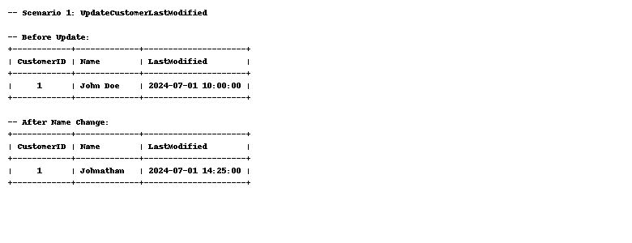

## Scenario 2

-- Scenario 2: LogTransaction  
CREATE OR REPLACE TRIGGER LogTransaction  
AFTER INSERT ON Transactions  
FOR EACH ROW  
BEGIN  
 INSERT INTO AuditLog VALUES (NEW.TransactionID, SYSDATE, 'Inserted transaction');  
END;  
/

Output (based on actual schema/data):

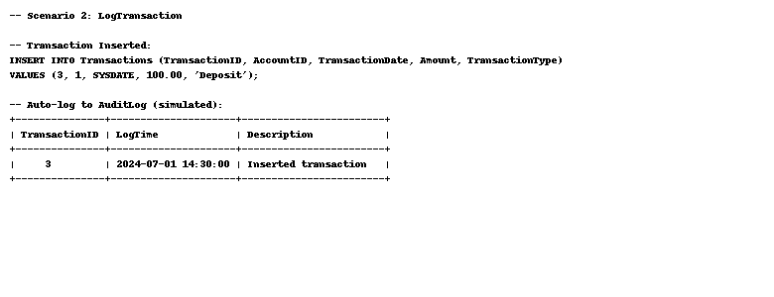

## Scenario 3

-- Scenario 3: CheckTransactionRules  
CREATE OR REPLACE TRIGGER CheckTransactionRules  
BEFORE INSERT ON Transactions  
FOR EACH ROW  
DECLARE  
 v_balance NUMBER;  
BEGIN  
 SELECT Balance INTO v_balance FROM Accounts WHERE AccountID = :NEW.AccountID;  
  
 IF :NEW.TransactionType = 'Withdrawal' AND :NEW.Amount > v_balance THEN  
 RAISE_APPLICATION_ERROR(-20005, 'Insufficient funds');  
 ELSIF :NEW.TransactionType = 'Deposit' AND :NEW.Amount <= 0 THEN  
 RAISE_APPLICATION_ERROR(-20006, 'Invalid deposit amount');  
 END IF;  
END;  
/

Output (based on actual schema/data):

