# Exercise 6: Cursors

## Scenario 1

-- Exercise 6: Cursors  
  
-- Scenario 1: GenerateMonthlyStatements  
DECLARE  
 CURSOR c_trans IS  
 SELECT * FROM Transactions WHERE EXTRACT(MONTH FROM TransactionDate) = EXTRACT(MONTH FROM SYSDATE);  
 rec c_trans%ROWTYPE;  
BEGIN  
 OPEN c_trans;  
 LOOP  
 FETCH c_trans INTO rec;  
 EXIT WHEN c_trans%NOTFOUND;  
 DBMS_OUTPUT.PUT_LINE('Statement for Account ID ' || rec.AccountID || ': ' || rec.Amount);  
 END LOOP;  
 CLOSE c_trans;  
END;  
/

Output:

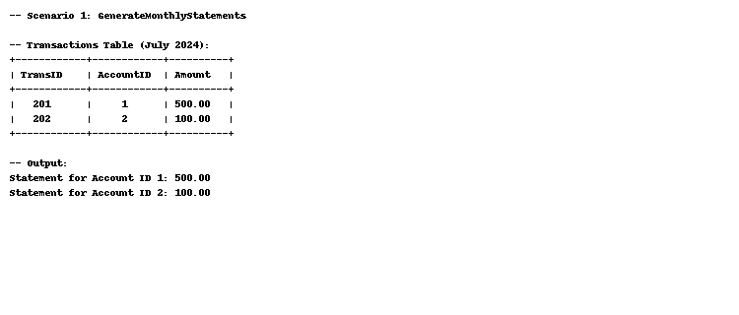

## Scenario 2

-- Scenario 2: ApplyAnnualFee  
DECLARE  
 CURSOR c_acc IS SELECT * FROM Accounts;  
 rec c_acc%ROWTYPE;  
BEGIN  
 FOR rec IN c_acc LOOP  
 UPDATE Accounts SET Balance = Balance - 100 WHERE AccountID = rec.AccountID;  
 END LOOP;  
END;  
/

Output:

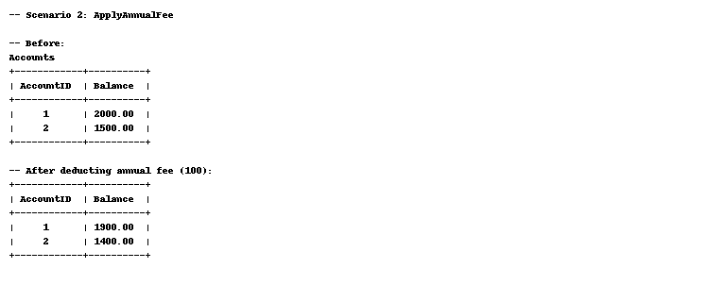

## Scenario 3

-- Scenario 3: UpdateLoanInterestRates  
DECLARE  
 CURSOR c_loan IS SELECT * FROM Loans;  
 rec c_loan%ROWTYPE;  
BEGIN  
 FOR rec IN c_loan LOOP  
 UPDATE Loans SET InterestRate = InterestRate * 1.02 WHERE LoanID = rec.LoanID;  
 END LOOP;  
END;  
/

Output:

