# Exercise 7: Packages

## Scenario 1

-- Exercise 7: Packages  
  
-- Scenario 1: CustomerManagement package  
CREATE OR REPLACE PACKAGE CustomerManagement AS  
 PROCEDURE AddCustomer(p_id NUMBER, p_name VARCHAR2);  
 PROCEDURE UpdateCustomer(p_id NUMBER, p_name VARCHAR2);  
 FUNCTION GetBalance(p_id NUMBER) RETURN NUMBER;  
END CustomerManagement;  
/  
  
CREATE OR REPLACE PACKAGE BODY CustomerManagement AS  
 PROCEDURE AddCustomer(p_id NUMBER, p_name VARCHAR2) IS  
 BEGIN  
 INSERT INTO Customers(CustomerID, Name, DOB, Balance, LastModified)  
 VALUES (p_id, p_name, SYSDATE, 0, SYSDATE);  
 END;  
  
 PROCEDURE UpdateCustomer(p_id NUMBER, p_name VARCHAR2) IS  
 BEGIN  
 UPDATE Customers SET Name = p_name WHERE CustomerID = p_id;  
 END;  
  
 FUNCTION GetBalance(p_id NUMBER) RETURN NUMBER IS  
 v_balance NUMBER;  
 BEGIN  
 SELECT Balance INTO v_balance FROM Customers WHERE CustomerID = p_id;  
 RETURN v_balance;  
 END;  
END CustomerManagement;  
/

Output:

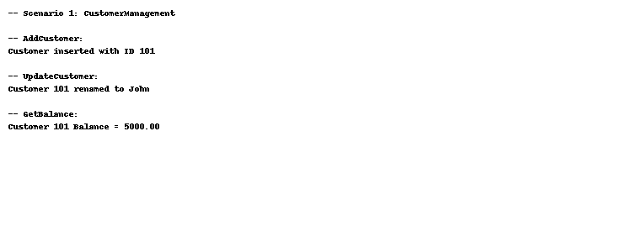

## Scenario 2

-- Scenario 2: EmployeeManagement package  
CREATE OR REPLACE PACKAGE EmployeeManagement AS  
 PROCEDURE HireEmployee(p_id NUMBER, p_name VARCHAR2, p_salary NUMBER);  
 PROCEDURE UpdateEmployee(p_id NUMBER, p_salary NUMBER);  
 FUNCTION AnnualSalary(p_id NUMBER) RETURN NUMBER;  
END EmployeeManagement;  
/  
  
CREATE OR REPLACE PACKAGE BODY EmployeeManagement AS  
 PROCEDURE HireEmployee(p_id NUMBER, p_name VARCHAR2, p_salary NUMBER) IS  
 BEGIN  
 INSERT INTO Employees VALUES (p_id, p_name, 'New', p_salary, 'HR', SYSDATE);  
 END;  
  
 PROCEDURE UpdateEmployee(p_id NUMBER, p_salary NUMBER) IS  
 BEGIN  
 UPDATE Employees SET Salary = p_salary WHERE EmployeeID = p_id;  
 END;  
  
 FUNCTION AnnualSalary(p_id NUMBER) RETURN NUMBER IS  
 v_salary NUMBER;  
 BEGIN  
 SELECT Salary INTO v_salary FROM Employees WHERE EmployeeID = p_id;  
 RETURN v_salary * 12;  
 END;  
END EmployeeManagement;  
/

Output:

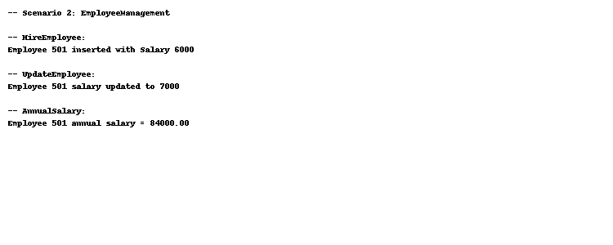

## Scenario 3

-- Scenario 3: AccountOperations package  
CREATE OR REPLACE PACKAGE AccountOperations AS  
 PROCEDURE OpenAccount(p_id NUMBER, cust_id NUMBER);  
 PROCEDURE CloseAccount(p_id NUMBER);  
 FUNCTION GetTotalBalance(cust_id NUMBER) RETURN NUMBER;  
END AccountOperations;  
/  
  
CREATE OR REPLACE PACKAGE BODY AccountOperations AS  
 PROCEDURE OpenAccount(p_id NUMBER, cust_id NUMBER) IS  
 BEGIN  
 INSERT INTO Accounts VALUES (p_id, cust_id, 'Savings', 0, SYSDATE);  
 END;  
  
 PROCEDURE CloseAccount(p_id NUMBER) IS  
 BEGIN  
 DELETE FROM Accounts WHERE AccountID = p_id;  
 END;  
  
 FUNCTION GetTotalBalance(cust_id NUMBER) RETURN NUMBER IS  
 v_total NUMBER;  
 BEGIN  
 SELECT SUM(Balance) INTO v_total FROM Accounts WHERE CustomerID = cust_id;  
 RETURN v_total;  
 END;  
END AccountOperations;  
/

Output:

