Github Repo : https://github.com/hari-44456/pl3practical5

1. Done with handson

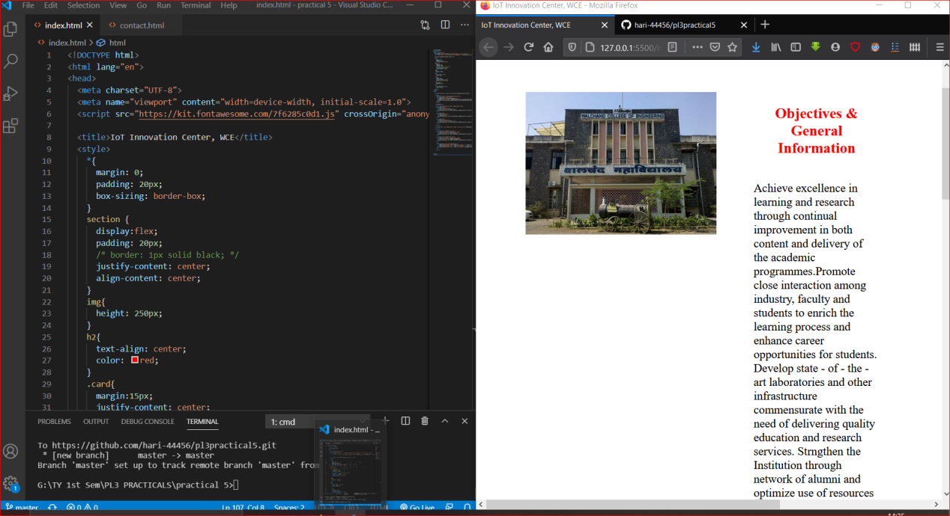

1. Accsessed via localhost

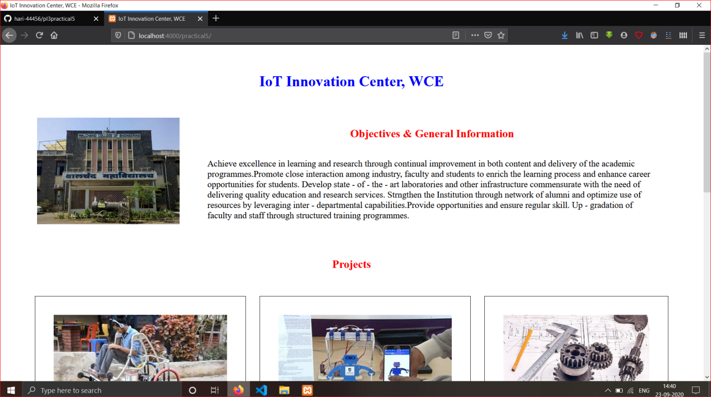

1. Accsessed via mobile

