Write a Prolog program to construct a knowledge based on kinship relations for the following family tree:
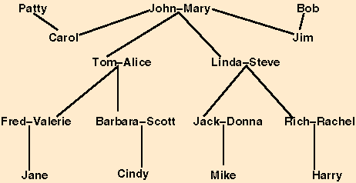
Initialize male, female, father, mother, spouse. Infer parent, brother, sister, cousin, sibling, grandfather, grandmother, grandson, granddaughter, aunt, uncle, nephew, niece relations.

