Rentique
A Rental Shop Based on Location

A Project for
Course code and Course Title: Code & Bachelor of Computer Application
Credits: 04
By
NIKHITHA MUDIYAPPA TIPPANAVAR
Seat Number :
ABC ID :
PRN :
Under the Supervision of

MRS. SHREESHA P J

Don Bosco College
Bachelor of Computer Application

GOA UNIVERSITY / DON BOSCO COLLEGE

Date:19TH FEBRARY 2026

Examined by: Seal of the School
DECLARATION BY STUDENT

I hereby declare that the data presented in this Project report entitled, “Title of the work” is based on the results of investigations carried out by me in the Mrs. Shreesha P J at the Bachelor of Computer Application Goa University/ Don Bosco College under the Supervision of Mr/Ms/Dr/Prof. (Mrs. Shreesha P J) and to the best of my/our knowledge, it has not previously formed the basis for the award of any diploma or degree by this or any other University. Further, I understand that Goa University or its authorities / Don Bosco College will be not be responsible for the correctness of observations / experimental or other findings given in the project work. It is also declared that this document is our original work and free of any plagiarism.

Sr No. | Roll No. | PR Number | Name of Student | Signature
1
2
3
4

Date:
Place: Goa University/ Don Bosco College

CERTIFICATE BY PROJECT SUPERVISOR

This is to certify that the project report “A Rentique local rental shoping based on location” is a bonafide work carried out by Mrs Nikhitha Mudiyappa Tippanavar under my supervision in the Discipline Mrs. Shreesha P J at the Bachelor of Computer Application Goa University/Don Bosco College. To the best of my knowledge, it has not previously formed the basis of the award of any degree or diploma by this or any other College/University. This work also complies with the requirements of Similarity index.

Mrs. Shreesha P J & Sign

Date:

PREFER
PREFER

This project titled “ A Rentique – A Location-Based Clothing Rental Marketplace” has been undertaken as part of the academic curriculum of TYBCA – B . The project represents our effort to apply theoretical knowledge gained during the course to solve a real-life problem using technology.
The idea for this project was inspired by the frequent college events where students purchase clothes for one-time use, which results in unnecessary spending and wastage of money. Rentique aims to provide a practical solution by connecting users with nearby rental shops and through a digital platform.
Through this project, we gained hands-on experience in requirement analysis, system design, UI design using Figma, and step-by-step web application development. The project helped us improve our technical knowledge, teamwork, and problem-solving skills. We believe that this project will contribute towards promoting sustainable fashion and supporting local rental businesses through digital transformation.

ACKNOWLEDGMENTS

ACKNOWLEDGMENTS

We express our sincere gratitude to our Project Guide Prof. Shreesha for her constant guidance, valuable suggestions, and encouragement throughout the development of our project “Rentique – A Location-Based Clothing Rental Marketplace.” Her support and feedback helped us understand the practical aspects of project development and improve our work at every stage.
We would also like to thank our Head of Department and all the faculty members of the BCA Department for providing us with the necessary academic support and resources during the course of this project. Their continuous motivation helped us stay focused and complete the project successfully.
We are thankful to our college for providing the required facilities and environment to work on this project. We also appreciate the support and cooperation of our classmates and friends who gave us useful feedback during the design and development process.

TABLES AND FIGURES

TABLES AND FIGURES

TABLES
Table No. | Description | Page no.
3.1

FIGURES
Figure No. | Description | Page no.
Figure 1.1 | Login page - rentique
Figure 1.2 | Home Page of Rentique
Figure 1.3 | Explore page of Rentique
Figure 3.2 | Use Case Study
Figure 3.3 | ER Diagram

LIST OF TABLES
Table 3.1 – Database Tables Description
Table 3.2 – Technology Stack Used
Table 3.3 – User Roles in the System
Table 3.1 Database Tables Description
Table Name | Description
users | Stores user details such as name, email, password, and role
shops | Stores rental shop details and location information
outfits | Stores clothing item details such as category, size, price, and shop ID
bookings | Stores booking details such as user ID, outfit ID, date, and status

Table 3.2 Technology Stack Use
Layer | Technology Used
UI Design | Figma
Frontend | React
Backend | Nodejs
Database | Mongo db
IDE | VS Code

Table 3.3 User Roles in the System
Role | Description
Customer | Browses outfits and books clothes from rental shops
Shop Owner | Adds and manages rental outfits
Admin | Manages users and platform content

ABBREVIATIONS USED

ABBREVIATIONS USED
Entity | Abbreviation
User Interface | UI
Database Management System | DBMS
Structured Query Language | SQL
HyperText Markup Language | HTML
Description…………………………………………………………………………………………………………………………….

ABSTRACT

ABSTRACT

Rentique is a location-based clothing rental web platform designed to address the problem of unnecessary spending and clothing waste caused by one-time use outfits for college events, parties, and special occasions. Students and young users often purchase expensive clothes for single-day events, which leads to financial burden and underutilization of clothing. At the same time, local rental shops and individuals face difficulty in reaching potential customers digitally.
The aim of this project is to provide a unified digital platform that connects users with nearby rental shops and individual clothing owners. The system allows users to browse outfits, filter based on preferences, and book clothes from nearby locations using pincode-based discovery. The platform supports multiple user roles including customers, shop owners, and individual renters.
The system was developed using a step-by-step approach including requirement analysis, system design using UML diagrams, UI design using Figma, and implementation using modern web technologies. The proposed solution promotes affordable fashion access and supports sustainable clothing practices by reducing unnecessary purchases and encouraging reuse
KEYWORDS
- Clothing Rental
- Location-Based Services
- Sustainable Fashion
- E-commerce Platform
- Peer-to-Peer Rental

INTRODUCTION

INTRODUCTION

Background
In colleges, many events such as traditional days, cultural festivals, farewell parties, and theme days are organized regularly. For such events, students often buy new clothes that are worn only once and rarely used again. This results in unnecessary spending and wastage of money. Many students find it difficult to afford expensive outfits for one-day events.
At the same time, there are local clothing rental shops that provide outfits for rent. However, these shops mostly operate offline, and students need to physically visit multiple shops to check availability, designs, sizes, and prices. There is no single digital platform where students can easily browse nearby rental shops and compare outfits.
Rentique is designed to solve this problem by providing a location-based clothing rental platform that connects students with nearby rental shops. The platform helps users discover rental outfits easily and supports local businesses by giving them a digital presence.

Aim and Objectives
Aim
To develop a location-based clothing rental web platform that provides affordable and convenient access to outfits for college events and special occasions.

Objectives
- To design and develop a user-friendly web application for clothing rentals
- To connect users with nearby rental shops through location-based search
- To reduce unnecessary spending on one-time clothing purchases
- To provide filter-based browsing of outfits (category, size, price, etc.)
- To support local rental businesses by giving them a digital platform
- To ensure easy login and role-based access for users and shop owners
- To promote sustainable fashion by encouraging reuse of clothes

1.3 Hypothesis/Research questions
- Can a location-based clothing rental platform reduce the time and effort required to find outfits for college events?
- Does providing digital access to nearby rental shops improve affordability for students?
- Can an organized online platform improve visibility and reach for local rental businesses?

1.4 Scope of the project
The scope of Rentique includes the development of a web-based platform that allows users to browse and view rental outfits from nearby rental shops based on location. The system provides basic features such as user login, viewing outfits, filtering options, and booking requests.
The current version of the project focuses only on professional rental shops and does not include individual users renting out personal clothes. The platform is mainly targeted towards college students and local communities.
In the future, the system can be expanded to include mobile applications, online payment integration, and advanced features such as outfit recommendations.

Entity Relationship Diagram

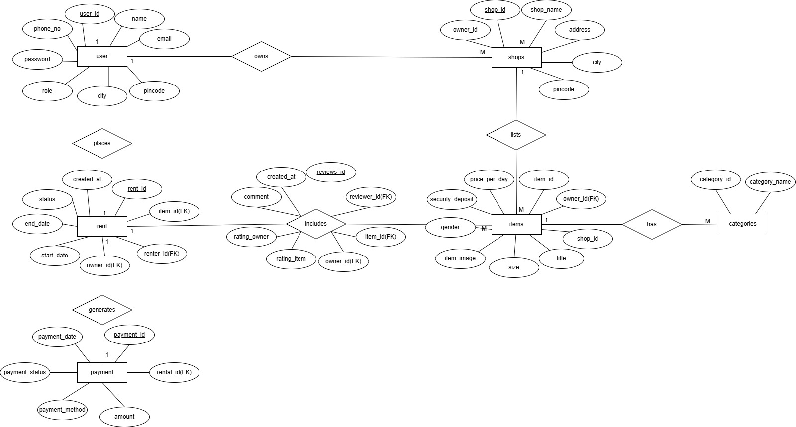

CLASS DIAGRAM

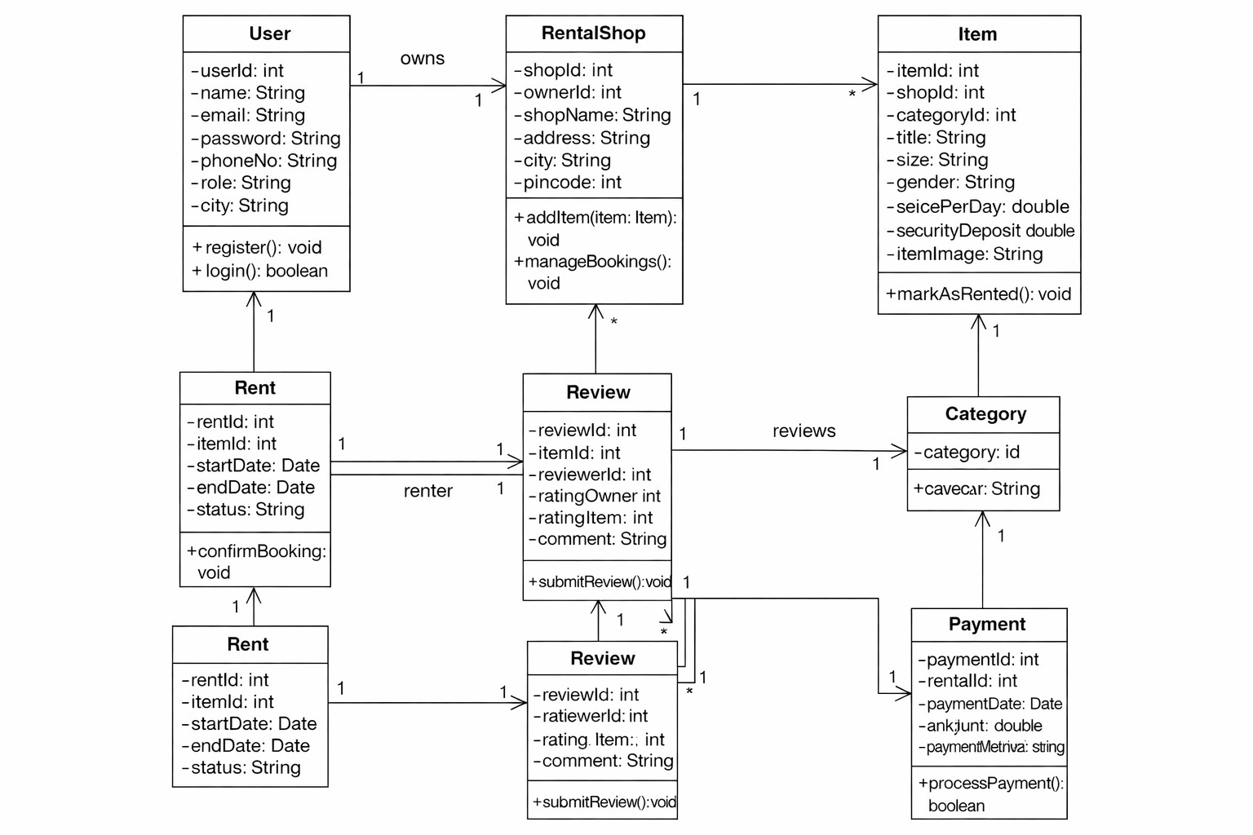

DATABASE DESIGN

DATABASE DESIGN
TABLE NAME: USER
Description: This table stores details of users of the system.
Primary Key: user_id
ATTRIBUTE | DATA TYPE | DESCRIPTION | CONSTRAINTS
user_id | INT | Unique ID of the user | PRIMARY KEY, AUTO INCREMENT
name | VARCHAR(100) | Name of the user | NOT NULL
email | VARCHAR(100) | Email of the user | NOT NULL, UNIQUE
password | VARCHAR(255) | Password of the user | NOT NULL
phone_no | VARCHAR(15) | Contact number of the user | NOT NULL
role | VARCHAR(20) | Role of user (Customer/ShopOwner/Admin) | NOT NULL
city | VARCHAR(50) | City of the user | NOT NULL
pincode | INT | Pincode of the user location | NOT NULL

TABLE NAME: SHOPS
Description: This table stores details of rental shops.
Primary Key: shop_id
Foreign Key: owner_id references user(user_id)
ATTRIBUTE | DATA TYPE | DESCRIPTION | CONSTRAINTS
shop_id | ObjecID | Unique ID of the shop | PRIMARY KEY, AUTO INCREMENT
owner_id | ObjectID | ID of shop owner | FOREIGN KEY REFERENCES user(user_id)
shop_name | VARCHAR(100) | Name of rental shop | NOT NULL
address | VARCHAR(255) | Shop address | NOT NULL
city | VARCHAR(50) | City of shop | NOT NULL
pincode | INT | Pincode of shop location | NOT NULL

TABLE NAME: CATEGORIES
Description: This table stores outfit categories.
Primary Key: category_id
ATTRIBUTE | DATA TYPE | DESCRIPTION | CONSTRAINTS
category_id | ObjectID | Unique category ID | PRIMARY KEY, AUTO INCREMENT
category_name | VARCHAR(100) | Name of the category | NOT NULL

TABLE NAME: ITEMS
Description: This table stores outfit details listed by shops.
Primary Key: item_id
Foreign Keys:
shop_id references shops(shop_id)
category_id references categories(category_id)
ATTRIBUTE | DATA TYPE | DESCRIPTION | CONSTRAINTS
item_id | ObjectID | Unique ID of the item | PRIMARY KEY, AUTO INCREMENT
shop_id | INT | Shop listing the item | FOREIGN KEY REFERENCES shops(shop_id)
category_id | INT | Category of outfit | FOREIGN KEY REFERENCES categories(category_id)
title | VARCHAR(150) | Title of outfit | NOT NULL
size | VARCHAR(20) | Size of outfit | NOT NULL
gender | VARCHAR(20) | Gender type (Male/Female/Unisex) | NOT NULL
price_per_day | DECIMAL(10,2) | Rental price per day | NOT NULL
security_deposit | DECIMAL(10,2) | Refundable deposit amount | NOT NULL
item_image | VARCHAR(255) | Image path of outfit | NOT NULL

TABLE NAME: RENT
Description: This table stores rental booking details.
Primary Key: rent_id
Foreign Keys:
item_id references items(item_id)
renter_id references user(user_id)
owner_id references user(user_id)
ATTRIBUTE | DATA TYPE | DESCRIPTION | CONSTRAINTS
rent_id | ObjectID | Unique rental ID | PRIMARY KEY, AUTO INCREMENT
item_id | ObjectID | Rented item ID | FOREIGN KEY REFERENCES items(item_id)
renter_id | ObjectID | User who rents the item | FOREIGN KEY REFERENCES user(user_id)
owner_id | ObjectID | Owner of the item | FOREIGN KEY REFERENCES user(user_id)
start_date | DATE | Rental start date | NOT NULL
end_date | DATE | Rental end date | NOT NULL
status | VARCHAR(20) | Rental status (Pending/Approved/Completed) | NOT NULL
created_at | DATETIME | Booking creation time | NOT NULL

TABLE NAME: PAYMENT
Description: This table stores payment details of rentals.
Primary Key: payment_id
Foreign Key: rental_id references rent(rent_id)
ATTRIBUTE | DATA TYPE | DESCRIPTION | CONSTRAINTS
payment_id | ObjectID | Unique payment ID | PRIMARY KEY, AUTO INCREMENT
rental_id | ObjectID | Associated rental ID | FOREIGN KEY REFERENCES rent(rent_id)
payment_date | DATE | Date of payment | NOT NULL
amount | DECIMAL(10,2) | Total payment amount | NOT NULL
payment_method | VARCHAR(50) | Mode of payment | NOT NULL
payment_status | VARCHAR(20) | Payment status | NOT NULL

TABLE NAME: REVIEWS
Description: This table stores reviews and ratings given after rental.
Primary Key: review_id
Foreign Keys:
item_id references items(item_id)
reviewer_id references user(user_id)
owner_id references user(user_id)
ATTRIBUTE | DATA TYPE | DESCRIPTION | CONSTRAINTS
review_id | INT | Unique review ID | PRIMARY KEY, AUTO INCREMENT
item_id | INT | Reviewed item | FOREIGN KEY REFERENCES items(item_id)
reviewer_id | INT | User giving review | FOREIGN KEY REFERENCES user(user_id)
owner_id | INT | Owner being reviewed | FOREIGN KEY REFERENCES user(user_id)
rating_item | INT | Rating given to item (1–5) | NOT NULL
rating_owner | INT | Rating given to owner (1–5) | NOT NULL
comment | TEXT | Review comment | NOT NULL
created_at | DATETIME | Review date | NOT NULL

USE CASE DIAGRAM

LITERATURE REVIEW
The concept of clothing rental has emerged as a practical and sustainable alternative to fast fashion. Fast fashion encourages frequent buying of new clothes, which leads to increased
clothing waste and unnecessary spending, especially among students and young consumers. Many studies and articles highlight that one-time use outfits for events and occasions contribute to textile waste and financial burden. Clothing rental platforms help reduce this problem by promoting the reuse of garments.
Several fashion rental services and platforms have shown that users prefer renting outfits for special occasions instead of purchasing expensive clothes that are rarely reused. These platforms provide benefits such as affordability, variety of choices, and convenience. However, most existing solutions are either large centralized platforms or limited to specific cities and do not focus on connecting users with nearby local rental shops.
Local clothing rental shops usually operate offline and depend on walk-in customers. Users have to physically visit multiple shops to check availability, styles, sizes, and prices. This process is time-consuming and inconvenient. There is a lack of digital platforms that provide location-based discovery of rental shops along with organized browsing and filtering of outfits.
Rentique addresses this gap by providing a location-based clothing rental web platform focused on connecting users with nearby rental shops. By offering digital browsing, filtering options, and easy discovery of local providers, Rentique improves accessibility for users and supports local rental businesses by giving them an online presence. This approach combines the benefits of e-commerce convenience with local service availability.

METHODOLOGY

This chapter describes the step-by-step approach followed to design and develop the Rentique project. The methodology includes requirement analysis, system design, UI design, development, database design, and testing.
3.1 Development Approach
The Rentique project follows a step-by-step development approach. The project was divided into multiple phases to ensure proper planning and implementation. Each phase was completed before moving to the next stage.
The phases include:
- Requirement Analysis
- System Design
- UI/UX Design
- Development
- Database Design
- Testing

3.2 Requirement Analysis
In this phase, the main problem was identified based on real-life observations in college, where students purchase clothes for one-time events. Requirements were collected by observing user needs and visiting local rental shops to understand their working process.
The key requirements identified were:
- Users should be able to view rental outfits online
- The system should show nearby rental shops
- The platform should allow filtering of outfits
- Rental shops should be able to list outfits
- The system should have a login system for users and shop owners

3.3 System Design
The system design phase focused on defining how the system will work internally. UML diagrams were used to represent system structure and interactions.
The following diagrams were prepared:
- Use Case Diagram – to show interactions between users and the system
- ER Diagram – to represent the database structure
These diagrams help in understanding system flow and data relationships clearly.

3.4 UI/UX Design
The user interface of Rentique was designed using Figma. The goal was to create a clean, simple, and user-friendly design. Screens such as the Login Page and Home Page were designed first.
The UI design focuses on:
- Simple layout
- Easy navigation
- Clear display of rental outfits
- Minimal and clean design suitable for students

3.5 Development Tools and Technologies
The development of Rentique is carried out using the following tools and technologies:
- UI Design Tool: Figma
- Frontend: React
- Backend: PHP
- Database: MySQL
- IDE: VS Code

3.6 Database Design
The database is designed to store and manage information related to users, rental shops, outfits, and bookings. Separate tables are created for each entity to ensure proper data organization.
The main tables include:
- Users
- Shops
- Outfits
- Bookings
The ER diagram represents the relationship between these tables.

3.7 Testing
Basic testing was performed on the developed modules such as Login Page and Home Page. The testing focused on verifying that:
- Users can log in successfully
- The home page loads correctly
- Navigation between pages works properly
Further testing will be done as additional modules are completed.

ANALYSIS AND CONCLUSION
This chapter presents the analysis of the developed system and the final conclusion of the Rentique project.

4.1 Analysis
The Rentique project focuses on providing a location-based clothing rental platform for users to easily find outfits from nearby rental shops. The initial implementation of the system includes core modules such as the Login Page and Home Page. These modules demonstrate the basic flow of the application and the user interface design.
The UI design created using Figma ensures that the platform is simple, clean, and easy to use for students. The layout is minimal and focuses on usability. The database structure is designed to support important functionalities such as user management, shop listings, outfit details, and booking records.
The step-by-step development approach helped in systematic planning and execution of the project. Even though the project is still under development, the current structure and design provide a strong foundation for adding more features such as booking management, payment integration, and advanced filtering options in the future.
The system also supports local rental shops by giving them a digital platform to showcase their outfits, which can help increase their visibility and customer reach.

4.2 Conclusion
Rentique successfully proposes a digital solution to the problem of one-time clothing purchases for college events and special occasions. By connecting users with nearby rental shops through a location-based platform, the system reduces the effort and cost involved in finding suitable outfits.
The project demonstrates how web technologies can be used to solve real-world problems and promote sustainable fashion by encouraging the reuse of clothes. Rentique also supports local rental businesses by providing them with an online presence.
Overall, the project meets its objectives of designing a user-friendly and location-based clothing rental platform. With further development and enhancements, Rentique has the potential to become a useful and practical solution for students and local communities.

REFERENCE

APPENDIX I :Title 1

APPENDIX I :Title 2

